# Volunteers/Veterans Service Organizations On/Off-Boarding



**Process Asset Library  
Office of Information and Technology**

**Table of Contents**

Process Maps: Volunteers/Veterans Service Organizations On/Off-Boarding 1

Process: Volunteers/Veterans Service Organizations On/Off-Boarding 20

Volunteers/Veterans Service Organizations On/Off Boarding Description and Goals 27

Description 27

Goals 27

Volunteers/Veterans Service Organizations On/Off Boarding RACI Information 29

Volunteers/Veterans Service Organizations On/Off-Boarding: Associated Artifacts Information 58

Volunteers/Veterans Service Organizations On/Off-Boarding: Tools and Web Sites Information 60

Volunteers/Veterans Service Organizations On/Off-Boarding: Standards Information 62

Volunteers/Veterans Service Organizations On/Off Boarding Process 64

Process Activity Name: VONB-01 Prepare for On-boarding 64

Process Activity Name: VONB-01.01 Identify Security Requirements 64

Process Activity Name: VONB-01.04 Submit Information 65

Process Activity Name: VONB-01.05 GFE Required? 65

Process Activity Name: VONB-01.06 Notify of GFE Requirements 66

Process Activity Name: VONB-01.07 Validate GFE Availability 66

Process Activity Name: VONB-02 Complete On-Boarding 66

Process Activity Name: VONB-02.01 Complete Required 66

Process Activity Name: VONB-02.01.01 Create TMS Profile 67

Process Activity Name: VONB-02.01.02 Complete Required Training 67

Process Activity Name: VONB-02.01.03 Issues? 67

Process Activity Name: VONB-02.01.04 Notify Supervisor Training Complete 67

Process Activity Name: VONB-02.01.05 Seek Assistance to Complete Training 68

Process Activity Name: VONB-02.01.06 Assist to Complete Training 68

Process Activity Name: VONB-02.01.07 Training Complete? 68

Process Activity Name: VONB-02.01.08 Update Volunteer List 68

Process Activity Name: VONB-02.01.09 Validate TMS 69

Process Activity Name: VONB-02.02 Conduct Special Agreement Check 69

Process Activity Name: VONB-02.02.01 Initiate Fingerprinting 69

Process Activity Name: VONB-02.02.02 Notify Individual 69

Process Activity Name: VONB-02.02.03 Obtain Fingerprints 69

Process Activity Name: VONB-02.02.04 Process Fingerprints 70

Process Activity Name: VONB-02.02.05 Process Special Agreement Check Report 70

Process Activity Name: VONB-02.02.06 SAC Status? 70

Process Activity Name: VONB-02.02.07 Withdraw? 70

Process Activity Name: VONB-02.02.08 Confirm SAC Adjudicated 71

Process Activity Name: VONB-02.02.09 Receive Special Agreement Check Report 71

Process Activity Name: VONB-02.02.10 Receive Special Agreement Check Report 71

Process Activity Name: VONB-02.03 Request Investigation 71

Process Activity Name: VONB-02.03.01 Complete Documents for Security and Investigation Center 72

Process Activity Name: VONB-02.03.02 Request Background Investigation 72

Process Activity Name: VONB-02.03.03 Complete e-QIP or Reciprocity 72

Process Activity Name: VONB-02.03.03.01 Prior Federal Service 72

Process Activity Name: VONB-02.03.03.02 Request Review 73

Process Activity Name: VONB-02.03.03.03 Conduct Reciprocity Applicability Review 73

Process Activity Name: VONB-02.03.03.04 Reciprocity? 73

Process Activity Name: VONB-02.03.03.05 Request e-QIP Questionnaire Completion 73

Process Activity Name: VONB-02.03.03.06 Submit Completed e-QIP 74

Process Activity Name: VONB-02.03.03.07 Submit Signature Pages 74

Process Activity Name: VONB-02.03.03.08 Send Certificate of Eligibility 74

Process Activity Name: VONB-02.03.04 Validate Investigation is Received 74

Process Activity Name: VONB-02.04 Investigation Received? 75

Process Activity Name: VONB-02.05 Review Current Status 75

Process Activity Name: VONB-02.06 Review Current Status 75

Process Activity Name: VONB-02.07 Create User Provisioning 75

Process Activity Name: VONB-02.07.01 Request User Provisioning 76

Process Activity Name: VONB-02.07.02 Review and Approve 76

Process Activity Name: VONB-02.07.03 Approve? 76

Process Activity Name: VONB-02.07.04 Review Request 76

Process Activity Name: VONB-02.07.05 Establish Initial Network Access 77

Process Activity Name: VONB-02.07.06 Establish E-mail Account 77

Process Activity Name: VONB-02.07.07 Configure E-mail Client for Soft Certificate 77

Process Activity Name: VONB-02.07.08 Remote Access? 77

Process Activity Name: VONB-02.07.09 Create Remote Access Account 78

Process Activity Name: VONB-02.08 Obtain PIV Card 78

Process Activity Name: VONB-02.08.01 Determine Need for New PIV 78

Process Activity Name: VONB-02.08.02 New PIV? 78

Process Activity Name: VONB-02.08.03 Request PIV Card 79

Process Activity Name: VONB-02.08.04 Determine if Soft Certificate Necessary 79

Process Activity Name: VONB-02.08.05 Review and Approve PIV Request 79

Process Activity Name: VONB-02.08.06 Approve? 80

Process Activity Name: VONB-02.08.07 Schedule PIV Appointment 80

Process Activity Name: VONB-02.08.08 Issue PIV Card 80

Process Activity Name: VONB-02.08.09 Soft Certificate Needed? 80

Process Activity Name: VONB-02.08.10 Submit Soft Certificate Request 81

Process Activity Name: VONB-02.08.11 Provide Soft Certificate Information 81

Process Activity Name: VONB-02.08.12 Validate Soft Certificate 81

Process Activity Name: VONB-02.08.13 Add to Auto Enroll Security Group 81

Process Activity Name: VONB-02.09 Request/Issue GFE 82

Process Activity Name: VONB-02.09.01 Complete GFE Request 82

Process Activity Name: VONB-02.09.02 Review and Process GFE Request 82

Process Activity Name: VONB-02.09.03 Stage and Ship GFE 82

Process Activity Name: VONB-02.09.04 Receive and/or Pick up GFE 82

Process Activity Name: VONB-02.09.05 Assist Individual In First Time Access 83

Process Activity Name: VONB-02.09.06 Sign VA Property Pass 83

Process Activity Name: VONB-02.09.07 Receive Notification the GFE was Picked-up 83

Process Activity Name: VONB-02.10 Elevated Privileges? 83

Process Activity Name: VONB-02.11 Complete Elevated Privileges 84

Process Activity Name: VONB-02.11.01 Request Elevated Privileges 84

Process Activity Name: VONB-02.11.02 Assign Elevated Privileges Required Training 84

Process Activity Name: VONB-02.11.03 Complete Elevated Privileges Required Training 84

Process Activity Name: VONB-02.11.04 Complete Elevated Privileges Request 85

Process Activity Name: VONB-02.11.05 Review and Approve Elevated Privileges Request 85

Process Activity Name: VONB-02.11.06 Approve? 85

Process Activity Name: VONB-02.11.07 Review and Approve Elevated Privileges Request 85

Process Activity Name: VONB-02.11.08 Approve? 86

Process Activity Name: VONB-02.11.09 Grant Elevated Privileges Request 86

Process Activity Name: VONB-02.11.10 Approve? 86

Process Activity Name: VONB-02.11.11 Complete Final Approval 87

Process Activity Name: VONB-02.11.12 Approve? 87

Process Activity Name: VONB-02.12 Complete Background Investigation 87

Process Activity Name: VONB-02.13 Upload BI Results 87

Process Activity Name: VONB-02.14 Notify Supervisor of BI Results 88

Process Activity Name: VONB-02.15 Notify Individual of BI Results 88

Process Activity Name: VONB-02.16 Investigation Results? 88

Process Activity Name: VONB-03 Monitor and Control Access 88

Process Activity Name: VONB-03.01 Monitor Status 88

Process Activity Name: VONB-03.02 Change in Status? 89

Process Activity Name: VONB-03.03 Verify Access Requirements Met 89

Process Activity Name: VONB-03.03.01 Generate Training Compliance - Deficiency Report 90

Process Activity Name: VONB-03.03.02 Review Training Status 90

Process Activity Name: VONB-03.03.03 Receive Training Notification 90

Process Activity Name: VONB-03.03.04 Compliant? 91

Process Activity Name: VONB-03.03.05 Request Suspension of Access 91

Process Activity Name: VONB-03.03.06 Suspend Individual's Access 91

Process Activity Name: VONB-03.03.07 Notify Individual of Suspended Access 92

Process Activity Name: VONB-03.03.08 Take Training? 92

Process Activity Name: VONB-03.03.09 Complete Required Training 92

Process Activity Name: VONB-03.03.10 Training Recorded in TMS? 92

Process Activity Name: VONB-03.03.11 Ensure Training Recorded in TMS 93

Process Activity Name: VONB-03.03.12 Request Restoration of Access 93

Process Activity Name: VONB-03.03.13 Restore Access 93

Process Activity Name: VONB-03.04 Separating? 93

Process Activity Name: VONB-03.05 Update TMS Profile 94

Process Activity Name: VONB-03.06 Verify Computer Access Permissions 94

Process Activity Name: VONB-03.07 Verify Required Risk Level 94

Process Activity Name: VONB-03.08 Increase Position Risk Level? 95

Process Activity Name: VONB-03.09 Increase Position Risk 95

Process Activity Name: VONB-03.09.01 SAC Without Issues? 96

Process Activity Name: VONB-03.09.02 Withdraw? 96

Process Activity Name: VONB-03.09.03 Review Current Status 96

Process Activity Name: VONB-03.09.04 Review Current Status 97

Process Activity Name: VONB-03.09.05 Update e-QIP 97

Process Activity Name: VONB-03.09.05.01 Request e-QIP Questionnaire Completion 97

Process Activity Name: VONB-03.09.05.02 Submit Completed e-QIP 97

Process Activity Name: VONB-03.09.05.03 Submit Signature Pages 97

Process Activity Name: VONB-03.09.06 Withdraw? 98

Process Activity Name: VONB-03.09.07 Complete Background Investigation 98

Process Activity Name: VONB-03.09.08 Upload BI Results 98

Process Activity Name: VONB-03.09.09 Unfavorable BI? 98

Process Activity Name: VONB-03.09.10 Update PIV Card 99

Process Activity Name: VONB-03.09.10.01 Determine Need for New PIV 99

Process Activity Name: VONB-03.09.10.02 Update PIV? 99

Process Activity Name: VONB-03.09.10.03 Request PIV Card Update 99

Process Activity Name: VONB-03.09.10.04 Review and Approve PIV Request 100

Process Activity Name: VONB-03.09.10.05 Approve? 100

Process Activity Name: VONB-03.09.10.06 Schedule PIV Appointment 100

Process Activity Name: VONB-03.09.10.07 Issue PIV Card 100

Process Activity Name: VONB-03.09.11 Update Electronic Access 101

Process Activity Name: VONB-03.09.11.01 Request Update to Electronic Access 101

Process Activity Name: VONB-03.09.11.02 Review Electronic Access Request 101

Process Activity Name: VONB-03.09.11.03 Update Electronic Access 101

Process Activity Name: VONB-03.09.11.04 Remote Access? 101

Process Activity Name: VONB-03.09.11.05 Create / Update Remote Access Account 102

Process Activity Name: VONB-03.09.11.06 Access Updated Resources 102

Process Activity Name: VONB-03.09.11.07 Create / Update Remote Access Account 102

Process Activity Name: VONB-03.09.12 Notify Individual of Unfavorable BI 103

Process Activity Name: VONB-03.10 Unfavorable BI? 103

Process Activity Name: VONB-03.11 Complete Appropriate Action 103

Process Activity Name: VONB-03.12 Update TMS Profile 103

Process Activity Name: VONB-03.13 Increase Access 104

Process Activity Name: VONB-04 Complete Off-Boarding 104

Process Activity Name: VONB-04.01 Issues? 105

Process Activity Name: VONB-04.02 Notify Sponsor of Change in Status 105

Process Activity Name: VONB-04.03 Notify Supervisor to Direct Off-Boarding 105

Process Activity Name: VONB-04.04 Direct Off-Boarding 105

Process Activity Name: VONB-04.05 Return Items for Off-Boarding 106

Process Activity Name: VONB-04.06 Accomplish Off-Boarding Local Actions 106

Process Activity Name: VONB-04.07 Notify Sponsor Local Off-Boarding Actions Complete 106

Process Activity Name: VONB-04.08 Receive Notification PIV Card Turned In 107

Process Activity Name: VONB-04.09 Coordinate Account Deactivations 107

Process Activity Name: VONB-04.10 Deactivate PIV 108

Process Activity Name: VONB-04.11 Deactivate Virtual Private Network 108

Process Activity Name: VONB-04.12 Deactivate VA Network Accounts 109

Process Activity Name: VONB-04.13 Complete Off-Boarding 109

Process Activity Name: VONB-04.14 Perform Emergent Off-Boarding 109

Process Activity Name: VONB-04.14.01 Initiate Emergent Off-Boarding 110

Process Activity Name: VONB-04.14.02 Provide 110

Process Activity Name: VONB-04.14.03 Deactivate VA Network Accounts 111

Process Activity Name: VONB-04.14.04 Escort Off Premises 112

Process Activity Name: VONB-04.14.05 Deactivate Virtual Private Network 112

Process Activity Name: VONB-04.14.06 Conduct Emergent Off-Boarding 113

Process Activity Name: VONB-04.14.07 Deactivate Physical Access 113

Process Activity Name: VONB-04.14.08 Notify Individual to Return Government Property 114

Process Activity Name: VONB-04.14.09 Return Government Property 115

Process Activity Name: VONB-04.14.10 Ensure Government Property Returned 115

Process Activity Name: VONB-04.14.11 Transfer Responsibility to Recover Property 115

Process Activity Name: VONB-04.14.12 Maintain Record of Emergent Off-Boarding 116

Process Activity Name: VONB-04.15 Archive Files 116

## Process Maps: Volunteers/Veterans Service Organizations On/Off-Boarding

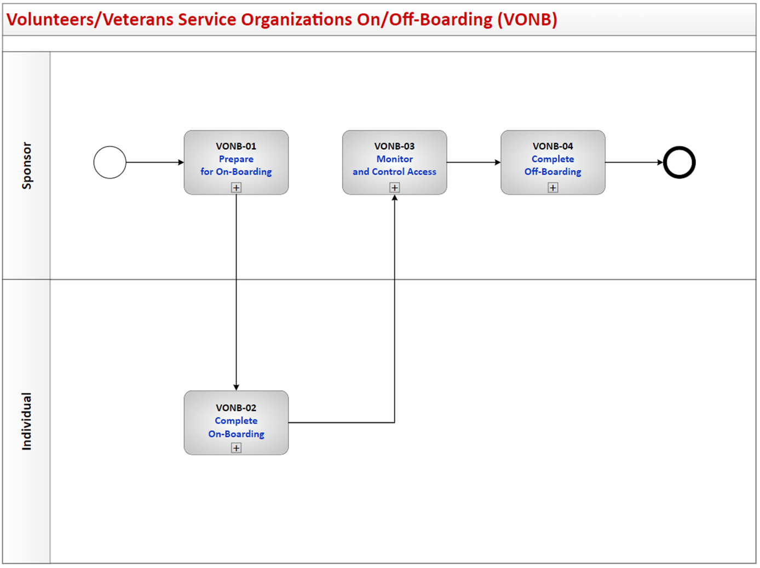

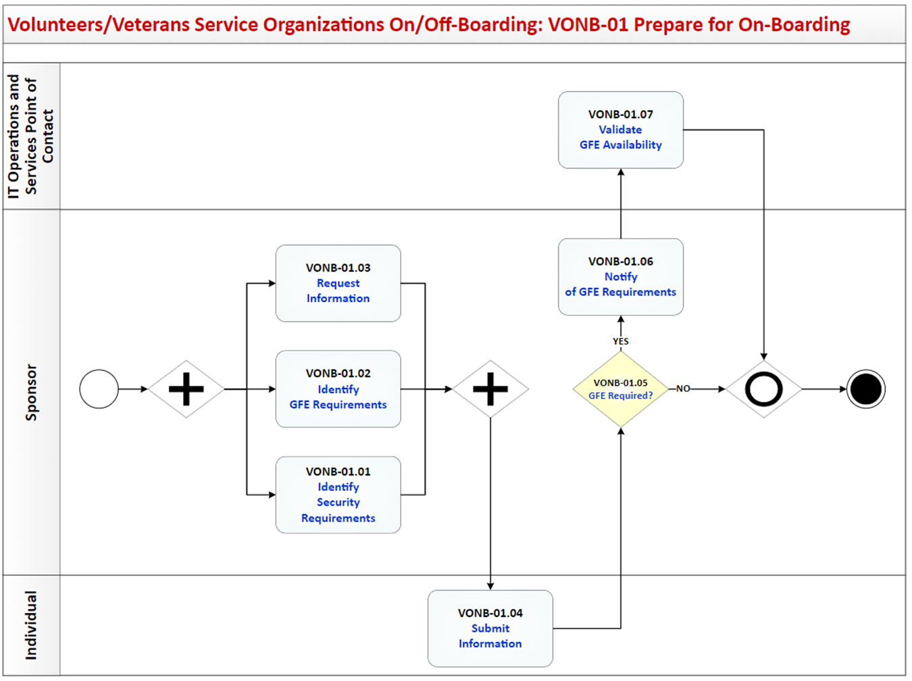

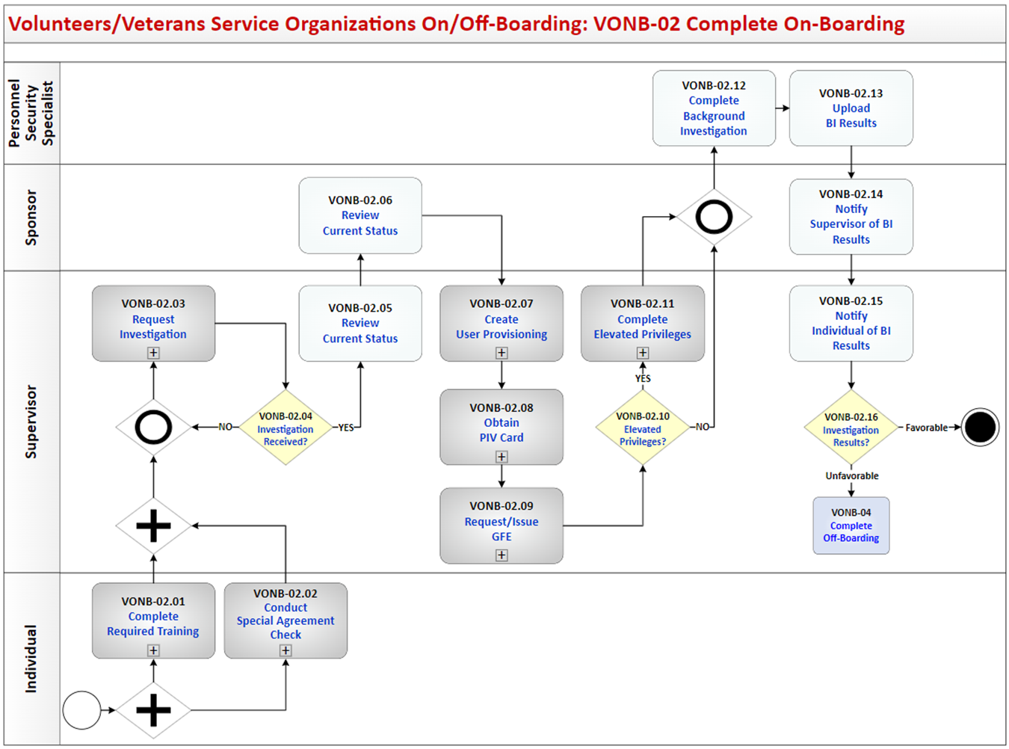

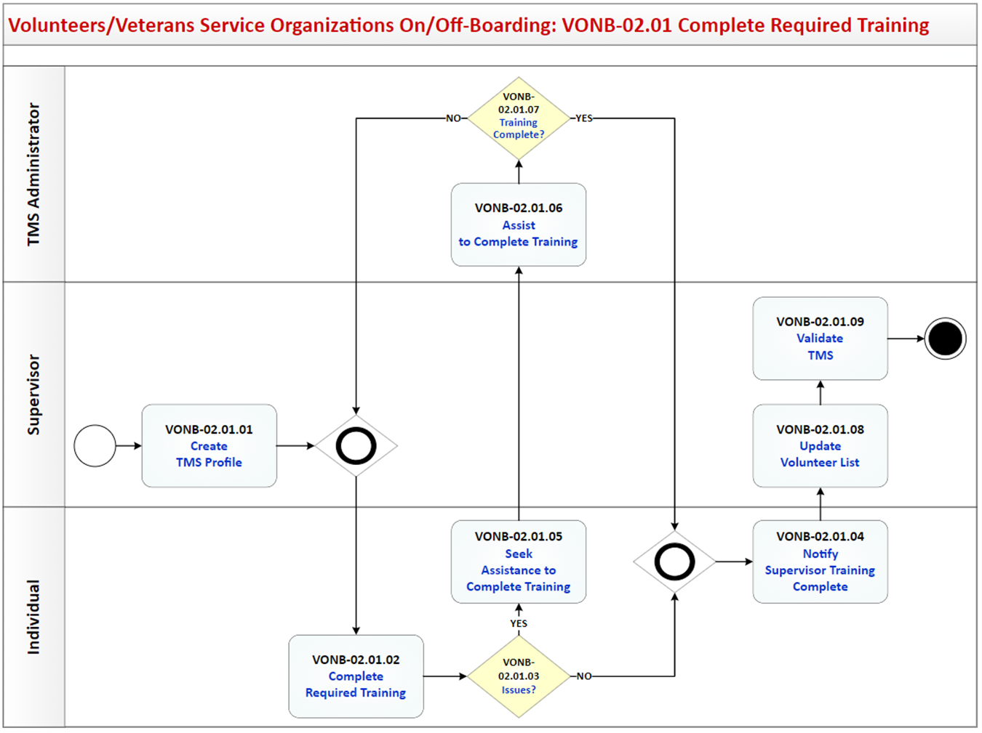

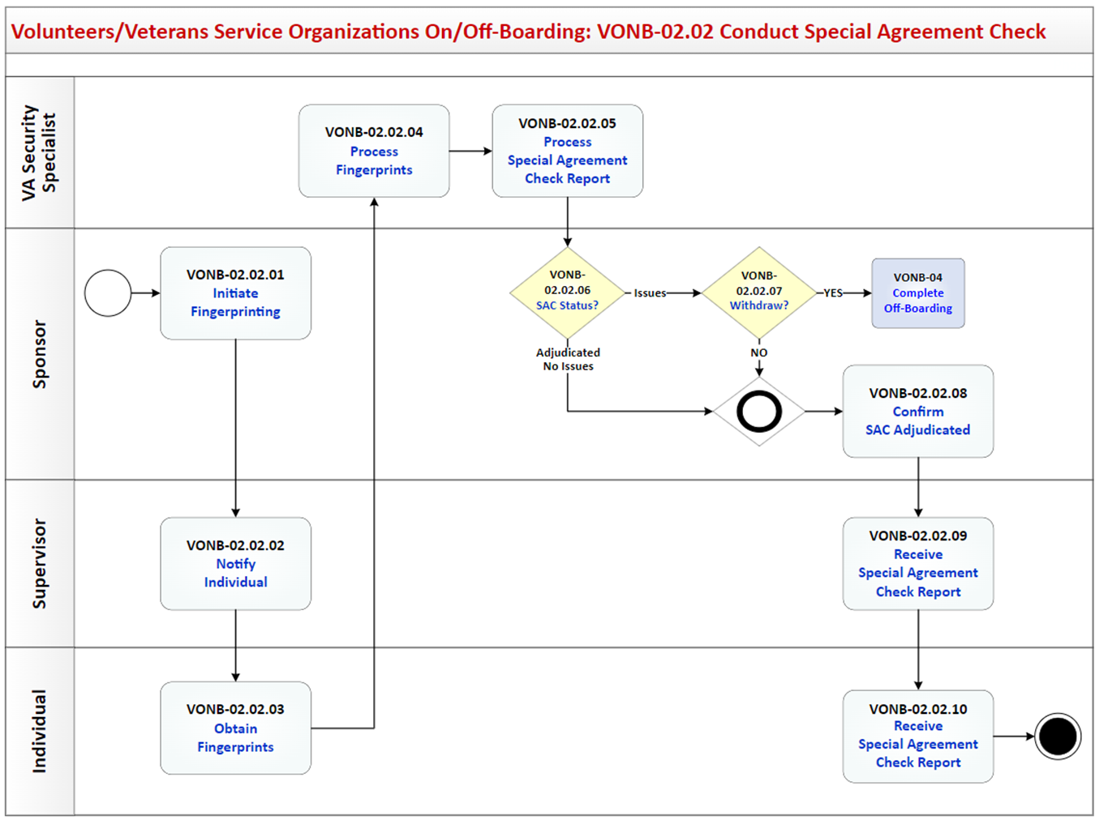

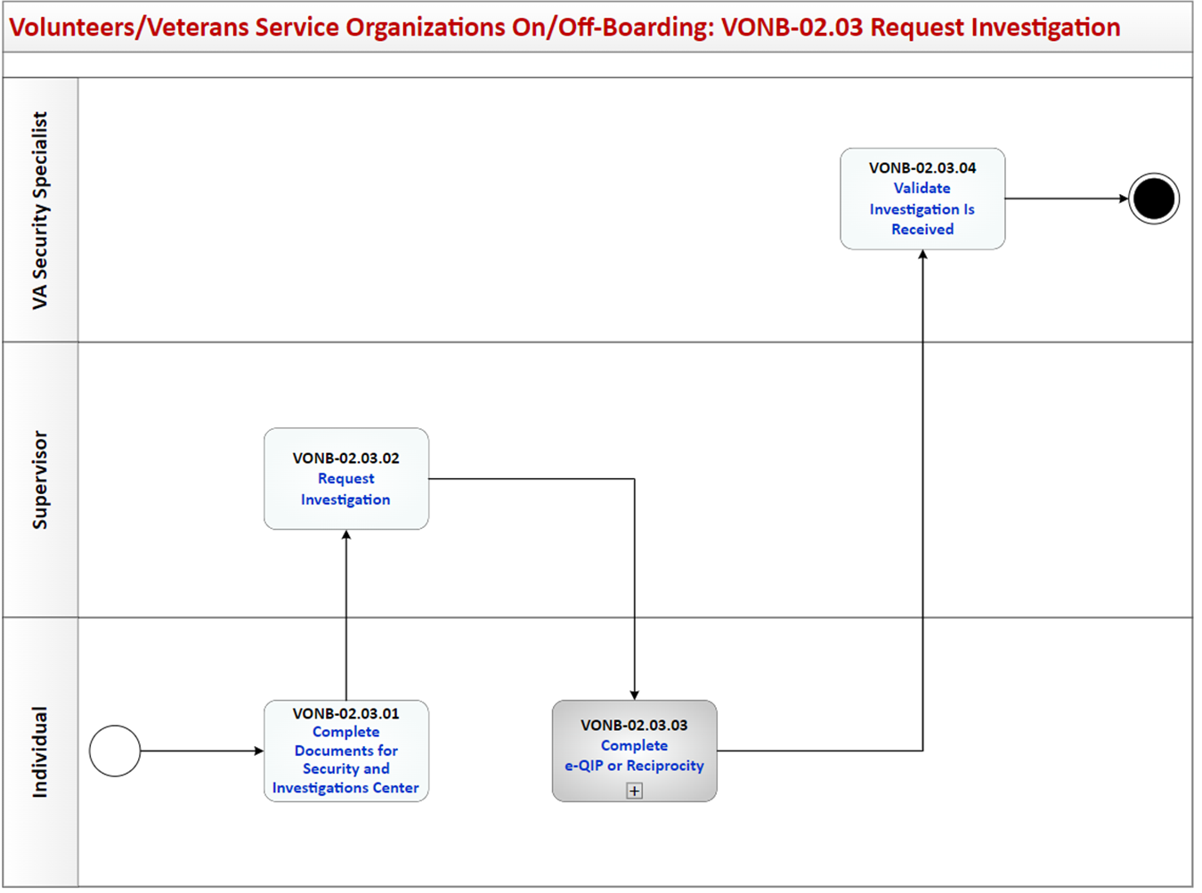

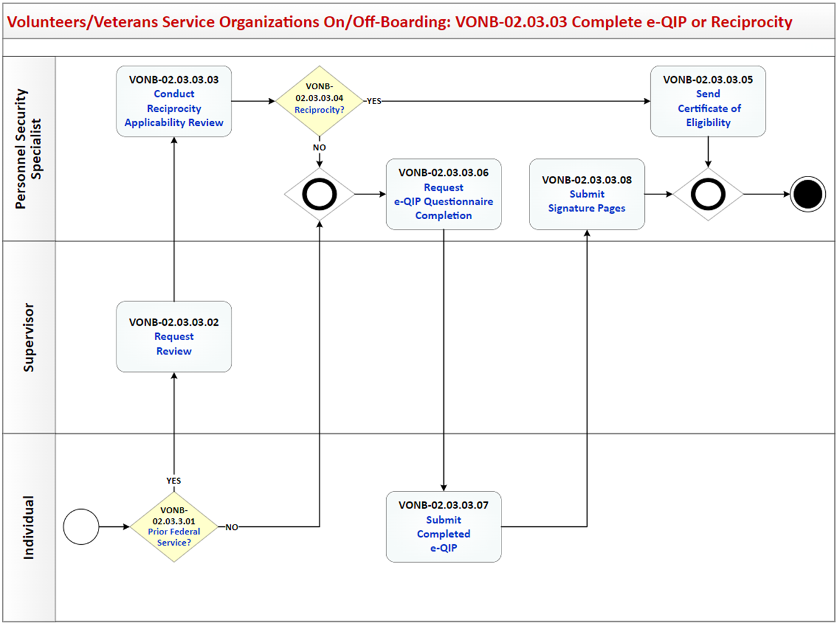

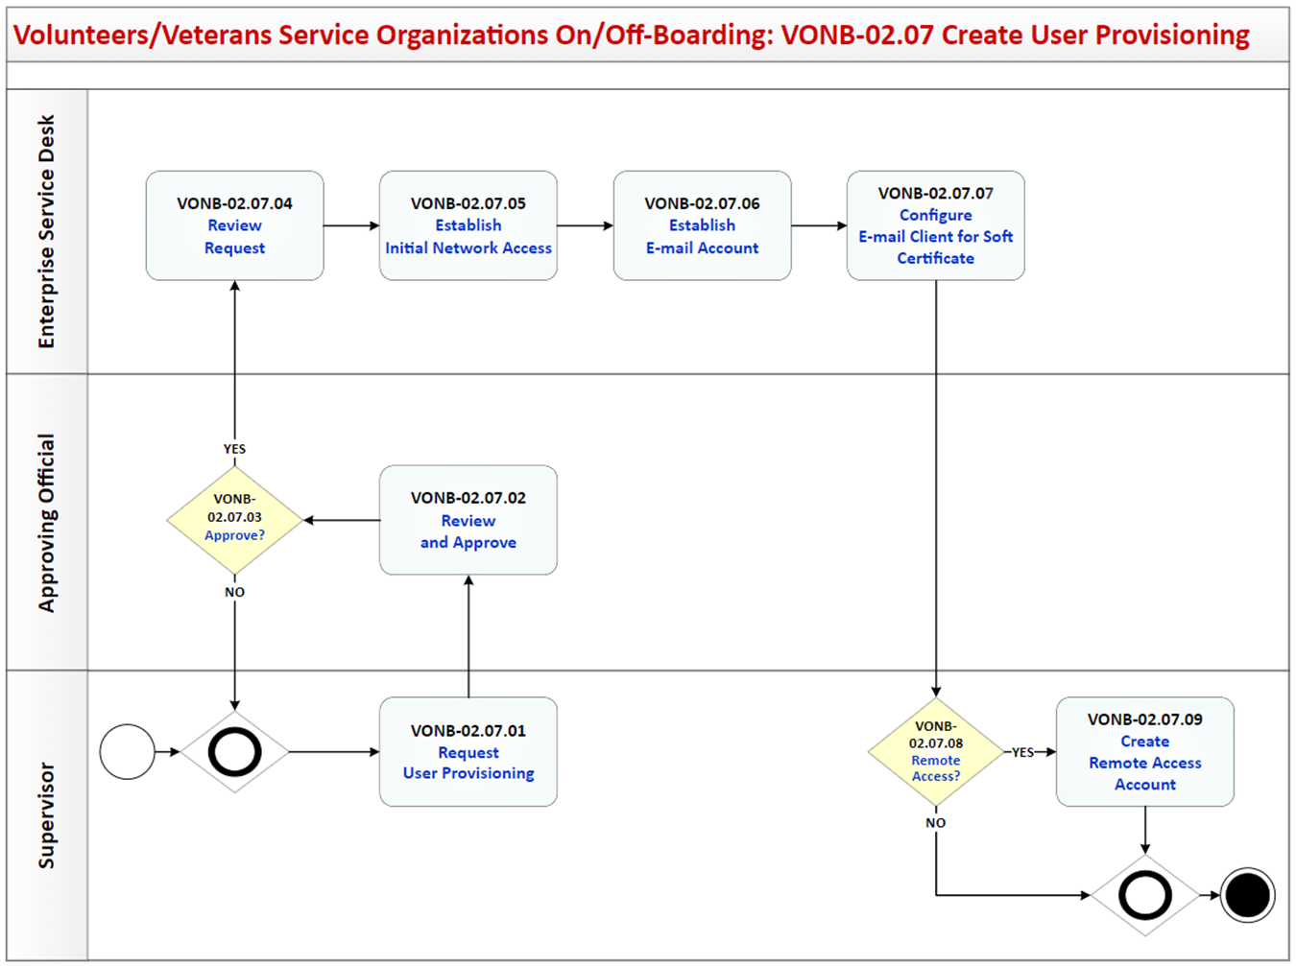

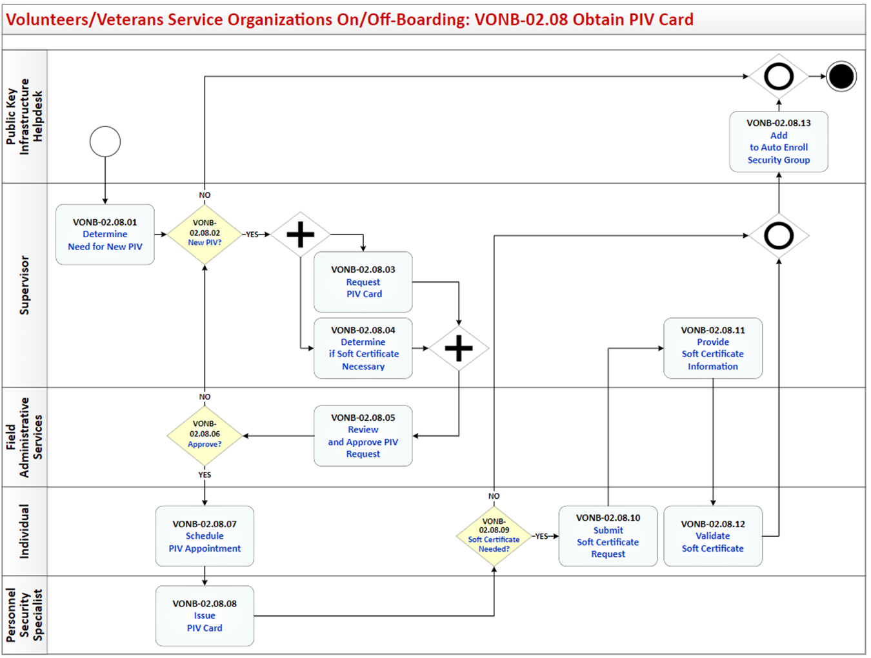

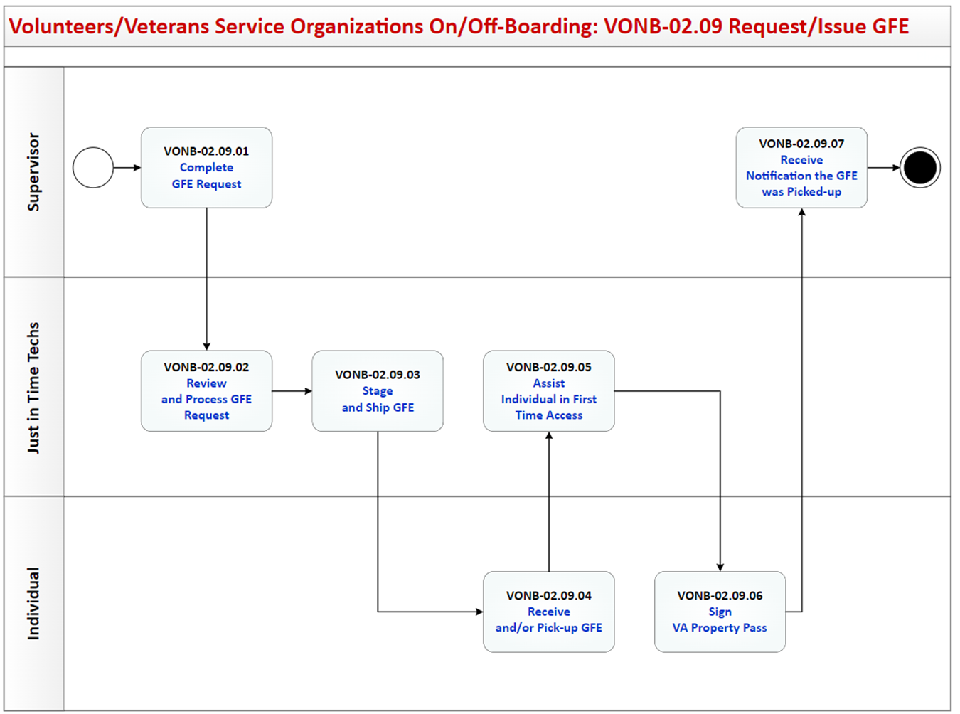

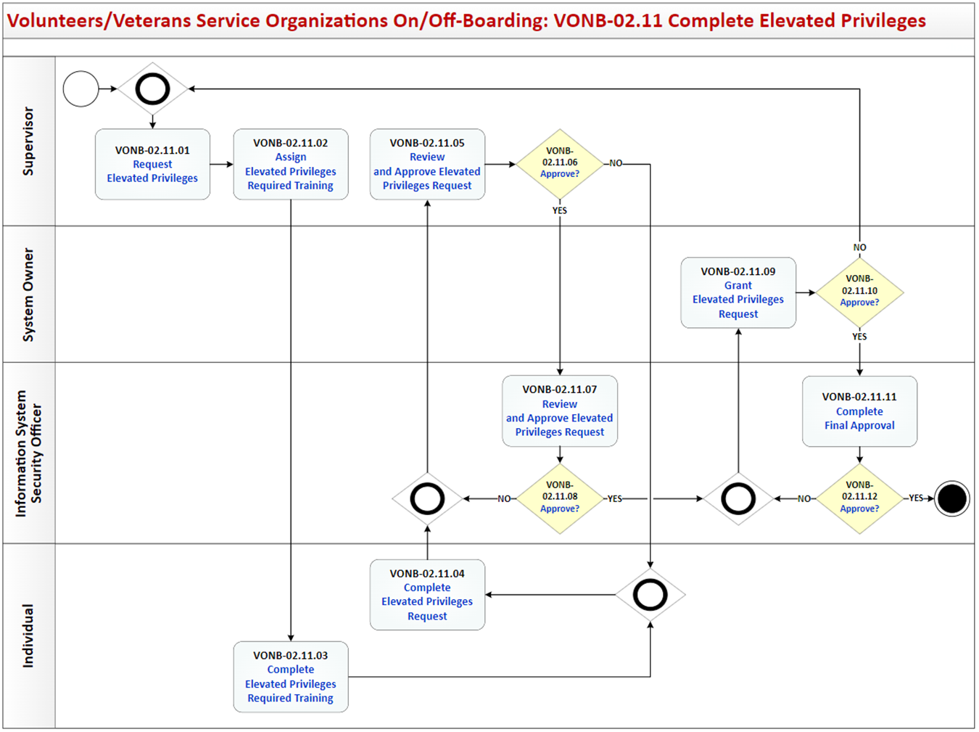

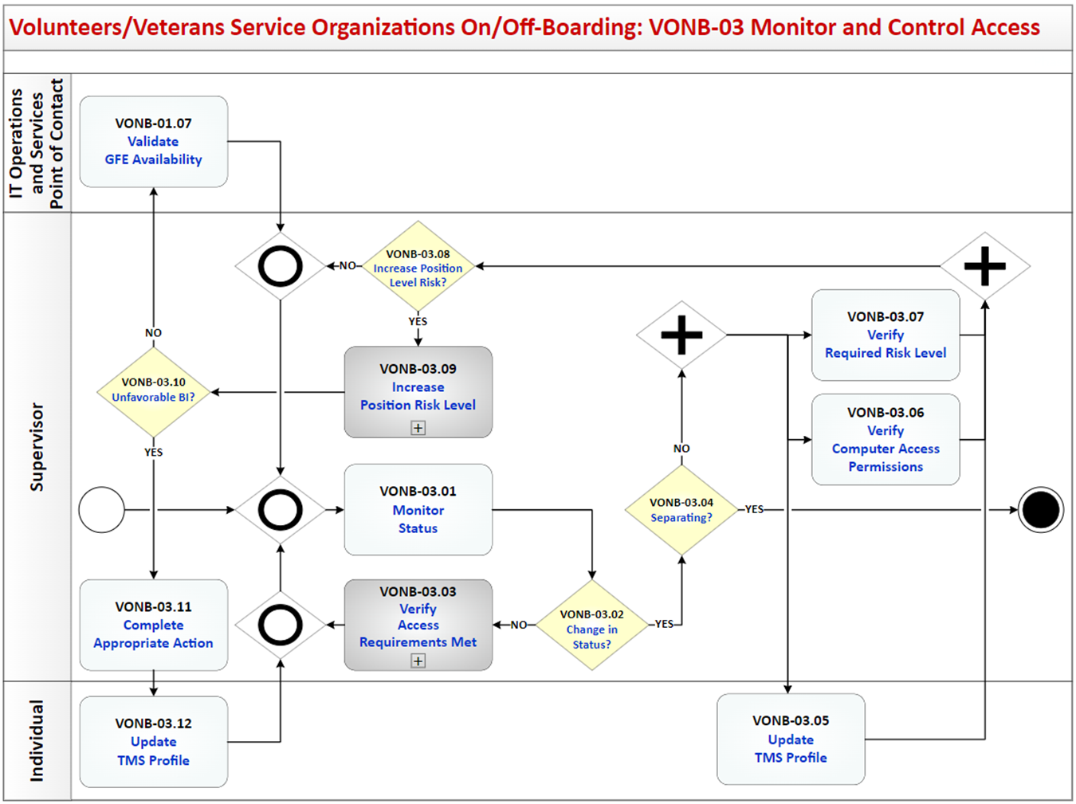

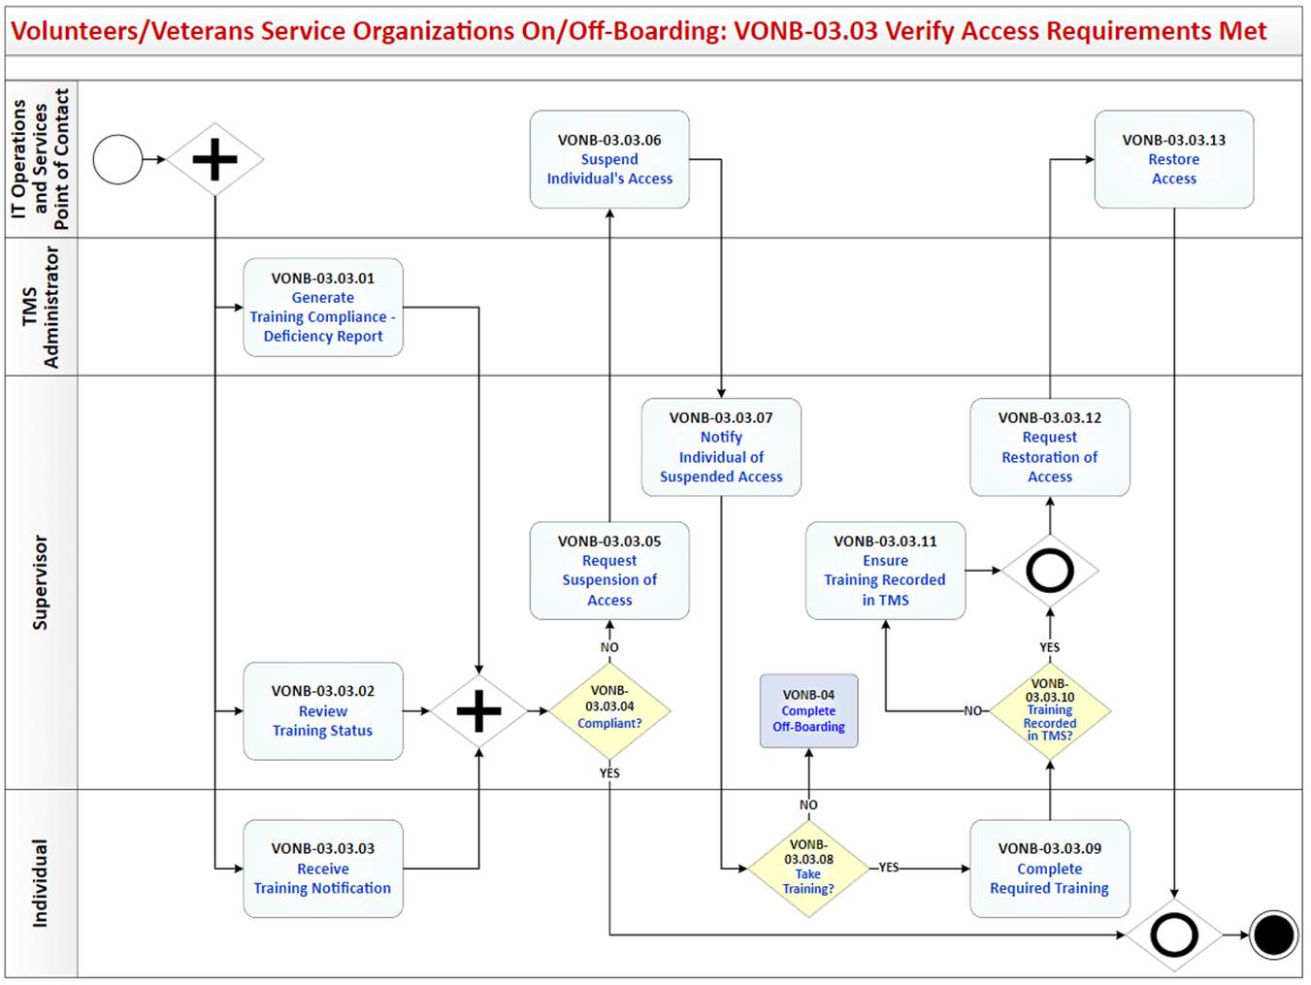

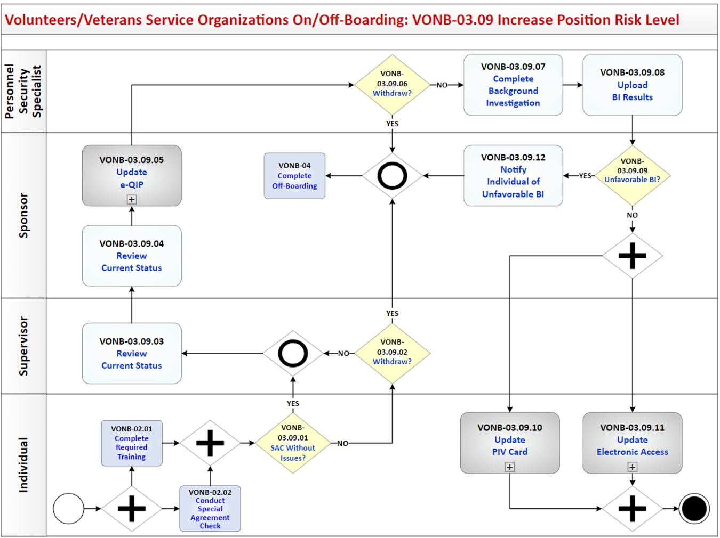

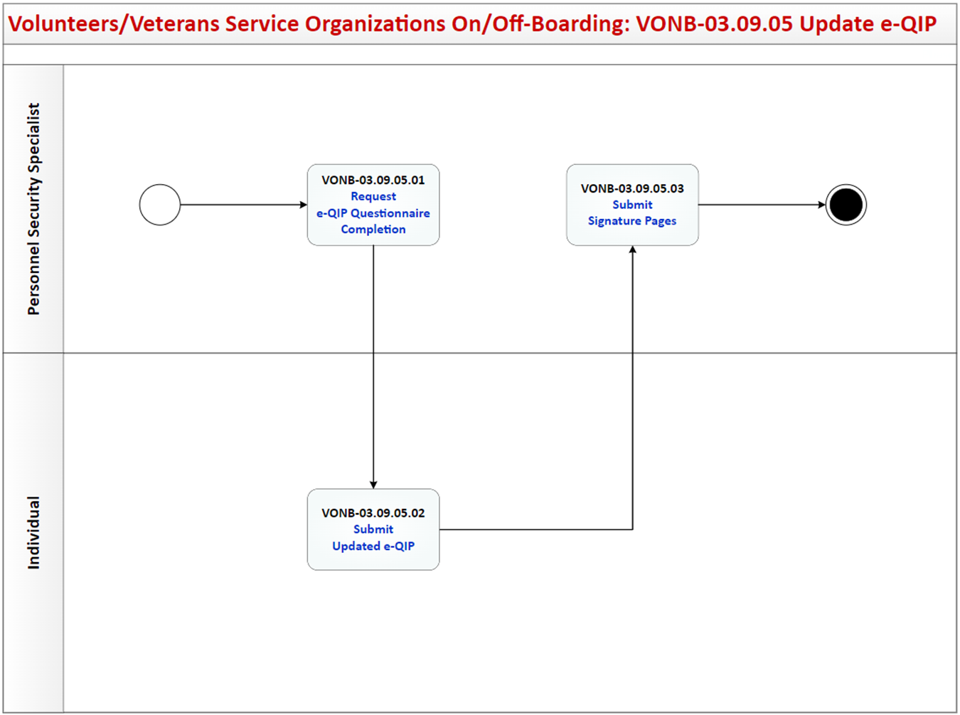

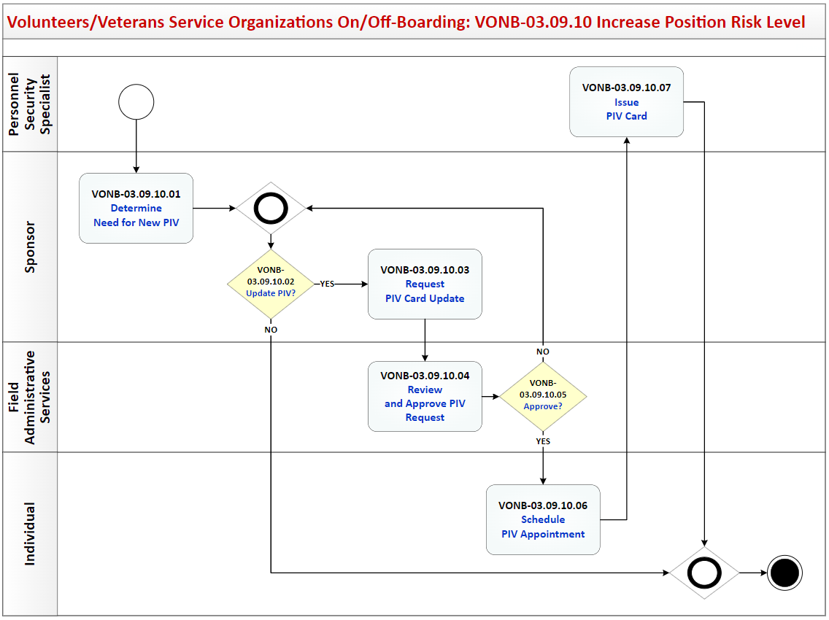

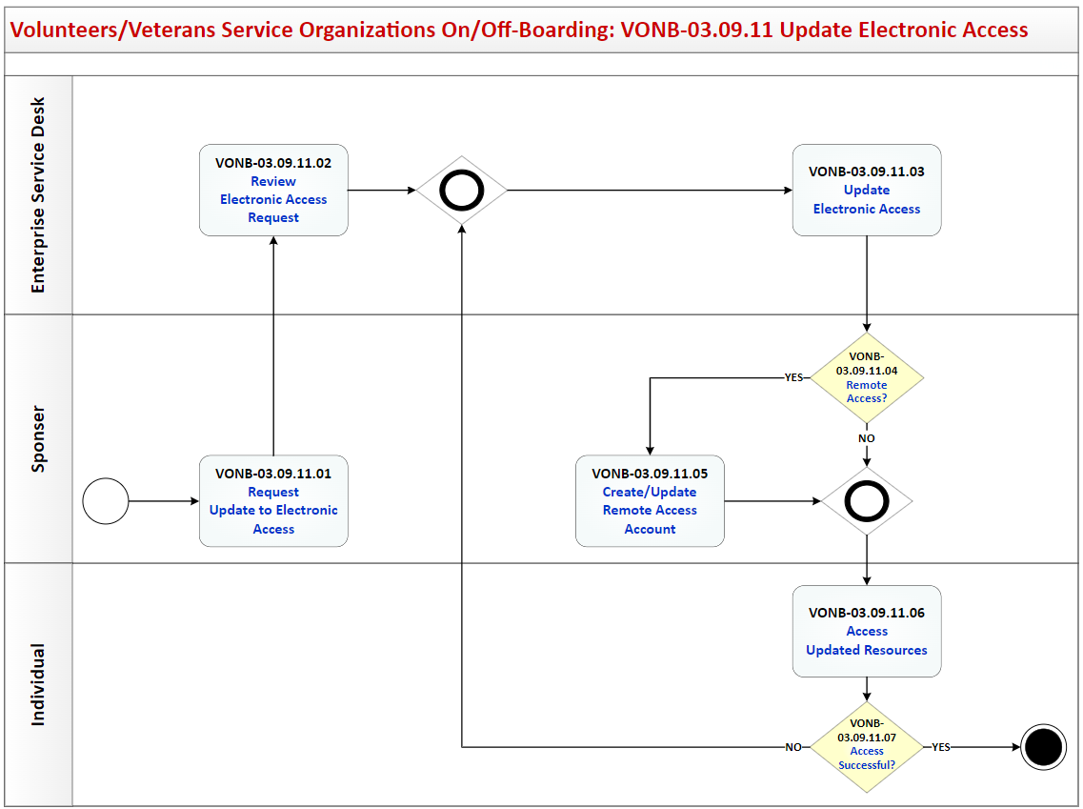

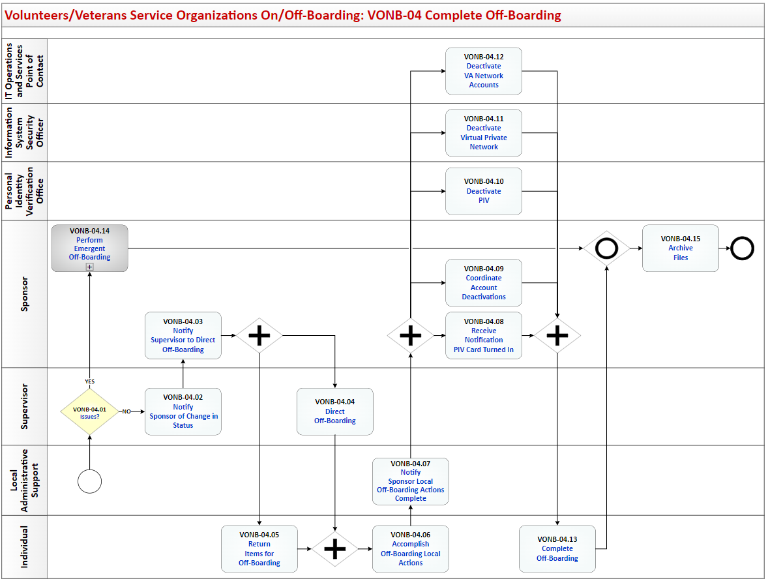

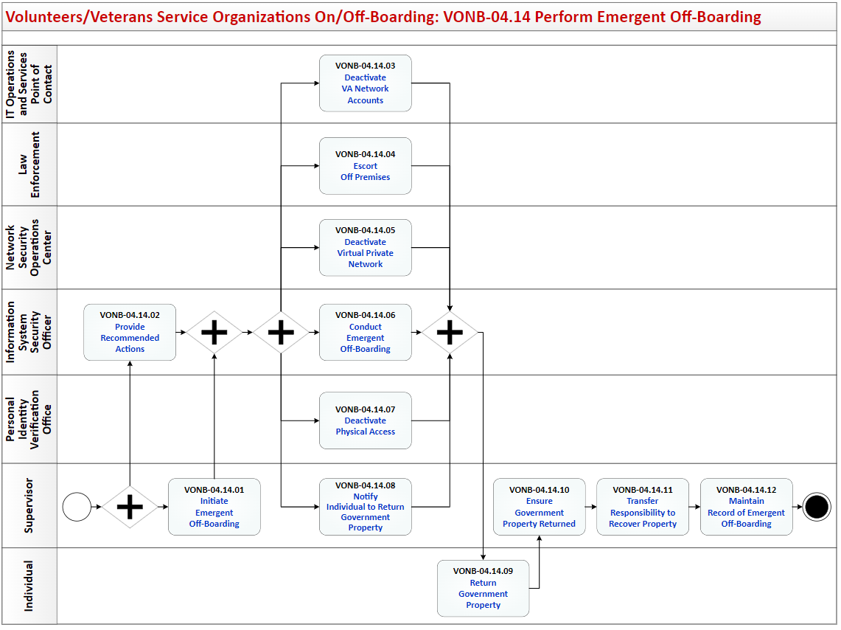

## Process: Volunteers/Veterans Service Organizations On/Off-Boarding

Overview: The process map for Volunteers/Veterans Service Organizations On/Off Boarding cycles through the following process and review activities:

VONB-01 Prepare for On-boarding

VONB-01.01 Identify Security Requirements

VONB-01.02 Identify GFE Requirements

VONB-01.03 Request Information

VONB-01.04 Submit Information

VONB-01.05 GFE Required?

VONB-01.06 Notify of GFE Requirements

VONB-01.07 Validate GFE Availability

VONB-02 Complete On-Boarding

VONB-02.01 Complete Required Training

VONB-02.01.01 Create TMS Profile

VONB-02.01.02 Complete Required Training

VONB-02.01.03 Issues?

VONB-02.01.04 Notify Supervisor Training Complete

VONB-02.01.05 Seek Assistance to Complete Training

VONB-02.01.06 Assist to Complete Training

VONB-02.01.07 Training Complete?

VONB-02.01.08 Update Volunteer List

VONB-02.01.09 Validate TMS

VONB-02.02 Conduct Special Agreement Check

VONB-02.02.01 Initiate Fingerprinting

VONB-02.02.02 Notify Individual

VONB-02.02.03 Obtain Fingerprints

VONB-02.02.04 Process Fingerprints

VONB-02.02.05 Process Special Agreement Check Report

VONB-02.02.06 SAC Status?

VONB-02.02.07 Withdraw?

VONB-02.02.08 Confirm SAC Adjudicated

VONB-02.02.09 Receive Special Agreement Check Report

VONB-02.02.10 Receive Special Agreement Check Report

VONB-02.03 Request Investigation

VONB-02.03.01 Complete Documents for Security and Investigation Center

VONB-02.03.02 Request Background Investigation

VONB-02.03.03 Complete e-QIP or Reciprocity

VONB-02.03.03.01 Prior Federal Service

VONB-02.03.03.02 Request Review

VONB-02.03.03.03 Conduct Reciprocity Applicability Review

VONB-02.03.03.04 Reciprocity?

VONB-02.03.03.05 Request e-QIP Questionnaire Completion

VONB-02.03.03.06 Submit Completed e-QIP

VONB-02.03.03.07 Submit Signature Pages

VONB-02.03.03.08 Send Certificate of Eligibility

VONB-02.03.04 Validate Investigation is Received

VONB-02.04 Investigation Received?

VONB-02.05 Review Current Status

VONB-02.06 Review Current Status

VONB-02.07 Create User Provisioning

VONB-02.07.01 Request User Provisioning

VONB-02.07.02 Review and Approve

VONB-02.07.03 Approve?

VONB-02.07.04 Review Request

VONB-02.07.05 Establish Initial Network Access

VONB-02.07.06 Establish E-mail Account

VONB-02.07.07 Configure E-mail Client for Soft Certificate

VONB-02.07.08 Remote Access?

VONB-02.07.09 Create Remote Access Account

VONB-02.08 Obtain PIV Card

VONB-02.08.01 Determine Need for New PIV

VONB-02.08.02 New PIV?

VONB-02.08.03 Request PIV Card

VONB-02.08.04 Determine if Soft Certificate Necessary

VONB-02.08.05 Review and Approve PIV Request

VONB-02.08.06 Approve?

VONB-02.08.07 Schedule PIV Appointment

VONB-02.08.08 Issue PIV Card

VONB-02.08.09 Soft Certificate Needed?

VONB-02.08.10 Submit Soft Certificate Request

VONB-02.08.11 Provide Soft Certificate Information

VONB-02.08.12 Validate Soft Certificate

VONB-02.08.13 Add to Auto Enroll Security Group

VONB-02.09 Request/Issue GFE

VONB-02.09.01 Complete GFE Request

VONB-02.09.02 Review and Process GFE Request

VONB-02.09.03 Stage and Ship GFE

VONB-02.09.04 Receive and/or Pick up GFE

VONB-02.09.05 Assist Individual In First Time Access

VONB-02.09.06 Sign VA Property Pass

VONB-02.09.07 Receive Notification the GFE was Picked-up

VONB-02.10 Elevated Privileges?

VONB-02.11 Complete Elevated Privileges

VONB-02.11.01 Request Elevated Privileges

VONB-02.11.02 Assign Elevated Privileges Required Training

VONB-02.11.03 Complete Elevated Privileges Required Training

VONB-02.11.04 Complete Elevated Privileges Request

VONB-02.11.05 Review and Approve Elevated Privileges Request

VONB-02.11.06 Approve?

VONB-02.11.07 Review and Approve Elevated Privileges Request

VONB-02.11.08 Approve?

VONB-02.11.09 Grant Elevated Privileges Request

VONB-02.11.10 Approve?

VONB-02.11.11 Complete Final Approval

VONB-02.11.12 Approve?

VONB-02.12 Complete Background Investigation

VONB-02.13 Upload BI Results

VONB-02.14 Notify Supervisor of BI Results

VONB-02.15 Notify Individual of BI Results

VONB-02.16 Investigation Results?

VONB-03 Monitor and Control Access

VONB-03.01 Monitor Status

VONB-03.02 Change in Status?

VONB-03.03 Verify Access Requirements Met

VONB-03.03.01 Generate Training Compliance - Deficiency Report

VONB-03.03.02 Review Training Status

VONB-03.03.03 Receive Training Notification

VONB-03.03.04 Compliant?

VONB-03.03.05 Request Suspension of Access

VONB-03.03.06 Suspend Individual's Access

VONB-03.03.07 Notify Individual of Suspended Access

VONB-03.03.08 Take Training?

VONB-03.03.09 Complete Required Training

VONB-03.03.10 Training Recorded in TMS?

VONB-03.03.11 Ensure Training Recorded in TMS

VONB-03.03.12 Request Restoration of Access

VONB-03.03.13 Restore Access

VONB-03.04 Separating?

VONB-03.05 Update TMS Profile

VONB-03.06 Verify Computer Access Permissions

VONB-03.07 Verify Required Risk Level

VONB-03.08 Increase Position Risk Level?

VONB-03.09 Increase Position Risk Level

VONB-03.09.01 SAC Without Issues?

VONB-03.09.02 Withdraw?

VONB-03.09.03 Review Current Status

VONB-03.09.04 Review Current Status

VONB-03.09.05 Update e-QIP

VONB-03.09.05.01 Request e-QIP Questionnaire Completion

VONB-03.09.05.02 Submit Completed e-QIP

VONB-03.09.05.03 Submit Signature Pages

VONB-03.09.06 Withdraw?

VONB-03.09.07 Complete Background Investigation

VONB-03.09.08 Upload BI Results

VONB-03.09.09 Unfavorable BI?

VONB-03.09.10 Update PIV Card

VONB-03.09.10.01 Determine Need for New PIV

VONB-03.09.10.02 Update PIV?

VONB-03.09.10.03 Request PIV Card Update

VONB-03.09.10.04 Review and Approve PIV Request

VONB-03.09.10.05 Approve?

VONB-03.09.10.06 Schedule PIV Appointment

VONB-03.09.10.07 Issue PIV Card

VONB-03.09.11 Update Electronic Access

VONB-03.09.11.01 Request Update to Electronic Access

VONB-03.09.11.02 Review Electronic Access Request

VONB-03.09.11.03 Update Electronic Access

VONB-03.09.11.04 Remote Access?

VONB-03.09.11.05 Create / Update Remote Access Account

VONB-03.09.11.06 Access Updated Resources

VONB-03.09.11.07 Create / Update Remote Access Account

VONB-03.09.12 Notify Individual of Unfavorable BI

VONB-03.10 Unfavorable BI?

VONB-03.11 Complete Appropriate Action

VONB-03.12 Update TMS Profile

VONB-03.13 Increase Access

VONB-04 Complete Off-Boarding

VONB-04.01 Issues?

VONB-04.02 Notify Sponsor of Change in Status

VONB-04.03 Notify Supervisor to Direct Off-Boarding

VONB-04.04 Direct Off-Boarding

VONB-04.05 Return Items for Off-Boarding

VONB-04.06 Accomplish Off-Boarding Local Actions

VONB-04.07 Notify Sponsor Local Off-Boarding Actions Complete

VONB-04.08 Receive Notification PIV Card Turned In

VONB-04.09 Coordinate Account Deactivations

VONB-04.10 Deactivate PIV

VONB-04.11 Deactivate Virtual Private Network

VONB-04.12 Deactivate VA Network Accounts

VONB-04.13 Complete Off-Boarding

VONB-04.14 Perform Emergent Off-Boarding

VONB-04.14.01 Initiate Emergent Off-Boarding

VONB-04.14.02 Provide Recommended Actions

VONB-04.14.03 Deactivate VA Network Accounts

VONB-04.14.04 Escort Off Premises

VONB-04.14.05 Deactivate Virtual Private Network

VONB-04.14.06 Conduct Emergent Off-Boarding

VONB-04.14.07 Deactivate Physical Access

VONB-04.14.08 Notify Individual to Return Government Property

VONB-04.14.09 Return Government Property

VONB-04.14.10 Ensure Government Property Returned

VONB-04.14.11 Transfer Responsibility to Recover Property

VONB-04.14.12 Maintain Record of Emergent Off-Boarding

VONB-04.15 Archive Files

## Volunteers/Veterans Service Organizations On/Off Boarding Description and Goals

### Description

The Volunteers and Veterans Service Organizations On/Off-Boarding (VONB) process describes the activities to obtain access to VA networks, facilities, and equipment by completing background investigations and required training and obtaining Government Furnished Equipment with appropriate software. After initial on-boarding, the process also establishes the framework for consistently ensuring that all Volunteers and Veterans Service Organizations individuals have the proper access necessary to perform the role they are assigned and that they continue to meet those minimum requirements necessary to support granting the access. The VONB process complies with the Federal security and privacy regulations.

### Goals

The goal of the VONB process is to establish the set of activities required to provide, monitor, control, and remove an individual's access to VA systems, equipment, and facilities as appropriate to meet the needs of the VA.

Specific goals include:

* Completing required background investigation and fingerprinting
* Reviewing and accepting VA Rules of Behavior
* Obtaining access to the Talent Management System
* Documenting the required information security and privacy training to access the VA network
* Receiving Government Furnished Equipment with needed software, if required
* Accessing the VA Network and establishing remote VA network access as required
* Obtaining VA identification and access to VA facilities
* Monitoring and verifying successful completion of annual security training requirements
* Monitoring and verifying successful adjudication of SAC, National Agency Check with Inquiries, Minimum Background Investigation, or Background Investigation as appropriate to the role
* Granting or withdrawing access based upon meeting or failing to meet requirements, initiate personnel actions as necessary
* Notifying appropriate management personnel of access changes required based upon clearance adjudications or failure to meet requirements
* Ensuring recovery of identity badges, Personal Identity Verification (PIV) cards, keys and other access granting items are recovered before the individual departs from the VA
* Ensuring access to Public Key Infrastructure (PKI), as applicable
* Ensuring recovery of all Government Furnished Equipment (desktops, laptops, smart phone, printers, faxes, etc.) and other government property are properly recovered and transferred to the appropriate office in the VA within 24 hours if the individual departs from the VA
* Ensuring that clearance through appropriate physical security personnel occurs
* Ensuring all system access privileges and network access are terminated
* Ensuring that all appropriate personnel actions are initiated and documented and notifications are made

## Volunteers/Veterans Service Organizations On/Off Boarding RACI Information

The following describes the RACI information for this process:

**VONB-01.01 Identify Security Requirements**

Responsible Role: Sponsor

Accountable Role: VA Security Specialist

Consulted Role: None Listed

Informed Role: None Listed

**VONB-01.02 Identify GFE Requirements**

Responsible Role: Sponsor

Accountable Role: VA Security Specialist

Consulted Role: None Listed

Informed Role: None Listed

**VONB-01.03 Request Information**

Responsible Role: Sponsor

Accountable Role: Personnel Security Specialist

Consulted Role: None Listed

Informed Role: None Listed

**VONB-01.04 Submit Information**

Responsible Role: Individual

Accountable Role: Sponsor

Consulted Role: None Listed

Informed Role: None Listed

**VONB-01.05 GFE Required?**

Responsible Role: Sponsor

Accountable Role: Supervisor

Consulted Role: None Listed

Informed Role: None Listed

**VONB-01.06 Notify of GFE Requirements**

Responsible Role: Sponsor

Accountable Role: Supervisor

Consulted Role: None Listed

Informed Role: None Listed

**VONB-01.07 Validate GFE Availability**

Responsible Role: IT Operations and Services Point of Contact

Accountable Role: Sponsor

Consulted Role: None Listed

Informed Role: None Listed

**VONB-02.01.01 Create TMS Profile**

Responsible Role: Supervisor

Accountable Role: Sponsor

Consulted Role: None Listed

Informed Role: None Listed

**VONB-02.01.02 Complete Required Training**

Responsible Role: Individual

Accountable Role: Supervisor

Consulted Role: None Listed

Informed Role: None Listed

**VONB-02.01.03 Issues?**

Responsible Role: Individual

Accountable Role: Supervisor

Consulted Role: None Listed

Informed Role: None Listed

**VONB-02.01.04 Notify Supervisor Training Complete**

Responsible Role: Individual

Accountable Role: Supervisor

Consulted Role: None Listed

Informed Role: None Listed

**VONB-02.01.05 Seek Assistance to Complete Training**

Responsible Role: Individual

Accountable Role: Supervisor

Consulted Role: None Listed

Informed Role: None Listed

**VONB-02.01.06 Assist to Complete Training**

Responsible Role: Talent Management System Administrator

Accountable Role: Supervisor

Consulted Role: None Listed

Informed Role: None Listed

**VONB-02.01.07 Training Complete?**

Responsible Role: Talent Management System Administrator

Accountable Role: Supervisor

Consulted Role: None Listed

Informed Role: None Listed

**VONB-02.01.08 Update Volunteer List**

Responsible Role: Supervisor

Accountable Role: Sponsor

Consulted Role: None Listed

Informed Role: None Listed

**VONB-02.01.09 Validate TMS**

Responsible Role: Supervisor

Accountable Role: Sponsor

Consulted Role: None Listed

Informed Role: None Listed

**VONB-02.02.01 Initiate Fingerprinting**

Responsible Role: Sponsor

Accountable Role: Law Enforcement

Consulted Role: Security and Investigations Center

Informed Role: None Listed

**VONB-02.02.02 Notify Individual**

Responsible Role: Supervisor

Accountable Role: Sponsor

Consulted Role: None Listed

Informed Role: None Listed

**VONB-02.02.03 Obtain Fingerprints**

Responsible Role: Individual

Accountable Role: Supervisor

Consulted Role: None Listed

Informed Role: None Listed

**VONB-02.02.04 Process Fingerprints**

Responsible Role: VA Security Specialist

Accountable Role: Sponsor

Consulted Role: Security and Investigations Center

Informed Role: Supervisor

**VONB-02.02.05 Process Special Agreement Check Report**

Responsible Role: VA Security Specialist

Accountable Role: Sponsor

Consulted Role: None Listed

Informed Role: Supervisor

**VONB-02.02.06 SAC Status?**

Responsible Role: Sponsor

Accountable Role: Supervisor

Consulted Role: None Listed

Informed Role: None Listed

**VONB-02.02.07 Withdraw?**

Responsible Role: Sponsor

Accountable Role: Supervisor

Consulted Role: VA Security Specialist; Supervisor

Informed Role: None Listed

**VONB-02.02.08 Confirm SAC Adjudicated**

Responsible Role: Sponsor

Accountable Role: VA Security Specialist

Consulted Role: Security and Investigations Center

Informed Role: None Listed

**VONB-02.02.09 Receive Special Agreement Check Report**

Responsible Role: Supervisor

Accountable Role: Sponsor

Consulted Role: None Listed

Informed Role: Individual

**VONB-02.02.10 Receive Special Agreement Check Report**

Responsible Role: Individual

Accountable Role: Supervisor

Consulted Role: None Listed

Informed Role: None Listed

**VONB-02.03.01 Complete Documents for Security and Investigation Center**

Responsible Role: Individual

Accountable Role: Supervisor

Consulted Role: None Listed

Informed Role: None Listed

**VONB-02.03.02 Request Background Investigation**

Responsible Role: Supervisor

Accountable Role: Sponsor

Consulted Role: Security and Investigations Center

Informed Role: None Listed

**VONB-02.03.03.01 Prior Federal Service**

Responsible Role: Individual

Accountable Role: Supervisor

Consulted Role: None Listed

Informed Role: None Listed

**VONB-02.03.03.02 Request Review**

Responsible Role: Sponsor

Accountable Role: Supervisor

Consulted Role: None Listed

Informed Role: None Listed

**VONB-02.03.03.03 Conduct Reciprocity Applicability Review**

Responsible Role: Personnel Security Specialist

Accountable Role: Supervisor

Consulted Role: Sponsor

Informed Role: None Listed

**VONB-02.03.03.04 Reciprocity?**

Responsible Role: Personnel Security Specialist

Accountable Role: Supervisor

Consulted Role: None Listed

Informed Role: None Listed

**VONB-02.03.03.05 Request e-QIP Questionnaire Completion**

Responsible Role: Personnel Security Specialist

Accountable Role: Supervisor

Consulted Role: None Listed

Informed Role: None Listed

**VONB-02.03.03.06 Submit Completed e-QIP**

Responsible Role: Individual

Accountable Role: Supervisor

Consulted Role: None Listed

Informed Role: None Listed

**VONB-02.03.03.07 Submit Signature Pages**

Responsible Role: Personnel Security Specialist

Accountable Role: Supervisor

Consulted Role: None Listed

Informed Role: None Listed

**VONB-02.03.03.08 Send Certificate of Eligibility**

Responsible Role: Personnel Security Specialist

Accountable Role: Supervisor

Consulted Role: None Listed

Informed Role: None Listed

**VONB-02.03.04 Validate Investigation is Received**

Responsible Role: Personnel Security Specialist

Accountable Role: Supervisor

Consulted Role: Security and Investigations Center

Informed Role: None Listed

**VONB-02.04 Investigation Received?**

Responsible Role: Supervisor

Accountable Role: Sponsor

Consulted Role: None Listed

Informed Role: None Listed

**VONB-02.05 Review Current Status**

Responsible Role: Supervisor

Accountable Role: Sponsor

Consulted Role: None Listed

Informed Role: None Listed

**VONB-02.06 Review Current Status**

Responsible Role: Sponsor

Accountable Role: Principal Deputy Assistant Secretary for Information and Technology

Consulted Role: None Listed

Informed Role: None Listed

**VONB-02.07.01 Request User Provisioning**

Responsible Role: Supervisor

Accountable Role: Approving Official

Consulted Role: None Listed

Informed Role: Sponsor; Individual

**VONB-02.07.02 Review and Approve**

Responsible Role: Approving Official

Accountable Role: Supervisor

Consulted Role: None Listed

Informed Role: Sponsor; Enterprise Service Desk

**VONB-02.07.03 Approve?**

Responsible Role: Approving Official

Accountable Role: Supervisor

Consulted Role: None Listed

Informed Role: None Listed

**VONB-02.07.04 Review Request**

Responsible Role: Enterprise Service Desk

Accountable Role: Approving Official

Consulted Role: Sponsor; Supervisor

Informed Role: Individual

**VONB-02.07.05 Establish Initial Network Access**

Responsible Role: Enterprise Service Desk

Accountable Role: Supervisor

Consulted Role: None Listed

Informed Role: Approving Official; Individual; Information System Security Officer

**VONB-02.07.06 Establish E-mail Account**Responsible Role: Enterprise Service Desk

Accountable Role: Supervisor

Consulted Role: None Listed

Informed Role: Individual; Sponsor

**VONB-02.07.07 Configure E-mail Client for Soft Certificate**

Responsible Role: Enterprise Service Desk

Accountable Role: Supervisor

Consulted Role: None Listed

Informed Role: Individual; Sponsor

**VONB-02.07.08 Remote Access?**

Responsible Role: Supervisor

Accountable Role: Individual

Consulted Role: None Listed

Informed Role: None Listed

**VONB-02.07.09 Create Remote Access Account**

Responsible Role: Supervisor

Accountable Role: Individual

Consulted Role: None Listed

Informed Role: Information System Security Officer; Sponsor

**VONB-02.08.01 Determine Need for New PIV**Responsible Role: Supervisor

Accountable Role: Sponsor

Consulted Role: None Listed

Informed Role: None Listed

**VONB-02.08.02 New PIV?**

Responsible Role: Supervisor

Accountable Role: Sponsor

Consulted Role: None Listed

Informed Role: None Listed

**VONB-02.08.03 Request PIV Card**

Responsible Role: Supervisor

Accountable Role: Sponsor

Consulted Role: None Listed

Informed Role: None Listed

**VONB-02.08.04 Determine if Soft Certificate Necessary**

Responsible Role: Supervisor

Accountable Role: Sponsor

Consulted Role: None Listed

Informed Role: None Listed

**VONB-02.08.05 Review and Approve PIV Request**

Responsible Role: Field Administrative Services

Accountable Role: Supervisor

Consulted Role: None Listed

Informed Role: Individual

**VONB-02.08.06 Approve?**

Responsible Role: Field Administrative Services

Accountable Role: Supervisor

Consulted Role: None Listed

Informed Role: None Listed

**VONB-02.08.07 Schedule PIV Appointment**

Responsible Role: Individual

Accountable Role: Supervisor

Consulted Role: None Listed

Informed Role: None Listed

**VONB-02.08.08 Issue PIV Card**

Responsible Role: Personnel Security Specialist

Accountable Role: Supervisor

Consulted Role: None Listed

Informed Role: None Listed

**VONB-02.08.09 Soft Certificate Needed?**

Responsible Role: Individual

Accountable Role: Supervisor

Consulted Role: None Listed

Informed Role: None Listed

**VONB-02.08.10 Submit Soft Certificate Request**

Responsible Role: Individual

Accountable Role: Supervisor

Consulted Role: None Listed

Informed Role: None Listed

**VONB-02.08.11 Provide Soft Certificate Information**

Responsible Role: Supervisor

Accountable Role: Sponsor

Consulted Role: None Listed

Informed Role: None Listed

**VONB-02.08.12 Validate Soft Certificate**

Responsible Role: Individual

Accountable Role: Supervisor

Consulted Role: None Listed

Informed Role: None Listed

**VONB-02.08.13 Add to Auto Enroll Security Group**

Responsible Role: Public Key Infrastructure (PKI) Help Desk

Accountable Role: Supervisor

Consulted Role: None Listed

Informed Role: None Listed

**VONB-02.09.01 Complete GFE Request**

Responsible Role: Supervisor

Accountable Role: Sponsor

Consulted Role: None Listed

Informed Role: Individual

**VONB-02.09.02 Review and Process GFE Request**

Responsible Role: Just In Time Techs

Accountable Role: Supervisor

Consulted Role: None Listed

Informed Role: Individual; Information System Security Officer; Sponsor

**VONB-02.09.03 Stage and Ship GFE**

Responsible Role: Just In Time Techs

Accountable Role: Supervisor

Consulted Role: None Listed

Informed Role: Individual; Information System Security Officer; Sponsor

**VONB-02.09.04 Receive and/or Pick up GFE**

Responsible Role: Individual

Accountable Role: Supervisor

Consulted Role: Just In Time Techs

Informed Role: Information System Security Officer

**VONB-02.09.05 Assist Individual In First Time Access**

Responsible Role: Just In Time Techs

Accountable Role: Individual

Consulted Role: None Listed

Informed Role: Supervisor; Information System Security Officer; Sponsor

**VONB-02.09.06 Sign VA Property Pass**

Responsible Role: Individual

Accountable Role: Just In Time Techs

Consulted Role: None Listed

Informed Role: Information System Security Officer; Supervisor; System Owner

**VONB-02.09.07 Receive Notification the GFE was Picked-up**Responsible Role: Supervisor

Accountable Role: Individual

Consulted Role: None Listed

Informed Role: Sponsor

**VONB-02.10 Elevated Privileges?**

Responsible Role: Supervisor

Accountable Role: Sponsor

Consulted Role: None Listed

Informed Role: None Listed

**VONB-02.11.01 Request Elevated Privileges**

Responsible Role: Supervisor

Accountable Role: Sponsor

Consulted Role: IT Operations and Services Point of Contact

Informed Role: None Listed

**VONB-02.11.02 Assign Elevated Privileges Required Training**

Responsible Role: Supervisor

Accountable Role: Sponsor

Consulted Role: None Listed

Informed Role: None Listed

**VONB-02.11.03 Complete Elevated Privileges Required Training**

Responsible Role: Individual

Accountable Role: Supervisor

Consulted Role: None Listed

Informed Role: None Listed

**VONB-02.11.04 Complete Elevated Privileges Request**

Responsible Role: Individual

Accountable Role: Supervisor

Consulted Role: None Listed

Informed Role: None Listed

**VONB-02.11.05 Review and Approve Elevated Privileges Request**

Responsible Role: Supervisor

Accountable Role: Sponsor

Consulted Role: None Listed

Informed Role: None Listed

**VONB-02.11.06 Approve?**

Responsible Role: Supervisor

Accountable Role: Sponsor

Consulted Role: None Listed

Informed Role: None Listed

**VONB-02.11.07 Review and Approve Elevated Privileges Request**

Responsible Role: Information System Security Officer

Accountable Role: Individual

Consulted Role: None Listed

Informed Role: None Listed

**VONB-02.11.08 Approve?**

Responsible Role: Information System Security Officer

Accountable Role: Supervisor

Consulted Role: None Listed

Informed Role: None Listed

**VONB-02.11.09 Grant Elevated Privileges Request**

Responsible Role: System Owner

Accountable Role: Supervisor

Consulted Role: None Listed

Informed Role: None Listed

**VONB-02.11.10 Approve?**

Responsible Role: System Owner

Accountable Role: Information System Security Officer

Consulted Role: None Listed

Informed Role: None Listed

**VONB-02.11.11 Complete Final Approval**

Responsible Role: Information System Security Officer

Accountable Role: Supervisor

Consulted Role: None Listed

Informed Role: None Listed

**VONB-02.11.12 Approve?**Responsible Role: Information System Security Officer

Accountable Role: Supervisor

Consulted Role: None Listed

Informed Role: None Listed

**VONB-02.12 Complete Background Investigation**

Responsible Role: Personnel Security Specialist

Accountable Role: Sponsor

Consulted Role: None Listed

Informed Role: None Listed

**VONB-02.13 Upload BI Results**

Responsible Role: Personnel Security Specialist

Accountable Role: Principal Deputy Assistant Secretary for Information and Technology

Consulted Role: None Listed

Informed Role: None Listed

**VONB-02.14 Notify Supervisor of BI Results**

Responsible Role: Sponsor

Accountable Role: Supervisor

Consulted Role: None Listed

Informed Role: None Listed

**VONB-02.15 Notify Individual of BI Results**

Responsible Role: Supervisor

Accountable Role: Sponsor

Consulted Role: None Listed

Informed Role: Individual

**VONB-02.16 Investigation Results?**

Responsible Role: Supervisor

Accountable Role: Sponsor

Consulted Role: None Listed

Informed Role: None Listed

**VONB-03.01 Monitor Status**

Responsible Role: Sponsor

Accountable Role: Principal Deputy Assistant Secretary for Information and Technology

Consulted Role: None Listed

Informed Role: None Listed

**VONB-03.02 Change in Status?**

Responsible Role: Supervisor

Accountable Role: Sponsor

Consulted Role: None Listed

Informed Role: None Listed

**VONB-03.03.01 Generate Training Compliance - Deficiency Report**

Responsible Role: Talent Management System Administrator

Accountable Role: Supervisor

Consulted Role: None Listed

Informed Role: None Listed

**VONB-03.03.02 Review Training Status**

Responsible Role: Sponsor

Accountable Role: Principal Deputy Assistant Secretary for Information and Technology

Consulted Role: None Listed

Informed Role: None Listed

**VONB-03.03.03 Receive Training Notification**

Responsible Role: Individual

Accountable Role: Supervisor

Consulted Role: None Listed

Informed Role: None Listed

**VONB-03.03.04 Compliant?**

Responsible Role: Supervisor

Accountable Role: Sponsor

Consulted Role: None Listed

Informed Role: None Listed

**VONB-03.03.05 Request Suspension of Access**

Responsible Role: Sponsor

Accountable Role: Principal Deputy Assistant Secretary for Information and Technology

Consulted Role: None Listed

Informed Role: None Listed

**VONB-03.03.06 Suspend Individual's Access**

Responsible Role: IT Operations and Services Point of Contact

Accountable Role: Supervisor

Consulted Role: None Listed

Informed Role: Sponsor

**VONB-03.03.07 Notify Individual of Suspended Access**

Responsible Role: Sponsor

Accountable Role: Principal Deputy Assistant Secretary for Information and Technology

Consulted Role: None Listed

Informed Role: None Listed

**VONB-03.03.08 Take Training?**

Responsible Role: Individual

Accountable Role: Supervisor

Consulted Role: None Listed

Informed Role: None Listed

**VONB-03.03.09 Complete Required Training**

Responsible Role: Individual

Accountable Role: Supervisor

Consulted Role: None Listed

Informed Role: None Listed

**VONB-03.03.10 Training Recorded in TMS?**

Responsible Role: Supervisor

Accountable Role: Sponsor

Consulted Role: None Listed

Informed Role: None Listed

**VONB-03.03.11 Ensure Training Recorded in TMS**

Responsible Role: Sponsor

Accountable Role: Principal Deputy Assistant Secretary for Information and Technology

Consulted Role: None Listed

Informed Role: None Listed

**VONB-03.03.12 Request Restoration of Access**

Responsible Role: Sponsor

Accountable Role: Principal Deputy Assistant Secretary for Information and Technology

Consulted Role: None Listed

Informed Role: None Listed

**VONB-03.03.13 Restore Access**

Responsible Role: IT Operations and Services Point of Contact

Accountable Role: Supervisor

Consulted Role: None Listed

Informed Role: None Listed

**VONB-03.04 Separating?**

Responsible Role: Supervisor

Accountable Role: Sponsor

Consulted Role: None Listed

Informed Role: None Listed

**VONB-03.05 Update TMS Profile**

Responsible Role: Individual

Accountable Role: Personnel Security Specialist

Consulted Role: None Listed

Informed Role: None Listed

**VONB-03.06 Verify Computer Access Permissions**

Responsible Role: Sponsor

Accountable Role: Principal Deputy Assistant Secretary for Information and Technology

Consulted Role: None Listed

Informed Role: None Listed

**VONB-03.07 Verify Required Risk Level**

Responsible Role: Sponsor

Accountable Role: Principal Deputy Assistant Secretary for Information and Technology

Consulted Role: None Listed

Informed Role: None Listed

**VONB-03.08 Increase Position Risk Level?**

Responsible Role: Supervisor

Accountable Role: Sponsor

Consulted Role: None Listed

Informed Role: None Listed

**VONB-03.09.01 SAC Without Issues?**

Responsible Role: Individual

Accountable Role: Supervisor

Consulted Role: None Listed

Informed Role: None Listed

**VONB-03.09.02 Withdraw?**

Responsible Role: Supervisor

Accountable Role: Individual

Consulted Role: None Listed

Informed Role: None Listed

**VONB-03.09.03 Review Current Status**

Responsible Role: Supervisor

Accountable Role: Principal Deputy Assistant Secretary for Information and Technology

Consulted Role: None Listed

Informed Role: None Listed

**VONB-03.09.04 Review Current Status**

Responsible Role: Sponsor

Accountable Role: Principal Deputy Assistant Secretary for Information and Technology

Consulted Role: None Listed

Informed Role: None Listed

**VONB-03.09.05.01 Request e-QIP Questionnaire Completion**

Responsible Role: Personnel Security Specialist

Accountable Role: Principal Deputy Assistant Secretary for Information and Technology

Consulted Role: None Listed

Informed Role: None Listed

**VONB-03.09.05.02 Submit Completed e-QIP**

Responsible Role: Individual

Accountable Role: Sponsor

Consulted Role: None Listed

Informed Role: None Listed

**VONB-03.09.05.03 Submit Signature Pages**

Responsible Role: Personnel Security Specialist

Accountable Role: Principal Deputy Assistant Secretary for Information and Technology

Consulted Role: None Listed

Informed Role: None Listed

**VONB-03.09.06 Withdraw?**

Responsible Role: Personnel Security Specialist

Accountable Role: Supervisor

Consulted Role: None Listed

Informed Role: None Listed

**VONB-03.09.07 Complete Background Investigation**

Responsible Role: Personnel Security Specialist

Accountable Role: Principal Deputy Assistant Secretary for Information and Technology

Consulted Role: None Listed

Informed Role: None Listed

**VONB-03.09.08 Upload BI Results**

Responsible Role: Personnel Security Specialist

Accountable Role: Principal Deputy Assistant Secretary for Information and Technology

Consulted Role: None Listed

Informed Role: None Listed

**VONB-03.09.09 Unfavorable BI?**

Responsible Role: Sponsor

Accountable Role: Personnel Security Specialist

Consulted Role: None Listed

Informed Role: None Listed

**VONB-03.09.10.01 Determine Need for New PIV**

Responsible Role: Supervisor

Accountable Role: Sponsor

Consulted Role: None Listed

Informed Role: Individual

**VONB-03.09.10.02 Update PIV?**

Responsible Role: Supervisor

Accountable Role: Sponsor

Consulted Role: None Listed

Informed Role: None Listed

**VONB-03.09.10.03 Request PIV Card Update**

Responsible Role: Supervisor

Accountable Role: Sponsor

Consulted Role: None Listed

Informed Role: Individual

**VONB-03.09.10.04 Review and Approve PIV Request**

Responsible Role: Field Administrative Services

Accountable Role: Sponsor

Consulted Role: None Listed

Informed Role: Individual

**VONB-03.09.10.05 Approve?**

Responsible Role: Field Administrative Services

Accountable Role: Supervisor

Consulted Role: None Listed

Informed Role: Sponsor

**VONB-03.09.10.06 Schedule PIV Appointment**

Responsible Role: Individual

Accountable Role: Field Administrative Services

Consulted Role: None Listed

Informed Role: Sponsor; Supervisor

**VONB-03.09.10.07 Issue PIV Card**

Responsible Role: Individual

Accountable Role: Individual

Consulted Role: None Listed

Informed Role: Supervisor

**VONB-03.09.11.01 Request Update to Electronic Access**

Responsible Role: Sponsor

Accountable Role: Enterprise Service Desk

Consulted Role: None Listed

Informed Role: None Listed

**VONB-03.09.11.02 Review Electronic Access Request**

Responsible Role: Enterprise Service Desk

Accountable Role: Sponsor

Consulted Role: None Listed

Informed Role: Facility Chief Information Officer; IT Operations and Services Point of Contact; Sponsor

**VONB-03.09.11.03 Update Electronic Access**

Responsible Role: Enterprise Service Desk

Accountable Role: Principal Deputy Assistant Secretary for Information and Technology

Consulted Role: None Listed

Informed Role: None Listed

**VONB-03.09.11.04 Remote Access?**

Responsible Role: Sponsor

Accountable Role: Supervisor

Consulted Role: Information System Security Officer

Informed Role: None Listed

**VONB-03.09.11.05 Create / Update Remote Access Account**

Responsible Role: Sponsor

Accountable Role: Supervisor

Consulted Role: Information System Security Officer

Informed Role: None Listed

**VONB-03.09.11.06 Access Updated Resources**

Responsible Role: Individual

Accountable Role: Sponsor

Consulted Role: None Listed

Informed Role: Supervisor

**VONB-03.09.11.07 Create / Update Remote Access Account**

Responsible Role: Individual

Accountable Role: Sponsor

Consulted Role: None Listed

Informed Role: Supervisor

**VONB-03.09.12 Notify Individual of Unfavorable BI**

Responsible Role: Sponsor

Accountable Role: Principal Deputy Assistant Secretary for Information and Technology

Consulted Role: None Listed

Informed Role: None Listed

**VONB-03.10 Unfavorable BI?**

Responsible Role: Supervisor

Accountable Role: Sponsor

Consulted Role: None Listed

Informed Role: None Listed

**VONB-03.11 Complete Appropriate Action**Responsible Role: Sponsor

Accountable Role: Principal Deputy Assistant Secretary for Information and Technology

Consulted Role: None Listed

Informed Role: None Listed

**VONB-03.12 Update TMS Profile**

Responsible Role: Individual

Accountable Role: Supervisor

Consulted Role: None Listed

Informed Role: None Listed

**VONB-03.13 Increase Access**

Responsible Role: IT Operations and Services Point of Contact

Accountable Role: Principal Deputy Assistant Secretary for Information and Technology

Consulted Role: None Listed

Informed Role: None Listed

**VONB-04.01 Issues?**

Responsible Role: Supervisor

Accountable Role: Sponsor

Consulted Role: None Listed

Informed Role: None Listed

**VONB-04.02 Notify Sponsor of Change in Status**

Responsible Role: Supervisor

Accountable Role: Sponsor

Consulted Role: None Listed

Informed Role: None Listed

**VONB-04.03 Notify Supervisor to Direct Off-Boarding**

Responsible Role: Sponsor

Accountable Role: Principal Deputy Assistant Secretary for Information and Technology

Consulted Role: None Listed

Informed Role: None Listed

**VONB-04.04 Direct Off-Boarding**

Responsible Role: Supervisor

Accountable Role: Sponsor

Consulted Role: None Listed

Informed Role: None Listed

**VONB-04.05 Return Items for Off-Boarding**

Responsible Role: Individual

Accountable Role: Supervisor

Consulted Role: None Listed

Informed Role: None Listed

**VONB-04.06 Accomplish Off-Boarding Local Actions**

Responsible Role: Individual

Accountable Role: Supervisor

Consulted Role: None Listed

Informed Role: None Listed

**VONB-04.07 Notify Sponsor Local Off-Boarding Actions Complete**

Responsible Role: Local Administrative Support

Accountable Role: Sponsor

Consulted Role: None Listed

Informed Role: None Listed

**VONB-04.08 Receive Notification PIV Card Turned In**

Responsible Role: Sponsor

Accountable Role: Principal Deputy Assistant Secretary for Information and Technology

Consulted Role: None Listed

Informed Role: None Listed

**VONB-04.09 Coordinate Account Deactivations**

Responsible Role: Sponsor

Accountable Role: Supervisor

Consulted Role: None Listed

Informed Role: Individual; Information System Security Officer; IT Operations and Services Point of Contact; Just In Time Techs; Enterprise Service Desk

**VONB-04.10 Deactivate PIV**

Responsible Role: PIV Office

Accountable Role: Sponsor

Consulted Role: None Listed

Informed Role: None Listed

**VONB-04.11 Deactivate Virtual Private Network**

Responsible Role: Information System Security Officer

Accountable Role: Sponsor

Consulted Role: None Listed

Informed Role: None Listed

**VONB-04.12 Deactivate VA Network Accounts**

Responsible Role: IT Operations and Services Point of Contact

Accountable Role: Sponsor

Consulted Role: None Listed

Informed Role: None Listed

**VONB-04.13 Complete Off-Boarding**

Responsible Role: Individual

Accountable Role: Sponsor

Consulted Role: None Listed

Informed Role: None Listed

**VONB-04.14.01 Initiate Emergent Off-Boarding**

Responsible Role: Sponsor

Accountable Role: Principal Deputy Assistant Secretary for Information and Technology

Consulted Role: None Listed

Informed Role: None Listed

**VONB-04.14.02 Provide Recommended Actions**

Responsible Role: Information System Security Officer

Accountable Role: Sponsor

Consulted Role: None Listed

Informed Role: None Listed

**VONB-04.14.03 Deactivate VA Network Accounts**

Responsible Role: IT Operations and Services Point of Contact

Accountable Role: Sponsor

Consulted Role: None Listed

Informed Role: None Listed

**VONB-04.14.04 Escort Off Premises**

Responsible Role: Law Enforcement

Accountable Role: Principal Deputy Assistant Secretary for Information and Technology

Consulted Role: None Listed

Informed Role: None Listed

**VONB-04.14.05 Deactivate Virtual Private Network**

Responsible Role: Network and Security Operation Center (NSOC)

Accountable Role: Principal Deputy Assistant Secretary for Information and Technology

Consulted Role: None Listed

Informed Role: None Listed

**VONB-04.14.06 Conduct Emergent Off-Boarding**

Responsible Role: Information System Security Officer

Accountable Role: Principal Deputy Assistant Secretary for Information and Technology

Consulted Role: None Listed

Informed Role: None Listed

**VONB-04.14.07 Deactivate Physical Access**

Responsible Role: PIV Office

Accountable Role: Sponsor

Consulted Role: None Listed

Informed Role: None Listed

**VONB-04.14.08 Notify Individual to Return Government Property**

Responsible Role: Sponsor

Accountable Role: Principal Deputy Assistant Secretary for Information and Technology

Consulted Role: None Listed

Informed Role: None Listed

**VONB-04.14.09 Return Government Property**

Responsible Role: Individual

Accountable Role: Sponsor

Consulted Role: None Listed

Informed Role: None Listed

**VONB-04.14.10 Ensure Government Property Returned**

Responsible Role: Sponsor

Accountable Role: Principal Deputy Assistant Secretary for Information and Technology

Consulted Role: None Listed

Informed Role: None Listed

**VONB-04.14.11 Transfer Responsibility to Recover Property**

Responsible Role: Sponsor

Accountable Role: Principal Deputy Assistant Secretary for Information and Technology

Consulted Role: None Listed

Informed Role: None Listed

**VONB-04.14.12 Maintain Record of Emergent Off-Boarding**

Responsible Role: Sponsor

Accountable Role: Principal Deputy Assistant Secretary for Information and Technology

Consulted Role: None Listed

Informed Role: None Listed

**VONB-04.15 Archive Files**

Responsible Role: Sponsor

Accountable Role: Principal Deputy Assistant Secretary for Information and Technology

Consulted Role: None Listed

Informed Role: None Listed

## Volunteers/Veterans Service Organizations On/Off-Boarding: Associated Artifacts Information

Associated Artifacts information for this process include:

Background Investigation Results

- Repository: Office of Personnel Management (OPM)

CRISP Screening Checklist

Elevated Privileges Request

- Repository: Contracting Officer's Representative (COR) - Toolkit

OPM Form OF306-Declaration for Federal Employment Template

OPM INV-70B Request for PIPS-CVS User ID-Access Template

OPM Standard Form 61-Appointment Affidavits Template

PIV Applicant Information for Employees and Contractors

Problem Ticket

- Repository: IT Service Management

Security and Investigations Center Contractor / Employee Fingerprinting Request Form Template

Self-Certification of Continuous Service Template

Soft Certificate [Public Key Infrastructure (PKI)] Enrollment Form

- Repository: VA PKI Information and Enrollment Portal

Special Agreement Check Request Form

USCIS Form I-9, Employment Eligibility Verification Template

VA Employee: Background Investigation Request Worksheet Template

VA Form 0710- Authorization for a Release of Information Template

VA Form 0752-Confidentiality of Sensitive Information Non-Disclosure Agreement Template

VA Form 0887-VA Government Property Loan Form Template

VA Form 0923-Serious Incident Report Template

VA Form 10-7055-Application for Voluntary Service Template

VA Form 3248-Employees Clearance from Indebtedness Template

VA Form 4236-Certificate of Eligibility Template

VA Handbook 6500.6 - Appendix A - Checklist For Information Security In The Initiation Phase Of Acquisitions

## Volunteers/Veterans Service Organizations On/Off-Boarding: Tools and Web Sites Information

The Tools and Web Sites associated with this process include:

Accreditation Search

Citrix Access Gateway

Electronic Questionnaires for Investigations Processing (e-QIP)

Field Administrative Services

Form I-9, Employment Eligibility Verification

Identity Documentation Criteria

ISSO Locator List

ISSO Virtual Private Network Portal

IT Service Management

MyVA Elevated Privileges

Network Security Operations Center Remedy Portal

Personal Identity Verification Database

Personnel Investigations Processing System (PIPS)

Physical Access Control System

PIV Appointment Scheduling Tool

PIV Badge Offices

PIV Card Management System

- Link: None Listed

Position Designation Automated Tool (PDAT)

Rational Team Concert (Change/Configuration Management)

Remote Access Portal

Rescue AnyConnect Virtual Private Network

Security and Investigations Center Resource Site

Service Desk Ticketing System

Talent Management System (TMS)

Talent Management System Self Enrollment Portal

VA HSPD-12 Program, How to Get a VA ID Badge

VA HSPD-12 Program, PIV Badge Offices

VA PIV Enrollment Portal

VA PKI Information and Enrollment Portal

## Volunteers/Veterans Service Organizations On/Off-Boarding: Standards Information

Standards associated with this process include:

Code of Federal Regulations, Part 731 - Suitability (Title 5, CFR 731)

Executive Order 13467, Reforming Processes Related to Suitability for Government Employment, Fitness for Contractor Employees, and Eligibility for Access to Classified National Security Information

Executive Order 13488, Granting Reciprocity on Excepted Service and Federal Contractor Employee Fitness and Reinvestigating Individuals in Positions of Public Trust

Federal Information Processing Standards Publications (FIPS) 140-2, Security Requirements for Cryptographic Modules

Federal Information Processing Standards Publications (FIPS) 201-2, Personal Identity Verification (PIV) of Federal Employees and Contractors

Framework for Improving Critical Infrastructure Cybersecurity Draft Version 1.1

How to Get a VA ID Badge

HSPD-12 Communication - New Identity Source Document Guidelines

Identity Documentation Criteria

Information Access and Privacy Program

Job Aid: Assign Learning via Assignment Profiles

Mandatory Use of PIV Multifactor Authentication for Users with Elevated Privileges (VAIQ 7613597)

Mandatory Use of PIV Multifactor Authentication to VA Information System (VAIQ 7613595)

Special Agreement Checks Requirements

Suitability Processing Handbook

VA Card Types and Requirements

VA Directive 0321, Serious Incident Reports

VA Directive 0710, Personnel Security and Suitability Program

VA Directive 0735, Homeland Security Presidential Directive 12 (HSPD-12) Program

VA Directive 6500, Managing Information Security Risk: VA Information Security Program

VA Handbook 0710, Personnel Suitability and Security Program

VA Handbook 0730/4, Security and Law Enforcement

VA Handbook 6500, Risk Management Framework for VA Information Systems - Tier 3: VA Information Security Program

VA Handbook 7002, Logistics Management Procedures

VA Public Key Infrastructure (PKI) Program Setting up E-mail Outlook 2003

VA Public Key Infrastructure (PKI) Program Setting up E-mail Outlook 2007

VA Public Key Infrastructure (PKI) Program Setting up E-mail Outlook 2010

VA Public Key Infrastructure (PKI) Program, Completing PKI Paperwork Instructional Document

VAPERSEC 17-02 Personal Identity Verification (PIV) Card Issuance

VAPERSEC 18-01 Special Agreement Checks Requirements

## Volunteers/Veterans Service Organizations On/Off Boarding Process

### Process Activity Name: VONB-01 Prepare for On-boarding

**Previous Activities**

Process Begins

**Next Activities**

VONB-01.01 Identify Security Requirements

And

VONB-01.02 Identify GFE Requirements

And

VONB-01.03 Request Information

### Process Activity Name: VONB-01.01 Identify Security Requirements

**Concurrent Activities**

VONB-01.02 Identify GFE Requirements

And

VONB-01.03 Request Information

**Previous Activities**

VONB-01 Prepare for On-boarding

**Next Activities**

VONB-01.04 Submit Information

**Process Activity Name: VONB-01.02 Identify GFE Requirements**

**Concurrent Activities**

VONB-01.01 Identify Security Requirements

And

VONB-01.03 Request Information

**Previous Activities**

VONB-01 Prepare for On-boarding

**Next Activities**

VONB-01.04 Submit Information

**Process Activity Name: VONB-01.03 Request Information**

**Concurrent Activities**

VONB-01.01 Identify Security Requirements

And

VONB-01.02 Identify GFE Requirements

**Previous Activities**

VONB-01 Prepare for On-boarding

**Next Activities**

VONB-01.04 Submit Information

### Process Activity Name: VONB-01.04 Submit Information

**Previous Activities**

VONB-01.01 Identify Security Requirements

AND

VONB-01.02 Identify GFE Requirements

AND

VONB-01.03 Request Information

**Next Activities**

VONB-01.05 GFE Required?

### Process Activity Name: VONB-01.05 GFE Required?

**Previous Activities**

VONB-01.04 Submit Information

**Next Activities**

If "Yes":

VONB-01.06 Notify of GFE Requirements

Or

If "No":

VONB-02 Complete On-Boarding

### Process Activity Name: VONB-01.06 Notify of GFE Requirements

**Previous Activities**

VONB-01.05 GFE Required?

**Next Activities**

VONB-01.07 Validate GFE Availability

### Process Activity Name: VONB-01.07 Validate GFE Availability

**Previous Activities**

VONB-01.06 Notify of GFE Requirements

**Next Activities**

VONB-02 Complete On-Boarding

### Process Activity Name: VONB-02 Complete On-Boarding

**Previous Activities**

VONB-01.05 GFE Required?

AND

VONB-01.07 Validate GFE Availability

**Next Activities**

VONB-02.01 Complete Required Training

And

VONB-02.02 Conduct Special Agreement Check

Process Activity Name: VONB-02.01 Complete Required **Training**

**Concurrent Activities**

VONB-02.02 Conduct Special Agreement Check

**Previous Activities**

VONB-02 Complete On-Boarding

**Next Activities**

VONB-02.01.01 Create TMS Profile

### Process Activity Name: VONB-02.01.01 Create TMS Profile

**Previous Activities**

VONB-02.01 Complete Required Training

**Next Activities**

VONB-02.01.02 Complete Required Training

### Process Activity Name: VONB-02.01.02 Complete Required Training

**Previous Activities**

VONB-02.01.01 Create TMS Profile

AND

VONB-02.01.07 Training Complete?

**Next Activities**

VONB-02.01.03 Issues?

### Process Activity Name: VONB-02.01.03 Issues?

**Previous Activities**

VONB-02.01.02 Complete Required Training

**Next Activities**

If "Yes":

VONB-02.01.05 Seek Assistance to Complete Training

Or

If "No":

VONB-02.01.04 Notify Supervisor Training Complete

### Process Activity Name: VONB-02.01.04 Notify Supervisor Training Complete

**Previous Activities**

VONB-02.01.03 Issues?

Or

VONB-02.01.07 Training Complete?

**Next Activities**

VONB-02.01.08 Update Volunteer List

### Process Activity Name: VONB-02.01.05 Seek Assistance to Complete Training

**Previous Activities**

VONB-02.01.03 Issues?

**Next Activities**

VONB-02.01.06 Assist to Complete Training

### Process Activity Name: VONB-02.01.06 Assist to Complete Training

**Previous Activities**

VONB-02.01.05 Seek Assistance to Complete Training

**Next Activities**

VONB-02.01.07 Training Complete?

### Process Activity Name: VONB-02.01.07 Training Complete?

**Previous Activities**

VONB-02.01.06 Assist to Complete Training

**Next Activities**

If "Yes":

VONB-02.01.04 Notify Supervisor Training Complete

Or

If "No":

VONB-02.01.02 Complete Required Training

### Process Activity Name: VONB-02.01.08 Update Volunteer List

**Previous Activities**

VONB-02.01.04 Notify Supervisor Training Complete

**Next Activities**

VONB-02.01.09 Validate TMS

### Process Activity Name: VONB-02.01.09 Validate TMS

**Previous Activities**

VONB-02.01.08 Update Volunteer List

**Next Activities**

VONB-02.03 Request Investigation

And

VONB-03.09.01 SAC Without Issues?

### Process Activity Name: VONB-02.02 Conduct Special Agreement Check

**Concurrent Activities**

VONB-02.01 Complete Required Training

**Previous Activities**

VONB-02 Complete On-Boarding

**Next Activities**

VONB-02.02.01 Initiate Fingerprinting

### Process Activity Name: VONB-02.02.01 Initiate Fingerprinting

**Previous Activities**

VONB-02.02 Conduct Special Agreement Check

**Next Activities**

VONB-02.02.02 Notify Individual

### Process Activity Name: VONB-02.02.02 Notify Individual

**Previous Activities**

VONB-02.02.01 Initiate Fingerprinting

**Next Activities**

VONB-02.02.03 Obtain Fingerprints

### Process Activity Name: VONB-02.02.03 Obtain Fingerprints

**Previous Activities**

VONB-02.02.02 Notify Individual

**Next Activities**

VONB-02.02.04 Process Fingerprints

### Process Activity Name: VONB-02.02.04 Process Fingerprints

**Previous Activities**

VONB-02.02.03 Obtain Fingerprints

**Next Activities**

VONB-02.02.05 Process Special Agreement Check Report

### Process Activity Name: VONB-02.02.05 Process Special Agreement Check Report

**Previous Activities**

VONB-02.02.04 Process Fingerprints

**Next Activities**

VONB-02.02.06 SAC Status?

### Process Activity Name: VONB-02.02.06 SAC Status?

**Previous Activities**

VONB-02.02.05 Process Special Agreement Check Report

**Next Activities**

If "Adjudicated No Issues":

VONB-02.02.08 Confirm SAC Adjudicated

Or

If "Issues":

VONB-02.02.07 Withdraw?

### Process Activity Name: VONB-02.02.07 Withdraw?

**Previous Activities**

VONB-02.02.06 SAC Status?

**Next Activities**

If "Yes":

VONB-04 Complete Off-Boarding

Or

If "No":

VONB-02.02.08 Confirm SAC Adjudicated

### Process Activity Name: VONB-02.02.08 Confirm SAC Adjudicated

**Previous Activities**

VONB-02.02.06 SAC Status?

Or

VONB-02.02.07 Withdraw?

**Next Activities**

VONB-02.02.09 Receive Special Agreement Check Report

### Process Activity Name: VONB-02.02.09 Receive Special Agreement Check Report

**Previous Activities**

VONB-02.02.08 Confirm SAC Adjudicated

**Next Activities**

VONB-02.02.10 Receive Special Agreement Check Report

### Process Activity Name: VONB-02.02.10 Receive Special Agreement Check Report

**Previous Activities**

VONB-02.02.09 Receive Special Agreement Check Report

**Next Activities**

VONB-02.03 Request Investigation

And

VONB-03.09.01 SAC Without Issues?

### Process Activity Name: VONB-02.03 Request Investigation

**Previous Activities**

VONB-02.01.09 Validate TMS

Or

VONB-02.02.10 Receive Special Agreement Check Report

**Next Activities**

VONB-02.03.01 Complete Documents for Security and Investigation Center

### Process Activity Name: VONB-02.03.01 Complete Documents for Security and Investigation Center

**Previous Activities**

VONB-02.03 Request Investigation

**Next Activities**

VONB-02.03.02 Request Background Investigation

### Process Activity Name: VONB-02.03.02 Request Background Investigation

**Previous Activities**

VONB-02.03.01 Complete Documents for Security and Investigation Center

**Next Activities**

VONB-02.03.03 Complete e-QIP or Reciprocity

### Process Activity Name: VONB-02.03.03 Complete e-QIP or Reciprocity

**Previous Activities**

VONB-02.03.02 Request Background Investigation

**Next Activities**

VONB-02.03.03.01 Prior Federal Service

### Process Activity Name: VONB-02.03.03.01 Prior Federal Service

**Previous Activities**

VONB-02.03.03 Complete e-QIP or Reciprocity

**Next Activities**

If "Yes":

VONB-02.03.03.02 Request Review

Or

If "No":

VONB-02.03.03.05 Request e-QIP Questionnaire Completion

### Process Activity Name: VONB-02.03.03.02 Request Review

**Previous Activities**

VONB-02.03.03.01 Prior Federal Service

**Next Activities**

VONB-02.03.03.03 Conduct Reciprocity Applicability Review

### Process Activity Name: VONB-02.03.03.03 Conduct Reciprocity Applicability Review

**Previous Activities**

VONB-02.03.03.02 Request Review

**Next Activities**

VONB-02.03.03.04 Reciprocity?

### Process Activity Name: VONB-02.03.03.04 Reciprocity?

**Previous Activities**

VONB-02.03.03.03 Conduct Reciprocity Applicability Review

**Next Activities**

If "Yes":

VONB-02.03.03.08 Send Certificate of Eligibility

Or

If "No":

VONB-02.03.03.05 Request e-QIP Questionnaire Completion

### Process Activity Name: VONB-02.03.03.05 Request e-QIP Questionnaire Completion

**Previous Activities**

VONB-02.03.03.01 Prior Federal Service

AND

VONB-02.03.03.04 Reciprocity?

**Next Activities**

VONB-02.03.03.06 Submit Completed e-QIP

### Process Activity Name: VONB-02.03.03.06 Submit Completed e-QIP

**Previous Activities**

VONB-02.03.03.05 Request e-QIP Questionnaire Completion

**Next Activities**

VONB-02.03.03.07 Submit Signature Pages

### Process Activity Name: VONB-02.03.03.07 Submit Signature Pages

**Previous Activities**

VONB-02.03.03.06 Submit Completed e-QIP

**Next Activities**

VONB-02.03.04 Validate Investigation is Received

### Process Activity Name: VONB-02.03.03.08 Send Certificate of Eligibility

**Previous Activities**

VONB-02.03.03.04 Reciprocity?

**Next Activities**

VONB-02.03.04 Validate Investigation is Received

### Process Activity Name: VONB-02.03.04 Validate Investigation is Received

**Previous Activities**

VONB-02.03.03.07 Submit Signature Pages

AND

VONB-02.03.03.08 Send Certificate of Eligibility

**Next Activities**

VONB-02.04 Investigation Received?

### Process Activity Name: VONB-02.04 Investigation Received?

**Previous Activities**

VONB-02.03.04 Validate Investigation is Received

**Next Activities**

If "Yes":

VONB-02.05 Review Current Status

Or

If "No":

VONB-02.03 Request Investigation

### Process Activity Name: VONB-02.05 Review Current Status

**Previous Activities**

VONB-02.04 Investigation Received?

**Next Activities**

VONB-02.06 Review Current Status

### Process Activity Name: VONB-02.06 Review Current Status

**Previous Activities**

VONB-02.05 Review Current Status

**Next Activities**

VONB-02.07 Create User Provisioning

### Process Activity Name: VONB-02.07 Create User Provisioning

**Previous Activities**

VONB-02.06 Review Current Status

**Next Activities**

VONB-02.07.01 Request User Provisioning

### Process Activity Name: VONB-02.07.01 Request User Provisioning

**Previous Activities**

VONB-02.07 Create User Provisioning

Or

VONB-02.07.03 Approve?

**Next Activities**

VONB-02.07.02 Review and Approve

### Process Activity Name: VONB-02.07.02 Review and Approve

**Previous Activities**

VONB-02.07.01 Request User Provisioning

**Next Activities**

VONB-02.07.03 Approve?

### Process Activity Name: VONB-02.07.03 Approve?

**Previous Activities**

VONB-02.07.02 Review and Approve

**Next Activities**

If "YES":

VONB-02.07.04 Review Request

Or

If "NO":

VONB-02.07.01 Request User Provisioning

### Process Activity Name: VONB-02.07.04 Review Request

**Previous Activities**

VONB-02.07.03 Approve?

**Next Activities**

VONB-02.07.05 Establish Initial Network Access

### Process Activity Name: VONB-02.07.05 Establish Initial Network Access

**Previous Activities**

VONB-02.07.04 Review Request

**Next Activities**

VONB-02.07.06 Establish E-mail Account

### Process Activity Name: VONB-02.07.06 Establish E-mail Account

**Previous Activities**

VONB-02.07.05 Establish Initial Network Access

**Next Activities**

VONB-02.07.07 Configure E-mail Client for Soft Certificate

### Process Activity Name: VONB-02.07.07 Configure E-mail Client for Soft Certificate

**Previous Activities**

VONB-02.07.06 Establish E-mail Account

**Next Activities**

VONB-02.07.08 Remote Access?

### Process Activity Name: VONB-02.07.08 Remote Access?

**Previous Activities**

VONB-02.07.07 Configure E-mail Client for Soft Certificate

**Next Activities**

If "Yes":

VONB-02.07.09 Create Remote Access Account

Or

If "No":

VONB-02.08 Obtain PIV Card

### Process Activity Name: VONB-02.07.09 Create Remote Access Account

**Previous Activities**

VONB-02.07.08 Remote Access?

**Next Activities**

VONB-02.08 Obtain PIV Card

### Process Activity Name: VONB-02.08 Obtain PIV Card

**Previous Activities**

VONB-02.07.08 Remote Access?

Or

VONB-02.07.09 Create Remote Access Account

**Next Activities**

VONB-02.08.01 Determine Need for New PIV

### Process Activity Name: VONB-02.08.01 Determine Need for New PIV

**Previous Activities**

VONB-02.08 Obtain PIV Card

**Next Activities**

VONB-02.08.02 New PIV?

### Process Activity Name: VONB-02.08.02 New PIV?

**Previous Activities**

VONB-02.08.01 Determine Need for New PIV

**Next Activities**

If "Yes":

VONB-02.08.03 Request PIV Card

And

VONB-02.08.04 Determine if Soft Certificate Necessary

Or

If "No":

VONB-02.09 Request/Issue GFE

### Process Activity Name: VONB-02.08.03 Request PIV Card

**Concurrent Activities**

VONB-02.08.04 Determine if Soft Certificate Necessary

**Previous Activities**

VONB-02.08.02 New PIV?

Or

VONB-02.08.06 Approve?

**Next Activities**

VONB-02.08.05 Review and Approve PIV Request

### Process Activity Name: VONB-02.08.04 Determine if Soft Certificate Necessary

**Concurrent Activities**

VONB-02.08.03 Request PIV Card

**Previous Activities**

VONB-02.08.02 New PIV?

Or

VONB-02.08.06 Approve?

**Next Activities**

VONB-02.08.05 Review and Approve PIV Request

### Process Activity Name: VONB-02.08.05 Review and Approve PIV Request

**Previous Activities**

VONB-02.08.03 Request PIV Card

AND

VONB-02.08.04 Determine if Soft Certificate Necessary

**Next Activities**

VONB-02.08.06 Approve?

### Process Activity Name: VONB-02.08.06 Approve?

**Previous Activities**

VONB-02.08.05 Review and Approve PIV Request

**Next Activities**

If "YES":

VONB-02.08.07 Schedule PIV Appointment

Or

If "NO":

VONB-02.08.03 Request PIV Card

And

VONB-02.08.04 Determine if Soft Certificate Necessary

### Process Activity Name: VONB-02.08.07 Schedule PIV Appointment

**Previous Activities**

VONB-02.08.06 Approve?

**Next Activities**

VONB-02.08.08 Issue PIV Card

### Process Activity Name: VONB-02.08.08 Issue PIV Card

**Previous Activities**

VONB-02.08.07 Schedule PIV Appointment

**Next Activities**

VONB-02.08.09 Soft Certificate Needed?

### Process Activity Name: VONB-02.08.09 Soft Certificate Needed?

**Previous Activities**

VONB-02.08.08 Issue PIV Card

**Next Activities**

If "Yes":

VONB-02.08.10 Submit Soft Certificate Request

Or

If "No":

VONB-02.08.13 Add to Auto Enroll Security Group

### Process Activity Name: VONB-02.08.10 Submit Soft Certificate Request

**Previous Activities**

VONB-02.08.09 Soft Certificate Needed?

**Next Activities**

VONB-02.08.11 Provide Soft Certificate Information

### Process Activity Name: VONB-02.08.11 Provide Soft Certificate Information

**Previous Activities**

VONB-02.08.10 Submit Soft Certificate Request

**Next Activities**

VONB-02.08.12 Validate Soft Certificate

### Process Activity Name: VONB-02.08.12 Validate Soft Certificate

**Previous Activities**

VONB-02.08.11 Provide Soft Certificate Information

**Next Activities**

VONB-02.08.13 Add to Auto Enroll Security Group

### Process Activity Name: VONB-02.08.13 Add to Auto Enroll Security Group

**Previous Activities**

VONB-02.08.09 Soft Certificate Needed?

Or

VONB-02.08.12 Validate Soft Certificate

**Next Activities**

VONB-02.09 Request/Issue GFE

### Process Activity Name: VONB-02.09 Request/Issue GFE

**Previous Activities**

VONB-02.08.02 New PIV?

Or

VONB-02.08.13 Add to Auto Enroll Security Group

**Next Activities**

VONB-02.09.01 Complete GFE Request

### Process Activity Name: VONB-02.09.01 Complete GFE Request

**Previous Activities**

VONB-02.09 Request/Issue GFE

**Next Activities**

VONB-02.09.02 Review and Process GFE Request

### Process Activity Name: VONB-02.09.02 Review and Process GFE Request

**Previous Activities**

VONB-02.09.01 Complete GFE Request

**Next Activities**

VONB-02.09.03 Stage and Ship GFE

### Process Activity Name: VONB-02.09.03 Stage and Ship GFE

**Previous Activities**

VONB-02.09.02 Review and Process GFE Request

**Next Activities**

VONB-02.09.04 Receive and/or Pick up GFE

### Process Activity Name: VONB-02.09.04 Receive and/or Pick up GFE

**Previous Activities**

VONB-02.09.03 Stage and Ship GFE

**Next Activities**

VONB-02.09.05 Assist Individual In First Time Access

### Process Activity Name: VONB-02.09.05 Assist Individual In First Time Access

**Previous Activities**

VONB-02.09.04 Receive and/or Pick up GFE

**Next Activities**

VONB-02.09.06 Sign VA Property Pass

### Process Activity Name: VONB-02.09.06 Sign VA Property Pass

**Previous Activities**

VONB-02.09.05 Assist Individual In First Time Access

**Next Activities**

VONB-02.09.07 Receive Notification the GFE was Picked-up

### Process Activity Name: VONB-02.09.07 Receive Notification the GFE was Picked-up

**Previous Activities**

VONB-02.09.06 Sign VA Property Pass

**Next Activities**

VONB-02.10 Elevated Privileges?

### Process Activity Name: VONB-02.10 Elevated Privileges?

**Previous Activities**

VONB-02.09.01 Complete GFE Request

AND

VONB-02.09.05 Assist Individual In First Time Access

**Next Activities**

If "Yes":

VONB-02.11 Complete Elevated Privileges

Or

If "No":

VONB-02.12 Complete Background Investigation

### Process Activity Name: VONB-02.11 Complete Elevated Privileges

**Previous Activities**

VONB-02.10 Elevated Privileges?

**Next Activities**

VONB-02.11.01 Request Elevated Privileges

### Process Activity Name: VONB-02.11.01 Request Elevated Privileges

**Previous Activities**

VONB-02.11 Complete Elevated Privileges

**Next Activities**

VONB-02.11.02 Assign Elevated Privileges Required Training

### Process Activity Name: VONB-02.11.02 Assign Elevated Privileges Required Training

**Previous Activities**

VONB-02.11.01 Request Elevated Privileges

**Next Activities**

VONB-02.11.03 Complete Elevated Privileges Required Training

### Process Activity Name: VONB-02.11.03 Complete Elevated Privileges Required Training

**Previous Activities**

VONB-02.11.02 Assign Elevated Privileges Required Training

**Next Activities**

VONB-02.11.04 Complete Elevated Privileges Request

### Process Activity Name: VONB-02.11.04 Complete Elevated Privileges Request

**Previous Activities**

VONB-02.11.03 Complete Elevated Privileges Required Training

Or

VONB-02.11.06 Approve?

**Next Activities**

VONB-02.11.05 Review and Approve Elevated Privileges Request

### Process Activity Name: VONB-02.11.05 Review and Approve Elevated Privileges Request

**Previous Activities**

VONB-02.11.04 Complete Elevated Privileges Request

Or

VONB-02.11.08 Approve?

**Next Activities**

VONB-02.11.06 Approve?

### Process Activity Name: VONB-02.11.06 Approve?

**Previous Activities**

VONB-02.11.05 Review and Approve Elevated Privileges Request

**Next Activities**

If "Yes":

VONB-02.11.07 Review and Approve Elevated Privileges Request

Or

If "No":

VONB-02.11.04 Complete Elevated Privileges Request

### Process Activity Name: VONB-02.11.07 Review and Approve Elevated Privileges Request

**Previous Activities**

VONB-02.11.06 Approve?

**Next Activities**

VONB-02.11.08 Approve?

### Process Activity Name: VONB-02.11.08 Approve?

**Previous Activities**

VONB-02.11.07 Review and Approve Elevated Privileges Request

**Next Activities**

If "Yes":

VONB-02.11.09 Grant Elevated Privileges Request

Or

If "No":

VONB-02.11.05 Review and Approve Elevated Privileges Request

### Process Activity Name: VONB-02.11.09 Grant Elevated Privileges Request

**Previous Activities**

VONB-02.11.08 Approve?

Or

VONB-02.11.12 Approve?

**Next Activities**

VONB-02.11.10 Approve?

### Process Activity Name: VONB-02.11.10 Approve?

**Previous Activities**

VONB-02.11.09 Grant Elevated Privileges Request

**Next Activities**

If "Yes":

VONB-02.11.11 Complete Final Approval

Or

If "No":

VONB-02.11.01 Request Elevated Privileges

### Process Activity Name: VONB-02.11.11 Complete Final Approval

**Previous Activities**

VONB-02.11.10 Approve?

**Next Activities**

VONB-02.11.12 Approve?

### Process Activity Name: VONB-02.11.12 Approve?

**Previous Activities**

VONB-02.11.11 Complete Final Approval

**Next Activities**

If "Yes":

VONB-02.12 Complete Background Investigation

Or

If "No":

VONB-02.11.09 Grant Elevated Privileges Request

### Process Activity Name: VONB-02.12 Complete Background Investigation

**Previous Activities**

VONB-02.10 Elevated Privileges?

Or

VONB-02.11.12 Approve?

**Next Activities**

VONB-02.13 Upload BI Results

### Process Activity Name: VONB-02.13 Upload BI Results

**Previous Activities**

VONB-02.12 Complete Background Investigation

**Next Activities**

VONB-02.14 Notify Supervisor of BI Results

### Process Activity Name: VONB-02.14 Notify Supervisor of BI Results

**Previous Activities**

VONB-02.13 Upload BI Results

**Next Activities**

VONB-02.15 Notify Individual of BI Results

### Process Activity Name: VONB-02.15 Notify Individual of BI Results

**Previous Activities**

VONB-02.14 Notify Supervisor of BI Results

**Next Activities**

VONB-02.16 Investigation Results?

### Process Activity Name: VONB-02.16 Investigation Results?

**Previous Activities**

VONB-02.15 Notify Individual of BI Results

**Next Activities**

If "Favorable":

VONB-03 Monitor and Control Access

Or

If "Unfavorable":

VONB-04 Complete Off-Boarding

### Process Activity Name: VONB-03 Monitor and Control Access

**Previous Activities**

VONB-02.16 Investigation Results?

**Next Activities**

VONB-03.01 Monitor Status

### Process Activity Name: VONB-03.01 Monitor Status

**Previous Activities**

VONB-03 Monitor and Control Access

Or

VONB-03.03.04 Compliant?

Or

VONB-03.03.13 Restore Access

Or

VONB-03.08 Increase Position Risk Level?

Or

VONB-03.12 Update TMS Profile

Or

VONB-03.13 Increase Access

**Next Activities**

VONB-03.02 Change in Status?

### Process Activity Name: VONB-03.02 Change in Status?

**Previous Activities**

VONB-03.01 Monitor Status

**Next Activities**

If "Yes":

VONB-03.04 Separating?

Or

If "No":

VONB-03.03 Verify Access Requirements Met

### Process Activity Name: VONB-03.03 Verify Access Requirements Met

**Previous Activities**

VONB-03.02 Change in Status?

**Next Activities**

VONB-03.03.01 Generate Training Compliance - Deficiency Report

And

VONB-03.03.02 Review Training Status

And

VONB-03.03.03 Receive Training Notification

### Process Activity Name: VONB-03.03.01 Generate Training Compliance - Deficiency Report

**Concurrent Activities**

VONB-03.03.02 Review Training Status

And

VONB-03.03.03 Receive Training Notification

**Previous Activities**

VONB-03.03 Verify Access Requirements Met

**Next Activities**

VONB-03.03.04 Compliant?

### Process Activity Name: VONB-03.03.02 Review Training Status

**Concurrent Activities**

VONB-03.03.01 Generate Training Compliance - Deficiency Report

And

VONB-03.03.03 Receive Training Notification

**Previous Activities**

VONB-03.03 Verify Access Requirements Met

**Next Activities**

VONB-03.03.04 Compliant?

### Process Activity Name: VONB-03.03.03 Receive Training Notification

**Concurrent Activities**

VONB-03.03.01 Generate Training Compliance - Deficiency Report

And

VONB-03.03.02 Review Training Status

**Previous Activities**

VONB-03.03 Verify Access Requirements Met

**Next Activities**

VONB-03.03.04 Compliant?

### Process Activity Name: VONB-03.03.04 Compliant?

**Previous Activities**

VONB-03.03.01 Generate Training Compliance - Deficiency Report

Or

VONB-03.03.02 Review Training Status

Or

VONB-03.03.03 Receive Training Notification

**Next Activities**

If "Yes":

VONB-03.01 Monitor Status

Or

If "No":

VONB-03.03.05 Request Suspension of Access

### Process Activity Name: VONB-03.03.05 Request Suspension of Access

**Previous Activities**

VONB-03.03.04 Compliant?

**Next Activities**

VONB-03.03.06 Suspend Individual's Access

### Process Activity Name: VONB-03.03.06 Suspend Individual's Access

**Previous Activities**

VONB-03.03.05 Request Suspension of Access

**Next Activities**

VONB-03.03.07 Notify Individual of Suspended Access

### Process Activity Name: VONB-03.03.07 Notify Individual of Suspended Access

**Previous Activities**

VONB-03.03.06 Suspend Individual's Access

**Next Activities**

VONB-03.03.08 Take Training?

### Process Activity Name: VONB-03.03.08 Take Training?

**Previous Activities**

VONB-03.03.07 Notify Individual of Suspended Access

**Next Activities**

If "Yes":

VONB-03.03.09 Complete Required Training

Or

If "No":

VONB-04 Complete Off-Boarding

### Process Activity Name: VONB-03.03.09 Complete Required Training

**Previous Activities**

VONB-03.03.08 Take Training?

**Next Activities**

VONB-03.03.10 Training Recorded in TMS?

### Process Activity Name: VONB-03.03.10 Training Recorded in TMS?

**Previous Activities**

VONB-03.03.09 Complete Required Training

**Next Activities**

If "Yes":

VONB-03.03.12 Request Restoration of Access

Or

If "No":

VONB-03.03.11 Ensure Training Recorded in TMS

### Process Activity Name: VONB-03.03.11 Ensure Training Recorded in TMS

**Previous Activities**

VONB-03.03.10 Training Recorded in TMS?

**Next Activities**

VONB-03.03.12 Request Restoration of Access

### Process Activity Name: VONB-03.03.12 Request Restoration of Access

**Previous Activities**

VONB-03.03.10 Training Recorded in TMS?

Or

VONB-03.03.11 Ensure Training Recorded in TMS

**Next Activities**

VONB-03.03.13 Restore Access

### Process Activity Name: VONB-03.03.13 Restore Access

**Previous Activities**

VONB-03.03.12 Request Restoration of Access

**Next Activities**

VONB-03.01 Monitor Status

### Process Activity Name: VONB-03.04 Separating?

**Previous Activities**

VONB-03.02 Change in Status?

**Next Activities**

If "Yes":

VONB-04 Complete Off-Boarding

Or

If "No":

VONB-03.05 Update TMS Profile

And

VONB-03.06 Verify Computer Access Permissions

And

VONB-03.07 Verify Required Risk Level

### Process Activity Name: VONB-03.05 Update TMS Profile

**Concurrent Activities**

VONB-03.06 Verify Computer Access Permissions

And

VONB-03.07 Verify Required Risk Level

**Previous Activities**

VONB-03.04 Separating?

**Next Activities**

VONB-03.08 Increase Position Risk Level?

### Process Activity Name: VONB-03.06 Verify Computer Access Permissions

**Concurrent Activities**

VONB-03.05 Update TMS Profile

And

VONB-03.07 Verify Required Risk Level

**Previous Activities**

VONB-03.04 Separating?

**Next Activities**

VONB-03.08 Increase Position Risk Level?

### Process Activity Name: VONB-03.07 Verify Required Risk Level

**Concurrent Activities**

VONB-03.05 Update TMS Profile

And

VONB-03.06 Verify Computer Access Permissions

**Previous Activities**

VONB-03.04 Separating?

**Next Activities**

VONB-03.08 Increase Position Risk Level?

### Process Activity Name: VONB-03.08 Increase Position Risk Level?

**Previous Activities**

VONB-03.05 Update TMS Profile

Or

VONB-03.06 Verify Computer Access Permissions

Or

VONB-03.07 Verify Required Risk Level

**Next Activities**

If "Yes":

VONB-03.09 Increase Position Risk Level

Or

If "No":

VONB-03.01 Monitor Status

Process Activity Name: VONB-03.09 Increase Position RiskLevel

**Previous Activities**

VONB-03.08 Increase Position Risk Level?

**Next Activities**

VONB-02.01 Complete Required Training

And

VONB-02.02 Conduct Special Agreement Check

### Process Activity Name: VONB-03.09.01 SAC Without Issues?

**Previous Activities**

VONB-03.09 Increase Position Risk Level

AND

VONB-02.01.09 Validate TMS

AND

VONB-02.02.10 Receive Special Agreement Check Report

**Next Activities**

If "Yes":

VONB-03.09.03 Review Current Status

Or

If "No":

VONB-03.09.02 Withdraw?

### Process Activity Name: VONB-03.09.02 Withdraw?

**Previous Activities**

VONB-03.09.01 SAC Without Issues?

**Next Activities**

If "Yes":

VONB-04 Complete Off-Boarding

Or

If "No":

VONB-03.09.03 Review Current Status

### Process Activity Name: VONB-03.09.03 Review Current Status

**Previous Activities**

VONB-03.09.01 SAC Without Issues?

Or

VONB-03.09.02 Withdraw?

**Next Activities**

VONB-03.09.04 Review Current Status

### Process Activity Name: VONB-03.09.04 Review Current Status

**Previous Activities**

VONB-03.09.03 Review Current Status

**Next Activities**

VONB-03.09.05 Update e-QIP

### Process Activity Name: VONB-03.09.05 Update e-QIP

**Previous Activities**

VONB-03.09.04 Review Current Status

**Next Activities**

VONB-03.09.05.01 Request e-QIP Questionnaire Completion

### Process Activity Name: VONB-03.09.05.01 Request e-QIP Questionnaire Completion

**Previous Activities**

VONB-03.09.05 Update e-QIP

**Next Activities**

VONB-03.09.05.02 Submit Completed e-QIP

### Process Activity Name: VONB-03.09.05.02 Submit Completed e-QIP

**Previous Activities**

VONB-03.09.05.01 Request e-QIP Questionnaire Completion

**Next Activities**

VONB-03.09.05.03 Submit Signature Pages

### Process Activity Name: VONB-03.09.05.03 Submit Signature Pages

**Previous Activities**

VONB-03.09.05.02 Submit Completed e-QIP

**Next Activities**

VONB-03.09.06 Withdraw?

### Process Activity Name: VONB-03.09.06 Withdraw?

**Previous Activities**

VONB-03.09.05.03 Submit Signature Pages

**Next Activities**

If "Yes":

VONB-04 Complete Off-Boarding

Or

If "No":

VONB-03.09.07 Complete Background Investigation

### Process Activity Name: VONB-03.09.07 Complete Background Investigation

**Previous Activities**

VONB-03.09.06 Withdraw?

**Next Activities**

VONB-03.09.08 Upload BI Results

### Process Activity Name: VONB-03.09.08 Upload BI Results

**Previous Activities**

VONB-03.09.07 Complete Background Investigation

**Next Activities**

VONB-03.09.09 Unfavorable BI?

### Process Activity Name: VONB-03.09.09 Unfavorable BI?

**Previous Activities**

VONB-03.09.08 Upload BI Results

**Next Activities**

If "Yes":

VONB-03.09.12 Notify Individual of Unfavorable BI

Or

If "No":

VONB-03.09.10 Update PIV Card

And

VONB-03.09.11 Update Electronic Access

### Process Activity Name: VONB-03.09.10 Update PIV Card

**Concurrent Activities**

VONB-03.09.11 Update Electronic Access

**Previous Activities**

VONB-03.09.09 Unfavorable BI?

**Next Activities**

VONB-03.09.10.01 Determine Need for New PIV

### Process Activity Name: VONB-03.09.10.01 Determine Need for New PIV

**Previous Activities**

VONB-03.09.10 Update PIV Card

**Next Activities**

VONB-03.09.10.02 Update PIV?

### Process Activity Name: VONB-03.09.10.02 Update PIV?

**Previous Activities**

VONB-03.09.10.01 Determine Need for New PIV

**Next Activities**

If "Yes":

VONB-03.09.10.03 Request PIV Card Update

Or

If "No":

VONB-03.10 Unfavorable BI?

### Process Activity Name: VONB-03.09.10.03 Request PIV Card Update

**Previous Activities**

VONB-03.09.10.02 Update PIV?

**Next Activities**

VONB-03.09.10.04 Review and Approve PIV Request

### Process Activity Name: VONB-03.09.10.04 Review and Approve PIV Request

**Previous Activities**

VONB-03.09.10.03 Request PIV Card Update

**Next Activities**

VONB-03.09.10.05 Approve?

### Process Activity Name: VONB-03.09.10.05 Approve?

**Previous Activities**

VONB-03.09.10.04 Review and Approve PIV Request

**Next Activities**

If "YES":

VONB-03.09.10.06 Schedule PIV Appointment

Or

If "NO":

VONB-03.09.10.02 Update PIV?

### Process Activity Name: VONB-03.09.10.06 Schedule PIV Appointment

**Previous Activities**

VONB-03.09.10.05 Approve?

**Next Activities**

VONB-03.09.10.07 Issue PIV Card

### Process Activity Name: VONB-03.09.10.07 Issue PIV Card

**Previous Activities**

VONB-03.09.10.06 Schedule PIV Appointment

**Next Activities**

VONB-03.10 Unfavorable BI?

### Process Activity Name: VONB-03.09.11 Update Electronic Access

**Concurrent Activities**

VONB-03.09.10 Update PIV Card

**Previous Activities**

VONB-03.09.09 Unfavorable BI?

**Next Activities**

VONB-03.09.11.01 Request Update to Electronic Access

### Process Activity Name: VONB-03.09.11.01 Request Update to Electronic Access

**Previous Activities**

VONB-03.09.11 Update Electronic Access

**Next Activities**

VONB-03.09.11.02 Review Electronic Access Request

### Process Activity Name: VONB-03.09.11.02 Review Electronic Access Request

**Previous Activities**

VONB-03.09.11.01 Request Update to Electronic Access

**Next Activities**

VONB-03.09.11.03 Update Electronic Access

### Process Activity Name: VONB-03.09.11.03 Update Electronic Access

**Previous Activities**

VONB-03.09.11.02 Review Electronic Access Request

**Next Activities**

VONB-03.09.11.04 Remote Access?

### Process Activity Name: VONB-03.09.11.04 Remote Access?

**Previous Activities**

VONB-03.09.11.03 Update Electronic Access

**Next Activities**

If "Yes":

VONB-03.09.11.05 Create / Update Remote Access Account

Or

If "No":

VONB-03.10 Unfavorable BI?

### Process Activity Name: VONB-03.09.11.05 Create / Update Remote Access Account

**Previous Activities**

VONB-03.09.11.04 Remote Access?

**Next Activities**

VONB-03.09.11.06 Access Updated Resources

### Process Activity Name: VONB-03.09.11.06 Access Updated Resources

**Previous Activities**

VONB-03.09.11.05 Create / Update Remote Access Account

**Next Activities**

VONB-03.09.11.07 Create / Update Remote Access Account

### Process Activity Name: VONB-03.09.11.07 Create / Update Remote Access Account

**Previous Activities**

VONB-03.09.11.06 Access Updated Resources

**Next Activities**

If "Yes":

VONB-03.10 Unfavorable BI?

Or

If "No":

VONB-03.09.11.03 Update Electronic Access

### Process Activity Name: VONB-03.09.12 Notify Individual of Unfavorable BI

**Previous Activities**

VONB-03.09.09 Unfavorable BI?

**Next Activities**

VONB-04 Complete Off-Boarding

### Process Activity Name: VONB-03.10 Unfavorable BI?

**Previous Activities**

VONB-03.09.10.02 Update PIV?

Or

VONB-03.09.10.07 Issue PIV Card

Or

VONB-03.09.11.07 Create / Update Remote Access Account

**Next Activities**

If "Yes":

VONB-03.11 Complete Appropriate Action

Or

If "No":

VONB-03.13 Increase Access

### Process Activity Name: VONB-03.11 Complete Appropriate Action

**Previous Activities**

VONB-03.10 Unfavorable BI?

**Next Activities**

VONB-03.12 Update TMS Profile

### Process Activity Name: VONB-03.12 Update TMS Profile

**Previous Activities**

VONB-03.11 Complete Appropriate Action

**Next Activities**

VONB-03.01 Monitor Status

### Process Activity Name: VONB-03.13 Increase Access

**Previous Activities**

VONB-03.10 Unfavorable BI?

**Next Activities**

VONB-03.01 Monitor Status

### Process Activity Name: VONB-04 Complete Off-Boarding

**Previous Activities**

VONB-02.08 Obtain PIV Card

Or

VONB-02.11 Complete Elevated Privileges

Or

VONB-03.04 Separating?

Or

VONB-02.02.07 Withdraw?

Or

VONB-02.16 Investigation Results?

Or

VONB-03.03.08 Take Training?

Or

VONB-03.09.02 Withdraw?

Or

VONB-03.09.06 Withdraw?

Or

VONB-03.09.12 Notify Individual of Unfavorable BI

**Next Activities**

VONB-04.01 Issues?

### Process Activity Name: VONB-04.01 Issues?

**Previous Activities**

VONB-04 Complete Off-Boarding

**Next Activities**

If "Yes":

VONB-04.14 Perform Emergent Off-Boarding

Or

If "No":

VONB-04.02 Notify Sponsor of Change in Status

### Process Activity Name: VONB-04.02 Notify Sponsor of Change in Status

**Previous Activities**

VONB-04.01 Issues?

**Next Activities**

VONB-04.03 Notify Supervisor to Direct Off-Boarding

### Process Activity Name: VONB-04.03 Notify Supervisor to Direct Off-Boarding

**Previous Activities**

VONB-04.02 Notify Sponsor of Change in Status

**Next Activities**

VONB-04.04 Direct Off-Boarding

And

VONB-04.05 Return Items for Off-Boarding

### Process Activity Name: VONB-04.04 Direct Off-Boarding

**Concurrent Activities**

VONB-04.05 Return Items for Off-Boarding

**Previous Activities**

VONB-04.03 Notify Supervisor to Direct Off-Boarding

**Next Activities**

VONB-04.06 Accomplish Off-Boarding Local Actions

### Process Activity Name: VONB-04.05 Return Items for Off-Boarding

**Concurrent Activities**

VONB-04.04 Direct Off-Boarding

**Previous Activities**

VONB-04.03 Notify Supervisor to Direct Off-Boarding

**Next Activities**

VONB-04.06 Accomplish Off-Boarding Local Actions

### Process Activity Name: VONB-04.06 Accomplish Off-Boarding Local Actions

**Previous Activities**

VONB-04.04 Direct Off-Boarding

Or

VONB-04.05 Return Items for Off-Boarding

**Next Activities**

VONB-04.07 Notify Sponsor Local Off-Boarding Actions Complete

### Process Activity Name: VONB-04.07 Notify Sponsor Local Off-Boarding Actions Complete

**Previous Activities**

VONB-04.06 Accomplish Off-Boarding Local Actions

**Next Activities**

VONB-04.08 Receive Notification PIV Card Turned In

And

VONB-04.09 Coordinate Account Deactivations

And

VONB-04.10 Deactivate PIV

And

VONB-04.11 Deactivate Virtual Private Network

And

VONB-04.12 Deactivate VA Network Accounts

### Process Activity Name: VONB-04.08 Receive Notification PIV Card Turned In

**Concurrent Activities**

VONB-04.09 Coordinate Account Deactivations

And

VONB-04.10 Deactivate PIV

And

VONB-04.11 Deactivate Virtual Private Network

And

VONB-04.12 Deactivate VA Network Accounts

**Previous Activities**

VONB-04.07 Notify Sponsor Local Off-Boarding Actions Complete

**Next Activities**

VONB-04.13 Complete Off-Boarding

### Process Activity Name: VONB-04.09 Coordinate Account Deactivations

**Concurrent Activities**

VONB-04.08 Receive Notification PIV Card Turned In

And

VONB-04.10 Deactivate PIV

And

VONB-04.11 Deactivate Virtual Private Network

And

VONB-04.12 Deactivate VA Network Accounts

**Previous Activities**

VONB-04.07 Notify Sponsor Local Off-Boarding Actions Complete

**Next Activities**

VONB-04.13 Complete Off-Boarding

### Process Activity Name: VONB-04.10 Deactivate PIV

**Concurrent Activities**

VONB-04.08 Receive Notification PIV Card Turned In

And

VONB-04.09 Coordinate Account Deactivations

And

VONB-04.11 Deactivate Virtual Private Network

And

VONB-04.12 Deactivate VA Network Accounts

**Previous Activities**

VONB-04.07 Notify Sponsor Local Off-Boarding Actions Complete

**Next Activities**

VONB-04.13 Complete Off-Boarding

### Process Activity Name: VONB-04.11 Deactivate Virtual Private Network

**Concurrent Activities**

VONB-04.08 Receive Notification PIV Card Turned In

And

VONB-04.09 Coordinate Account Deactivations

And

VONB-04.10 Deactivate PIV

And

VONB-04.12 Deactivate VA Network Accounts

**Previous Activities**

VONB-04.07 Notify Sponsor Local Off-Boarding Actions Complete

**Next Activities**

VONB-04.13 Complete Off-Boarding

### Process Activity Name: VONB-04.12 Deactivate VA Network Accounts

**Concurrent Activities**

VONB-04.08 Receive Notification PIV Card Turned In

And

VONB-04.09 Coordinate Account Deactivations

And

VONB-04.10 Deactivate PIV

And

VONB-04.11 Deactivate Virtual Private Network

**Previous Activities**

VONB-04.07 Notify Sponsor Local Off-Boarding Actions Complete

**Next Activities**

VONB-04.13 Complete Off-Boarding

### Process Activity Name: VONB-04.13 Complete Off-Boarding

**Previous Activities**

VONB-04.08 Receive Notification PIV Card Turned In

AND

VONB-04.09 Coordinate Account Deactivations

AND

VONB-04.10 Deactivate PIV

AND

VONB-04.11 Deactivate Virtual Private Network

AND

VONB-04.12 Deactivate VA Network Accounts

**Next Activities**

VONB-04.15 Archive Files

### Process Activity Name: VONB-04.14 Perform Emergent Off-Boarding

**Previous Activities**

VONB-04.01 Issues?

**Next Activities**

VONB-04.14.01 Initiate Emergent Off-Boarding

And

VONB-04.14.02 Provide Recommended Actions

### Process Activity Name: VONB-04.14.01 Initiate Emergent Off-Boarding

**Concurrent Activities**

VONB-04.14.02 Provide Recommended Actions

**Previous Activities**

VONB-04.14 Perform Emergent Off-Boarding

**Next Activities**

VONB-04.14.03 Deactivate VA Network Accounts

And

VONB-04.14.04 Escort Off Premises

And

VONB-04.14.05 Deactivate Virtual Private Network

And

VONB-04.14.06 Conduct Emergent Off-Boarding

And

VONB-04.14.07 Deactivate Physical Access

And

VONB-04.14.08 Notify Individual to Return Government Property

Process Activity Name: VONB-04.14.02 ProvideRecommended Actions

**Concurrent Activities**

VONB-04.14.01 Initiate Emergent Off-Boarding

**Previous Activities**

VONB-04.14 Perform Emergent Off-Boarding

**Next Activities**

VONB-04.14.03 Deactivate VA Network Accounts

And

VONB-04.14.04 Escort Off Premises

And

VONB-04.14.05 Deactivate Virtual Private Network

And

VONB-04.14.06 Conduct Emergent Off-Boarding

And

VONB-04.14.07 Deactivate Physical Access

And

VONB-04.14.08 Notify Individual to Return Government Property

### Process Activity Name: VONB-04.14.03 Deactivate VA Network Accounts

**Concurrent Activities**

VONB-04.14.04 Escort Off Premises

And

VONB-04.14.05 Deactivate Virtual Private Network

And

VONB-04.14.06 Conduct Emergent Off-Boarding

And

VONB-04.14.07 Deactivate Physical Access

And

VONB-04.14.08 Notify Individual to Return Government Property

**Previous Activities**

VONB-04.14.01 Initiate Emergent Off-Boarding

AND

VONB-04.14.02 Provide Recommended Actions

**Next Activities**

VONB-04.14.09 Return Government Property

### Process Activity Name: VONB-04.14.04 Escort Off Premises

**Concurrent Activities**

VONB-04.14.03 Deactivate VA Network Accounts

And

VONB-04.14.05 Deactivate Virtual Private Network

And

VONB-04.14.06 Conduct Emergent Off-Boarding

And

VONB-04.14.07 Deactivate Physical Access

And

VONB-04.14.08 Notify Individual to Return Government Property

**Previous Activities**

VONB-04.14.01 Initiate Emergent Off-Boarding

AND

VONB-04.14.02 Provide Recommended Actions

**Next Activities**

VONB-04.14.09 Return Government Property

### Process Activity Name: VONB-04.14.05 Deactivate Virtual Private Network

**Concurrent Activities**

VONB-04.14.03 Deactivate VA Network Accounts

And

VONB-04.14.04 Escort Off Premises

And

VONB-04.14.06 Conduct Emergent Off-Boarding

And

VONB-04.14.07 Deactivate Physical Access

And

VONB-04.14.08 Notify Individual to Return Government Property

**Previous Activities**

VONB-04.14.01 Initiate Emergent Off-Boarding

AND

VONB-04.14.02 Provide Recommended Actions

**Next Activities**

VONB-04.14.09 Return Government Property

### Process Activity Name: VONB-04.14.06 Conduct Emergent Off-Boarding

**Concurrent Activities**

VONB-04.14.03 Deactivate VA Network Accounts

And

VONB-04.14.04 Escort Off Premises

And

VONB-04.14.05 Deactivate Virtual Private Network

And

VONB-04.14.07 Deactivate Physical Access

And

VONB-04.14.08 Notify Individual to Return Government Property

**Previous Activities**

VONB-04.14.01 Initiate Emergent Off-Boarding

AND

VONB-04.14.02 Provide Recommended Actions

**Next Activities**

VONB-04.14.09 Return Government Property

### Process Activity Name: VONB-04.14.07 Deactivate Physical Access

**Concurrent Activities**

VONB-04.14.03 Deactivate VA Network Accounts

And

VONB-04.14.04 Escort Off Premises

And

VONB-04.14.05 Deactivate Virtual Private Network

And

VONB-04.14.06 Conduct Emergent Off-Boarding

And

VONB-04.14.08 Notify Individual to Return Government Property

**Previous Activities**

VONB-04.14.01 Initiate Emergent Off-Boarding

AND

VONB-04.14.02 Provide Recommended Actions

**Next Activities**

VONB-04.14.09 Return Government Property

### Process Activity Name: VONB-04.14.08 Notify Individual to Return Government Property

**Concurrent Activities**

VONB-04.14.03 Deactivate VA Network Accounts

And

VONB-04.14.04 Escort Off Premises

And

VONB-04.14.05 Deactivate Virtual Private Network

And

VONB-04.14.06 Conduct Emergent Off-Boarding

And

VONB-04.14.07 Deactivate Physical Access

**Previous Activities**

VONB-04.14.01 Initiate Emergent Off-Boarding

AND

VONB-04.14.02 Provide Recommended Actions

**Next Activities**

VONB-04.14.09 Return Government Property

### Process Activity Name: VONB-04.14.09 Return Government Property

**Previous Activities**

VONB-04.14.03 Deactivate VA Network Accounts

AND

VONB-04.14.04 Escort Off Premises

AND

VONB-04.14.05 Deactivate Virtual Private Network

AND

VONB-04.14.06 Conduct Emergent Off-Boarding

AND

VONB-04.14.07 Deactivate Physical Access

AND

VONB-04.14.08 Notify Individual to Return Government Property

**Next Activities**

VONB-04.14.10 Ensure Government Property Returned

### Process Activity Name: VONB-04.14.10 Ensure Government Property Returned

**Previous Activities**

VONB-04.14.09 Return Government Property

**Next Activities**

VONB-04.14.11 Transfer Responsibility to Recover Property

### Process Activity Name: VONB-04.14.11 Transfer Responsibility to Recover Property

**Previous Activities**

VONB-04.14.10 Ensure Government Property Returned

**Next Activities**

VONB-04.14.12 Maintain Record of Emergent Off-Boarding

### Process Activity Name: VONB-04.14.12 Maintain Record of Emergent Off-Boarding

**Previous Activities**

VONB-04.14.11 Transfer Responsibility to Recover Property

**Next Activities**

VONB-04.15 Archive Files

### Process Activity Name: VONB-04.15 Archive Files

**Previous Activities**

VONB-04.13 Complete Off-Boarding

Or

VONB-04.14.12 Maintain Record of Emergent Off-Boarding

**Next Activities**

Process Ends

END OF PROCESS