# Health Professions Trainees On/Off-Boarding



**Process Asset Library  
Office of Information and Technology**

**Table of Contents**

Process Maps: Health Professions Trainees On/Off-Boarding 1

Process: Health Professions Trainees On/Off-Boarding 16

Health Professions Trainees On/Off Boarding Description and Goals 22

Description 22

Goals 22

Health Professions Trainees On/Off Boarding RACI Information 24

Health Professions Trainees On/Off-Boarding: Associated Artifacts Information 48

Health Professions Trainees On/Off-Boarding: Tools and Web Sites Information 49

Health Professions Trainees On/Off-Boarding: Standards Information 51

Health Professions Trainees On/Off Boarding Process 53

Process Activity Name: TONB-01 Prepare for On-Boarding 53

Process Activity Name: TONB-01.01 Identify Security Requirements 53

Process Activity Name: TONB-01.02 Initiate Fingerprinting 53

Process Activity Name: TONB-01.03 Distribute On-Boarding Packet 53

Process Activity Name: TONB-01.04 Process Information 53

Process Activity Name: TONB-01.04.01 Submit Information 54

Process Activity Name: TONB-01.04.01.01 Complete Required Training 54

Process Activity Name: TONB-01.04.01.02 Issues? 54

Process Activity Name: TONB-01.04.01.03 Seek Assistance to Complete Training 54

Process Activity Name: TONB-01.04.01.04 Assist to Complete Training 55

Process Activity Name: TONB-01.04.01.05 Training Complete? 55

Process Activity Name: TONB-01.04.01.06 Withdraw? 55

Process Activity Name: TONB-01.04.01.07 Submit Information 55

Process Activity Name: TONB-01.04.01.08 Validate TMS and Submitted Information 56

Process Activity Name: TONB-01.04.02 Obtain Fingerprints 56

Process Activity Name: TONB-01.04.03 Process Fingerprints 56

Process Activity Name: TONB-01.04.04 Process Special Agreement Check Report 56

Process Activity Name: TONB-01.04.05 Receive Special Agreement Check Report 56

Process Activity Name: TONB-01.05 Review HPT Training Information 57

Process Activity Name: TONB-01.06 Identify HPT Screening Needs 57

Process Activity Name: TONB-01.07 Review HPT HR Information 57

Process Activity Name: TONB-01.08 Additional Screening Needs? 58

Process Activity Name: TONB-01.09 Perform Additional HPT Screening 58

Process Activity Name: TONB-01.10 Unfavorable/ Adverse? 58

Process Activity Name: TONB-01.11 Adjudicate HPT Information 59

Process Activity Name: TONB-01.12 Appointment Recommendation? 59

Process Activity Name: TONB-01.13 Notify Sponsoring Entity of Unfavorable Candidate 59

Process Activity Name: TONB-01.14 Notification of Recommendation 59

Process Activity Name: TONB-02 Complete On-Boarding 60

Process Activity Name: TONB-02.01 Signoff TQCVLs 60

Process Activity Name: TONB-02.02 Paid? 60

Process Activity Name: TONB-02.03 Send Appointment Letter to WOC Trainees 60

Process Activity Name: TONB-02.04 Enter Into PAID 60

Process Activity Name: TONB-02.05 Identify GFE Requirements 61

Process Activity Name: TONB-02.05.01 GFE Required? 61

Process Activity Name: TONB-02.05.02 Notify of GFE Requirements 61

Process Activity Name: TONB-02.05.03 Validate GFE Availability 62

Process Activity Name: TONB-02.06 Determine BI Requirements 62

Process Activity Name: TONB-02.07 BI Required? 62

Process Activity Name: TONB-02.08 Complete e-Qip or Reciprocity 62

Process Activity Name: TONB-02.08.01 Prior Federal Service? 63

Process Activity Name: TONB-02.08.02 Complete Self Certification of Continuous Service 63

Process Activity Name: TONB-02.08.03 Request Review 63

Process Activity Name: TONB-02.08.04 Upload Self Certification of Continuous Service 63

Process Activity Name: TONB-02.08.05 Conduct Reciprocity Applicability Review 64

Process Activity Name: TONB-02.08.06 Reciprocity? 64

Process Activity Name: TONB-02.08.07 Send Certificate of Eligibility 64

Process Activity Name: TONB-02.08.08 Request Background Investigation 64

Process Activity Name: TONB-02.08.09 Prepare Background Investigation 65

Process Activity Name: TONB-02.08.10 Receive and Forward Documents 65

Process Activity Name: TONB-02.08.11 Prepare Documents for Security and Investigations Center 65

Process Activity Name: TONB-02.08.12 Request e-QIP Questionnaire Completion 65

Process Activity Name: TONB-02.08.13 Submit Completed e-QIP 65

Process Activity Name: TONB-02.08.14 Submit Signature Pages 66

Process Activity Name: TONB-02.08.15 Rejected? 66

Process Activity Name: TONB-02.09 Create User Provisioning 66

Process Activity Name: TONB-02.09.01 Request User Provisioning 67

Process Activity Name: TONB-02.09.02 Review and Approve 67

Process Activity Name: TONB-02.09.03 Approve? 67

Process Activity Name: TONB-02.09.04 Review Request 67

Process Activity Name: TONB-02.09.05 Create Network Access 67

Process Activity Name: TONB-02.09.06 Create E-Mail Account 68

Process Activity Name: TONB-02.09.07 Remote Access? 68

Process Activity Name: TONB-02.09.08 Create Remote Access Account 68

Process Activity Name: TONB-02.10 Schedule PIV/Non-PIV Card and Initiate Certificate 68

Process Activity Name: TONB-02.10.01 Request PIV/Non-PIV Card 69

Process Activity Name: TONB-02.10.02 Determine if Soft Certificate Necessary 69

Process Activity Name: TONB-02.10.03 Review and Approve PIV Request 69

Process Activity Name: TONB-02.10.04 Approve? 70

Process Activity Name: TONB-02.10.05 Schedule PIV/Non-PIV Appointment 70

Process Activity Name: TONB-02.10.06 Soft Certificate Needed? 70

Process Activity Name: TONB-02.10.07 Submit Soft Certificate Request 71

Process Activity Name: TONB-02.10.08 Provide Soft Certificate Information 71

Process Activity Name: TONB-02.10.09 Add to Auto Enroll Security Group 71

Process Activity Name: TONB-02.10.10 Obtain Soft Certificate 71

Process Activity Name: TONB-02.10.11 Initiate Soft Certificate 71

Process Activity Name: TONB-02.10.12 Configure E-mail Client for Software Certificate 72

Process Activity Name: TONB-02.10.13 Issue PIV/Non-PIV Card 72

Process Activity Name: TONB-02.11 Request/Issue GFE 72

Process Activity Name: TONB-02.11.01 Complete GFE Request 72

Process Activity Name: TONB-02.11.02 Review and Process GFE Request 73

Process Activity Name: TONB-02.11.03 Stage and Ship GFE 73

Process Activity Name: TONB-02.11.04 Receive and/or Pick-up GFE 73

Process Activity Name: TONB-02.11.05 Assist Individual In First Time Access 73

Process Activity Name: TONB-02.11.06 Sign VA Property Pass 73

Process Activity Name: TONB-02.11.07 Receive Notification the GFE was Picked-up 74

Process Activity Name: TONB-02.12 Distribute Computer Access Codes 74

Process Activity Name: TONB-02.13 Schedule CPRS and Computer Training 74

Process Activity Name: TONB-02.14 Complete CPRS and Computer Training 74

Process Activity Name: TONB-02.15 BI Required? 74

Process Activity Name: TONB-02.16 Complete Background Investigation 75

Process Activity Name: TONB-02.17 Upload BI Results 75

Process Activity Name: TONB-02.18 Notify Sponsor of BI Results 75

Process Activity Name: TONB-02.19 Unfavorable BI? 75

Process Activity Name: TONB-02.20 Notify HPT of Unfavorable BI 76

Process Activity Name: TONB-03 Monitor and Control Access 76

Process Activity Name: TONB-03.01 Monitor Status 76

Process Activity Name: TONB-03.02 Change in Status? 76

Process Activity Name: TONB-03.03 Verify Access Requirements Met 77

Process Activity Name: TONB-03.03.01 Generate Training Compliance - Deficiency Report 77

Process Activity Name: TONB-03.03.02 Review Training Status 77

Process Activity Name: TONB-03.03.03 Receive Training Notification 78

Process Activity Name: TONB-03.03.04 Compliant? 78

Process Activity Name: TONB-03.03.05 Request Suspension of Access 78

Process Activity Name: TONB-03.03.06 Suspend HPTs Access 79

Process Activity Name: TONB-03.03.07 Notify HPT of Suspended Access 79

Process Activity Name: TONB-03.03.08 Take Training? 79

Process Activity Name: TONB-03.03.09 Complete Required Training 79

Process Activity Name: TONB-03.03.10 Training Recorded in TMS? 80

Process Activity Name: TONB-03.03.11 Request Restoration of Access 80

Process Activity Name: TONB-03.03.12 Ensure Training Recorded in TMS 80

Process Activity Name: TONB-03.03.13 Restore Access 80

Process Activity Name: TONB-03.04 Separating? 81

Process Activity Name: TONB-03.05 Update TMS Profile 81

Process Activity Name: TONB-03.06 TMS Admin Required? 81

Process Activity Name: TONB-03.07 Update of TMS Profile by TMS Administrator 81

Process Activity Name: TONB-03.08 Performance Management? 82

Process Activity Name: TONB-03.09 PIV Required? 82

Process Activity Name: TONB-03.10 Initiate PIV Card 82

Process Activity Name: TONB-03.10.01 Request PIV Card 83

Process Activity Name: TONB-03.10.02 Review and Approve PIV Request 83

Process Activity Name: TONB-03.10.03 Approve? 83

Process Activity Name: TONB-03.10.04 Schedule PIV Appointment 83

Process Activity Name: TONB-03.10.05 Issue PIV Card 83

Process Activity Name: TONB-04 Complete Off-Boarding 84

Process Activity Name: TONB-04.01 Issues? 84

Process Activity Name: TONB-04.02 Notify HRMO of Change in Status 84

Process Activity Name: TONB-04.03 Notify HRMO to Direct Off-Boarding 85

Process Activity Name: TONB-04.04 Direct Off-Boarding 85

Process Activity Name: TONB-04.05 Return Items for Off-Boarding 85

Process Activity Name: TONB-04.06 Accomplish Off-Boarding Local Actions 85

Process Activity Name: TONB-04.07 Notify HRMO Local Off-Boarding Actions Complete 86

Process Activity Name: TONB-04.08 Receive Notification PIV Card Turned In 86

Process Activity Name: TONB-04.09 Coordinate Account Deactivations 87

Process Activity Name: TONB-04.10 Deactivate PIV 87

Process Activity Name: TONB-04.11 Deactivate Virtual Private Network 88

Process Activity Name: TONB-04.12 Deactivate VA Network Accounts 88

Process Activity Name: TONB-04.13 Complete Off-Boarding 88

Process Activity Name: TONB-04.14 Perform Emergent Off-Boarding 89

Process Activity Name: TONB-04.14.01 Initiate Emergent Off-Boarding 89

Process Activity Name: TONB-04.14.02 Provide Recommended Actions 90

Process Activity Name: TONB-04.14.03 Deactivate VA Network Accounts 90

Process Activity Name: TONB-04.14.04 Escort Off Premises 91

Process Activity Name: TONB-04.14.05 Deactivate Virtual Private Network 92

Process Activity Name: TONB-04.14.06 Conduct Emergent Off-Boarding 92

Process Activity Name: TONB-04.14.07 Deactivate Physical Access 93

Process Activity Name: TONB-04.14.08 Notify HPT to Return Government Property 94

Process Activity Name: TONB-04.14.09 Return Government Property 94

Process Activity Name: TONB-04.14.10 Ensure Government Property Returned 95

Process Activity Name: TONB-04.14.11 Transfer Responsibility to Recover Property 95

Process Activity Name: TONB-04.14.12 Maintain Record of Emergent Off-Boarding 95

Process Activity Name: TONB-04.15 Archive Files 95

## Process Maps: Health Professions Trainees On/Off-Boarding

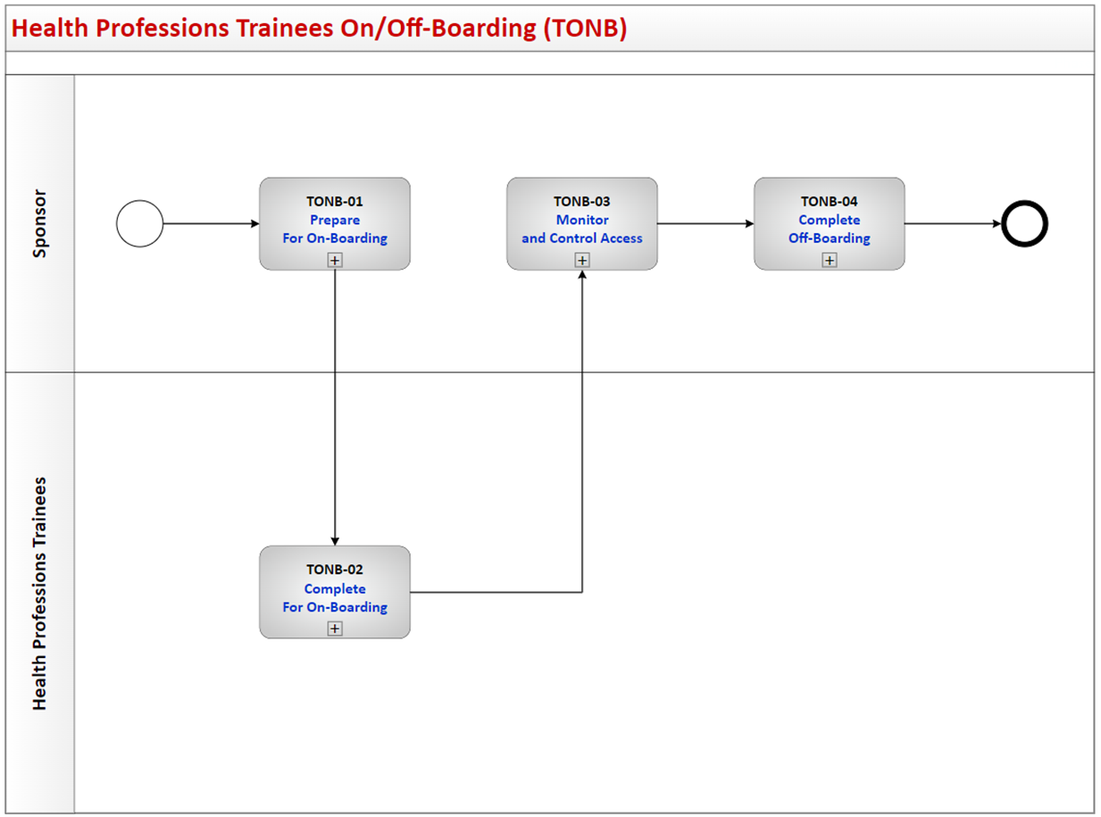

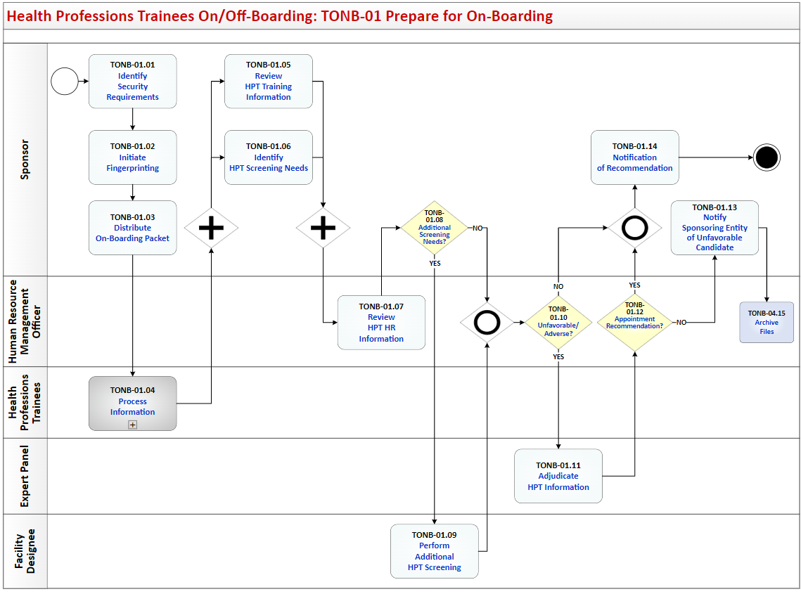

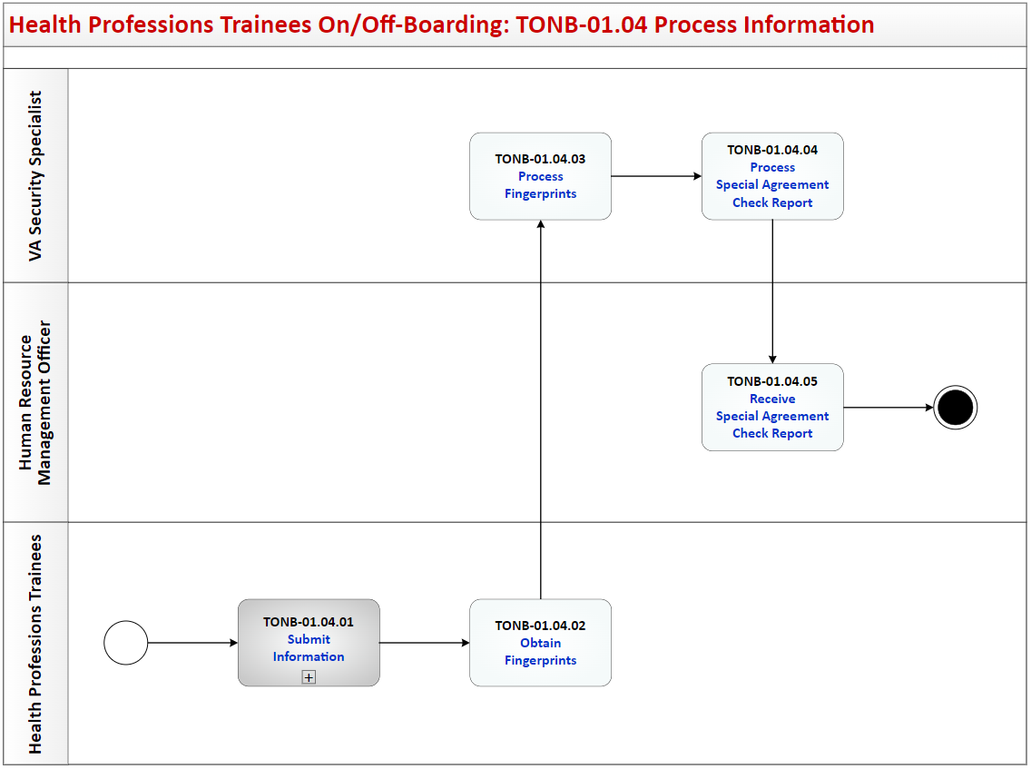

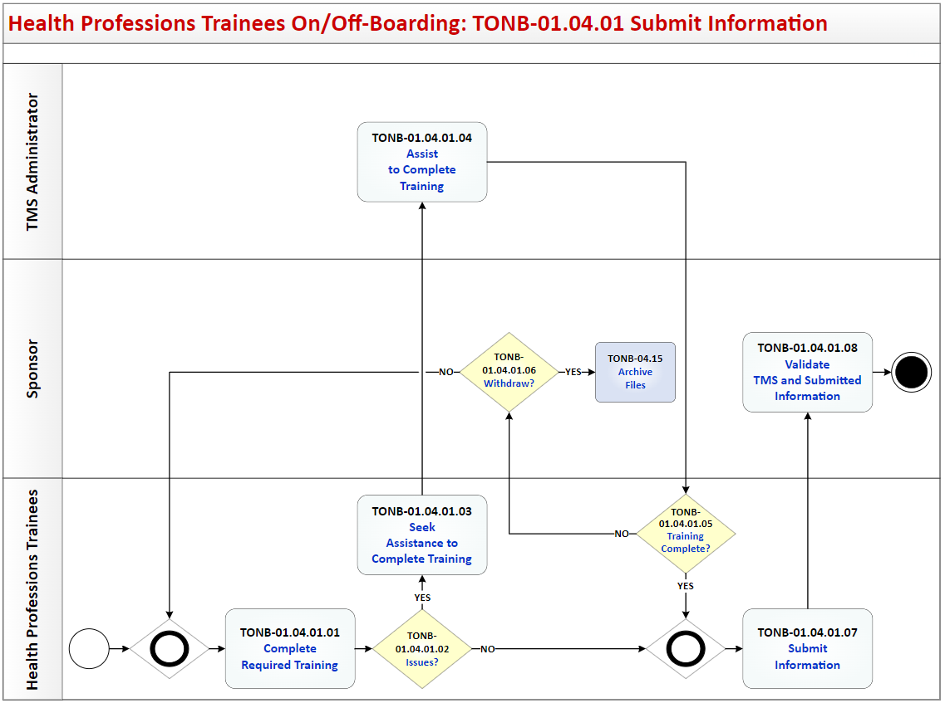

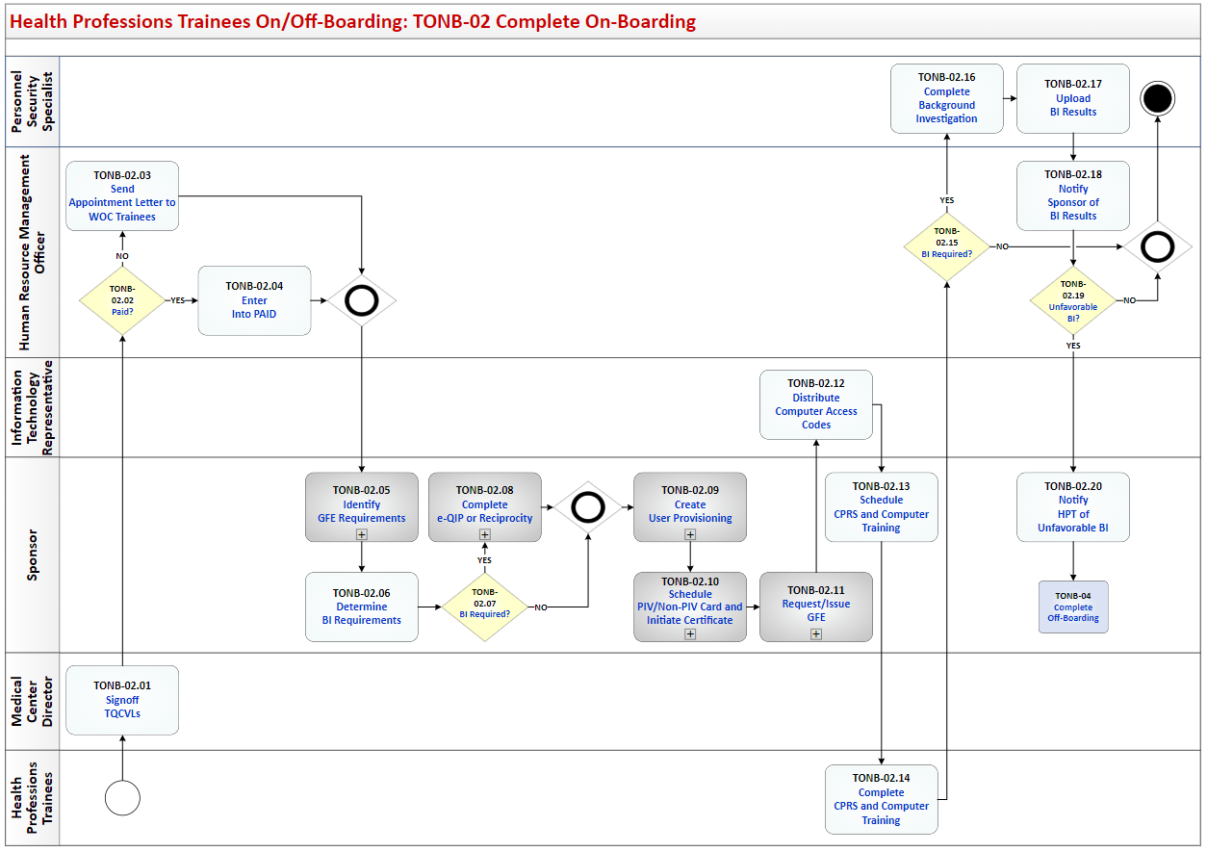

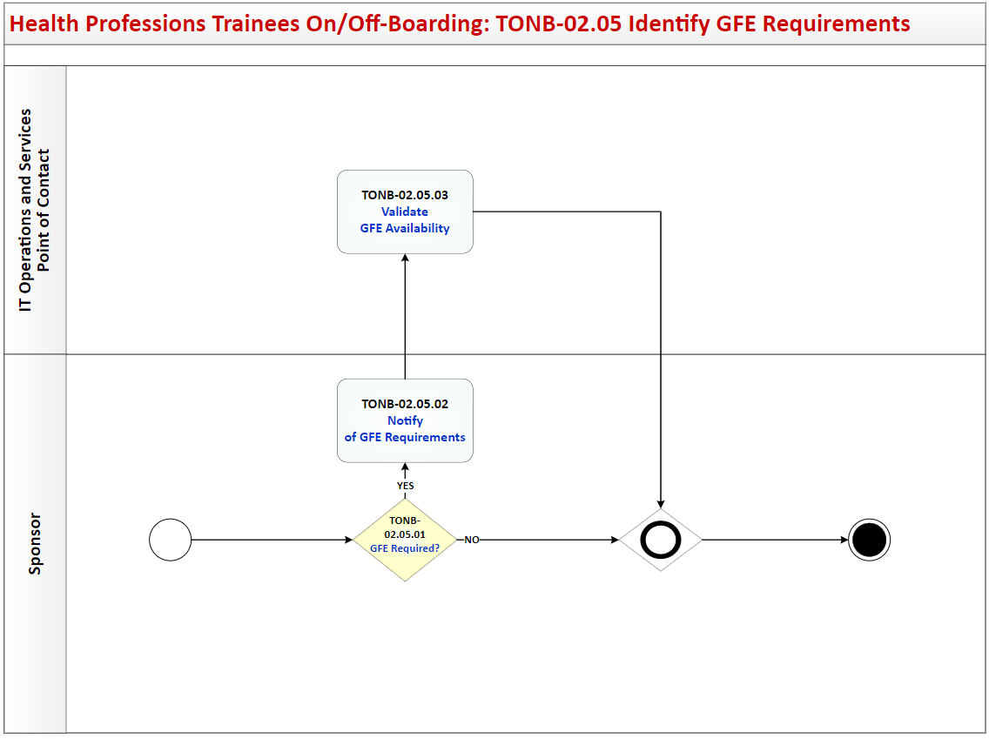

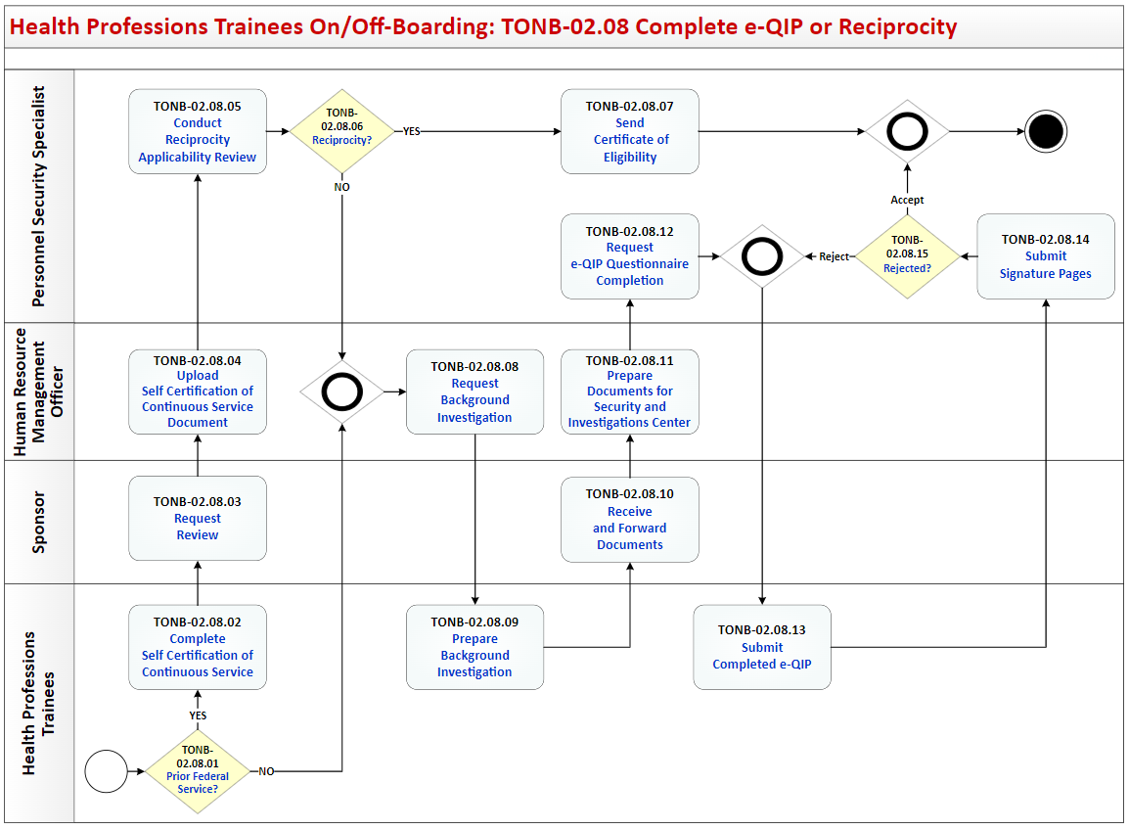

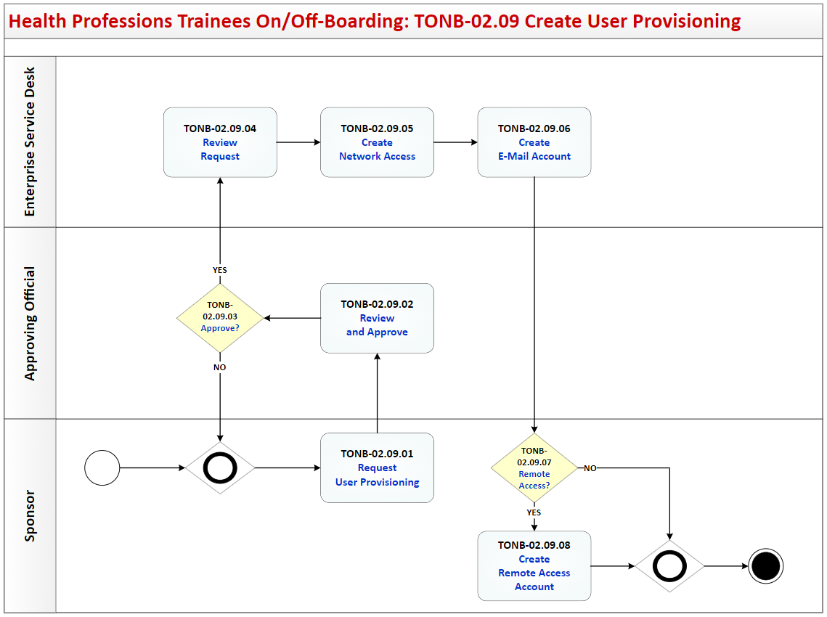

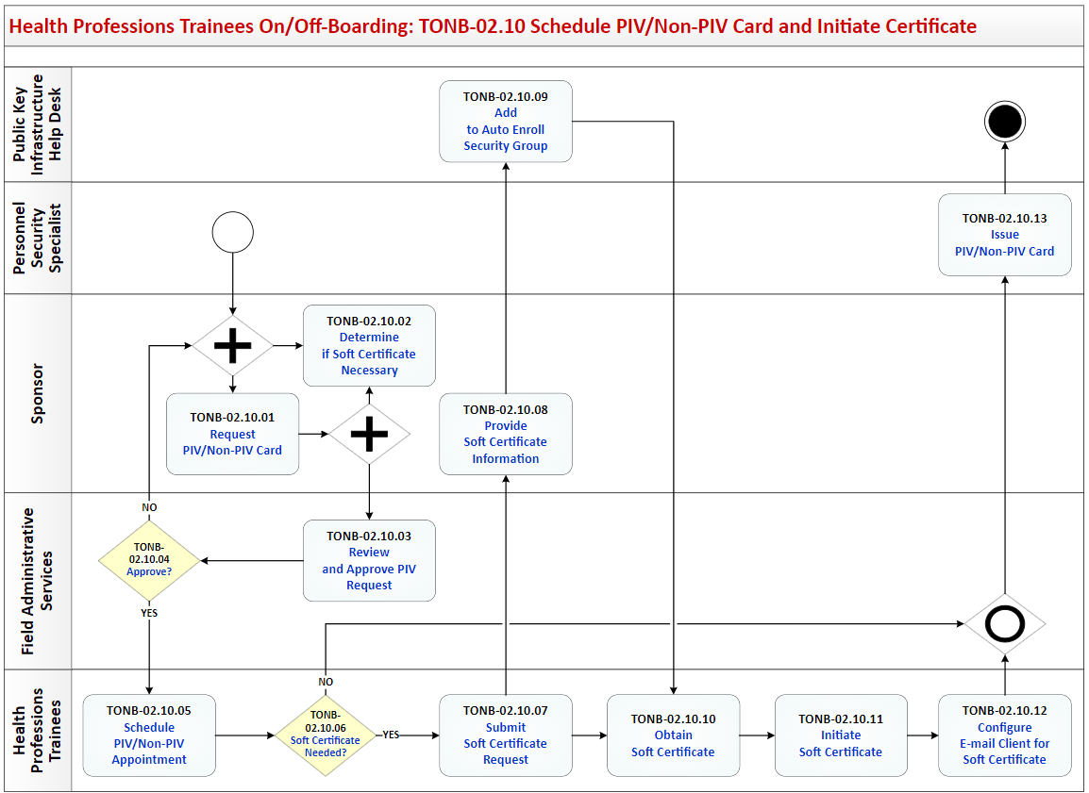

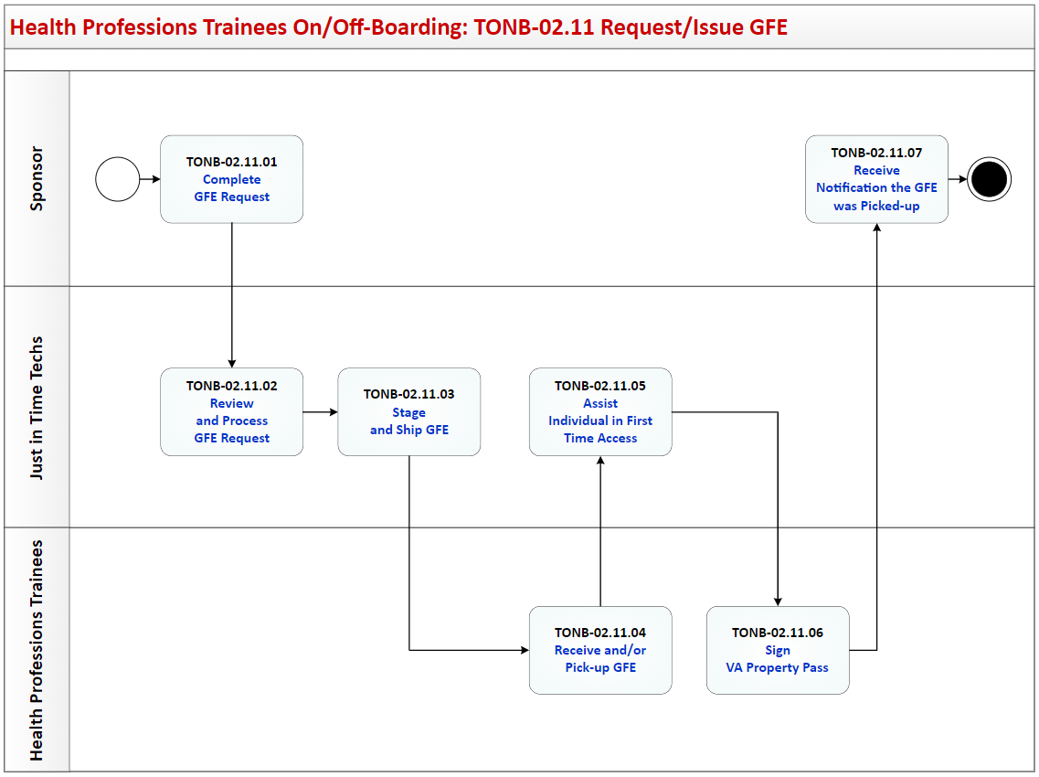

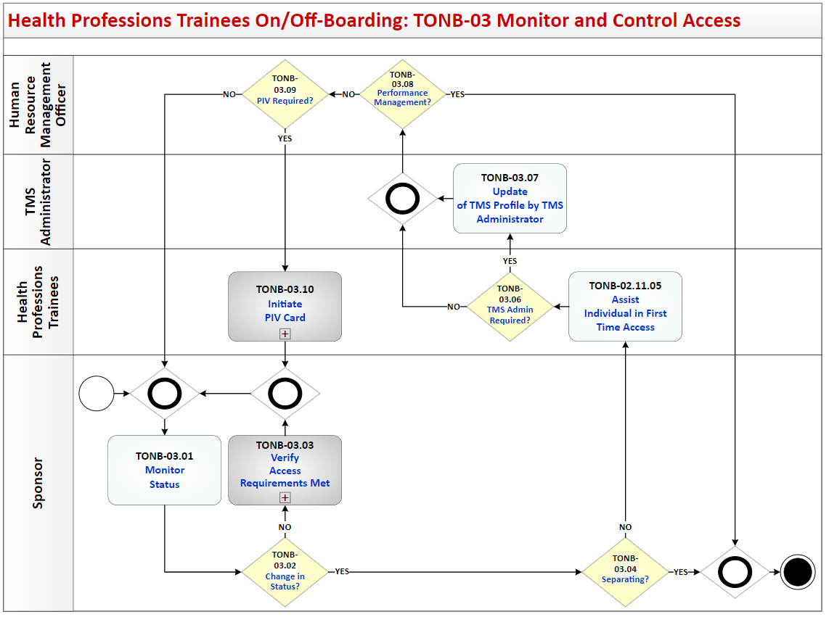

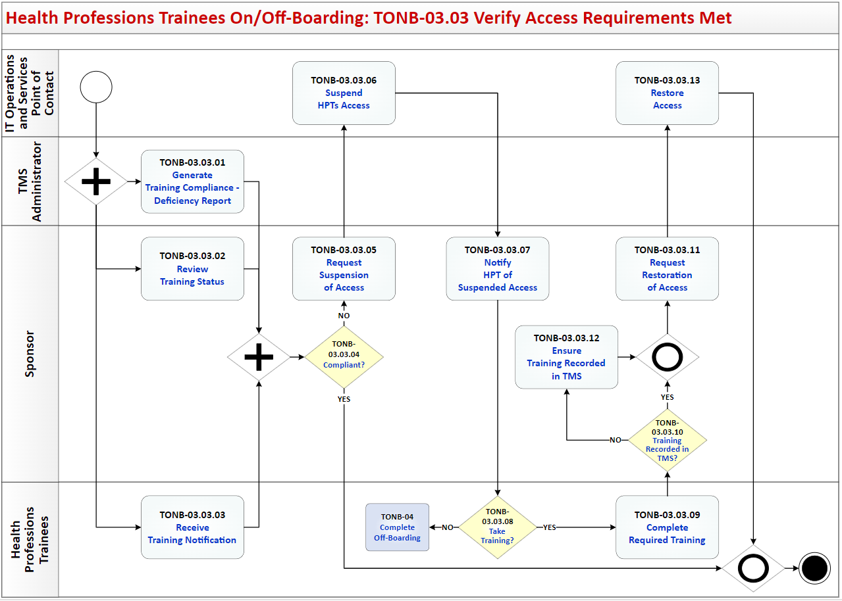

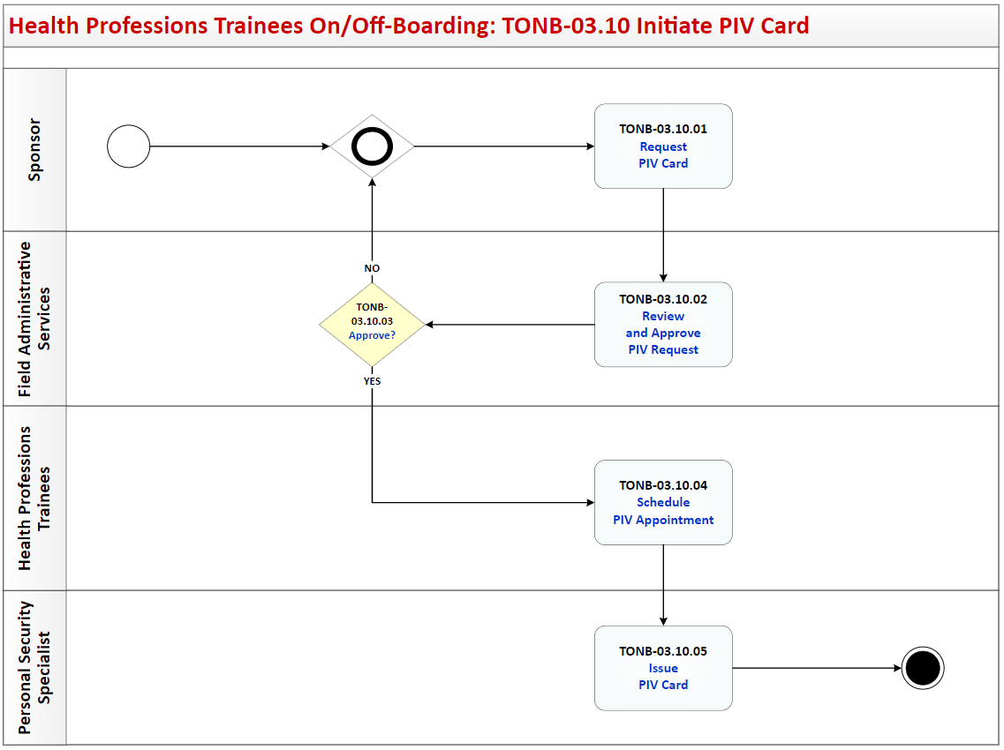

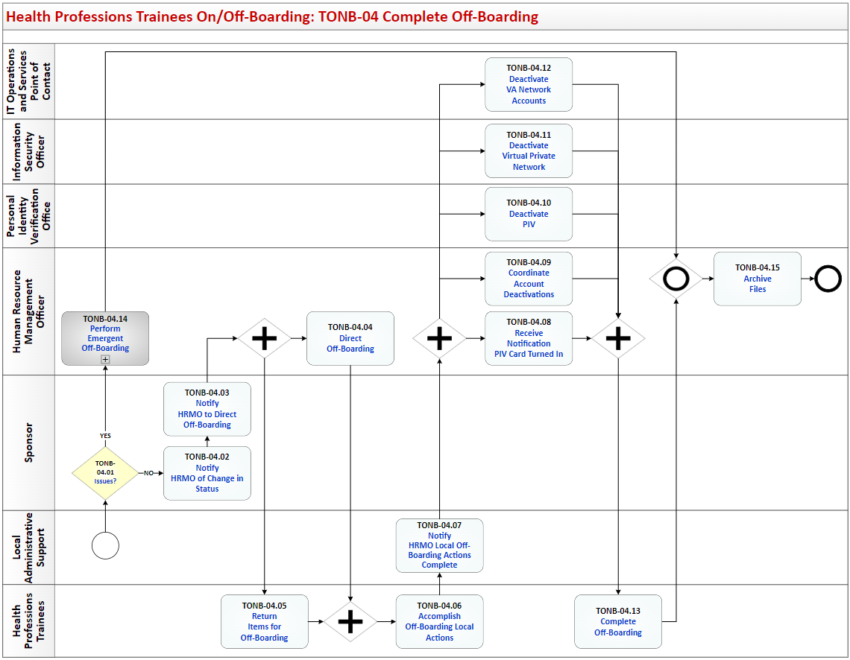

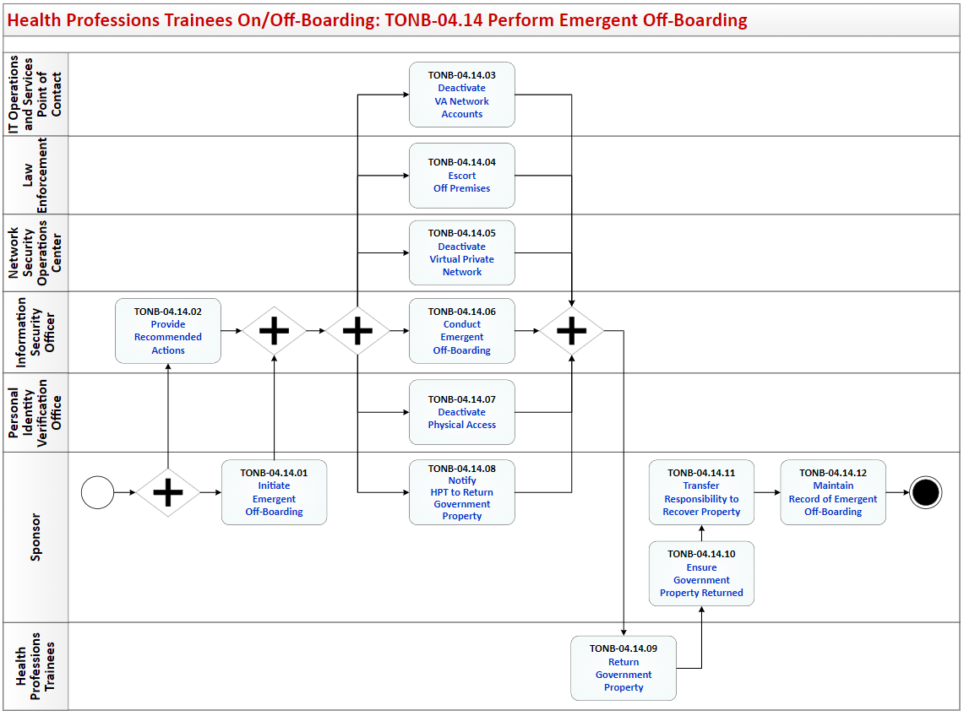

## Process: Health Professions Trainees On/Off-Boarding

Overview: The process map for Health Professions Trainees On/Off Boarding cycles through the following process and review activities:

TONB-01 Prepare for On-Boarding

TONB-01.01 Identify Security Requirements

TONB-01.02 Initiate Fingerprinting

TONB-01.03 Distribute On-Boarding Packet

TONB-01.04 Process Information

TONB-01.04.01 Submit Information

TONB-01.04.01.01 Complete Required Training

TONB-01.04.01.02 Issues?

TONB-01.04.01.03 Seek Assistance to Complete Training

TONB-01.04.01.04 Assist to Complete Training

TONB-01.04.01.05 Training Complete?

TONB-01.04.01.06 Withdraw?

TONB-01.04.01.07 Submit Information

TONB-01.04.01.08 Validate TMS and Submitted Information

TONB-01.04.02 Obtain Fingerprints

TONB-01.04.03 Process Fingerprints

TONB-01.04.04 Process Special Agreement Check Report

TONB-01.04.05 Receive Special Agreement Check Report

TONB-01.05 Review HPT Training Information

TONB-01.06 Identify HPT Screening Needs

TONB-01.07 Review HPT HR Information

TONB-01.08 Additional Screening Needs?

TONB-01.09 Perform Additional HPT Screening

TONB-01.10 Unfavorable/ Adverse?

TONB-01.11 Adjudicate HPT Information

TONB-01.12 Appointment Recommendation?

TONB-01.13 Notify Sponsoring Entity of Unfavorable Candidate

TONB-01.14 Notification of Recommendation

TONB-02 Complete On-Boarding

TONB-02.01 Signoff TQCVLs

TONB-02.02 Paid?

TONB-02.03 Send Appointment Letter to WOC Trainees

TONB-02.04 Enter Into PAID

TONB-02.05 Identify GFE Requirements

TONB-02.05.01 GFE Required?

TONB-02.05.02 Notify of GFE Requirements

TONB-02.05.03 Validate GFE Availability

TONB-02.06 Determine BI Requirements

TONB-02.07 BI Required?

TONB-02.08 Complete e-Qip or Reciprocity

TONB-02.08.01 Prior Federal Service?

TONB-02.08.02 Complete Self Certification of Continuous Service

TONB-02.08.03 Request Review

TONB-02.08.04 Upload Self Certification of Continuous Service Document

TONB-02.08.05 Conduct Reciprocity Applicability Review

TONB-02.08.06 Reciprocity?

TONB-02.08.07 Send Certificate of Eligibility

TONB-02.08.08 Request Background Investigation

TONB-02.08.09 Prepare Background Investigation

TONB-02.08.10 Receive and Forward Documents

TONB-02.08.11 Prepare Documents for Security and Investigations Center

TONB-02.08.12 Request e-QIP Questionnaire Completion

TONB-02.08.13 Submit Completed e-QIP

TONB-02.08.14 Submit Signature Pages

TONB-02.08.15 Rejected?

TONB-02.09 Create User Provisioning

TONB-02.09.01 Request User Provisioning

TONB-02.09.02 Review and Approve

TONB-02.09.03 Approve?

TONB-02.09.04 Review Request

TONB-02.09.05 Create Network Access

TONB-02.09.06 Create E-Mail Account

TONB-02.09.07 Remote Access?

TONB-02.09.08 Create Remote Access Account

TONB-02.10 Schedule PIV/Non-PIV Card and Initiate Certificate

TONB-02.10.01 Request PIV/Non-PIV Card

TONB-02.10.02 Determine if Soft Certificate Necessary

TONB-02.10.03 Review and Approve PIV Request

TONB-02.10.04 Approve?

TONB-02.10.05 Schedule PIV/Non-PIV Appointment

TONB-02.10.06 Soft Certificate Needed?

TONB-02.10.07 Submit Soft Certificate Request

TONB-02.10.08 Provide Soft Certificate Information

TONB-02.10.09 Add to Auto Enroll Security Group

TONB-02.10.10 Obtain Soft Certificate

TONB-02.10.11 Initiate Soft Certificate

TONB-02.10.12 Configure E-mail Client for Software Certificate

TONB-02.10.13 Issue PIV/Non-PIV Card

TONB-02.11 Request/Issue GFE

TONB-02.11.01 Complete GFE Request

TONB-02.11.02 Review and Process GFE Request

TONB-02.11.03 Stage and Ship GFE

TONB-02.11.04 Receive and/or Pick-up GFE

TONB-02.11.05 Assist Individual In First Time Access

TONB-02.11.06 Sign VA Property Pass

TONB-02.11.07 Receive Notification the GFE was Picked-up

TONB-02.12 Distribute Computer Access Codes

TONB-02.13 Schedule CPRS and Computer Training

TONB-02.14 Complete CPRS and Computer Training

TONB-02.15 BI Required?

TONB-02.16 Complete Background Investigation

TONB-02.17 Upload BI Results

TONB-02.18 Notify Sponsor of BI Results

TONB-02.19 Unfavorable BI?

TONB-02.20 Notify HPT of Unfavorable BI

TONB-03 Monitor and Control Access

TONB-03.01 Monitor Status

TONB-03.02 Change in Status?

TONB-03.03 Verify Access Requirements Met

TONB-03.03.01 Generate Training Compliance - Deficiency Report

TONB-03.03.02 Review Training Status

TONB-03.03.03 Receive Training Notification

TONB-03.03.04 Compliant?

TONB-03.03.05 Request Suspension of Access

TONB-03.03.06 Suspend HPTs Access

TONB-03.03.07 Notify HPT of Suspended Access

TONB-03.03.08 Take Training?

TONB-03.03.09 Complete Required Training

TONB-03.03.10 Training Recorded in TMS?

TONB-03.03.11 Request Restoration of Access

TONB-03.03.12 Ensure Training Recorded in TMS

TONB-03.03.13 Restore Access

TONB-03.04 Separating?

TONB-03.05 Update TMS Profile

TONB-03.06 TMS Admin Required?

TONB-03.07 Update of TMS Profile by TMS Administrator

TONB-03.08 Performance Management?

TONB-03.09 PIV Required?

TONB-03.10 Initiate PIV Card

TONB-03.10.01 Request PIV Card

TONB-03.10.02 Review and Approve PIV Request

TONB-03.10.03 Approve?

TONB-03.10.04 Schedule PIV Appointment

TONB-03.10.05 Issue PIV Card

TONB-04 Complete Off-Boarding

TONB-04.01 Issues?

TONB-04.02 Notify HRMO of Change in Status

TONB-04.03 Notify HRMO to Direct Off-Boarding

TONB-04.04 Direct Off-Boarding

TONB-04.05 Return Items for Off-Boarding

TONB-04.06 Accomplish Off-Boarding Local Actions

TONB-04.07 Notify HRMO Local Off-Boarding Actions Complete

TONB-04.08 Receive Notification PIV Card Turned In

TONB-04.09 Coordinate Account Deactivations

TONB-04.10 Deactivate PIV

TONB-04.11 Deactivate Virtual Private Network

TONB-04.12 Deactivate VA Network Accounts

TONB-04.13 Complete Off-Boarding

TONB-04.14 Perform Emergent Off-Boarding

TONB-04.14.01 Initiate Emergent Off-Boarding

TONB-04.14.02 Provide Recommended Actions

TONB-04.14.03 Deactivate VA Network Accounts

TONB-04.14.04 Escort Off Premises

TONB-04.14.05 Deactivate Virtual Private Network

TONB-04.14.06 Conduct Emergent Off-Boarding

TONB-04.14.07 Deactivate Physical Access

TONB-04.14.08 Notify HPT to Return Government Property

TONB-04.14.09 Return Government Property

TONB-04.14.10 Ensure Government Property Returned

TONB-04.14.11 Transfer Responsibility to Recover Property

TONB-04.14.12 Maintain Record of Emergent Off-Boarding

TONB-04.15 Archive Files

## Health Professions Trainees On/Off Boarding Description and Goals

### Description

The Health Professions Trainees On/Off-Boarding (TONB) describes the objectives to obtain access to VA networks, facilities, and equipment by completing background investigations and required training, and if needed, obtaining Government Furnished Equipment with appropriate software. After initial on-boarding, the process also establishes the framework for consistently ensuring that all trainees have the proper access necessary to perform the role they are assigned and that they continue to meet those minimum requirements necessary to support granting the access. The TONB process complies with the federal acquisition, security and privacy regulations.

### Goals

The goal of the TONB process is to establish the set of activities required to provide, monitor, control, and remove an HPTs access to VA systems, equipment, and facilities as appropriate to meet the needs of the VA.

Specific goals include:

* Completing required background investigation including the Special Agreement Check (SAC) for fingerprinting
* Reviewing and accepting VA Rules of Behavior
* Obtaining access to the Talent Management System
* Documenting the required information security and privacy training to access the VA network
* Receiving Government Furnished Equipment with needed software
* Accessing the VA network and establishing remote VA network access as required
* Obtaining VA identification and access to VA facilities
* Monitoring and verifying successful completion of annual security training requirements
* Monitoring and verifying successful adjudication of SAC, National Agency Check with Inquiries (NACI), Minimum Background Investigation (MBI), or Background Investigation (BI) as appropriate to the role
* Granting or withdrawing access based upon meeting or failing to meet requirements, and initiating personnel actions as necessary
* Notifying appropriate management personnel of access changes required based upon clearance adjudications or failure to meet requirements
* Ensuring identity badges, Personal Identity Verification (PIV) cards, keys and other access granting items are recovered before the Health Professions Trainee (HPT) departs from the VA
* Ensuring access to Public Key Infrastructure (PKI), as applicable
* Ensuring recovery of all Government Furnished Equipment (desktops, laptops, smart phone, printers, faxes, etc.) and other government property are properly recovered and transferred to the appropriate office in the VA within 24 hours if the HPT departs from the VA
* Ensuring that clearance through appropriate physical security personnel occurs
* Ensuring all system access privileges and network access are terminated
* Ensuring that all appropriate personnel actions are initiated and documented and notifications are made

## Health Professions Trainees On/Off Boarding RACI Information

The following describes the RACI information for this process:

**TONB-01.01 Identify Security Requirements**

Responsible Role: Sponsor

Accountable Role: VA Security Specialist

Consulted Role: Law Enforcement

Informed Role: None Listed

**TONB-01.02 Initiate Fingerprinting**

Responsible Role: Sponsor

Accountable Role: Human Resource Management Officer

Consulted Role: None Listed

Informed Role: None Listed

**TONB-01.03 Distribute On-Boarding Packet**

Responsible Role: Sponsor

Accountable Role: Human Resource Management Officer

Consulted Role: None Listed

Informed Role: None Listed

**TONB-01.04.01.01 Complete Required Training**

Responsible Role: Health Professions Trainees

Accountable Role: Sponsor

Consulted Role: None Listed

Informed Role: None Listed

**TONB-01.04.01.02 Issues?**

Responsible Role: Health Professions Trainees

Accountable Role: Sponsor

Consulted Role: None Listed

Informed Role: None Listed

**TONB-01.04.01.03 Seek Assistance to Complete Training**

Responsible Role: Health Professions Trainees

Accountable Role: Talent Management System Administrator

Consulted Role: None Listed

Informed Role: None Listed

**TONB-01.04.01.04 Assist to Complete Training**

Responsible Role: Talent Management System Administrator

Accountable Role: Health Professions Trainees

Consulted Role: None Listed

Informed Role: None Listed

**TONB-01.04.01.05 Training Complete?**

Responsible Role: Health Professions Trainees

Accountable Role: Sponsor

Consulted Role: None Listed

Informed Role: None Listed

**TONB-01.04.01.06 Withdraw?**

Responsible Role: Sponsor

Accountable Role: Talent Management System Administrator

Consulted Role: None Listed

Informed Role: None Listed

**TONB-01.04.01.07 Submit Information**

Responsible Role: Health Professions Trainees

Accountable Role: Sponsor

Consulted Role: None Listed

Informed Role: None Listed

**TONB-01.04.01.08 Validate TMS and Submitted Information**

Responsible Role: Sponsor

Accountable Role: Health Professions Trainees

Consulted Role: None Listed

Informed Role: None Listed

**TONB-01.04.02 Obtain Fingerprints**

Responsible Role: Health Professions Trainees

Accountable Role: Sponsor

Consulted Role: None Listed

Informed Role: None Listed

**TONB-01.04.03 Process Fingerprints**

Responsible Role: VA Security Specialist

Accountable Role: Human Resource Management Officer

Consulted Role: None Listed

Informed Role: Security and Investigations Center

**TONB-01.04.04 Process Special Agreement Check Report**

Responsible Role: VA Security Specialist

Accountable Role: Human Resource Management Officer

Consulted Role: Security and Investigations Center

Informed Role: None Listed

**TONB-01.04.05 Receive Special Agreement Check Report**

Responsible Role: Human Resource Management Officer

Accountable Role: Sponsor

Consulted Role: None Listed

Informed Role: None Listed

**TONB-01.05 Review HPT Training Information**

Responsible Role: Sponsor

Accountable Role: Human Resource Management Officer

Consulted Role: None Listed

Informed Role: None Listed

**TONB-01.06 Identify HPT Screening Needs**

Responsible Role: Sponsor

Accountable Role: Human Resource Management Officer

Consulted Role: None Listed

Informed Role: None Listed

**TONB-01.07 Review HPT HR Information**

Responsible Role: Human Resource Management Officer

Accountable Role: Sponsor

Consulted Role: None Listed

Informed Role: None Listed

**TONB-01.08 Additional Screening Needs?**

Responsible Role: Sponsor

Accountable Role: Human Resource Management Officer

Consulted Role: None Listed

Informed Role: None Listed

**TONB-01.09 Perform Additional HPT Screening**

Responsible Role: Facility Designee

Accountable Role: Human Resource Management Officer

Consulted Role: None Listed

Informed Role: None Listed

**TONB-01.10 Unfavorable/ Adverse?**

Responsible Role: Human Resource Management Officer

Accountable Role: Sponsor

Consulted Role: None Listed

Informed Role: None Listed

**TONB-01.11 Adjudicate HPT Information**

Responsible Role: Expert Panel

Accountable Role: Human Resource Management Officer

Consulted Role: None Listed

Informed Role: None Listed

**TONB-01.12 Appointment Recommendation?**

Responsible Role: Human Resource Management Officer

Accountable Role: Sponsor

Consulted Role: None Listed

Informed Role: None Listed

**TONB-01.13 Notify Sponsoring Entity of Unfavorable Candidate**

Responsible Role: Sponsor

Accountable Role: Human Resource Management Officer

Consulted Role: None Listed

Informed Role: None Listed

**TONB-01.14 Notification of Recommendation**

Responsible Role: Sponsor

Accountable Role: Human Resource Management Officer

Consulted Role: None Listed

Informed Role: None Listed

**TONB-02.01 Signoff TQCVLs**

Responsible Role: Medical Center Director

Accountable Role: Sponsor

Consulted Role: None Listed

Informed Role: None Listed

**TONB-02.02 Paid?**

Responsible Role: Human Resource Management Officer

Accountable Role: Sponsor

Consulted Role: None Listed

Informed Role: None Listed

**TONB-02.03 Send Appointment Letter to WOC Trainees**

Responsible Role: Human Resource Management Officer

Accountable Role: Medical Center Director

Consulted Role: None Listed

Informed Role: None Listed

**TONB-02.04 Enter Into PAID**

Responsible Role: Human Resource Management Officer

Accountable Role: Medical Center Director

Consulted Role: None Listed

Informed Role: None Listed

**TONB-02.05.01 GFE Required?**

Responsible Role: Sponsor

Accountable Role: Human Resource Management Officer

Consulted Role: None Listed

Informed Role: None Listed

**TONB-02.05.02 Notify of GFE Requirements**

Responsible Role: Sponsor

Accountable Role: IT Operations and Services Point of Contact

Consulted Role: None Listed

Informed Role: None Listed

**TONB-02.05.03 Validate GFE Availability**

Responsible Role: IT Operations and Services Point of Contact

Accountable Role: Sponsor

Consulted Role: None Listed

Informed Role: None Listed

**TONB-02.06 Determine BI Requirements**

Responsible Role: Sponsor

Accountable Role: Human Resource Management Officer

Consulted Role: Security and Investigations Center

Informed Role: None Listed

**TONB-02.07 BI Required?**

Responsible Role: Sponsor

Accountable Role: Human Resource Management Officer

Consulted Role: None Listed

Informed Role: None Listed

**TONB-02.08.01 Prior Federal Service?**

Responsible Role: Health Professions Trainees

Accountable Role: Sponsor

Consulted Role: None Listed

Informed Role: None Listed

**TONB-02.08.02 Complete Self Certification of Continuous Service**

Responsible Role: Health Professions Trainees

Accountable Role: Sponsor

Consulted Role: None Listed

Informed Role: Security and Investigations Center

**TONB-02.08.03 Request Review**

Responsible Role: Sponsor

Accountable Role: Human Resource Management Officer

Consulted Role: None Listed

Informed Role: None Listed

**TONB-02.08.04 Upload Self Certification of Continuous Service Document**

Responsible Role: Human Resource Management Officer

Accountable Role: Sponsor

Consulted Role: None Listed

Informed Role: None Listed

**TONB-02.08.05 Conduct Reciprocity Applicability Review**

Responsible Role: Personnel Security Specialist

Accountable Role: Security and Investigations Center

Consulted Role: None Listed

Informed Role: Human Resource Management Officer

**TONB-02.08.06 Reciprocity?**

Responsible Role: Personnel Security Specialist

Accountable Role: Human Resource Management Officer

Consulted Role: None Listed

Informed Role: None Listed

**TONB-02.08.07 Send Certificate of Eligibility**

Responsible Role: Personnel Security Specialist

Accountable Role: Human Resource Management Officer

Consulted Role: None Listed

Informed Role: None Listed

**TONB-02.08.08 Request Background Investigation**

Responsible Role: Human Resource Management Officer

Accountable Role: Sponsor

Consulted Role: Security and Investigations Center

Informed Role: None Listed

**TONB-02.08.09 Prepare Background Investigation**

Responsible Role: Health Professions Trainees

Accountable Role: Sponsor

Consulted Role: None Listed

Informed Role: None Listed

**TONB-02.08.10 Receive and Forward Documents**

Responsible Role: Sponsor

Accountable Role: Human Resource Management Officer

Consulted Role: None Listed

Informed Role: None Listed

**TONB-02.08.11 Prepare Documents for Security and Investigations Center**

Responsible Role: Human Resource Management Officer

Accountable Role: Sponsor

Consulted Role: None Listed

Informed Role: Security and Investigations Center

**TONB-02.08.12 Request e-QIP Questionnaire Completion**

Responsible Role: Personnel Security Specialist

Accountable Role: Human Resource Management Officer

Consulted Role: None Listed

Informed Role: None Listed

**TONB-02.08.13 Submit Completed e-QIP**

Responsible Role: Health Professions Trainees

Accountable Role: Sponsor

Consulted Role: None Listed

Informed Role: Security and Investigations Center

**TONB-02.08.14 Submit Signature Pages**

Responsible Role: Personnel Security Specialist

Accountable Role: Sponsor

Consulted Role: None Listed

Informed Role: None Listed

**TONB-02.08.15 Rejected?**

Responsible Role: Personnel Security Specialist

Accountable Role: Sponsor

Consulted Role: None Listed

Informed Role: None Listed

**TONB-02.09.01 Request User Provisioning**

Responsible Role: Sponsor

Accountable Role: Human Resource Management Officer

Consulted Role: None Listed

Informed Role: None Listed

**TONB-02.09.02 Review and Approve**

Responsible Role: Approving Official

Accountable Role: Sponsor

Consulted Role: None Listed

Informed Role: Health Professions Trainees; Enterprise Service Desk

**TONB-02.09.03 Approve?**

Responsible Role: Approving Official

Accountable Role: Sponsor

Consulted Role: None Listed

Informed Role: None Listed

**TONB-02.09.04 Review Request**

Responsible Role: Enterprise Service Desk

Accountable Role: Approving Official

Consulted Role: Sponsor

Informed Role: None Listed

**TONB-02.09.05 Create Network Access**

Responsible Role: Enterprise Service Desk

Accountable Role: Sponsor

Consulted Role: None Listed

Informed Role: None Listed

**TONB-02.09.06 Create E-Mail Account**

Responsible Role: Enterprise Service Desk

Accountable Role: Sponsor

Consulted Role: None Listed

Informed Role: Information System Security Officer; Health Professions Trainees

**TONB-02.09.07 Remote Access?**

Responsible Role: Sponsor

Accountable Role: Health Professions Trainees

Consulted Role: None Listed

Informed Role: None Listed

**TONB-02.09.08 Create Remote Access Account**

Responsible Role: Sponsor

Accountable Role: Health Professions Trainees

Consulted Role: None Listed

Informed Role: Information System Security Officer; Enterprise Service Desk

**TONB-02.10.01 Request PIV/Non-PIV Card**

Responsible Role: Sponsor

Accountable Role: Human Resource Management Officer

Consulted Role: None Listed

Informed Role: Field Administrative Services

**TONB-02.10.02 Determine if Soft Certificate Necessary**

Responsible Role: Sponsor

Accountable Role: Human Resource Management Officer

Consulted Role: None Listed

Informed Role: None Listed

**TONB-02.10.03 Review and Approve PIV Request**

Responsible Role: Field Administrative Services

Accountable Role: Sponsor

Consulted Role: None Listed

Informed Role: Health Professions Trainees

**TONB-02.10.04 Approve?**

Responsible Role: Field Administrative Services

Accountable Role: Sponsor

Consulted Role: None Listed

Informed Role: None Listed

**TONB-02.10.05 Schedule PIV/Non-PIV Appointment**

Responsible Role: Health Professions Trainees

Accountable Role: Sponsor

Consulted Role: None Listed

Informed Role: None Listed

**TONB-02.10.06 Soft Certificate Needed?**

Responsible Role: Health Professions Trainees

Accountable Role: Sponsor

Consulted Role: None Listed

Informed Role: None Listed

**TONB-02.10.07 Submit Soft Certificate Request**

Responsible Role: Health Professions Trainees

Accountable Role: Sponsor

Consulted Role: None Listed

Informed Role: None Listed

**TONB-02.10.08 Provide Soft Certificate Information**

Responsible Role: Sponsor

Accountable Role: Human Resource Management Officer

Consulted Role: None Listed

Informed Role: None Listed

**TONB-02.10.09 Add to Auto Enroll Security Group**

Responsible Role: Public Key Infrastructure (PKI) Help Desk

Accountable Role: Sponsor

Consulted Role: None Listed

Informed Role: None Listed

**TONB-02.10.10 Obtain Soft Certificate**

Responsible Role: Health Professions Trainees

Accountable Role: Sponsor

Consulted Role: None Listed

Informed Role: None Listed

**TONB-02.10.11 Initiate Soft Certificate**

Responsible Role: Health Professions Trainees

Accountable Role: Sponsor

Consulted Role: None Listed

Informed Role: None Listed

**TONB-02.10.12 Configure E-mail Client for Software Certificate**

Responsible Role: Health Professions Trainees

Accountable Role: Sponsor

Consulted Role: None Listed

Informed Role: None Listed

**TONB-02.10.13 Issue PIV/Non-PIV Card**

Responsible Role: Personnel Security Specialist

Accountable Role: Sponsor

Consulted Role: None Listed

Informed Role: None Listed

**TONB-02.11.01 Complete GFE Request**

Responsible Role: Sponsor

Accountable Role: Just In Time Techs

Consulted Role: None Listed

Informed Role: Health Professions Trainees

**TONB-02.11.02 Review and Process GFE Request**

Responsible Role: Just In Time Techs

Accountable Role: Sponsor

Consulted Role: None Listed

Informed Role: Health Professions Trainees; Information System Security Officer

**TONB-02.11.03 Stage and Ship GFE**

Responsible Role: Just In Time Techs

Accountable Role: Sponsor

Consulted Role: None Listed

Informed Role: Health Professions Trainees

**TONB-02.11.04 Receive and/or Pick-up GFE**

Responsible Role: Health Professions Trainees

Accountable Role: Sponsor

Consulted Role: Just In Time Techs

Informed Role: None Listed

**TONB-02.11.05 Assist Individual In First Time Access**

Responsible Role: Just In Time Techs

Accountable Role: Sponsor

Consulted Role: None Listed

Informed Role: Sponsor

**TONB-02.11.06 Sign VA Property Pass**

Responsible Role: Health Professions Trainees

Accountable Role: Just In Time Techs

Consulted Role: None Listed

Informed Role: Sponsor; Human Resource Management Officer

**TONB-02.11.07 Receive Notification the GFE was Picked-up**

Responsible Role: Sponsor

Accountable Role: Health Professions Trainees

Consulted Role: None Listed

Informed Role: None Listed

**TONB-02.12 Distribute Computer Access Codes**

Responsible Role: IT Representative

Accountable Role: Sponsor

Consulted Role: None Listed

Informed Role: None Listed

**TONB-02.13 Schedule CPRS and Computer Training**

Responsible Role: Sponsor

Accountable Role: Human Resource Management Officer

Consulted Role: None Listed

Informed Role: None Listed

**TONB-02.14 Complete CPRS and Computer Training**

Responsible Role: Health Professions Trainees

Accountable Role: Sponsor

Consulted Role: None Listed

Informed Role: None Listed

**TONB-02.15 BI Required?**

Responsible Role: Human Resource Management Officer

Accountable Role: Sponsor

Consulted Role: None Listed

Informed Role: None Listed

**TONB-02.16 Complete Background Investigation**

Responsible Role: Personnel Security Specialist

Accountable Role: Sponsor

Consulted Role: None Listed

Informed Role: None Listed

**TONB-02.17 Upload BI Results**

Responsible Role: Personnel Security Specialist

Accountable Role: Human Resource Management Officer

Consulted Role: None Listed

Informed Role: None Listed

**TONB-02.18 Notify Sponsor of BI Results**

Responsible Role: Human Resource Management Officer

Accountable Role: Personnel Security Specialist

Consulted Role: None Listed

Informed Role: None Listed

**TONB-02.19 Unfavorable BI?**

Responsible Role: Human Resource Management Officer

Accountable Role: Sponsor

Consulted Role: None Listed

Informed Role: None Listed

**TONB-02.20 Notify HPT of Unfavorable BI**

Responsible Role: Human Resource Management Officer

Accountable Role: Sponsor

Consulted Role: None Listed

Informed Role: None Listed

**TONB-03.01 Monitor Status**

Responsible Role: Sponsor

Accountable Role: Human Resource Management Officer

Consulted Role: None Listed

Informed Role: None Listed

**TONB-03.02 Change in Status?**

Responsible Role: Sponsor

Accountable Role: Human Resource Management Officer

Consulted Role: None Listed

Informed Role: None Listed

**TONB-03.03.01 Generate Training Compliance - Deficiency Report**

Responsible Role: Talent Management System Administrator

Accountable Role: Sponsor

Consulted Role: None Listed

Informed Role: None Listed

**TONB-03.03.02 Review Training Status**

Responsible Role: Sponsor

Accountable Role: Human Resource Management Officer

Consulted Role: None Listed

Informed Role: None Listed

**TONB-03.03.03 Receive Training Notification**

Responsible Role: Health Professions Trainees

Accountable Role: Sponsor

Consulted Role: None Listed

Informed Role: None Listed

**TONB-03.03.04 Compliant?**

Responsible Role: Sponsor

Accountable Role: Human Resource Management Officer

Consulted Role: None Listed

Informed Role: None Listed

**TONB-03.03.05 Request Suspension of Access**

Responsible Role: Sponsor

Accountable Role: Human Resource Management Officer

Consulted Role: None Listed

Informed Role: None Listed

**TONB-03.03.06 Suspend HPTs Access**

Responsible Role: IT Operations and Services Point of Contact

Accountable Role: Human Resource Management Officer

Consulted Role: None Listed

Informed Role: None Listed

**TONB-03.03.07 Notify HPT of Suspended Access**

Responsible Role: Sponsor

Accountable Role: Human Resource Management Officer

Consulted Role: None Listed

Informed Role: None Listed

**TONB-03.03.08 Take Training?**

Responsible Role: Sponsor

Accountable Role: Human Resource Management Officer

Consulted Role: None Listed

Informed Role: None Listed

**TONB-03.03.09 Complete Required Training**

Responsible Role: Health Professions Trainees

Accountable Role: Sponsor

Consulted Role: None Listed

Informed Role: None Listed

**TONB-03.03.10 Training Recorded in TMS?**

Responsible Role: Sponsor

Accountable Role: Human Resource Management Officer

Consulted Role: None Listed

Informed Role: None Listed

**TONB-03.03.11 Request Restoration of Access**

Responsible Role: Sponsor

Accountable Role: Human Resource Management Officer

Consulted Role: None Listed

Informed Role: None Listed

**TONB-03.03.12 Ensure Training Recorded in TMS**

Responsible Role: Sponsor

Accountable Role: Human Resource Management Officer

Consulted Role: None Listed

Informed Role: None Listed

**TONB-03.03.13 Restore Access**

Responsible Role: IT Operations and Services Point of Contact

Accountable Role: Human Resource Management Officer

Consulted Role: None Listed

Informed Role: None Listed

**TONB-03.04 Separating?**

Responsible Role: Sponsor

Accountable Role: Human Resource Management Officer

Consulted Role: None Listed

Informed Role: None Listed

**TONB-03.05 Update TMS Profile**

Responsible Role: Health Professions Trainees

Accountable Role: Sponsor

Consulted Role: None Listed

Informed Role: None Listed

**TONB-03.06 TMS Admin Required?**

Responsible Role: Health Professions Trainees

Accountable Role: Sponsor

Consulted Role: None Listed

Informed Role: None Listed

**TONB-03.07 Update of TMS Profile by TMS Administrator**

Responsible Role: Talent Management System Administrator

Accountable Role: Sponsor

Consulted Role: None Listed

Informed Role: None Listed

**TONB-03.08 Performance Management?**

Responsible Role: Human Resource Management Officer

Accountable Role: Sponsor

Consulted Role: None Listed

Informed Role: None Listed

**TONB-03.09 PIV Required?**

Responsible Role: Human Resource Management Officer

Accountable Role: Sponsor

Consulted Role: None Listed

Informed Role: None Listed

**TONB-03.10.01 Request PIV Card**

Responsible Role: Sponsor

Accountable Role: Human Resource Management Officer

Consulted Role: None Listed

Informed Role: None Listed

**TONB-03.10.02 Review and Approve PIV Request**

Responsible Role: Field Administrative Services

Accountable Role: Sponsor

Consulted Role: None Listed

Informed Role: Health Professions Trainees

**TONB-03.10.03 Approve?**

Responsible Role: Field Administrative Services

Accountable Role: Sponsor

Consulted Role: None Listed

Informed Role: None Listed

**TONB-03.10.04 Schedule PIV Appointment**

Responsible Role: Health Professions Trainees

Accountable Role: Sponsor

Consulted Role: None Listed

Informed Role: None Listed

**TONB-03.10.05 Issue PIV Card**

Responsible Role: Personnel Security Specialist

Accountable Role: Sponsor

Consulted Role: None Listed

Informed Role: None Listed

**TONB-04.01 Issues?**

Responsible Role: Sponsor

Accountable Role: Human Resource Management Officer

Consulted Role: None Listed

Informed Role: None Listed

**TONB-04.02 Notify HRMO of Change in Status**

Responsible Role: Sponsor

Accountable Role: Human Resource Management Officer

Consulted Role: None Listed

Informed Role: None Listed

**TONB-04.03 Notify HRMO to Direct Off-Boarding**

Responsible Role: Sponsor

Accountable Role: Human Resource Management Officer

Consulted Role: None Listed

Informed Role: None Listed

**TONB-04.04 Direct Off-Boarding**

Responsible Role: Human Resource Management Officer

Accountable Role: Sponsor

Consulted Role: None Listed

Informed Role: None Listed

**TONB-04.05 Return Items for Off-Boarding**

Responsible Role: Health Professions Trainees

Accountable Role: Sponsor

Consulted Role: None Listed

Informed Role: None Listed

**TONB-04.06 Accomplish Off-Boarding Local Actions**

Responsible Role: Health Professions Trainees

Accountable Role: Sponsor

Consulted Role: None Listed

Informed Role: None Listed

**TONB-04.07 Notify HRMO Local Off-Boarding Actions Complete**

Responsible Role: Local Administrative Support

Accountable Role: Human Resource Management Officer

Consulted Role: None Listed

Informed Role: None Listed

**TONB-04.08 Receive Notification PIV Card Turned In**

Responsible Role: Human Resource Management Officer

Accountable Role: Sponsor

Consulted Role: None Listed

Informed Role: None Listed

**TONB-04.09 Coordinate Account Deactivations**

Responsible Role: Human Resource Management Officer

Accountable Role: Sponsor

Consulted Role: None Listed

Informed Role: Health Professions Trainees

**TONB-04.10 Deactivate PIV**

Responsible Role: PIV Office

Accountable Role: Sponsor

Consulted Role: None Listed

Informed Role: None Listed

**TONB-04.11 Deactivate Virtual Private Network**

Responsible Role: Information System Security Officer

Accountable Role: Sponsor

Consulted Role: None Listed

Informed Role: None Listed

**TONB-04.12 Deactivate VA Network Accounts**

Responsible Role: IT Operations and Services Point of Contact

Accountable Role: Human Resource Management Officer

Consulted Role: None Listed

Informed Role: None Listed

**TONB-04.13 Complete Off-Boarding**

Responsible Role: Health Professions Trainees

Accountable Role: Human Resource Management Officer

Consulted Role: None Listed

Informed Role: None Listed

**TONB-04.14.01 Initiate Emergent Off-Boarding**

Responsible Role: Sponsor

Accountable Role: Human Resource Management Officer

Consulted Role: None Listed

Informed Role: None Listed

**TONB-04.14.02 Provide Recommended Actions**

Responsible Role: Information System Security Officer

Accountable Role: Sponsor

Consulted Role: None Listed

Informed Role: None Listed

**TONB-04.14.03 Deactivate VA Network Accounts**

Responsible Role: IT Operations and Services Point of Contact

Accountable Role: Sponsor

Consulted Role: None Listed

Informed Role: None Listed

**TONB-04.14.04 Escort Off Premises**

Responsible Role: Law Enforcement

Accountable Role: Human Resource Management Officer

Consulted Role: None Listed

Informed Role: None Listed

**TONB-04.14.05 Deactivate Virtual Private Network**

Responsible Role: Network and Security Operation Center (NSOC)

Accountable Role: Human Resource Management Officer

Consulted Role: None Listed

Informed Role: None Listed

**TONB-04.14.06 Conduct Emergent Off-Boarding**

Responsible Role: Information System Security Officer

Accountable Role: Human Resource Management Officer

Consulted Role: None Listed

Informed Role: None Listed

**TONB-04.14.07 Deactivate Physical Access**

Responsible Role: PIV Office

Accountable Role: Human Resource Management Officer

Consulted Role: None Listed

Informed Role: None Listed

**TONB-04.14.08 Notify HPT to Return Government Property**

Responsible Role: Sponsor

Accountable Role: Human Resource Management Officer

Consulted Role: None Listed

Informed Role: None Listed

**TONB-04.14.09 Return Government Property**

Responsible Role: Health Professions Trainees

Accountable Role: Sponsor

Consulted Role: None Listed

Informed Role: None Listed

**TONB-04.14.10 Ensure Government Property Returned**

Responsible Role: Sponsor

Accountable Role: Human Resource Management Officer

Consulted Role: None Listed

Informed Role: None Listed

**TONB-04.14.11 Transfer Responsibility to Recover Property**

Responsible Role: Sponsor

Accountable Role: Human Resource Management Officer

Consulted Role: None Listed

Informed Role: None Listed

**TONB-04.14.12 Maintain Record of Emergent Off-Boarding**

Responsible Role: Sponsor

Accountable Role: Human Resource Management Officer

Consulted Role: None Listed

Informed Role: None Listed

**TONB-04.15 Archive Files**

Responsible Role: Human Resource Management Officer

Accountable Role: Sponsor

Consulted Role: None Listed

Informed Role: None Listed

## Health Professions Trainees On/Off-Boarding: Associated Artifacts Information

Associated Artifacts information for this process include:

CRISP Screening Checklist

MSE-TMS Completion Record for Mandatory Training for Trainees Template

OPM Form OF306-Declaration for Federal Employment Template

OPM INV-70B Request for PIPS-CVS User ID-Access Template

OPM Standard Form 61-Appointment Affidavits Template

PIV Applicant Information for Employees and Contractors

Security and Investigations Center Contractor / Employee Fingerprinting Request Form Template

Self-Certification of Continuous Service Template

Soft Certificate [Public Key Infrastructure (PKI)] Enrollment Form

- Repository: VA PKI Information and Enrollment Portal

Special Agreement Check Request Form

USCIS Form I-9, Employment Eligibility Verification Template

VA Employee: Background Investigation Request Worksheet Template

VA Form 0710- Authorization for a Release of Information Template

VA Form 0752-Confidentiality of Sensitive Information Non-Disclosure Agreement Template

VA Form 0887-VA Government Property Loan Form Template

VA Form 0923-Serious Incident Report Template

VA Form 10-2850d APPLICATION FOR HEALTH PROFESSIONS TRAINEES

VA Form 3248-Employees Clearance from Indebtedness Template

VA Form 4236-Certificate of Eligibility Template

## Health Professions Trainees On/Off-Boarding: Tools and Web Sites Information

The Tools and Web Sites associated with this process include:

Citrix Access Gateway

Electronic Official Personnel Folder (eOPF)

Electronic Questionnaires for Investigations Processing (e-QIP)

Field Administrative Services

Form I-9, Employment Eligibility Verification

Identity Documentation Criteria

ISSO Locator List

ISSO Virtual Private Network Portal

IT Service Management

Network Security Operations Center Remedy Portal

Personal Identity Verification Database

Personnel and Accounting Integrated Data (PAID) System

Personnel Investigations Processing System (PIPS)

Physical Access Control System

PIV Appointment Scheduling Tool

PIV Badge Offices

PIV Card Management System

Position Designation Automated Tool (PDAT)

Rational Team Concert (Change/Configuration Management)

Remote Access Portal

Rescue AnyConnect Virtual Private Network

Security and Investigations Center Resource Site

Service Desk Ticketing System

Talent Management System (TMS)

Talent Management System Self Enrollment Portal

Trainee Qualifications and Credentials Verification Letter (TQCVL) Appendix C

Trainee Qualifications and Credentials Verification Letter (TQCVL) Appendix D

VA HSPD-12 Program, How to Get a VA ID Badge

VA Office of Academic Affiliations - Educational Affiliation Agreements

VA PIV Enrollment Portal

VA PKI Information and Enrollment Portal

VHA Mandatory Training for Trainees

## Health Professions Trainees On/Off-Boarding: Standards Information

Standards associated with this process include:

Code of Federal Regulations, Part 731 - Suitability (Title 5, CFR 731)

Executive Order 13467, Reforming Processes Related to Suitability for Government Employment, Fitness for Contractor Employees, and Eligibility for Access to Classified National Security Information

Executive Order 13488, Granting Reciprocity on Excepted Service and Federal Contractor Employee Fitness and Reinvestigating Individuals in Positions of Public Trust

Federal Information Processing Standards Publications (FIPS) 140-2, Security Requirements for Cryptographic Modules

Federal Information Processing Standards Publications (FIPS) 201-2, Personal Identity Verification (PIV) of Federal Employees and Contractors

Framework for Improving Critical Infrastructure Cybersecurity Draft Version 1.1

How to Get a VA ID Badge

How to Self-Enroll and Take the MTT in TMS

HSPD-12 Communication - New Identity Source Document Guidelines

Identity Documentation Criteria

Information Access and Privacy Program

Special Agreement Checks Requirements

Suitability Processing Handbook

VA Card Types and Requirements

VA Directive 0321, Serious Incident Reports

VA Directive 0735, Homeland Security Presidential Directive 12 (HSPD-12) Program

VA Directive 5005, Staffing

VA Directive 6500, Managing Information Security Risk: VA Information Security Program

VA Handbook 0730/4, Security and Law Enforcement

VA Handbook 6500, Risk Management Framework for VA Information Systems - Tier 3: VA Information Security Program

VA Handbook 6500.1, Electronic Media Sanitization

VA Handbook 7002, Logistics Management Procedures

VA Public Key Infrastructure (PKI) Program Setting up E-mail Outlook 2003

VA Public Key Infrastructure (PKI) Program Setting up E-mail Outlook 2007

VA Public Key Infrastructure (PKI) Program Setting up E-mail Outlook 2010

VA Public Key Infrastructure (PKI) Program, Completing PKI Paperwork Instructional Document

VAPERSEC 17-02 Personal Identity Verification (PIV) Card Issuance

VAPERSEC 18-01 Special Agreement Checks Requirements

VHA Directive 0710, Personnel Security and Suitability Program

VHA Directive 2004-066 - Educational Affiliation Agreements

VHA Handbook 0710.01, Position Risk and Sensitivity Designations for VHA Positions and Medical Center Policy

## Health Professions Trainees On/Off Boarding Process

### Process Activity Name: TONB-01 Prepare for On-Boarding

**Previous Activities**

Process Begins

**Next Activities**

TONB-01.01 Identify Security Requirements

### Process Activity Name: TONB-01.01 Identify Security Requirements

**Previous Activities**

TONB-01 Prepare for On-Boarding

**Next Activities**

TONB-01.02 Initiate Fingerprinting

### Process Activity Name: TONB-01.02 Initiate Fingerprinting

**Previous Activities**

TONB-01.01 Identify Security Requirements

**Next Activities**

TONB-01.03 Distribute On-Boarding Packet

### Process Activity Name: TONB-01.03 Distribute On-Boarding Packet

**Previous Activities**

TONB-01.02 Initiate Fingerprinting

**Next Activities**

TONB-01.04 Process Information

### Process Activity Name: TONB-01.04 Process Information

**Previous Activities**

TONB-01.03 Distribute On-Boarding Packet

**Next Activities**

TONB-01.04.01 Submit Information

### Process Activity Name: TONB-01.04.01 Submit Information

**Previous Activities**

TONB-01.04 Process Information

**Next Activities**

TONB-01.04.01.01 Complete Required Training

### Process Activity Name: TONB-01.04.01.01 Complete Required Training

**Previous Activities**

TONB-01.04.01 Submit Information

**Next Activities**

TONB-01.04.01.02 Issues?

### Process Activity Name: TONB-01.04.01.02 Issues?

**Previous Activities**

TONB-01.04.01.01 Complete Required Training

**Next Activities**

If "YES":

TONB-01.04.01.03 Seek Assistance to Complete Training

Or

If "NO":

TONB-01.04.01.07 Submit Information

### Process Activity Name: TONB-01.04.01.03 Seek Assistance to Complete Training

**Previous Activities**

TONB-01.04.01.02 Issues?

**Next Activities**

TONB-01.04.01.04 Assist to Complete Training

### Process Activity Name: TONB-01.04.01.04 Assist to Complete Training

**Previous Activities**

TONB-01.04.01.03 Seek Assistance to Complete Training

**Next Activities**

TONB-01.04.01.05 Training Complete?

### Process Activity Name: TONB-01.04.01.05 Training Complete?

**Previous Activities**

TONB-01.04.01.04 Assist to Complete Training

**Next Activities**

If "YES":

TONB-01.04.01.07 Submit Information

Or

If "NO":

TONB-01.04.01.06 Withdraw?

### Process Activity Name: TONB-01.04.01.06 Withdraw?

**Previous Activities**

TONB-01.04.01.05 Training Complete?

**Next Activities**

If "YES":

TONB-04.15 Archive Files

Or

If "NO":

TONB-01.04.01.01 Complete Required Training

### Process Activity Name: TONB-01.04.01.07 Submit Information

**Previous Activities**

TONB-01.04.01.02 Issues?

Or

TONB-01.04.01.05 Training Complete?

**Next Activities**

TONB-01.04.01.08 Validate TMS and Submitted Information

### Process Activity Name: TONB-01.04.01.08 Validate TMS and Submitted Information

**Previous Activities**

TONB-01.04.01.07 Submit Information

**Next Activities**

TONB-01.04.02 Obtain Fingerprints

### Process Activity Name: TONB-01.04.02 Obtain Fingerprints

**Previous Activities**

TONB-01.04.01.08 Validate TMS and Submitted Information

**Next Activities**

TONB-01.04.03 Process Fingerprints

### Process Activity Name: TONB-01.04.03 Process Fingerprints

**Previous Activities**

TONB-01.04.02 Obtain Fingerprints

**Next Activities**

TONB-01.04.04 Process Special Agreement Check Report

### Process Activity Name: TONB-01.04.04 Process Special Agreement Check Report

**Previous Activities**

TONB-01.04.03 Process Fingerprints

**Next Activities**

TONB-01.04.05 Receive Special Agreement Check Report

### Process Activity Name: TONB-01.04.05 Receive Special Agreement Check Report

**Previous Activities**

TONB-01.04.04 Process Special Agreement Check Report

**Next Activities**

TONB-01.05 Review HPT Training Information

And

TONB-01.06 Identify HPT Screening Needs

### Process Activity Name: TONB-01.05 Review HPT Training Information

**Concurrent Activities**

TONB-01.06 Identify HPT Screening Needs

**Previous Activities**

TONB-01.04.05 Receive Special Agreement Check Report

**Next Activities**

TONB-01.07 Review HPT HR Information

### Process Activity Name: TONB-01.06 Identify HPT Screening Needs

**Concurrent Activities**

TONB-01.05 Review HPT Training Information

**Previous Activities**

TONB-01.04.05 Receive Special Agreement Check Report

**Next Activities**

TONB-01.07 Review HPT HR Information

### Process Activity Name: TONB-01.07 Review HPT HR Information

**Previous Activities**

TONB-01.05 Review HPT Training Information

AND

TONB-01.06 Identify HPT Screening Needs

**Next Activities**

TONB-01.08 Additional Screening Needs?

### Process Activity Name: TONB-01.08 Additional Screening Needs?

**Previous Activities**

TONB-01.07 Review HPT HR Information

**Next Activities**

If "YES":

TONB-01.09 Perform Additional HPT Screening

Or

If "NO":

TONB-01.10 Unfavorable/ Adverse?

### Process Activity Name: TONB-01.09 Perform Additional HPT Screening

**Previous Activities**

TONB-01.08 Additional Screening Needs?

**Next Activities**

TONB-01.10 Unfavorable/ Adverse?

### Process Activity Name: TONB-01.10 Unfavorable/ Adverse?

**Previous Activities**

TONB-01.08 Additional Screening Needs?

Or

TONB-01.09 Perform Additional HPT Screening

**Next Activities**

If "YES":

TONB-01.11 Adjudicate HPT Information

Or

If "NO":

TONB-01.14 Notification of Recommendation

### Process Activity Name: TONB-01.11 Adjudicate HPT Information

**Previous Activities**

TONB-01.10 Unfavorable/ Adverse?

**Next Activities**

TONB-01.12 Appointment Recommendation?

### Process Activity Name: TONB-01.12 Appointment Recommendation?

**Previous Activities**

TONB-01.11 Adjudicate HPT Information

**Next Activities**

If "YES":

TONB-01.14 Notification of Recommendation

Or

If "NO":

TONB-01.13 Notify Sponsoring Entity of Unfavorable Candidate

### Process Activity Name: TONB-01.13 Notify Sponsoring Entity of Unfavorable Candidate

**Previous Activities**

TONB-01.12 Appointment Recommendation?

**Next Activities**

TONB-04.15 Archive Files

### Process Activity Name: TONB-01.14 Notification of Recommendation

**Previous Activities**

TONB-01.10 Unfavorable/ Adverse?

Or

TONB-01.12 Appointment Recommendation?

**Next Activities**

TONB-02 Complete On-Boarding

### Process Activity Name: TONB-02 Complete On-Boarding

**Previous Activities**

TONB-01.14 Notification of Recommendation

**Next Activities**

TONB-02.01 Signoff TQCVLs

### Process Activity Name: TONB-02.01 Signoff TQCVLs

**Previous Activities**

TONB-02 Complete On-Boarding

**Next Activities**

TONB-02.02 Paid?

### Process Activity Name: TONB-02.02 Paid?

**Previous Activities**

TONB-02.01 Signoff TQCVLs

**Next Activities**

If "YES":

TONB-02.04 Enter Into PAID

Or

If "NO":

TONB-02.03 Send Appointment Letter to WOC Trainees

### Process Activity Name: TONB-02.03 Send Appointment Letter to WOC Trainees

**Previous Activities**

TONB-02.02 Paid?

**Next Activities**

TONB-02.05 Identify GFE Requirements

### Process Activity Name: TONB-02.04 Enter Into PAID

**Previous Activities**

TONB-02.02 Paid?

**Next Activities**

TONB-02.05 Identify GFE Requirements

### Process Activity Name: TONB-02.05 Identify GFE Requirements

**Previous Activities**

TONB-02.03 Send Appointment Letter to WOC Trainees

Or

TONB-02.04 Enter Into PAID

**Next Activities**

TONB-02.05.01 GFE Required?

### Process Activity Name: TONB-02.05.01 GFE Required?

**Previous Activities**

TONB-02.05 Identify GFE Requirements

**Next Activities**

If "YES":

TONB-02.05.02 Notify of GFE Requirements

Or

If "NO":

TONB-02.06 Determine BI Requirements

### Process Activity Name: TONB-02.05.02 Notify of GFE Requirements

**Previous Activities**

TONB-02.05.01 GFE Required?

**Next Activities**

TONB-02.05.03 Validate GFE Availability

### Process Activity Name: TONB-02.05.03 Validate GFE Availability

**Previous Activities**

TONB-02.05.02 Notify of GFE Requirements

**Next Activities**

TONB-02.06 Determine BI Requirements

### Process Activity Name: TONB-02.06 Determine BI Requirements

**Previous Activities**

TONB-02.05.01 GFE Required?

Or

TONB-02.05.03 Validate GFE Availability

**Next Activities**

TONB-02.07 BI Required?

### Process Activity Name: TONB-02.07 BI Required?

**Previous Activities**

TONB-02.06 Determine BI Requirements

**Next Activities**

If "YES":

TONB-02.08 Complete e-Qip or Reciprocity

Or

If "NO":

TONB-02.09 Create User Provisioning

### Process Activity Name: TONB-02.08 Complete e-Qip or Reciprocity

**Previous Activities**

TONB-02.07 BI Required?

**Next Activities**

TONB-02.08.01 Prior Federal Service?

### Process Activity Name: TONB-02.08.01 Prior Federal Service?

**Previous Activities**

TONB-02.08 Complete e-Qip or Reciprocity

**Next Activities**

If "YES":

TONB-02.08.02 Complete Self Certification of Continuous Service

Or

If "NO":

TONB-02.08.08 Request Background Investigation

### Process Activity Name: TONB-02.08.02 Complete Self Certification of Continuous Service

**Previous Activities**

TONB-02.08.01 Prior Federal Service?

**Next Activities**

TONB-02.08.03 Request Review

### Process Activity Name: TONB-02.08.03 Request Review

**Previous Activities**

TONB-02.08.02 Complete Self Certification of Continuous Service

**Next Activities**

TONB-02.08.04 Upload Self Certification of Continuous Service Document

Process Activity Name: TONB-02.08.04 Upload Self Certification of Continuous Service Document

**Previous Activities**

TONB-02.08.03 Request Review

**Next Activities**

TONB-02.08.05 Conduct Reciprocity Applicability Review

### Process Activity Name: TONB-02.08.05 Conduct Reciprocity Applicability Review

**Previous Activities**

TONB-02.08.04 Upload Self Certification of Continuous Service Document

**Next Activities**

TONB-02.08.06 Reciprocity?

### Process Activity Name: TONB-02.08.06 Reciprocity?

**Previous Activities**

TONB-02.08.05 Conduct Reciprocity Applicability Review

**Next Activities**

If "YES":

TONB-02.08.07 Send Certificate of Eligibility

Or

If "NO":

TONB-02.08.08 Request Background Investigation

### Process Activity Name: TONB-02.08.07 Send Certificate of Eligibility

**Previous Activities**

TONB-02.08.06 Reciprocity?

**Next Activities**

TONB-02.09 Create User Provisioning

### Process Activity Name: TONB-02.08.08 Request Background Investigation

**Previous Activities**

TONB-02.08.01 Prior Federal Service?

Or

TONB-02.08.06 Reciprocity?

**Next Activities**

TONB-02.08.09 Prepare Background Investigation

### Process Activity Name: TONB-02.08.09 Prepare Background Investigation

**Previous Activities**

TONB-02.08.08 Request Background Investigation

**Next Activities**

TONB-02.08.10 Receive and Forward Documents

### Process Activity Name: TONB-02.08.10 Receive and Forward Documents

**Previous Activities**

TONB-02.08.09 Prepare Background Investigation

**Next Activities**

TONB-02.08.11 Prepare Documents for Security and Investigations Center

### Process Activity Name: TONB-02.08.11 Prepare Documents for Security and Investigations Center

**Previous Activities**

TONB-02.08.10 Receive and Forward Documents

**Next Activities**

TONB-02.08.12 Request e-QIP Questionnaire Completion

### Process Activity Name: TONB-02.08.12 Request e-QIP Questionnaire Completion

**Previous Activities**

TONB-02.08.11 Prepare Documents for Security and Investigations Center

**Next Activities**

TONB-02.08.13 Submit Completed e-QIP

### Process Activity Name: TONB-02.08.13 Submit Completed e-QIP

**Previous Activities**

TONB-02.08.12 Request e-QIP Questionnaire Completion

Or

TONB-02.08.15 Rejected?

**Next Activities**

TONB-02.08.14 Submit Signature Pages

### Process Activity Name: TONB-02.08.14 Submit Signature Pages

**Previous Activities**

TONB-02.08.13 Submit Completed e-QIP

**Next Activities**

TONB-02.08.15 Rejected?

### Process Activity Name: TONB-02.08.15 Rejected?

**Previous Activities**

TONB-02.08.14 Submit Signature Pages

**Next Activities**

If "REJECT":

TONB-02.08.13 Submit Completed e-QIP

Or

If "ACCEPT":

TONB-02.09 Create User Provisioning

### Process Activity Name: TONB-02.09 Create User Provisioning

**Previous Activities**

TONB-02.08.07 Send Certificate of Eligibility

Or

TONB-02.08.15 Rejected?

**Next Activities**

TONB-02.09.01 Request User Provisioning

### Process Activity Name: TONB-02.09.01 Request User Provisioning

**Previous Activities**

TONB-02.09 Create User Provisioning

Or

TONB-02.09.04 Review Request

**Next Activities**

TONB-02.09.02 Review and Approve

### Process Activity Name: TONB-02.09.02 Review and Approve

**Previous Activities**

TONB-02.09.01 Request User Provisioning

**Next Activities**

TONB-02.09.03 Approve?

### Process Activity Name: TONB-02.09.03 Approve?

**Previous Activities**

TONB-02.09.02 Review and Approve

**Next Activities**

If "YES":

TONB-02.09.04 Review Request

Or

If "NO":

TONB-02.09.01 Request User Provisioning

### Process Activity Name: TONB-02.09.04 Review Request

**Previous Activities**

TONB-02.09.03 Approve?

**Next Activities**

TONB-02.09.05 Create Network Access

### Process Activity Name: TONB-02.09.05 Create Network Access

**Previous Activities**

TONB-02.09.04 Review Request

**Next Activities**

TONB-02.09.06 Create E-Mail Account

### Process Activity Name: TONB-02.09.06 Create E-Mail Account

**Previous Activities**

TONB-02.09.05 Create Network Access

**Next Activities**

TONB-02.09.07 Remote Access?

### Process Activity Name: TONB-02.09.07 Remote Access?

**Previous Activities**

TONB-02.09.06 Create E-Mail Account

**Next Activities**

If "YES":

TONB-02.09.08 Create Remote Access Account

Or

If "NO":

TONB-02.10 Schedule PIV/Non-PIV Card and Initiate Certificate

### Process Activity Name: TONB-02.09.08 Create Remote Access Account

**Previous Activities**

TONB-02.09.07 Remote Access?

**Next Activities**

TONB-02.10 Schedule PIV/Non-PIV Card and Initiate Certificate

### Process Activity Name: TONB-02.10 Schedule PIV/Non-PIV Card and Initiate Certificate

**Previous Activities**

TONB-02.09.06 Create E-Mail Account

Or

TONB-02.09.07 Remote Access?

**Next Activities**

TONB-02.10.01 Request PIV/Non-PIV Card

And

TONB-02.10.02 Determine if Soft Certificate Necessary

### Process Activity Name: TONB-02.10.01 Request PIV/Non-PIV Card

**Concurrent Activities**

TONB-02.10.02 Determine if Soft Certificate Necessary

**Previous Activities**

TONB-02.10 Schedule PIV/Non-PIV Card and Initiate Certificate

Or

TONB-02.10.04 Approve?

**Next Activities**

TONB-02.10.03 Review and Approve PIV Request

### Process Activity Name: TONB-02.10.02 Determine if Soft Certificate Necessary

**Concurrent Activities**

TONB-02.10.01 Request PIV/Non-PIV Card

**Previous Activities**

TONB-02.10 Schedule PIV/Non-PIV Card and Initiate Certificate

Or

TONB-02.10.04 Approve?

**Next Activities**

TONB-02.10.03 Review and Approve PIV Request

### Process Activity Name: TONB-02.10.03 Review and Approve PIV Request

**Previous Activities**

TONB-02.10.01 Request PIV/Non-PIV Card

AND

TONB-02.10.02 Determine if Soft Certificate Necessary

**Next Activities**

TONB-02.10.04 Approve?

### Process Activity Name: TONB-02.10.04 Approve?

**Previous Activities**

TONB-02.10.03 Review and Approve PIV Request

**Next Activities**

If "YES":

TONB-02.10.05 Schedule PIV/Non-PIV Appointment

Or

If "NO":

TONB-02.10.01 Request PIV/Non-PIV Card

And

TONB-02.10.02 Determine if Soft Certificate Necessary

### Process Activity Name: TONB-02.10.05 Schedule PIV/Non-PIV Appointment

**Previous Activities**

TONB-02.10.04 Approve?

**Next Activities**

TONB-02.10.06 Soft Certificate Needed?

### Process Activity Name: TONB-02.10.06 Soft Certificate Needed?

**Previous Activities**

TONB-02.10.05 Schedule PIV/Non-PIV Appointment

**Next Activities**

If "YES":

TONB-02.10.07 Submit Soft Certificate Request

Or

If "NO":

TONB-02.10.13 Issue PIV/Non-PIV Card

### Process Activity Name: TONB-02.10.07 Submit Soft Certificate Request

**Previous Activities**

TONB-02.10.06 Soft Certificate Needed?

**Next Activities**

TONB-02.10.08 Provide Soft Certificate Information

### Process Activity Name: TONB-02.10.08 Provide Soft Certificate Information

**Previous Activities**

TONB-02.10.07 Submit Soft Certificate Request

**Next Activities**

TONB-02.10.09 Add to Auto Enroll Security Group

### Process Activity Name: TONB-02.10.09 Add to Auto Enroll Security Group

**Previous Activities**

TONB-02.10.08 Provide Soft Certificate Information

**Next Activities**

TONB-02.10.10 Obtain Soft Certificate

### Process Activity Name: TONB-02.10.10 Obtain Soft Certificate

**Previous Activities**

TONB-02.10.09 Add to Auto Enroll Security Group

**Next Activities**

TONB-02.10.11 Initiate Soft Certificate

### Process Activity Name: TONB-02.10.11 Initiate Soft Certificate

**Previous Activities**

TONB-02.10.10 Obtain Soft Certificate

**Next Activities**

TONB-02.10.12 Configure E-mail Client for Software Certificate

### Process Activity Name: TONB-02.10.12 Configure E-mail Client for Software Certificate

**Previous Activities**

TONB-02.10.11 Initiate Soft Certificate

**Next Activities**

TONB-02.10.13 Issue PIV/Non-PIV Card

### Process Activity Name: TONB-02.10.13 Issue PIV/Non-PIV Card

**Previous Activities**

TONB-02.10.06 Soft Certificate Needed?

Or

TONB-02.10.12 Configure E-mail Client for Software Certificate

**Next Activities**

TONB-02.11 Request/Issue GFE

### Process Activity Name: TONB-02.11 Request/Issue GFE

**Previous Activities**

TONB-02.10.11 Initiate Soft Certificate

**Next Activities**

TONB-02.11.01 Complete GFE Request

### Process Activity Name: TONB-02.11.01 Complete GFE Request

**Previous Activities**

TONB-02.11 Request/Issue GFE

**Next Activities**

TONB-02.11.02 Review and Process GFE Request

### Process Activity Name: TONB-02.11.02 Review and Process GFE Request

**Previous Activities**

TONB-02.11.01 Complete GFE Request

**Next Activities**

TONB-02.11.03 Stage and Ship GFE

### Process Activity Name: TONB-02.11.03 Stage and Ship GFE

**Previous Activities**

TONB-02.11.02 Review and Process GFE Request

**Next Activities**

TONB-02.11.04 Receive and/or Pick-up GFE

### Process Activity Name: TONB-02.11.04 Receive and/or Pick-up GFE

**Previous Activities**

TONB-02.11.03 Stage and Ship GFE

**Next Activities**

TONB-02.11.05 Assist Individual In First Time Access

### Process Activity Name: TONB-02.11.05 Assist Individual In First Time Access

**Previous Activities**

TONB-02.11.04 Receive and/or Pick-up GFE

**Next Activities**

TONB-02.11.06 Sign VA Property Pass

### Process Activity Name: TONB-02.11.06 Sign VA Property Pass

**Previous Activities**

TONB-02.11.05 Assist Individual In First Time Access

**Next Activities**

TONB-02.11.07 Receive Notification the GFE was Picked-up

### Process Activity Name: TONB-02.11.07 Receive Notification the GFE was Picked-up

**Previous Activities**

TONB-02.11.06 Sign VA Property Pass

**Next Activities**

TONB-02.12 Distribute Computer Access Codes

### Process Activity Name: TONB-02.12 Distribute Computer Access Codes

**Previous Activities**

TONB-02.11.01 Complete GFE Request

Or

TONB-02.11.05 Assist Individual In First Time Access

**Next Activities**

TONB-02.13 Schedule CPRS and Computer Training

### Process Activity Name: TONB-02.13 Schedule CPRS and Computer Training

**Previous Activities**

TONB-02.12 Distribute Computer Access Codes

**Next Activities**

TONB-02.14 Complete CPRS and Computer Training

### Process Activity Name: TONB-02.14 Complete CPRS and Computer Training

**Previous Activities**

TONB-02.13 Schedule CPRS and Computer Training

**Next Activities**

TONB-02.15 BI Required?

### Process Activity Name: TONB-02.15 BI Required?

**Previous Activities**

TONB-02.14 Complete CPRS and Computer Training

**Next Activities**

If "YES":

TONB-02.16 Complete Background Investigation

Or

If "NO":

TONB-03 Monitor and Control Access

### Process Activity Name: TONB-02.16 Complete Background Investigation

**Previous Activities**

TONB-02.15 BI Required?

**Next Activities**

TONB-02.17 Upload BI Results

### Process Activity Name: TONB-02.17 Upload BI Results

**Previous Activities**

TONB-02.16 Complete Background Investigation

**Next Activities**

TONB-02.18 Notify Sponsor of BI Results

### Process Activity Name: TONB-02.18 Notify Sponsor of BI Results

**Previous Activities**

TONB-02.17 Upload BI Results

**Next Activities**

TONB-02.19 Unfavorable BI?

### Process Activity Name: TONB-02.19 Unfavorable BI?

**Previous Activities**

TONB-02.18 Notify Sponsor of BI Results

**Next Activities**

If "YES":

TONB-02.20 Notify HPT of Unfavorable BI

Or

If "NO":

TONB-03 Monitor and Control Access

### Process Activity Name: TONB-02.20 Notify HPT of Unfavorable BI

**Previous Activities**

TONB-02.19 Unfavorable BI?

**Next Activities**

TONB-04 Complete Off-Boarding

### Process Activity Name: TONB-03 Monitor and Control Access

**Previous Activities**

TONB-02.15 BI Required?

Or

TONB-02.19 Unfavorable BI?

**Next Activities**

TONB-03.01 Monitor Status

### Process Activity Name: TONB-03.01 Monitor Status

**Previous Activities**

TONB-03 Monitor and Control Access

**Next Activities**

TONB-03.02 Change in Status?

### Process Activity Name: TONB-03.02 Change in Status?

**Previous Activities**

TONB-03.01 Monitor Status

**Next Activities**

If "YES":

TONB-03.04 Separating?

Or

If "NO":

TONB-03.03 Verify Access Requirements Met

### Process Activity Name: TONB-03.03 Verify Access Requirements Met

**Previous Activities**

TONB-03.02 Change in Status?

**Next Activities**

TONB-03.03.01 Generate Training Compliance - Deficiency Report

And

TONB-03.03.02 Review Training Status

And

TONB-03.03.03 Receive Training Notification

### Process Activity Name: TONB-03.03.01 Generate Training Compliance - Deficiency Report

**Concurrent Activities**

TONB-03.03.02 Review Training Status

And

TONB-03.03.03 Receive Training Notification

**Previous Activities**

TONB-03.03 Verify Access Requirements Met

**Next Activities**

TONB-03.03.04 Compliant?

### Process Activity Name: TONB-03.03.02 Review Training Status

**Concurrent Activities**

TONB-03.03.01 Generate Training Compliance - Deficiency Report

And

TONB-03.03.03 Receive Training Notification

**Previous Activities**

TONB-03.03 Verify Access Requirements Met

**Next Activities**

TONB-03.03.04 Compliant?

### Process Activity Name: TONB-03.03.03 Receive Training Notification

**Concurrent Activities**

TONB-03.03.01 Generate Training Compliance - Deficiency Report

And

TONB-03.03.02 Review Training Status

**Previous Activities**

TONB-03.03 Verify Access Requirements Met

**Next Activities**

TONB-03.03.04 Compliant?

### Process Activity Name: TONB-03.03.04 Compliant?

**Previous Activities**

TONB-03.03.01 Generate Training Compliance - Deficiency Report

AND

TONB-03.03.02 Review Training Status

AND

TONB-03.03.03 Receive Training Notification

**Next Activities**

If "YES":

TONB-03.01 Monitor Status

Or

If "NO":

TONB-03.03.05 Request Suspension of Access

### Process Activity Name: TONB-03.03.05 Request Suspension of Access

**Previous Activities**

TONB-03.03.04 Compliant?

**Next Activities**

TONB-03.03.06 Suspend HPTs Access

### Process Activity Name: TONB-03.03.06 Suspend HPTs Access

**Previous Activities**

TONB-03.03.05 Request Suspension of Access

**Next Activities**

TONB-03.03.07 Notify HPT of Suspended Access

### Process Activity Name: TONB-03.03.07 Notify HPT of Suspended Access

**Previous Activities**

TONB-03.03.06 Suspend HPTs Access

**Next Activities**

TONB-03.03.08 Take Training?

### Process Activity Name: TONB-03.03.08 Take Training?

**Previous Activities**

TONB-03.03.07 Notify HPT of Suspended Access

**Next Activities**

If "YES":

TONB-03.03.09 Complete Required Training

Or

If "NO":

TONB-04 Complete Off-Boarding

### Process Activity Name: TONB-03.03.09 Complete Required Training

**Previous Activities**

TONB-03.03.08 Take Training?

**Next Activities**

TONB-03.03.10 Training Recorded in TMS?

### Process Activity Name: TONB-03.03.10 Training Recorded in TMS?

**Previous Activities**

TONB-03.03.09 Complete Required Training

**Next Activities**

If "YES":

TONB-03.03.11 Request Restoration of Access

Or

If "NO":

TONB-03.03.12 Ensure Training Recorded in TMS

### Process Activity Name: TONB-03.03.11 Request Restoration of Access

**Previous Activities**

TONB-03.03.10 Training Recorded in TMS?

Or

TONB-03.03.12 Ensure Training Recorded in TMS

**Next Activities**

TONB-03.03.13 Restore Access

### Process Activity Name: TONB-03.03.12 Ensure Training Recorded in TMS

**Previous Activities**

TONB-03.03.10 Training Recorded in TMS?

**Next Activities**

TONB-03.03.11 Request Restoration of Access

### Process Activity Name: TONB-03.03.13 Restore Access

**Previous Activities**

TONB-03.03.11 Request Restoration of Access

**Next Activities**

TONB-03.01 Monitor Status

### Process Activity Name: TONB-03.04 Separating?

**Previous Activities**

TONB-03.02 Change in Status?

**Next Activities**

If "YES":

TONB-04 Complete Off-Boarding

Or

If "NO":

TONB-03.05 Update TMS Profile

### Process Activity Name: TONB-03.05 Update TMS Profile

**Previous Activities**

TONB-03.04 Separating?

**Next Activities**

TONB-03.06 TMS Admin Required?

### Process Activity Name: TONB-03.06 TMS Admin Required?

**Previous Activities**

TONB-03.05 Update TMS Profile

**Next Activities**

If "YES":

TONB-03.07 Update of TMS Profile by TMS Administrator

Or

If "NO":

TONB-03.08 Performance Management?

### Process Activity Name: TONB-03.07 Update of TMS Profile by TMS Administrator

**Previous Activities**

TONB-03.06 TMS Admin Required?

**Next Activities**

TONB-03.08 Performance Management?

### Process Activity Name: TONB-03.08 Performance Management?

**Previous Activities**

TONB-03.06 TMS Admin Required?

Or

TONB-03.07 Update of TMS Profile by TMS Administrator

**Next Activities**

If "YES":

TONB-04 Complete Off-Boarding

Or

If "NO":

TONB-03.09 PIV Required?

### Process Activity Name: TONB-03.09 PIV Required?

**Previous Activities**

TONB-03.08 Performance Management?

**Next Activities**

If "YES":

TONB-03.10 Initiate PIV Card

Or

If "NO":

TONB-03.01 Monitor Status

### Process Activity Name: TONB-03.10 Initiate PIV Card

**Previous Activities**

TONB-03.09 PIV Required?

**Next Activities**

TONB-03.10.01 Request PIV Card

### Process Activity Name: TONB-03.10.01 Request PIV Card

**Previous Activities**

TONB-03.10 Initiate PIV Card

**Next Activities**

TONB-03.10.02 Review and Approve PIV Request

### Process Activity Name: TONB-03.10.02 Review and Approve PIV Request

**Previous Activities**

TONB-03.10.01 Request PIV Card

**Next Activities**

TONB-03.10.03 Approve?

### Process Activity Name: TONB-03.10.03 Approve?

**Previous Activities**

TONB-03.10.02 Review and Approve PIV Request

**Next Activities**

If "YES":

TONB-03.10.04 Schedule PIV Appointment

Or

If "NO":

TONB-03.10.01 Request PIV Card

### Process Activity Name: TONB-03.10.04 Schedule PIV Appointment

**Previous Activities**

TONB-03.10.03 Approve?

**Next Activities**

TONB-03.10.05 Issue PIV Card

### Process Activity Name: TONB-03.10.05 Issue PIV Card

**Previous Activities**

TONB-03.10.04 Schedule PIV Appointment

**Next Activities**

TONB-03.01 Monitor Status

### Process Activity Name: TONB-04 Complete Off-Boarding

**Previous Activities**

TONB-02.20 Notify HPT of Unfavorable BI

Or

TONB-03.04 Separating?

Or

TONB-03.08 Performance Management?

**Next Activities**

TONB-04.01 Issues?

### Process Activity Name: TONB-04.01 Issues?

**Previous Activities**

TONB-04 Complete Off-Boarding

**Next Activities**

If "YES":

TONB-04.14 Perform Emergent Off-Boarding

Or

If "NO":

TONB-04.02 Notify HRMO of Change in Status

### Process Activity Name: TONB-04.02 Notify HRMO of Change in Status

**Previous Activities**

TONB-04.01 Issues?

**Next Activities**

TONB-04.03 Notify HRMO to Direct Off-Boarding

### Process Activity Name: TONB-04.03 Notify HRMO to Direct Off-Boarding

**Previous Activities**

TONB-04.02 Notify HRMO of Change in Status

**Next Activities**

TONB-04.04 Direct Off-Boarding

And

TONB-04.05 Return Items for Off-Boarding

### Process Activity Name: TONB-04.04 Direct Off-Boarding

**Concurrent Activities**

TONB-04.05 Return Items for Off-Boarding

**Previous Activities**

TONB-04.03 Notify HRMO to Direct Off-Boarding

**Next Activities**

TONB-04.06 Accomplish Off-Boarding Local Actions

### Process Activity Name: TONB-04.05 Return Items for Off-Boarding

**Concurrent Activities**

TONB-04.04 Direct Off-Boarding

**Previous Activities**

TONB-04.03 Notify HRMO to Direct Off-Boarding

**Next Activities**

TONB-04.06 Accomplish Off-Boarding Local Actions

### Process Activity Name: TONB-04.06 Accomplish Off-Boarding Local Actions

**Previous Activities**

TONB-04.04 Direct Off-Boarding

AND

TONB-04.05 Return Items for Off-Boarding

**Next Activities**

TONB-04.07 Notify HRMO Local Off-Boarding Actions Complete

### Process Activity Name: TONB-04.07 Notify HRMO Local Off-Boarding Actions Complete

**Previous Activities**

TONB-04.06 Accomplish Off-Boarding Local Actions

**Next Activities**

TONB-04.08 Receive Notification PIV Card Turned In

And

TONB-04.09 Coordinate Account Deactivations

And

TONB-04.10 Deactivate PIV

And

TONB-04.11 Deactivate Virtual Private Network

And

TONB-04.12 Deactivate VA Network Accounts

### Process Activity Name: TONB-04.08 Receive Notification PIV Card Turned In

**Concurrent Activities**

TONB-04.09 Coordinate Account Deactivations

And

TONB-04.10 Deactivate PIV

And

TONB-04.11 Deactivate Virtual Private Network

And

TONB-04.12 Deactivate VA Network Accounts

**Previous Activities**

TONB-04.07 Notify HRMO Local Off-Boarding Actions Complete

**Next Activities**

TONB-04.13 Complete Off-Boarding

### Process Activity Name: TONB-04.09 Coordinate Account Deactivations

**Concurrent Activities**

TONB-04.08 Receive Notification PIV Card Turned In

And

TONB-04.10 Deactivate PIV

And

TONB-04.11 Deactivate Virtual Private Network

And

TONB-04.12 Deactivate VA Network Accounts

**Previous Activities**

TONB-04.07 Notify HRMO Local Off-Boarding Actions Complete

**Next Activities**

TONB-04.13 Complete Off-Boarding

### Process Activity Name: TONB-04.10 Deactivate PIV

**Concurrent Activities**

TONB-04.08 Receive Notification PIV Card Turned In

And

TONB-04.09 Coordinate Account Deactivations

And

TONB-04.11 Deactivate Virtual Private Network

And

TONB-04.12 Deactivate VA Network Accounts

**Previous Activities**

TONB-04.07 Notify HRMO Local Off-Boarding Actions Complete

**Next Activities**

TONB-04.13 Complete Off-Boarding

### Process Activity Name: TONB-04.11 Deactivate Virtual Private Network

**Concurrent Activities**

TONB-04.08 Receive Notification PIV Card Turned In

And

TONB-04.09 Coordinate Account Deactivations

And

TONB-04.10 Deactivate PIV

And

TONB-04.12 Deactivate VA Network Accounts

**Previous Activities**

TONB-04.07 Notify HRMO Local Off-Boarding Actions Complete

**Next Activities**

TONB-04.13 Complete Off-Boarding

### Process Activity Name: TONB-04.12 Deactivate VA Network Accounts

**Concurrent Activities**

TONB-04.08 Receive Notification PIV Card Turned In

And

TONB-04.09 Coordinate Account Deactivations

And

TONB-04.10 Deactivate PIV

And

TONB-04.11 Deactivate Virtual Private Network

**Previous Activities**

TONB-04.07 Notify HRMO Local Off-Boarding Actions Complete

**Next Activities**

TONB-04.13 Complete Off-Boarding

### Process Activity Name: TONB-04.13 Complete Off-Boarding

**Previous Activities**

TONB-04.08 Receive Notification PIV Card Turned In

AND

TONB-04.09 Coordinate Account Deactivations

AND

TONB-04.10 Deactivate PIV

AND

TONB-04.11 Deactivate Virtual Private Network

AND

TONB-04.12 Deactivate VA Network Accounts

**Next Activities**

TONB-04.15 Archive Files

### Process Activity Name: TONB-04.14 Perform Emergent Off-Boarding

**Previous Activities**

TONB-04.01 Issues?

**Next Activities**

TONB-04.14.01 Initiate Emergent Off-Boarding

And

TONB-04.14.02 Provide Recommended Actions

### Process Activity Name: TONB-04.14.01 Initiate Emergent Off-Boarding

**Concurrent Activities**

TONB-04.14.02 Provide Recommended Actions

**Previous Activities**

TONB-04.14 Perform Emergent Off-Boarding

**Next Activities**

TONB-04.14.03 Deactivate VA Network Accounts

And

TONB-04.14.04 Escort Off Premises

And

TONB-04.14.05 Deactivate Virtual Private Network

And

TONB-04.14.06 Conduct Emergent Off-Boarding

And

TONB-04.14.07 Deactivate Physical Access

And

TONB-04.14.08 Notify HPT to Return Government Property

### Process Activity Name: TONB-04.14.02 Provide Recommended Actions

**Concurrent Activities**

TONB-04.14.01 Initiate Emergent Off-Boarding

**Previous Activities**

TONB-04.14 Perform Emergent Off-Boarding

**Next Activities**

TONB-04.14.03 Deactivate VA Network Accounts

And

TONB-04.14.04 Escort Off Premises

And

TONB-04.14.05 Deactivate Virtual Private Network

And

TONB-04.14.06 Conduct Emergent Off-Boarding

And

TONB-04.14.07 Deactivate Physical Access

And

TONB-04.14.08 Notify HPT to Return Government Property

### Process Activity Name: TONB-04.14.03 Deactivate VA Network Accounts

**Concurrent Activities**

TONB-04.14.04 Escort Off Premises

And

TONB-04.14.05 Deactivate Virtual Private Network

And

TONB-04.14.06 Conduct Emergent Off-Boarding

And

TONB-04.14.07 Deactivate Physical Access

And

TONB-04.14.08 Notify HPT to Return Government Property

**Previous Activities**

TONB-04.14.01 Initiate Emergent Off-Boarding

AND

TONB-04.14.02 Provide Recommended Actions

**Next Activities**

TONB-04.14.09 Return Government Property

### Process Activity Name: TONB-04.14.04 Escort Off Premises

**Concurrent Activities**

TONB-04.14.03 Deactivate VA Network Accounts

And

TONB-04.14.05 Deactivate Virtual Private Network

And

TONB-04.14.06 Conduct Emergent Off-Boarding

And

TONB-04.14.07 Deactivate Physical Access

And

TONB-04.14.08 Notify HPT to Return Government Property

**Previous Activities**

TONB-04.14.01 Initiate Emergent Off-Boarding

AND

TONB-04.14.02 Provide Recommended Actions

**Next Activities**

TONB-04.14.09 Return Government Property

### Process Activity Name: TONB-04.14.05 Deactivate Virtual Private Network

**Concurrent Activities**

TONB-04.14.03 Deactivate VA Network Accounts

And

TONB-04.14.04 Escort Off Premises

And

TONB-04.14.06 Conduct Emergent Off-Boarding

And

TONB-04.14.07 Deactivate Physical Access

And

TONB-04.14.08 Notify HPT to Return Government Property

**Previous Activities**

TONB-04.14.01 Initiate Emergent Off-Boarding

AND

TONB-04.14.02 Provide Recommended Actions

**Next Activities**

TONB-04.14.09 Return Government Property

### Process Activity Name: TONB-04.14.06 Conduct Emergent Off-Boarding

**Concurrent Activities**

TONB-04.14.03 Deactivate VA Network Accounts

And

TONB-04.14.04 Escort Off Premises

And

TONB-04.14.05 Deactivate Virtual Private Network

And

TONB-04.14.07 Deactivate Physical Access

And

TONB-04.14.08 Notify HPT to Return Government Property

**Previous Activities**

TONB-04.14.01 Initiate Emergent Off-Boarding

AND

TONB-04.14.02 Provide Recommended Actions

**Next Activities**

TONB-04.14.09 Return Government Property

### Process Activity Name: TONB-04.14.07 Deactivate Physical Access

**Concurrent Activities**

TONB-04.14.03 Deactivate VA Network Accounts

And

TONB-04.14.04 Escort Off Premises

And

TONB-04.14.05 Deactivate Virtual Private Network

And

TONB-04.14.06 Conduct Emergent Off-Boarding

And

TONB-04.14.08 Notify HPT to Return Government Property

**Previous Activities**

TONB-04.14.01 Initiate Emergent Off-Boarding

AND

TONB-04.14.02 Provide Recommended Actions

**Next Activities**

TONB-04.14.09 Return Government Property

### Process Activity Name: TONB-04.14.08 Notify HPT to Return Government Property

**Concurrent Activities**

TONB-04.14.03 Deactivate VA Network Accounts

And

TONB-04.14.04 Escort Off Premises

And

TONB-04.14.05 Deactivate Virtual Private Network

And

TONB-04.14.06 Conduct Emergent Off-Boarding

And

TONB-04.14.07 Deactivate Physical Access

**Previous Activities**

TONB-04.14.01 Initiate Emergent Off-Boarding

AND

TONB-04.14.02 Provide Recommended Actions

**Next Activities**

TONB-04.14.09 Return Government Property

### Process Activity Name: TONB-04.14.09 Return Government Property

**Previous Activities**

TONB-04.14.03 Deactivate VA Network Accounts

AND

TONB-04.14.04 Escort Off Premises

AND

TONB-04.14.05 Deactivate Virtual Private Network

AND

TONB-04.14.06 Conduct Emergent Off-Boarding

AND

TONB-04.14.07 Deactivate Physical Access

AND

TONB-04.14.08 Notify HPT to Return Government Property

**Next Activities**

TONB-04.14.10 Ensure Government Property Returned

### Process Activity Name: TONB-04.14.10 Ensure Government Property Returned

**Previous Activities**

TONB-04.14.09 Return Government Property

**Next Activities**

TONB-04.14.11 Transfer Responsibility to Recover Property

### Process Activity Name: TONB-04.14.11 Transfer Responsibility to Recover Property

**Previous Activities**

TONB-04.14.10 Ensure Government Property Returned

**Next Activities**

TONB-04.14.12 Maintain Record of Emergent Off-Boarding

### Process Activity Name: TONB-04.14.12 Maintain Record of Emergent Off-Boarding

**Previous Activities**

TONB-04.14.11 Transfer Responsibility to Recover Property

**Next Activities**

TONB-04.15 Archive Files

### Process Activity Name: TONB-04.15 Archive Files

**Previous Activities**

TONB-01.13 Notify Sponsoring Entity of Unfavorable Candidate

Or

TONB-03.03.12 Ensure Training Recorded in TMS

Or

TONB-04.13 Complete Off-Boarding

Or

TONB-04.14.12 Maintain Record of Emergent Off-Boarding

**Next Activities**

Process Ends

END OF PROCESS