Technology Transfer Program
Process Asset Library
Office of Information and Technology

Table of Contents
Technology Transfer Program Process Maps 1
Process: Technology Transfer Program 10
Technology Transfer Program Description and Goals 12
Description 12
Goals 12
Technology Transfer Program RACI Information 13
Technology Transfer Program Associated Artifacts Information 29
Technology Transfer Program Tools and Web Sites Information 29
Technology Transfer Program Standards Information 30
Technology Transfer Program Process 31
Process Activity Name: TTP-01 Submit Package 31
Process Activity Name: TTP-01.01 Prepare Invention Disclosure 31
Process Activity Name: TTP-01.02 Prepare Invention Certification 32
Process Activity Name: TTP-01.03 Submit Invention Disclosure Package 33
Process Activity Name: TTP-01.04 Prepare Query 34
Process Activity Name: TTP-01.05 Submit Query 35
Process Activity Name: TTP-02 Invention or Query? 35
Process Activity Name: TTP-03 Process Invention Disclosure Package 36
Process Activity Name: TTP-03.01 Receive Invention Disclosure Package 37
Process Activity Name: TTP-03.02 Package Complete? 37
Process Activity Name: TTP-03.03 Corrections Needed? 38
Process Activity Name: TTP-03.04 Update Information 39
Process Activity Name: TTP-03.05 Approve Invention Disclosure Package 40
Process Activity Name: TTP-03.06 Corrections Needed? 41
Process Activity Name: TTP-03.07 Create Invention Disclosure Records in SOPHIA 41
Process Activity Name: TTP-04 Evaluate Invention for Ownership and Innovation 42
Process Activity Name: TTP-05 DOR Waived by Inventor? 43
Process Activity Name: TTP-06 Determine Rights to Invention 44
Process Activity Name: TTP-07 VA Ownership Rights? 45
Process Activity Name: TTP-08 Notify Academic Affiliate 45
Process Activity Name: TTP-09 VA Credentials? 46
Process Activity Name: TTP-10 Obtain VA Credentials 47
Process Activity Name: TTP-11 IAMS Integration Needed? 48
Process Activity Name: TTP-12 Identity and Access Management Services 49
Process Activity Name: TTP-13 Lead on Innovation? 50
Process Activity Name: TTP-14 Manage Invention 50
Process Activity Name: TTP-15 Perform Commercialization Assessment 51
Process Activity Name: TTP-16 Value to Patent? 52
Process Activity Name: TTP-17 Value to Market? 52
Process Activity Name: TTP-18 Patent Invention 53
Process Activity Name: TTP-18.01 Assemble / Update Invention Disclosure Package for Outside Patent Control 54
Process Activity Name: TTP-18.02 Review Invention for Conflict of Interest 55
Process Activity Name: TTP-18.03 Conflict of Interest? 56
Process Activity Name: TTP-18.04 Obtain New Outside Patent Counsel 56
Process Activity Name: TTP-18.05 Initiate Patent Application 57
Process Activity Name: TTP-18.06 Gather Patent Information 58
Process Activity Name: TTP-18.07 Information Sufficient? 59
Process Activity Name: TTP-18.08 Respond to Request for Information 60
Process Activity Name: TTP-18.09 Complete Patent Application 60
Process Activity Name: TTP-18.10 Approve Patent Application for Submission 61
Process Activity Name: TTP-18.11 Submit Application and Respond to Office Actions 62
Process Activity Name: TTP-18.12 Examine for Patent Issuance 63
Process Activity Name: TTP-18.13 Result of Examining? 64
Process Activity Name: TTP-18.14 Appeal? 65
Process Activity Name: TTP-18.15 Process Appeal 65
Process Activity Name: TTP-18.16 Appeal Successful? 66
Process Activity Name: TTP-19 Market Invention 67
Process Activity Name: TTP-19.01 Market Invention to Find Licenses 67
Process Activity Name: TTP-19.02 License Needs Identified? 68
Process Activity Name: TTP-19.03 Negotiate License 69
Process Activity Name: TTP-20 Distribute Royalties 69
Process Activity Name: TTP-20.01 Lead Organization? 70
Process Activity Name: TTP-20.02 Receive Royalty Check 71
Process Activity Name: TTP-20.03 Determine Royalty Portion to Academic Affiliate 72
Process Activity Name: TTP-20.04 Receive Royalty Check 72
Process Activity Name: TTP-20.05 Distribute VA Royalty Portion to TTP 73
Process Activity Name: TTP-20.06 Receive Royalty Check 74
Process Activity Name: TTP-20.07 Determine Royalty Portion to VAMC 75
Process Activity Name: TTP-20.08 Determine Royalty Portion to Inventors 76
Process Activity Name: TTP-20.09 Inventor on Vendor List? 77
Process Activity Name: TTP-20.10 Complete Vendorization 77
Process Activity Name: TTP-20.11 Provide Information to ORD Finance 78
Process Activity Name: TTP-20.12 Disburse Funds 79
Process Activity Name: TTP-21 Process Query 80
Process Activity Name: TTP-21.01 Receive Query 80
Process Activity Name: TTP-21.02 Analyze Query 81
Process Activity Name: TTP-21.03 Develop Response 82
Process Activity Name: TTP-21.04 Submit Response 83
Process Activity Name: TTP-21.05 Update Frequently Asked Questions 84
Process Activity Name: TTP-22 Conduct Outreach 84
Process Activity Name: TTP-22.01 Determine Sites to Visit 85
Process Activity Name: TTP-22.02 Approve Sites? 86
Process Activity Name: TTP-22.03 Prepare Materials 86
Process Activity Name: TTP-22.04 Approve Materials? 87
Process Activity Name: TTP-22.05 Conduct Pre-visit Coordination 88
Process Activity Name: TTP-22.06 Conduct Outreach 89
Process Activity Name: TTP-22.07 Communicate Outcomes 90
Process Activity Name: TTP-23 Submit Annual NIST Report 91
Process Activity Name: TTP-23.01 Gather Information 91
Process Activity Name: TTP-23.02 Submit CTAA or IMA Report 92
Process Activity Name: TTP-23.03 Prepare Annual NIST Report 93
Process Activity Name: TTP-23.04 Approve Annual NIST Report? 94
Process Activity Name: TTP-23.05 Submit Annual NIST Report 94

Technology Transfer Program Process Maps
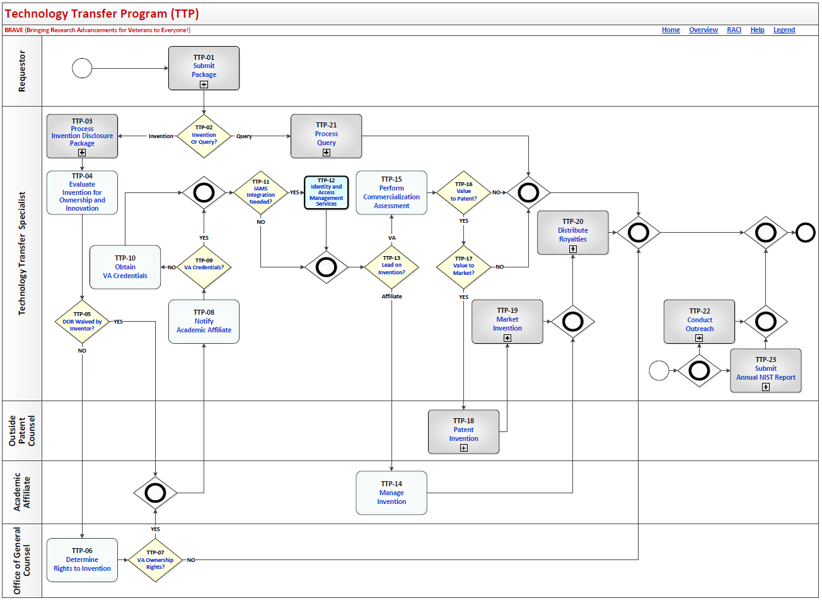
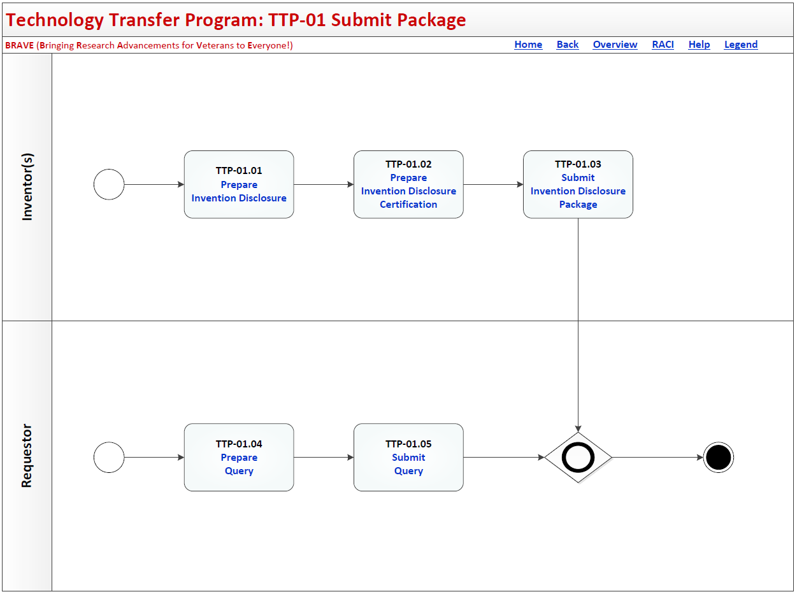
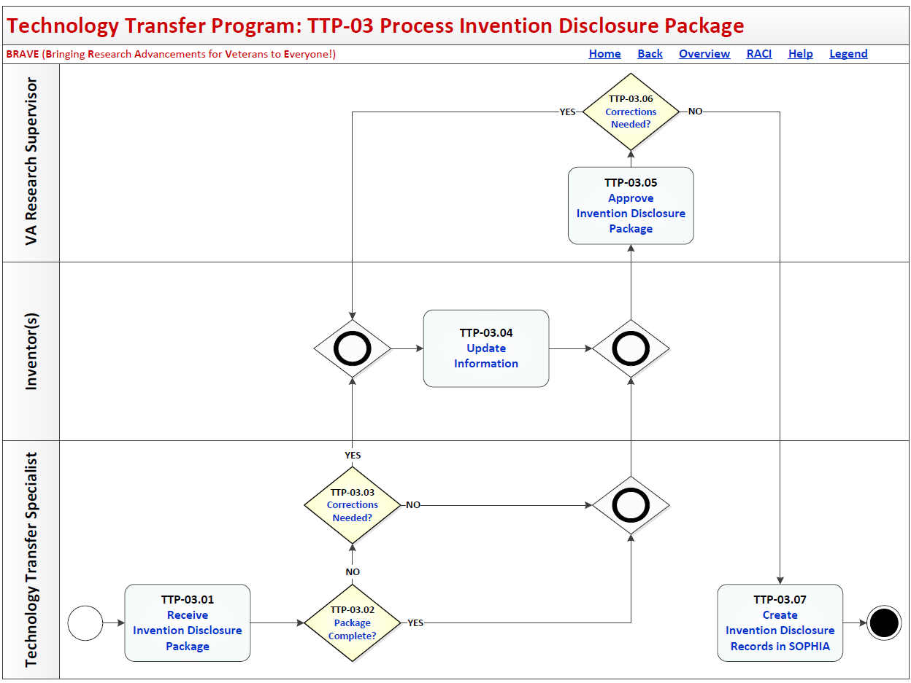
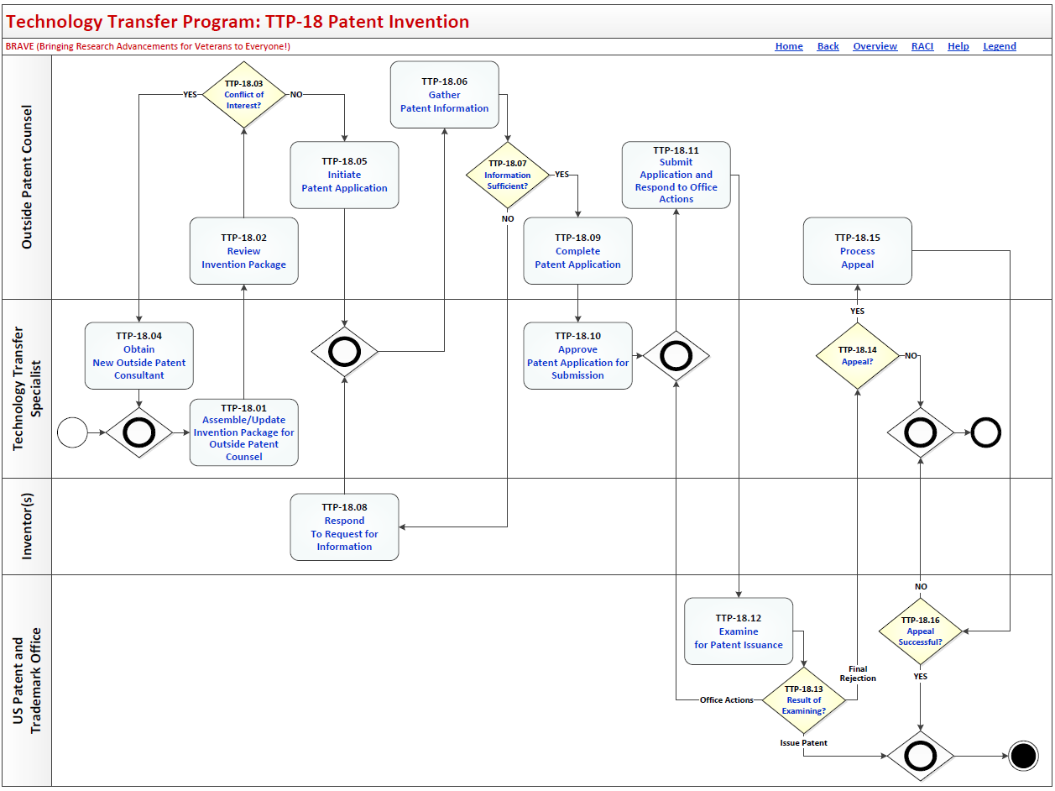
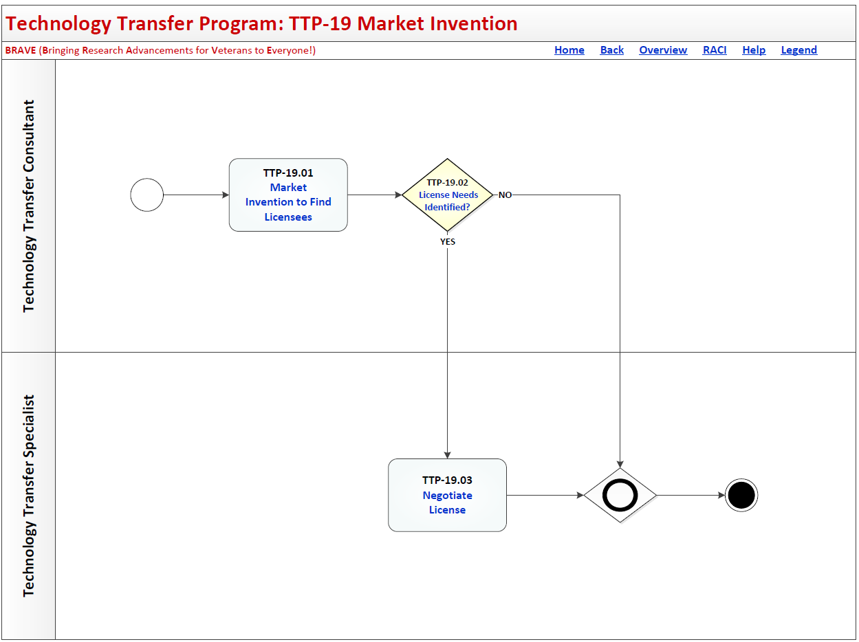
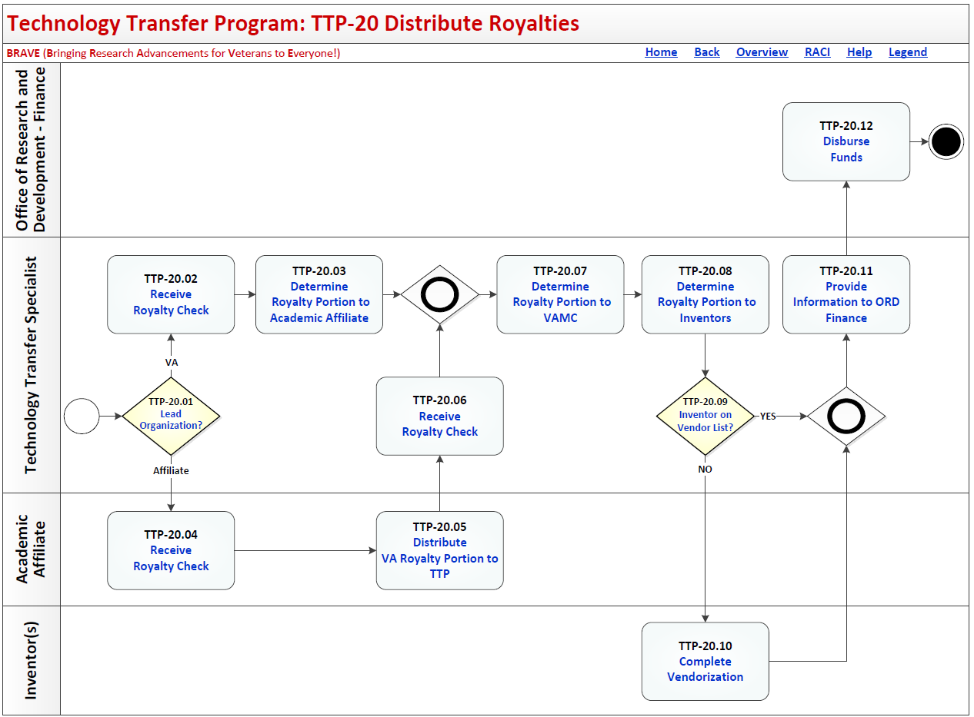
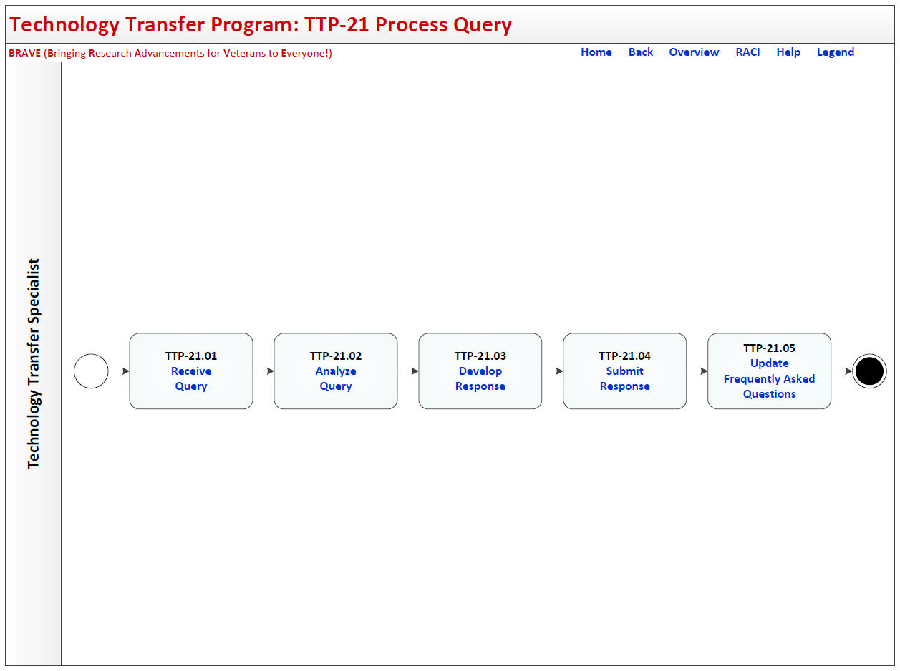
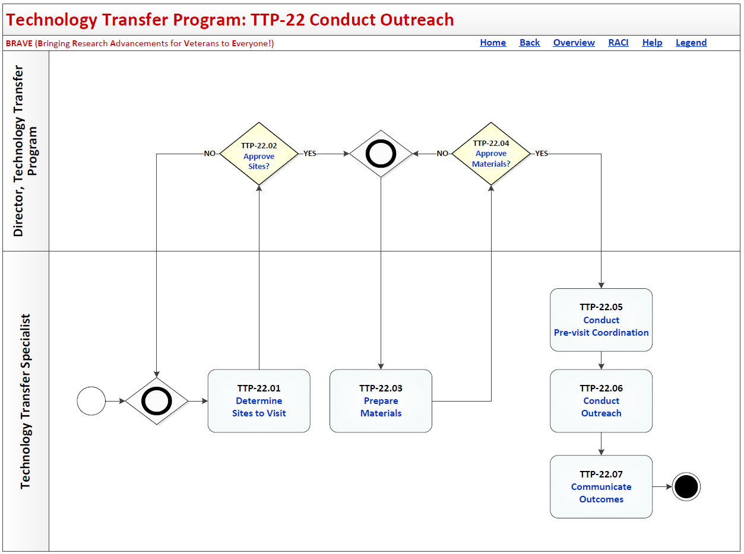
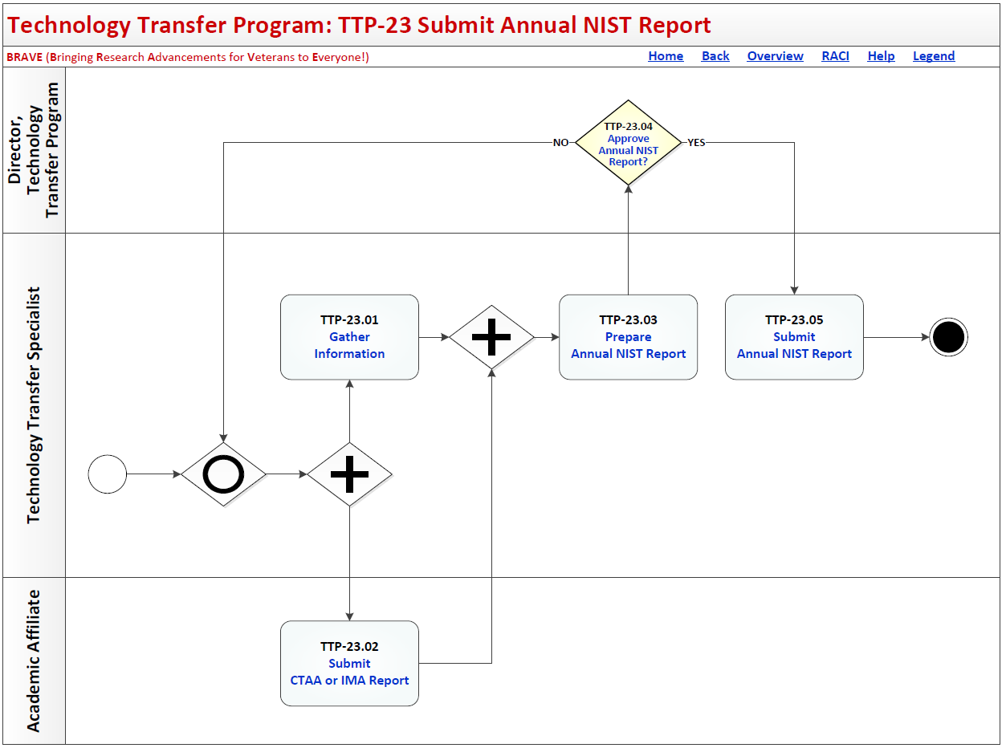

Process: Technology Transfer Program
Overview: The process map for Technology Transfer Program cycles through the following process and review activities:
TTP-01 Submit Package
TTP-01.01 Prepare Invention Disclosure
TTP-01.02 Prepare Invention Certification
TTP-01.03 Submit Invention Disclosure Package
TTP-01.04 Prepare Query
TTP-01.05 Submit Query
TTP-02 Invention or Query?
TTP-03 Process Invention Disclosure Package
TTP-03.01 Receive Invention Disclosure Package
TTP-03.02 Package Complete?
TTP-03.03 Corrections Needed?
TTP-03.04 Update Information
TTP-03.05 Approve Invention Disclosure Package
TTP-03.06 Corrections Needed?
TTP-03.07 Create Invention Disclosure Records in SOPHIA
TTP-04 Evaluate Invention for Ownership and Innovation
TTP-05 DOR Waived by Inventor?
TTP-06 Determine Rights to Invention
TTP-07 VA Ownership Rights?
TTP-08 Notify Academic Affiliate
TTP-09 VA Credentials?
TTP-10 Obtain VA Credentials
TTP-11 IAMS Integration Needed?
TTP-12 Identity and Access Management Services
TTP-13 Lead on Innovation?
TTP-14 Manage Invention
TTP-15 Perform Commercialization Assessment
TTP-16 Value to Patent?
TTP-17 Value to Market?
TTP-18 Patent Invention
TTP-18.01 Assemble / Update Invention Disclosure Package for Outside Patent Control
TTP-18.02 Review Invention for Conflict of Interest
TTP-18.03 Conflict of Interest?
TTP-18.04 Obtain New Outside Patent Counsel
TTP-18.05 Initiate Patent Application
TTP-18.06 Gather Patent Information
TTP-18.07 Information Sufficient?
TTP-18.08 Respond to Request for Information
TTP-18.09 Complete Patent Application
TTP-18.10 Approve Patent Application for Submission
TTP-18.11 Submit Application and Respond to Office Actions
TTP-18.12 Examine for Patent Issuance
TTP-18.13 Result of Examining?
TTP-18.14 Appeal?
TTP-18.15 Process Appeal
TTP-18.16 Appeal Successful?
TTP-19 Market Invention
TTP-19.01 Market Invention to Find Licenses
TTP-19.02 License Needs Identified?
TTP-19.03 Negotiate License
TTP-20 Distribute Royalties
TTP-20.01 Lead Organization?
TTP-20.02 Receive Royalty Check
TTP-20.03 Determine Royalty Portion to Academic Affiliate
TTP-20.04 Receive Royalty Check
TTP-20.05 Distribute VA Royalty Portion to TTP
TTP-20.06 Receive Royalty Check
TTP-20.07 Determine Royalty Portion to VAMC
TTP-20.08 Determine Royalty Portion to Inventors
TTP-20.09 Inventor on Vendor List?
TTP-20.10 Complete Vendorization
TTP-20.11 Provide Information to ORD Finance
TTP-20.12 Disburse Funds
TTP-21 Process Query
TTP-21.01 Receive Query
TTP-21.02 Analyze Query
TTP-21.03 Develop Response
TTP-21.04 Submit Response
TTP-21.05 Update Frequently Asked Questions
TTP-22 Conduct Outreach
TTP-22.01 Determine Sites to Visit
TTP-22.02 Approve Sites?
TTP-22.03 Prepare Materials
TTP-22.04 Approve Materials?
TTP-22.05 Conduct Pre-visit Coordination
TTP-22.06 Conduct Outreach
TTP-22.07 Communicate Outcomes
TTP-23 Submit Annual NIST Report
TTP-23.01 Gather Information
TTP-23.02 Submit CTAA or IMA Report
TTP-23.03 Prepare Annual NIST Report
TTP-23.04 Approve Annual NIST Report?
TTP-23.05 Submit Annual NIST Report

Technology Transfer Program Description and Goals

Description
The VA Technology Transfer Program (TTP) is committed to transferring research resulting in inventions that address veteran needs into commercially viable products that can be patented and licensed for use. TTP functions as a liaison between VA researchers and industry partners to facilitate the technology transfer process. The conception of an invention initiates the technology transfer process. An invention is typically conceived within the context of a research project. The conception of the invention may involve an individual or several individuals, sometimes from other institutions or who practice in a VA medical facility under a joint appointment. The invention can also be the result of a collaborative research agreement.

Goals
• Accurate and timely reporting and recording of the development of the discovery
• The efficient and formal disclosure of the invention which allows the inventor to clearly describe the innovation, its possible commercial applications, and record individuals who were involved in the invention process
• The evaluation of the invention disclosure to determine ownership rights, the commercialization potential and patentability of the technology
• The protection of the invention, typically in the form of a US patent and through foreign patents as warranted
• The commercialization of the invention to attract licensing opportunities including research material that is not patentable but has some commercial application and benefit
• The licensing of the technology which defines the rights, responsibilities, exclusivity, and terms of the agreement
• The management of royalty payments and compliance with the license agreement under which a percentage of royalties will go to the inventor and a portion are retained by the VA to be reinvested for the development of additional technologies that can meet other veteran health needs.

Technology Transfer Program RACI Information
The following describes the RACI information for this process:

TTP-01.01 Prepare Invention Disclosure
Responsible Role: Inventor(s)
Accountable Role: Inventor(s)
Consulted Role: Technology Transfer Specialist
Informed Role: None Listed

TTP-01.02 Prepare Invention Certification
Responsible Role: Inventor(s)
Accountable Role: Inventor(s)
Consulted Role: Technology Transfer Specialist
Informed Role: None Listed
Accountable Role: Requestor
Consulted Role: Technology Transfer Program Support Staff
Informed Role: None Listed

TTP-01.03 Submit Invention Disclosure Package
Responsible Role: Inventor(s)
Accountable Role: Inventor(s)
Consulted Role: Technology Transfer Specialist
Informed Role: None Listed

TTP-01.04 Prepare Query
Responsible Role: Inventor(s)
Accountable Role: Inventor(s)
Consulted Role: None Listed
Informed Role: None Listed

TTP-01.05 Submit Query
Responsible Role: Requestor

TTP-02 Invention or Query?
Responsible Role: Technology Transfer Specialist
Accountable Role: Director, Technology Transfer Program
Consulted Role: None Listed
Informed Role: None Listed

TTP-03.01 Receive Invention Disclosure Package
Responsible Role: Technology Transfer Specialist
Accountable Role: Director, Technology Transfer Program
Consulted Role: Requestor
Informed Role: None Listed

TTP-03.02 Package Complete?
Responsible Role: Technology Transfer Specialist
Accountable Role: Director, Technology Transfer Program
Consulted Role: Inventor(s)
Informed Role: Stakeholders

TTP-03.03 Corrections Needed?
Responsible Role: Technology Transfer Specialist
Accountable Role: Director, Technology Transfer Program
Consulted Role: None Listed
Informed Role: None Listed

TTP-03.04 Update Information
Responsible Role: Technology Transfer Specialist
Accountable Role: Director, Technology Transfer Program
Consulted Role: Inventor(s)
Informed Role: None Listed

TTP-03.05 Approve Invention Disclosure Package
Responsible Role: VA Research Supervisor
Accountable Role: Director, Technology Transfer Program
Consulted Role: None Listed
Informed Role: Stakeholders

TTP-03.06 Corrections Needed?
Responsible Role: VA Research Supervisor
Accountable Role: VA Research Supervisor
Consulted Role: None Listed
Informed Role: None Listed

TTP-03.07 Create Invention Disclosure Records in SOPHIA
Responsible Role: Technology Transfer Specialist
Accountable Role: Director, Technology Transfer Program
Consulted Role: None Listed
Informed Role: None Listed

TTP-04 Evaluate Invention for Ownership and Innovation
Responsible Role: Technology Transfer Specialist
Accountable Role: Director, Technology Transfer Program
Consulted Role: Office of General Counsel
Informed Role: Stakeholders

TTP-05 DOR Waived by Inventor?
Responsible Role: Technology Transfer Specialist
Accountable Role: Director, Technology Transfer Program
Consulted Role: Inventor(s); Office of General Counsel
Informed Role: Stakeholders

TTP-06 Determine Rights to Invention
Responsible Role: Office of General Counsel
Accountable Role: Director, Technology Transfer Program
Consulted Role: None Listed
Informed Role: Stakeholders

TTP-07 VA Ownership Rights?
Responsible Role: Office of General Counsel
Accountable Role: Director, Technology Transfer Program
Consulted Role: None Listed
Informed Role: Technology Transfer Specialist

TTP-08 Notify Academic Affiliate
Responsible Role: Technology Transfer Specialist
Accountable Role: Director, Technology Transfer Program
Consulted Role: None Listed
Informed Role: Academic Affiliate

TTP-09 VA Credentials?
Responsible Role: Technology Transfer Specialist
Accountable Role: Director, Technology Transfer Program
Consulted Role: None Listed
Informed Role: None Listed

TTP-10 Obtain VA Credentials
Responsible Role: Technology Transfer Specialist
Accountable Role: Director, Technology Transfer Program
Consulted Role: Inventor(s); Academic Affiliate
Informed Role: Stakeholders

TTP-11 IAMS Integration Needed?
Responsible Role: Technology Transfer Specialist
Accountable Role: Director, Technology Transfer Program
Consulted Role: None Listed
Informed Role: None Listed

TTP-12 Identity and Access Management Services
Responsible Role: Technology Transfer Specialist
Accountable Role: Director, Technology Transfer Program
Consulted Role: None Listed
Informed Role: Stakeholders

TTP-13 Lead on Innovation?
Responsible Role: Technology Transfer Specialist
Accountable Role: Director, Technology Transfer Program
Consulted Role: None Listed
Informed Role: None Listed

TTP-14 Manage Invention
Responsible Role: Academic Affiliate
Accountable Role: Director, Technology Transfer Program
Consulted Role: None Listed
Informed Role: Stakeholders

TTP-15 Perform Commercialization Assessment
Responsible Role: Technology Transfer Specialist
Accountable Role: Director, Technology Transfer Program
Consulted Role: Inventor(s)
Informed Role: None Listed

TTP-16 Value to Patent?
Responsible Role: Technology Transfer Specialist
Accountable Role: Director, Technology Transfer Program
Consulted Role: None Listed
Informed Role: Stakeholders

TTP-17 Value to Market?
Responsible Role: Technology Transfer Specialist
Accountable Role: Director, Technology Transfer Program
Consulted Role: None Listed
Informed Role: Stakeholders

TTP-18.01 Assemble / Update Invention Disclosure Package for Outside Patent Control
Responsible Role: Technology Transfer Specialist
Accountable Role: Director, VA Integrated Operations Center
Consulted Role: Outside Patent Counsel
Informed Role: Stakeholders

TTP-18.02 Review Invention for Conflict of Interest
Responsible Role: Outside Patent Counsel
Accountable Role: Director, Technology Transfer Program
Consulted Role: None Listed
Informed Role: Stakeholders

TTP-18.03 Conflict of Interest?
Responsible Role: Outside Patent Counsel
Accountable Role: Director, Technology Transfer Program
Consulted Role: None Listed
Informed Role: Stakeholders; Inventor(s)

TTP-18.04 Obtain New Outside Patent Counsel
Responsible Role: Technology Transfer Specialist
Accountable Role: Director, Technology Transfer Program
Consulted Role: Director, Technology Transfer Program; Office of General Counsel
Informed Role: Stakeholders

TTP-18.05 Initiate Patent Application
Responsible Role: Outside Patent Counsel
Accountable Role: Director, Technology Transfer Program
Consulted Role: None Listed
Informed Role: Inventor(s); Stakeholders

TTP-18.06 Gather Patent Information
Responsible Role: Outside Patent Counsel
Accountable Role: Director, Technology Transfer Program
Consulted Role: None Listed
Informed Role: Stakeholders

TTP-18.07 Information Sufficient?
Responsible Role: Outside Patent Counsel
Accountable Role: Director, Technology Transfer Program
Consulted Role: None Listed
Informed Role: Stakeholder Offices

TTP-18.08 Respond to Request for Information
Responsible Role: Inventor(s)
Accountable Role: Director, Technology Transfer Program
Consulted Role: None Listed
Informed Role: Stakeholders; IT Specialist

TTP-18.09 Complete Patent Application
Responsible Role: Outside Patent Counsel
Accountable Role: Director, Technology Transfer Program
Consulted Role: Inventor(s)
Informed Role: Stakeholders

TTP-18.10 Approve Patent Application for Submission
Responsible Role: Technology Transfer Specialist
Accountable Role: Director, Technology Transfer Program
Consulted Role: None Listed
Informed Role: Stakeholders

TTP-18.11 Submit Application and Respond to Office Actions
Responsible Role: Outside Patent Counsel
Accountable Role: Director, Technology Transfer Program
Consulted Role: None Listed
Informed Role: Stakeholders

TTP-18.12 Examine for Patent Issuance
Responsible Role: US Patent and Trademark Office
Accountable Role: US Patent and Trademark Office
Consulted Role: None Listed
Informed Role: None Listed

TTP-18.13 Result of Examining?
Responsible Role: US Patent and Trademark Office
Accountable Role: US Patent and Trademark Office
Consulted Role: None Listed
Informed Role: None Listed

TTP-18.14 Appeal?
Responsible Role: Technology Transfer Specialist
Accountable Role: Director, Technology Transfer Program
Consulted Role: Inventor(s)
Informed Role: Stakeholders

TTP-18.15 Process Appeal
Responsible Role: Technology Transfer Specialist
Accountable Role: Director, Technology Transfer Program
Consulted Role: Outside Patent Counsel
Informed Role: Stakeholders

TTP-18.16 Appeal Successful?
Responsible Role: US Patent and Trademark Office
Accountable Role: US Patent and Trademark Office
Consulted Role: None Listed
Informed Role: None Listed

TTP-19.01 Market Invention to Find Licenses
Responsible Role: Technology Transfer Consultant
Accountable Role: Director, Technology Transfer Program
Consulted Role: Technology Transfer Specialist; Inventor(s)
Informed Role: Stakeholders

TTP-19.02 License Needs Identified?
Responsible Role: Technology Transfer Specialist
Accountable Role: Director, Technology Transfer Program
Consulted Role: Technology Transfer Consultant
Informed Role: Stakeholders

TTP-19.03 Negotiate License
Responsible Role: Technology Transfer Specialist
Accountable Role: Director, Technology Transfer Program
Consulted Role: None Listed
Informed Role: Stakeholders

TTP-20.01 Lead Organization?
Responsible Role: Technology Transfer Specialist
Accountable Role: Director, Technology Transfer Program
Consulted Role: None Listed
Informed Role: None Listed

TTP-20.02 Receive Royalty Check
Responsible Role: Technology Transfer Specialist
Accountable Role: Director, Technology Transfer Program
Consulted Role: None Listed
Informed Role: None Listed

TTP-20.03 Determine Royalty Portion to Academic Affiliate
Responsible Role: Technology Transfer Specialist
Accountable Role: Director, Technology Transfer Program
Consulted Role: None Listed
Informed Role: Inventor(s); Stakeholders

TTP-20.04 Receive Royalty Check
Responsible Role: Academic Affiliate
Accountable Role: Director, Technology Transfer Program
Consulted Role: None Listed
Informed Role: Stakeholders

TTP-20.05 Distribute VA Royalty Portion to TTP
Responsible Role: Academic Affiliate
Accountable Role: Director, Technology Transfer Program
Consulted Role: None Listed
Informed Role: Stakeholders; Technology Transfer Specialist

TTP-20.06 Receive Royalty Check
Responsible Role: Technology Transfer Specialist
Accountable Role: Director, Technology Transfer Program
Consulted Role: None Listed
Informed Role: None Listed

TTP-20.07 Determine Royalty Portion to VAMC
Responsible Role: Technology Transfer Specialist
Accountable Role: Director, Technology Transfer Program
Consulted Role: VAMC
Informed Role: Stakeholders

TTP-20.08 Determine Royalty Portion to Inventors
Responsible Role: Technology Transfer Specialist
Accountable Role: Director, Technology Transfer Program
Consulted Role: None Listed
Informed Role: None Listed

TTP-20.09 Inventor on Vendor List?
Responsible Role: Technology Transfer Specialist
Accountable Role: Director, Technology Transfer Program
Consulted Role: None Listed
Informed Role: None Listed

TTP-20.10 Complete Vendorization
Responsible Role: Inventor(s)
Accountable Role: Inventor(s)
Consulted Role: None Listed
Informed Role: None Listed

TTP-20.11 Provide Information to ORD Finance
Responsible Role: Technology Transfer Specialist
Accountable Role: Director, Technology Transfer Program
Consulted Role: None Listed
Informed Role: Office of Research and Development - Finance

TTP-20.12 Disburse Funds
Responsible Role: Office of Research and Development - Finance
Accountable Role: Director, Technology Transfer Program
Consulted Role: VAMC; Inventor(s); Academic Affiliate
Informed Role: None Listed

TTP-21.01 Receive Query
Responsible Role: Technology Transfer Specialist
Accountable Role: Director, Technology Transfer Program
Consulted Role: None Listed
Informed Role: None Listed

TTP-21.02 Analyze Query
Responsible Role: Technology Transfer Specialist
Accountable Role: Director, Technology Transfer Program
Consulted Role: None Listed
Informed Role: None Listed

TTP-21.03 Develop Response
Responsible Role: Technology Transfer Specialist
Accountable Role: Director, Technology Transfer Program
Consulted Role: None Listed
Informed Role: None Listed

TTP-21.04 Submit Response
Responsible Role: Technology Transfer Specialist
Accountable Role: Director, Office of Privacy and Records Management
Consulted Role: None Listed
Informed Role: None Listed

TTP-21.05 Update Frequently Asked Questions
Responsible Role: Technology Transfer Specialist
Accountable Role: Director, Technology Transfer Program
Consulted Role: None Listed
Informed Role: None Listed

TTP-22.01 Determine Sites to Visit
Responsible Role: Technology Transfer Specialist
Accountable Role: Director, Technology Transfer Program
Consulted Role: Technology Transfer Consultant
Informed Role: Stakeholders

TTP-22.02 Approve Sites?
Responsible Role: Director, Technology Transfer Program
Accountable Role: Director, Technology Transfer Program
Consulted Role: None Listed
Informed Role: None Listed

TTP-22.03 Prepare Materials
Responsible Role: Technology Transfer Specialist
Accountable Role: Director, Technology Transfer Program
Consulted Role: Technology Transfer Consultant
Informed Role: None Listed

TTP-22.04 Approve Materials?
Responsible Role: Director, Technology Transfer Program
Accountable Role: Director, Technology Transfer Program
Consulted Role: None Listed
Informed Role: None Listed

TTP-22.05 Conduct Pre-visit Coordination
Responsible Role: Technology Transfer Specialist
Accountable Role: Director, Technology Transfer Program
Consulted Role: None Listed
Informed Role: None Listed

TTP-22.06 Conduct Outreach
Responsible Role: Technology Transfer Specialist
Accountable Role: Director, Technology Transfer Program
Consulted Role: Technology Transfer Consultant
Informed Role: Stakeholders

TTP-22.07 Communicate Outcomes
Responsible Role: Technology Transfer Specialist
Accountable Role: Director, Technology Transfer Program
Consulted Role: Technology Transfer Consultant
Informed Role: Stakeholders

TTP-23.01 Gather Information
Responsible Role: Technology Transfer Specialist
Accountable Role: Director, Technology Transfer Program
Consulted Role: None Listed
Informed Role: None Listed

TTP-23.02 Submit CTAA or IMA Report
Responsible Role: Academic Affiliate
Accountable Role: Director, Technology Transfer Program
Consulted Role: Technology Transfer Specialist
Informed Role: Stakeholders

TTP-23.03 Prepare Annual NIST Report
Responsible Role: Technology Transfer Specialist
Accountable Role: Director, Technology Transfer Program
Consulted Role: None Listed
Informed Role: None Listed

TTP-23.04 Approve Annual NIST Report?
Responsible Role: Director, Technology Transfer Program
Accountable Role: Director, Technology Transfer Program
Consulted Role: None Listed
Informed Role: None Listed

TTP-23.05 Submit Annual NIST Report
Responsible Role: Technology Transfer Specialist
Accountable Role: Director, Technology Transfer Program
Consulted Role: None Listed
Informed Role: Stakeholders

Technology Transfer Program Associated Artifacts Information
Associated Artifacts information (including hyperlinks) for this process include:
Certification of Reporting for Inventions
Determination of Rights Letter Template
PIV Office Fingerprint Request Form
U.S. DEPARTMENT OF VETERANS AFFAIRS AND ___ UNIVERSITY INVENTION MANAGMENT AGREEMENT
VA Information Security Rules of Behavior
VA Invention Disclosure Form

Technology Transfer Program Tools and Web Sites Information
The Tools and Web Sites associated with this process (including hyperlinks) include:
Office of General Council SharePoint Site
Office of Information Security Portal
Office of Research and Development Forms and Templates
SOPHIA
Talent Management System Self Enrollment Portal
VA Office of Research & Development Policies & Procedures
VA Talent Management System (TMS)
VA Technology Transfer Program

Technology Transfer Program Standards Information
Standards associated with this process (including hyperlinks) include:
38 U.S.C.1.650 through 1.653, 37 Part 501
Federal Information Processing Standards Publications (FIPS) 186-4, Digital Signature Standard (DSS)
IAM Service Request Submission User Guide
VA Directive 0710, Personnel Security and Suitability Program
VA Directive 6300, Records and Information Management
VA Directive 6500, VA Cybersecurity Program
VA Directive 6502, VA Enterprise Privacy Program
VA Handbook 6500, Risk Management Framework for VA Information Systems - Tier 3: VA Information Security Program
VA Handbook 6510, VA Identity and Access Management
VA Memorandum (VAIQ 7714283) Modified VA Information Security Rules of Behavior
VHA Directive 1200, Research and Development Program
VHA Directive 1206, Use of a Cooperative Research and Development Agreement (CRADA)
VHA HANDBOOK 1100.19 CREDENTIALING AND PRIVILEGING
VHA Handbook 1200.18, Determination of Rights for Inventions and Discoveries

Technology Transfer Program Process

Process Activity Name: TTP-01 Submit Package
Previous Activities
Process Begins
Next Activities
TTP-01.01 Prepare Invention Disclosure
And
TTP-01.04 Prepare Query
Description
The sub-process map for Submit Package cycles through the following dependent activities:
- Prepare Invention Disclosure
- Prepare Invention Disclosure Certification
- Submit Invention Disclosure Package

OR

- Prepare Query
- Submit Query

Process Activity Name: TTP-01.01 Prepare Invention Disclosure
Previous Activities
TTP-01 Submit Package
Next Activities
TTP-01.02 Prepare Invention Certification
Description
Inventor(s) prepare the invention disclosure form detailing what the invention is, what the benefit(s) from the invention may be, and who participated in creating the invention.
Input
Invention Planning Documents
Output
Invention Disclosure Form
Associated Artifacts
VA Invention Disclosure Form
Responsible Role
Inventor(s)
Accountable Role
Inventor(s)
Consulted Role
Technology Transfer Specialist
Informed Role
None Listed
Tools and Websites
VA Office of Research & Development Policies & Procedures
VA Technology Transfer Program
More Info
None Listed

Process Activity Name: TTP-01.02 Prepare Invention Certification
Previous Activities
TTP-01.01 Prepare Invention Disclosure
Next Activities
TTP-01.03 Submit Invention Disclosure Package
Description
The Inventor(s) prepares the VA Invention Certification Form that certifies how and where invention was created, who was involved, and what resources were used.
Input
VA Invention Disclosure Form
Output
Certification of Reporting for Inventions
Associated Artifacts
Certification of Reporting for Inventions
VA Invention Disclosure Form
Responsible Role
Inventor(s)
Accountable Role
Inventor(s)
Consulted Role
Technology Transfer Specialist
Informed Role
None Listed
Tools and Websites
VA Office of Research & Development Policies & Procedures
VA Technology Transfer Program
More Info
None Listed

Process Activity Name: TTP-01.03 Submit Invention Disclosure Package
Previous Activities
TTP-01.02 Prepare Invention Certification
Next Activities
TTP-02 Invention or Query?
Description
Inventor(s) submit(s) the Invention Disclosure Package to the Technology Transfer Program. The Invention Disclosure Package consists of the completed VA Invention Disclosure Form and the Certification of Reporting of Inventions.

Input
Certification of Reporting for Inventions
VA Invention Disclosure Form
Output
Invention Disclosure Package
Associated Artifacts
None Listed
Responsible Role
Inventor(s)
Accountable Role
Inventor(s)
Consulted Role
Technology Transfer Specialist
Informed Role
None Listed
Tools and Websites
Talent Management System Self Enrollment Portal
VA Talent Management System (TMS)
More Info
None Listed

Process Activity Name: TTP-01.04 Prepare Query
Previous Activities
TTP-01 Submit Package
Next Activities
TTP-01.05 Submit Query
Description
Inventor(s) prepare(s) the Query requesting information from the Technology Transfer Program (TTP) Office.

Input
None Listed
Output
Query
Associated Artifacts
None Listed
Responsible Role
Inventor(s)
Accountable Role
Inventor(s)
Consulted Role
None Listed
Informed Role
None Listed
Tools and Websites
None Listed
More Info
The query may take the form of an email, a letter, a phone call, or a conversation.

Process Activity Name: TTP-01.05 Submit Query
Previous Activities
TTP-01.04 Prepare Query
Next Activities
TTP-02 Invention or Query?
Description
Requestor(s) submit a query requesting information from the Technology Transfer Program (TTP) Office.

Input
Query
Output
Submitted Query
Associated Artifacts
None Listed
Responsible Role
Requestor
Accountable Role
Requestor
Consulted Role
Technology Transfer Program Support Staff
Informed Role
None Listed
Tools and Websites
None Listed
More Info
None Listed

Process Activity Name: TTP-02 Invention or Query?
Previous Activities
TTP-01.03 Submit Invention Disclosure Package
Or
TTP-01.05 Submit Query
Next Activities
If "Invention":
TTP-03 Process Invention Disclosure Package
Or
If "Query":
TTP-21 Process Query
Description
The Technology Transfer Specialist determines if submission is an invention (INVENTION) or a query (QUERY).
Responsible Role
Technology Transfer Specialist
Accountable Role
Director, Technology Transfer Program
Consulted Role
None Listed
Informed Role
None Listed

Process Activity Name: TTP-03 Process Invention Disclosure Package
Previous Activities
TTP-02 Invention or Query?
Next Activities
TTP-03.01 Receive Invention Disclosure Package
Description
The sub-process map for Process Invention Disclosure Package cycles through the following dependent activities:
- Receive Invention Disclosure Package
- Package Complete?
- Corrections Needed?
- Update Information
- Approve Invention Disclosure Package
- Corrections Needed?
- Create Invention Disclosure Records in Sophia

Process Activity Name: TTP-03.01 Receive Invention Disclosure Package
Previous Activities
TTP-03 Process Invention Disclosure Package
Next Activities
TTP-03.02 Package Complete?
Description
The Technology Transfer Specialist receives the Invention Disclosure Package and prepares to validate content.

Input
Invention Disclosure Package
Output
Validated Invention Disclosure Package
Associated Artifacts
Certification of Reporting for Inventions
VA Invention Disclosure Form
Responsible Role
Technology Transfer Specialist
Accountable Role
Director, Technology Transfer Program
Consulted Role
Requestor
Informed Role
None Listed
Tools and Websites
Office of Research and Development Forms and Templates
More Info
None Listed

Process Activity Name: TTP-03.02 Package Complete?
Previous Activities
TTP-03.01 Receive Invention Disclosure Package
Next Activities
If "YES":
TTP-03.05 Approve Invention Disclosure Package
Or
If "NO":
TTP-03.03 Corrections Needed?
Description
The Technology Transfer Specialist determines if (YES), the Package is complete, or (NO), the package is not complete.
Responsible Role
Technology Transfer Specialist
Accountable Role
Director, Technology Transfer Program
Consulted Role
Inventor(s)
Informed Role
Stakeholders

Process Activity Name: TTP-03.03 Corrections Needed?
Previous Activities
TTP-03.02 Package Complete?
Next Activities
If "YES":
TTP-03.04 Update Information
Or
If "NO":
TTP-03.05 Approve Invention Disclosure Package
Description
The Technology Transfer Specialist determines if corrections are needed in the package (YES) or if the package does not need corrections (NO).
Responsible Role
Technology Transfer Specialist
Accountable Role
Director, Technology Transfer Program
Consulted Role
None Listed
Informed Role
None Listed

Process Activity Name: TTP-03.04 Update Information
Previous Activities
TTP-03.03 Corrections Needed?
Next Activities
TTP-03.05 Approve Invention Disclosure Package
Description
The Technology Transfer Specialist contacts the Inventor(s) and elicits any remaining information needed to complete the Invention Disclosure Package.

Input
Invention Disclosure Package
Output
Updated Invention Disclosure Package
Associated Artifacts
Certification of Reporting for Inventions
VA Invention Disclosure Form
Responsible Role
Technology Transfer Specialist
Accountable Role
Director, Technology Transfer Program
Consulted Role
Inventor(s)
Informed Role
None Listed
Tools and Websites
None Listed
More Info
None Listed

Process Activity Name: TTP-03.05 Approve Invention Disclosure Package
Previous Activities
TTP-03.02 Package Complete?
Or
TTP-03.03 Corrections Needed?
Or
TTP-03.04 Update Information
Next Activities
TTP-03.06 Corrections Needed?
Description
The VA Researcher(s)' Supervisor or ACOS approves the Invention Disclosure Package for processing.

Input
Invention Disclosure Package
Output
Approved Invention Disclosure Package
Associated Artifacts
Certification of Reporting for Inventions
VA Invention Disclosure Form
Responsible Role
VA Research Supervisor
Accountable Role
Director, Technology Transfer Program
Consulted Role
None Listed
Informed Role
Stakeholders
Tools and Websites
Office of Research and Development Forms and Templates
More Info
None Listed

Process Activity Name: TTP-03.06 Corrections Needed?
Previous Activities
TTP-03.05 Approve Invention Disclosure Package
Next Activities
If "Yes":
TTP-03.04 Update Information
Or
If "No":
TTP-03.07 Create Invention Disclosure Records in SOPHIA
Description
The VA Research Supervisor determines (YES), the Invention Disclosure Package needs corrections, or (NO), the Invention Disclosure Package does not need corrections.
Responsible Role
VA Research Supervisor
Accountable Role
VA Research Supervisor
Consulted Role
None Listed
Informed Role
None Listed

Process Activity Name: TTP-03.07 Create Invention Disclosure Records in SOPHIA
Previous Activities
TTP-03.05 Approve Invention Disclosure Package
Next Activities
TTP-04 Evaluate Invention for Ownership and Innovation
Description
The Technology Transfer Specialist creates the initial SOPHIA database entries, obtains the VA Invention Disclosure number for this disclosure, and creates a shared folder corresponding to the VA ID number (i.e., 2016-100)

Input
Invention Disclosure Package
Output
Invention Disclosure Folder
Invention Disclosure Number
SOPHIA Database Entries
Updated Invention Disclosure Number
Associated Artifacts
None Listed
Responsible Role
Technology Transfer Specialist
Accountable Role
Director, Technology Transfer Program
Consulted Role
None Listed
Informed Role
None Listed
Tools and Websites
SOPHIA
More Info
None Listed

Process Activity Name: TTP-04 Evaluate Invention for Ownership and Innovation
Previous Activities
TTP-03.06 Corrections Needed?
Next Activities
TTP-05 DOR Waived by Inventor?
Description
The Technology Transfer Specialist creates the Invention Evaluation (IE), saves the information in the Technology Transfer Specialist's SharePoint drive, updates SOPHIA, creates a folder in the Office of General Counsel (OGC's) SharePoint site corresponding to the VA ID number, loads the VA ID number, certification and IE information into the OGC SharePoint site and notifies OGC with an email so OGC can complete a Determination of Rights.

Input
Invention Disclosure Package
VA ID Number
Output
Email Notification to OGC
Invention Evaluation
OGC SharePoint Invention File Folder
Updated SOPHIA
Associated Artifacts
None Listed
Responsible Role
Technology Transfer Specialist
Accountable Role
Director, Technology Transfer Program
Consulted Role
Office of General Counsel
Informed Role
Stakeholders
Tools and Websites
Office of General Council SharePoint Site
More Info
None Listed

Process Activity Name: TTP-05 DOR Waived by Inventor?
Previous Activities
TTP-04 Evaluate Invention for Ownership and Innovation
Next Activities
If "Yes":
TTP-08 Notify Academic Affiliate
Or
If "No":
TTP-06 Determine Rights to Invention
Description
The Technology Transfer Specialist determines (YES), the Inventor waived Determination of Rights (DOR) or (NO), the inventor did not waive Determination of Rights.
Responsible Role
Technology Transfer Specialist
Accountable Role
Director, Technology Transfer Program
Consulted Role
Inventor(s); Office of General Counsel
Informed Role
Stakeholders

Process Activity Name: TTP-06 Determine Rights to Invention
Previous Activities
TTP-05 DOR Waived by Inventor?
Next Activities
TTP-07 VA Ownership Rights?
Description
The Office of General Counsel reviews the Invention Disclosure Package, including the Invention Evaluation, and provides a Determination of Rights (DOR) Letter.
Input
Invention Disclosure Package
Invention Evaluation
Output
Determination of Rights Letter
Associated Artifacts
Determination of Rights Letter Template
Responsible Role
Office of General Counsel
Accountable Role
Director, Technology Transfer Program
Consulted Role
None Listed
Informed Role
Stakeholders
Tools and Websites
VA Office of Research & Development Policies & Procedures
More Info
None Listed

Process Activity Name: TTP-07 VA Ownership Rights?
Previous Activities
TTP-06 Determine Rights to Invention
Next Activities
If "Yes":
TTP-08 Notify Academic Affiliate
Or
If "No":
Process Ends
Description
The Office of General Counsel/ Specialty Team Advising Research (OGC/STAR) determines if there are VA Ownership Rights (YES) or there are no VA Ownership Rights (NO).
Responsible Role
Office of General Counsel
Accountable Role
Director, Technology Transfer Program
Consulted Role
None Listed
Informed Role
Technology Transfer Specialist

Process Activity Name: TTP-08 Notify Academic Affiliate
Previous Activities
TTP-05 DOR Waived by Inventor?
Or
TTP-07 VA Ownership Rights?
Next Activities
TTP-09 VA Credentials?
Description
The Technology Transfer Specialist saves the Determination of Rights Letter (DOR) to the Technology Transfer Specialist shared drive, uploads it to Sophia, and e-mails the DOR to the Academic Affiliate. Additionally the Technology Transfer Specialist executes the Invention Management Agreement and adds it to the Invention Disclosure Package.

Input
Determination of Rights Letter
Invention Disclosure Package
Output
Email to Academic Affiliate with Determination of Rights Letter
Invention Management Agreement
Updated Invention Disclosure Package
Updated SOPHIA Database
Associated Artifacts
Determination of Rights Letter Template
U.S. DEPARTMENT OF VETERANS AFFAIRS AND ___ UNIVERSITY INVENTION MANAGMENT AGREEMENT
Responsible Role
Technology Transfer Specialist
Accountable Role
Director, Technology Transfer Program
Consulted Role
None Listed
Informed Role
Academic Affiliate
Tools and Websites
SOPHIA
More Info
None Listed

Process Activity Name: TTP-09 VA Credentials?
Previous Activities
TTP-08 Notify Academic Affiliate
Next Activities
If "Yes":
TTP-11 IAMS Integration Needed?
Or
If "No":
TTP-10 Obtain VA Credentials
Description
The Technology Transfer Specialist determines if the inventors have VA credentials (YES), or not (NO).

Responsible Role
Technology Transfer Specialist
Accountable Role
Director, Technology Transfer Program
Consulted Role
None Listed
Informed Role
None Listed

Process Activity Name: TTP-10 Obtain VA Credentials
Previous Activities
TTP-09 VA Credentials?
Next Activities
TTP-11 IAMS Integration Needed?
Description
The Technology Transfer Specialist works with the Inventors to obtain VA Credentials allowing access to the VA Intranet.
Input
GOV SAC Fingerprint Request Worksheet
Security and Investigation Center Contractor/Employee Fingerprint Card

Output
PIV Card
Signed VA Information Security Rules of Behavior
VA Intranet Access
Associated Artifacts
PIV Office Fingerprint Request Form
Responsible Role
Technology Transfer Specialist
Accountable Role
Director, Technology Transfer Program
Consulted Role
Inventor(s); Academic Affiliate
Informed Role
Stakeholders
Tools and Websites
Office of Information Security Portal
VA Office of Research & Development Policies & Procedures
VA Technology Transfer Program
More Info
None Listed

Process Activity Name: TTP-11 IAMS Integration Needed?
Previous Activities
TTP-09 VA Credentials?
Or
TTP-10 Obtain VA Credentials
Next Activities
If "Yes":
TTP-12 Identity and Access Management Services
Or
If "No":
TTP-13 Lead on Innovation?
Description
The Technology Transfer Specialist determines if the Identity and Access Process needs to be followed (YES), or if the Identity and Access Management Process does not need to be followed (NO).
Responsible Role
Technology Transfer Specialist
Accountable Role
Director, Technology Transfer Program
Consulted Role
None Listed
Informed Role
None Listed

Process Activity Name: TTP-12 Identity and Access Management Services
Previous Activities
TTP-11 IAMS Integration Needed?
Next Activities
If "Go to IAMS":
Or
If "Continue in TTP":
TTP-13 Lead on Innovation?
Description
The Technology Transfer Specialist follows the activities in the Identity and Access Management (IAMS) Process and then returns to complete the Technology Transfer Process (TTP)
Input
None Listed
Output
None Listed
Associated Artifacts
None Listed
Responsible Role
Technology Transfer Specialist
Accountable Role
Director, Technology Transfer Program
Consulted Role
None Listed
Informed Role
Stakeholders
Tools and Websites
None Listed
More Info
None Listed

Process Activity Name: TTP-13 Lead on Innovation?
Previous Activities
TTP-11 IAMS Integration Needed?
Or
TTP-12 Identity and Access Management Services
Next Activities
If "VA":
TTP-15 Perform Commercialization Assessment
Or
If "Affiliate":
TTP-14 Manage Invention
Description
The Technology Transfer Specialist determines if the VA is the lead (VA) or the Affiliate is the lead (AFFILIATE).

Responsible Role
Technology Transfer Specialist
Accountable Role
Director, Technology Transfer Program
Consulted Role
None Listed
Informed Role
None Listed

Process Activity Name: TTP-14 Manage Invention
Previous Activities
TTP-13 Lead on Innovation?
Next Activities
TTP-20 Distribute Royalties
Description
The Academic Affiliate assumes management responsibility for the invention and is responsible for preparing the Monthly Management Report.

Input
Invention Disclosure Package
Output
Monthly Management Report
Associated Artifacts
None Listed
Responsible Role
Academic Affiliate
Accountable Role
Director, Technology Transfer Program
Consulted Role
None Listed
Informed Role
Stakeholders
Tools and Websites
VA Office of Research & Development Policies & Procedures
More Info
None Listed

Process Activity Name: TTP-15 Perform Commercialization Assessment
Previous Activities
TTP-13 Lead on Innovation?
Next Activities
TTP-16 Value to Patent?
Description
The Technology Transfer Specialist performs the Commercialization Assessment determining if there is value to the patent and value to marketing the invention.
Input
Invention Disclosure Package
Output
Commercialization Assessment
Associated Artifacts
None Listed
Responsible Role
Technology Transfer Specialist
Accountable Role
Director, Technology Transfer Program
Consulted Role
Inventor(s)
Informed Role
None Listed
Tools and Websites
VA Office of Research & Development Policies & Procedures
More Info
None Listed

Process Activity Name: TTP-16 Value to Patent?
Previous Activities
TTP-15 Perform Commercialization Assessment
Next Activities
If "Yes":
TTP-17 Value to Market?
Or
If "No":
Process Ends
Description
The Technology Transfer Specialist determines if there is value to the patent (YES) or there is no value to the patent (NO).
Responsible Role
Technology Transfer Specialist
Accountable Role
Director, Technology Transfer Program
Consulted Role
None Listed
Informed Role
Stakeholders

Process Activity Name: TTP-17 Value to Market?
Previous Activities
TTP-16 Value to Patent?
Next Activities
If "Yes":
TTP-18 Patent Invention
Or
If "No":
Process Ends
Description
The Technology Transfer Specialist reviews the Commercialization Assessment and determines is there is market value (YES) or there is no market value (NO) to the invention.
Responsible Role
Technology Transfer Specialist
Accountable Role
Director, Technology Transfer Program
Consulted Role
None Listed
Informed Role
Stakeholders

Process Activity Name: TTP-18 Patent Invention
Previous Activities
TTP-17 Value to Market?
Next Activities
TTP-18.01 Assemble / Update Invention Disclosure Package for Outside Patent Control
Description
The sub-process map for Patent Invention cycles through the following dependent activities:
- Assemble/Update Invention Package for Outside Patent Control
- Review Invention for Conflict of Interest
- Conflict of Interest?
- Obtain New Outside Patent Counsel
- Initiate Patent Application
- Gather Patent Information
- Information Sufficient?
- Complete Patent Application
- Approve Patent Application for Submission
- Submit Application and Respond to Office Actions
- Examine for Patent Issuance
- Result of Examining?
- Appeal?
- Process Appeal
- Appeal Successful?

Process Activity Name: TTP-18.01 Assemble / Update Invention Disclosure Package for Outside Patent Control
Previous Activities
TTP-18 Patent Invention
Or
TTP-18.03 Conflict of Interest?
Or
TTP-18.04 Obtain New Outside Patent Counsel
Next Activities
TTP-18.02 Review Invention for Conflict of Interest
Description
The Technology Transfer Specialist assembles the Invention Disclosure Package for evaluation by the Outside Patent Counsel. If the Outside Patent Counsel determines there may be a conflict of interest related to the invention, the Technology Transfer Specialist repeats this process with a different Outside Patent Counsel.

Input
Invention Disclosure Package
Output
Complete Invention Disclosure Package
Associated Artifacts
Certification of Reporting for Inventions
Responsible Role
Technology Transfer Specialist
Accountable Role
Director, VA Integrated Operations Center
Consulted Role
Outside Patent Counsel
Informed Role
Stakeholders
Tools and Websites
VA Office of Research & Development Policies & Procedures
More Info
None Listed

Process Activity Name: TTP-18.02 Review Invention for Conflict of Interest
Previous Activities
TTP-18.01 Assemble / Update Invention Disclosure Package for Outside Patent Control
Next Activities
TTP-18.03 Conflict of Interest?
Description
The Outside Patent Counsel reviews the invention to ensure there is no conflict with other existing work in the law firm.

Input
Invention Disclosure Package
Output
Approved Invention Disclosure Package
Associated Artifacts
Certification of Reporting for Inventions
VA Invention Disclosure Form
Responsible Role
Outside Patent Counsel
Accountable Role
Director, Technology Transfer Program
Consulted Role
None Listed
Informed Role
Stakeholders
Tools and Websites
VA Office of Research & Development Policies & Procedures
More Info
None Listed

Process Activity Name: TTP-18.03 Conflict of Interest?
Previous Activities
TTP-18.02 Review Invention for Conflict of Interest
Next Activities
If "Yes":
TTP-18.04 Obtain New Outside Patent Counsel
Or
If "No":
TTP-18.05 Initiate Patent Application
Description
The Outside Patent Counsel decides if there is a conflict of interest (YES) or if there is no conflict of interest (NO).
Responsible Role
Outside Patent Counsel
Accountable Role
Director, Technology Transfer Program
Consulted Role
None Listed
Informed Role
Stakeholders; Inventor(s)

Process Activity Name: TTP-18.04 Obtain New Outside Patent Counsel
Previous Activities
TTP-18.03 Conflict of Interest?
Next Activities
TTP-18.01 Assemble / Update Invention Disclosure Package for Outside Patent Control
Description
The Technology Transfer Specialist determines the current Outside Patent Counsel is unable to resolve the conflict of interest and obtains a new Outside Patent Counsel to resolve the issues.
Input
Unresolvable Conflict of Interest Notice
Output
Outside Patent Counsel Contract Termination Letter
Outside Patent Counsel Contract
Associated Artifacts
None Listed
Responsible Role
Technology Transfer Specialist
Accountable Role
Director, Technology Transfer Program
Consulted Role
Director, Technology Transfer Program; Office of General Counsel
Informed Role
Stakeholders
Tools and Websites
Office of General Council SharePoint Site
Office of Research and Development Forms and Templates
More Info
None Listed

Process Activity Name: TTP-18.05 Initiate Patent Application
Previous Activities
TTP-18.03 Conflict of Interest?
Next Activities
TTP-18.06 Gather Patent Information
Description
The Outside Patent Counsel initiates the patent application.

Input
Invention Disclosure Package
Output
Approved Invention Disclosure Package
Associated Artifacts
Certification of Reporting for Inventions
VA Invention Disclosure Form
Responsible Role
Outside Patent Counsel
Accountable Role
Director, Technology Transfer Program
Consulted Role
None Listed
Informed Role
Inventor(s); Stakeholders
Tools and Websites
VA Office of Research & Development Policies & Procedures
More Info
None Listed

Process Activity Name: TTP-18.06 Gather Patent Information
Previous Activities
TTP-18.05 Initiate Patent Application
Or
TTP-18.08 Respond to Request for Information
Next Activities
TTP-18.07 Information Sufficient?
Description
The Outside Patent Counsel completes the patent application.

Input
Invention Disclosure Package
Patent Application
Output
Updated Patent Application
Associated Artifacts
Certification of Reporting for Inventions
VA Invention Disclosure Form
Responsible Role
Outside Patent Counsel
Accountable Role
Director, Technology Transfer Program
Consulted Role
None Listed
Informed Role
Stakeholders
Tools and Websites
VA Office of Research & Development Policies & Procedures
More Info
None Listed

Process Activity Name: TTP-18.07 Information Sufficient?
Previous Activities
TTP-18.06 Gather Patent Information
Next Activities
If "Yes":
TTP-18.09 Complete Patent Application
Or
If "No":
TTP-18.08 Respond to Request for Information
Description
The Outside Patent Counsel determines if there is sufficient information for a patent (YES) or there is not sufficient information (NO).

Responsible Role
Outside Patent Counsel
Accountable Role
Director, Technology Transfer Program
Consulted Role
None Listed
Informed Role
Stakeholder Offices

Process Activity Name: TTP-18.08 Respond to Request for Information
Previous Activities
TTP-18.07 Information Sufficient?
Next Activities
TTP-18.06 Gather Patent Information
Description
The Inventor(s) respond to all information requests from the Outside Patent Counsel.

Input
Information Request
Patent Application
Output
Updated Patent Application
Associated Artifacts
Certification of Reporting for Inventions
VA Invention Disclosure Form
Responsible Role
Inventor(s)
Accountable Role
Director, Technology Transfer Program
Consulted Role
None Listed
Informed Role
Stakeholders; IT Specialist
Tools and Websites
VA Office of Research & Development Policies & Procedures
More Info
None Listed

Process Activity Name: TTP-18.09 Complete Patent Application
Previous Activities
TTP-18.07 Information Sufficient?
Next Activities
TTP-18.10 Approve Patent Application for Submission
Description
The Outside Patent Counsel receives the information request responses and completes the patent application

Input
Patent Application
Output
Updated Patent Application
Associated Artifacts
None Listed
Responsible Role
Outside Patent Counsel
Accountable Role
Director, Technology Transfer Program
Consulted Role
Inventor(s)
Informed Role
Stakeholders
Tools and Websites
VA Office of Research & Development Policies & Procedures
More Info
None Listed

Process Activity Name: TTP-18.10 Approve Patent Application for Submission
Previous Activities
TTP-18.09 Complete Patent Application
Next Activities
TTP-18.11 Submit Application and Respond to Office Actions
Description
The Technology Transfer Specialists reviews and approves the patent application

Input
Patent Application
Output
Approved Patent Application
Associated Artifacts
None Listed
Responsible Role
Technology Transfer Specialist
Accountable Role
Director, Technology Transfer Program
Consulted Role
None Listed
Informed Role
Stakeholders
Tools and Websites
None Listed
More Info
None Listed

Process Activity Name: TTP-18.11 Submit Application and Respond to Office Actions
Previous Activities
TTP-18.10 Approve Patent Application for Submission
Or
TTP-18.13 Result of Examining?
Next Activities
TTP-18.12 Examine for Patent Issuance
Description
The Outside Patent Counsel submits the patent application to the US Patent and Trademark Office (USPTO) and the Outside Patent Counsel responds to any Office Actions by the USPTO.

Input
Patent Application
Output
Submitted Patent Application
Associated Artifacts
None Listed
Responsible Role
Outside Patent Counsel
Accountable Role
Director, Technology Transfer Program
Consulted Role
None Listed
Informed Role
Stakeholders
Tools and Websites
VA Office of Research & Development Policies & Procedures
More Info
None Listed

Process Activity Name: TTP-18.12 Examine for Patent Issuance
Previous Activities
TTP-18.11 Submit Application and Respond to Office Actions
Next Activities
TTP-18.13 Result of Examining?
Description
The US Patent and Trademark Office (USPTO) examines the application for patent issuance.

Input
Patent Application
Output
Patent
Associated Artifacts
None Listed
Responsible Role
US Patent and Trademark Office
Accountable Role
US Patent and Trademark Office
Consulted Role
None Listed
Informed Role
None Listed
Tools and Websites
VA Office of Research & Development Policies & Procedures
More Info
There is significant back and forth information exchange between patent counsel and the USPTO, sometimes spanning multiple years, before a patent is allowed.

Process Activity Name: TTP-18.13 Result of Examining?
Previous Activities
TTP-18.12 Examine for Patent Issuance
Next Activities
If "Office Actions":
TTP-18.11 Submit Application and Respond to Office Actions
Or
If "Final Rejection":
TTP-18.14 Appeal?
Or
If "Issue Patent":
TTP-19 Market Invention
Description
The US Patent and Trademark Office determines if the patent is issued (ISSUE PATENT), requires office actions (OFFICE ACTIONS) or if this is the final rejection (FINAL REJECTION).
Responsible Role
US Patent and Trademark Office
Accountable Role
US Patent and Trademark Office
Consulted Role
None Listed
Informed Role
None Listed

Process Activity Name: TTP-18.14 Appeal?
Previous Activities
TTP-18.13 Result of Examining?
Next Activities
If "Yes":
TTP-18.15 Process Appeal
Or
If "No":
Process Ends
Description
The Technology Transfer Specialist determines if the Patent Decision will be appealed (YES) or will not be appealed (NO).
Responsible Role
Technology Transfer Specialist
Accountable Role
Director, Technology Transfer Program
Consulted Role
Inventor(s)
Informed Role
Stakeholders

Process Activity Name: TTP-18.15 Process Appeal
Previous Activities
TTP-18.14 Appeal?
Next Activities
TTP-18.16 Appeal Successful?
Description
The Technology Transfer Specialist receives the Patent Denial Letter and prepares an appeal addressing all issues identified.
Input
Invention Disclosure Package
Patent Denial Letter
Output
Updated Invention Disclosure Package
Associated Artifacts
Certification of Reporting for Inventions
VA Invention Disclosure Form
Responsible Role
Technology Transfer Specialist
Accountable Role
Director, Technology Transfer Program
Consulted Role
Outside Patent Counsel
Informed Role
Stakeholders
Tools and Websites
VA Office of Research & Development Policies & Procedures
VA Technology Transfer Program
More Info
None Listed

Process Activity Name: TTP-18.16 Appeal Successful?
Previous Activities
TTP-18.15 Process Appeal
Next Activities
If "Yes":
TTP-19 Market Invention
Or
If "No":
Process Ends
Description
The US Patent and Trademark Office determines if the appeal is successful (YES) or if the appeal is not successful (NO).
Responsible Role
US Patent and Trademark Office
Accountable Role
US Patent and Trademark Office
Consulted Role
None Listed
Informed Role
None Listed

Process Activity Name: TTP-19 Market Invention
Previous Activities
TTP-18.13 Result of Examining?
Or
TTP-18.16 Appeal Successful?
Next Activities
TTP-19.01 Market Invention to Find Licenses
Description
The sub-process map for Market Invention cycles through the following dependent activities:
- Market Invention to Find Licensees
- License Needs Identified?
- Negotiate License

Process Activity Name: TTP-19.01 Market Invention to Find Licenses
Previous Activities
TTP-19 Market Invention
Next Activities
TTP-19.02 License Needs Identified?
Description
After reviewing the Invention Disclosure Package and Invention Evaluation and interviewing the inventor(s), the Technology Transfer Consultant prepares a Marketing Plan. Once the marketing plan is approved, the Technology Transfer Consultant initiates marketing activities.

Input
Invention Disclosure Package
Invention Evaluation
Output
Marketing Closeout Report
Marketing Plan
Associated Artifacts
None Listed
Responsible Role
Technology Transfer Consultant
Accountable Role
Director, Technology Transfer Program
Consulted Role
Technology Transfer Specialist; Inventor(s)
Informed Role
Stakeholders
Tools and Websites
None Listed
More Info
None Listed

Process Activity Name: TTP-19.02 License Needs Identified?
Previous Activities
TTP-19.01 Market Invention to Find Licenses
Next Activities
If "Yes":
TTP-19.03 Negotiate License
Or
If "No":
TTP-20 Distribute Royalties
Description
The Technology Transfer Specialist in conjunction with the Technology Transfer Consultant determines if license needs have been identified (YES) or no license needs have been identified (NO).
Responsible Role
Technology Transfer Specialist
Accountable Role
Director, Technology Transfer Program
Consulted Role
Technology Transfer Consultant
Informed Role
Stakeholders

Process Activity Name: TTP-19.03 Negotiate License
Previous Activities
TTP-19.02 License Needs Identified?
Next Activities
TTP-20 Distribute Royalties
Description
The Technology Transfer Specialist negotiates license agreements with each interested party.

Input
Licensing Report
Output
Licensing Contracts
Negotiated Licensing Contracts
Associated Artifacts
None Listed
Responsible Role
Technology Transfer Specialist
Accountable Role
Director, Technology Transfer Program
Consulted Role
None Listed
Informed Role
Stakeholders
Tools and Websites
VA Office of Research & Development Policies & Procedures
More Info
None Listed

Process Activity Name: TTP-20 Distribute Royalties
Previous Activities
TTP-14 Manage Invention
Or
TTP-19 Market Invention
Next Activities
TTP-20.01 Lead Organization?
Description
The sub-process Distribute Royalties cycles through the following dependent activities:
- Lead Organization?
- Receive Royalty Check
- Determine Royalty Portion to Academic Affiliate
- Receive Royalty Check
- Distribute VA Royalty Portion to TTP
- Receive Royalty Check
- Determine Royalty Portion to VAMC
- Determine Royalty Portion to Inventors
- Inventor on Vendor List?
- Complete Vendorization
- Provide Information to ORD Finance
- Disburse Funds

Process Activity Name: TTP-20.01 Lead Organization?
Previous Activities
TTP-20 Distribute Royalties
Next Activities
If "VA":
TTP-20.02 Receive Royalty Check
Or
If "Affiliate":
TTP-20.04 Receive Royalty Check
Description
The Technology Transfer Specialist determines if the VA (VA) or the Academic Affiliate (AFFILIATE) is the lead organization for the invention.
Responsible Role
Technology Transfer Specialist
Accountable Role
Director, Technology Transfer Program
Consulted Role
None Listed
Informed Role
None Listed

Process Activity Name: TTP-20.02 Receive Royalty Check
Previous Activities
TTP-20.01 Lead Organization?
Next Activities
TTP-20.03 Determine Royalty Portion to Academic Affiliate
Description
The Technology Transfer Specialist receives the royalty check for the VA from the licensee if the VA is the lead organization.
Input
Royalty Check
Output
Notification of Receipt
Associated Artifacts
None Listed
Responsible Role
Technology Transfer Specialist
Accountable Role
Director, Technology Transfer Program
Consulted Role
None Listed
Informed Role
None Listed
Tools and Websites
VA Office of Research & Development Policies & Procedures
More Info
None Listed

Process Activity Name: TTP-20.03 Determine Royalty Portion to Academic Affiliate
Previous Activities
TTP-20.02 Receive Royalty Check
Next Activities
TTP-20.07 Determine Royalty Portion to VAMC
Description
The Technology Transfer Specialist determines distribution of the royalty to the Academic Affiliate based on VA Royalty Distribution Policy and/or Cooperative Technology Administration Agreement (CTAA).
Input
Cooperative Technology Administration Agreement (CTAA)
Royalty Check
Output
Royalty Distribution Plan
Associated Artifacts
None Listed
Responsible Role
Technology Transfer Specialist
Accountable Role
Director, Technology Transfer Program
Consulted Role
None Listed
Informed Role
Inventor(s); Stakeholders
Tools and Websites
VA Office of Research & Development Policies & Procedures
More Info
None Listed

Process Activity Name: TTP-20.04 Receive Royalty Check
Previous Activities
TTP-20.01 Lead Organization?
Next Activities
TTP-20.05 Distribute VA Royalty Portion to TTP
Description
The Academic Affiliate receives the royalty check from the licensee if it is the lead organization.

Input
Royalty Check
Output
Notification of Receipt
Associated Artifacts
None Listed
Responsible Role
Academic Affiliate
Accountable Role
Director, Technology Transfer Program
Consulted Role
None Listed
Informed Role
Stakeholders
Tools and Websites
VA Office of Research & Development Policies & Procedures
More Info
None Listed

Process Activity Name: TTP-20.05 Distribute VA Royalty Portion to TTP
Previous Activities
TTP-20.04 Receive Royalty Check
Next Activities
TTP-20.06 Receive Royalty Check
Description
The Academic Affiliate determines royalty distribution based on VA Royalty Distribution Policy and/or Cooperative Technology Administration Agreement (CTAA).
Input
Royalty Check
Output
Royalty Distribution to Technology Transfer Specialist
Associated Artifacts
None Listed
Responsible Role
Academic Affiliate
Accountable Role
Director, Technology Transfer Program
Consulted Role
None Listed
Informed Role
Stakeholders; Technology Transfer Specialist
Tools and Websites
None Listed
More Info
None Listed

Process Activity Name: TTP-20.06 Receive Royalty Check
Previous Activities
TTP-20.05 Distribute VA Royalty Portion to TTP
Next Activities
TTP-20.07 Determine Royalty Portion to VAMC
Description
The Technology Transfer Specialist receives the royalty check for the VA from the Academic Affiliate.
Input
Royalty Check
Output
Notification of Receipt
Associated Artifacts
None Listed
Responsible Role
Technology Transfer Specialist
Accountable Role
Director, Technology Transfer Program
Consulted Role
None Listed
Informed Role
None Listed
Tools and Websites
VA Office of Research & Development Policies & Procedures
More Info
None Listed

Process Activity Name: TTP-20.07 Determine Royalty Portion to VAMC
Previous Activities
TTP-20.03 Determine Royalty Portion to Academic Affiliate
Or
TTP-20.06 Receive Royalty Check
Next Activities
TTP-20.08 Determine Royalty Portion to Inventors
Description
The Technology Transfer Specialist determines distribution of the royalty to the VAMC based on VA Royalty Distribution Policy and/or Cooperative Technology Administration Agreement (CTAA).
Input
Cooperative Technology Administration Agreement (CTAA).
Royalty Check
Output
Royalty Distribution Plan
Associated Artifacts
None Listed
Responsible Role
Technology Transfer Specialist
Accountable Role
Director, Technology Transfer Program
Consulted Role
VAMC
Informed Role
Stakeholders
Tools and Websites
VA Office of Research & Development Policies & Procedures
More Info
None Listed

Process Activity Name: TTP-20.08 Determine Royalty Portion to Inventors
Previous Activities
TTP-20.07 Determine Royalty Portion to VAMC
Next Activities
TTP-20.09 Inventor on Vendor List?
Description
The Technology Transfer Specialist determines distribution of the royalty to the Inventors based on VA Royalty Distribution Policy and/or Cooperative Technology Administration Agreement (CTAA).
Input
Cooperative Technology Administration Agreement (CTAA).
Royalty Check
Output
Royalty Distribution Plan
Associated Artifacts
None Listed
Responsible Role
Technology Transfer Specialist
Accountable Role
Director, Technology Transfer Program
Consulted Role
None Listed
Informed Role
None Listed
Tools and Websites
Office of Research and Development Forms and Templates
More Info
None Listed

Process Activity Name: TTP-20.09 Inventor on Vendor List?
Previous Activities
TTP-20.08 Determine Royalty Portion to Inventors
Next Activities
If "Yes":
TTP-20.11 Provide Information to ORD Finance
Or
If "No":
TTP-20.10 Complete Vendorization
Description
The Technology Transfer Specialist determines if the Inventor is on the Vendor List (YES), or the Vendor is not on the Vendor List (NO).

Responsible Role
Technology Transfer Specialist
Accountable Role
Director, Technology Transfer Program
Consulted Role
None Listed
Informed Role
None Listed

Process Activity Name: TTP-20.10 Complete Vendorization
Previous Activities
TTP-20.09 Inventor on Vendor List?
Next Activities
TTP-20.11 Provide Information to ORD Finance
Description
The Inventor(s) completes the process of getting placed on the Vendor List.

Input
Inventor Inputs
Vendor List
Output
Updated Vendor List
Associated Artifacts
None Listed
Responsible Role
Inventor(s)
Accountable Role
Inventor(s)
Consulted Role
None Listed
Informed Role
None Listed
Tools and Websites
None Listed
More Info
None Listed

Process Activity Name: TTP-20.11 Provide Information to ORD Finance
Previous Activities
TTP-20.09 Inventor on Vendor List?
Or
TTP-20.10 Complete Vendorization
Next Activities
TTP-20.12 Disburse Funds
Description
The Technology Transfer Specialist provides the royalty distribution information to the Office of Research and Development (ORD) Finance Office if the vendor is on the vendor list.

Input
Roster of Inventors not on Vendor List
Royalty Check
Vendor Roster
Output
Royalty Disbursement Spreadsheet
Associated Artifacts
None Listed
Responsible Role
Technology Transfer Specialist
Accountable Role
Director, Technology Transfer Program
Consulted Role
None Listed
Informed Role
Office of Research and Development - Finance
Tools and Websites
VA Office of Research & Development Policies & Procedures
More Info
None Listed

Process Activity Name: TTP-20.12 Disburse Funds
Previous Activities
TTP-20.11 Provide Information to ORD Finance
Next Activities
Process Ends
Description
The Office of Research and Development (ORD) Finance disburses the royalties to the Inventor(s), VAMC and Academic Affiliates.

Input
Royalty Disbursement Spreadsheet
Output
Royalty Disbursements
Associated Artifacts
None Listed
Responsible Role
Office of Research and Development - Finance
Accountable Role
Director, Technology Transfer Program
Consulted Role
VAMC; Inventor(s); Academic Affiliate
Informed Role
None Listed
Tools and Websites
None Listed
More Info
None Listed

Process Activity Name: TTP-21 Process Query
Previous Activities
TTP-02 Invention or Query?
Next Activities
TTP-21.01 Receive Query
Description
The sub-process Process Query cycles through the following dependent activities:
- Receive Query
- Analyze Query
- Develop Response
- Submit Response
- Update Frequently Asked Questions

Process Activity Name: TTP-21.01 Receive Query
Previous Activities
TTP-21 Process Query
Next Activities
TTP-21.02 Analyze Query
Description
The TTP Specialist receives the query and creates a query file.

Input
Query
Output
Query File
Associated Artifacts
None Listed
Responsible Role
Technology Transfer Specialist
Accountable Role
Director, Technology Transfer Program
Consulted Role
None Listed
Informed Role
None Listed
Tools and Websites
VA Office of Research & Development Policies & Procedures
More Info
Queries may take the form of email requests, telephone conversations, or letters.

Process Activity Name: TTP-21.02 Analyze Query
Previous Activities
TTP-21.01 Receive Query
Next Activities
TTP-21.03 Develop Response
Description
The Technology Transfer Specialist analyzes the inquiry to ensure complete understanding of the request.

Input
Query File
Output
Updated Query File
Associated Artifacts
None Listed
Responsible Role
Technology Transfer Specialist
Accountable Role
Director, Technology Transfer Program
Consulted Role
None Listed
Informed Role
None Listed
Tools and Websites
VA Office of Research & Development Policies & Procedures
More Info
None Listed

Process Activity Name: TTP-21.03 Develop Response
Previous Activities
TTP-21.02 Analyze Query
Next Activities
TTP-21.04 Submit Response
Description
The Technology Transfer Specialist develops the response to the inquiry ensuring all questions are answered.

Input
Query File
Output
Response Letter
Associated Artifacts
None Listed
Responsible Role
Technology Transfer Specialist
Accountable Role
Director, Technology Transfer Program
Consulted Role
None Listed
Informed Role
None Listed
Tools and Websites
VA Office of Research & Development Policies & Procedures
More Info
None Listed

Process Activity Name: TTP-21.04 Submit Response
Previous Activities
TTP-21.03 Develop Response
Next Activities
TTP-21.05 Update Frequently Asked Questions
Description
The Technology Transfer Specialist submits the Query Response Letter to the submitter.

Input
Response Letter
Output
Submitted Response Letter
Associated Artifacts
None Listed
Responsible Role
Technology Transfer Specialist
Accountable Role
Director, Office of Privacy and Records Management
Consulted Role
None Listed
Informed Role
None Listed
Tools and Websites
VA Office of Research & Development Policies & Procedures
More Info
None Listed

Process Activity Name: TTP-21.05 Update Frequently Asked Questions
Previous Activities
TTP-21.04 Submit Response
Next Activities
Process Ends
Description
The Technology Transfer Specialist updates the Frequently Asked Questions file with any new information developed for the response letter.

Input
Frequently Asked Questions
Response Letter
Output
Updated Frequently Asked Questions
Associated Artifacts
None Listed
Responsible Role
Technology Transfer Specialist
Accountable Role
Director, Technology Transfer Program
Consulted Role
None Listed
Informed Role
None Listed
Tools and Websites
VA Office of Research & Development Policies & Procedures
VA Technology Transfer Program
More Info
None Listed

Process Activity Name: TTP-22 Conduct Outreach
Previous Activities
Process Begins
Next Activities
TTP-22.01 Determine Sites to Visit
Description
The sub-process Conduct Outreach cycles through the following dependent activities:
- Determine Sites to Visit
- Approve Sites?
- Prepare Materials
- Approve Materials?
- Conduct Pre-visit Coordination
- Conduct Outreach
- Communicate Outcomes

Process Activity Name: TTP-22.01 Determine Sites to Visit
Previous Activities
TTP-22 Conduct Outreach
Or
TTP-22.02 Approve Sites?
Next Activities
TTP-22.02 Approve Sites?
Description
The Technology Transfer Specialist determines which sites to visit based upon potential technologies in use (level of research funding at the site, understanding of processes involved)

Input
Prioritized Site Outreach Listing
Output
Prioritized List of Sites
Associated Artifacts
None Listed
Responsible Role
Technology Transfer Specialist
Accountable Role
Director, Technology Transfer Program
Consulted Role
Technology Transfer Consultant
Informed Role
Stakeholders
Tools and Websites
VA Office of Research & Development Policies & Procedures
VA Technology Transfer Program
More Info
None Listed

Process Activity Name: TTP-22.02 Approve Sites?
Previous Activities
TTP-22.01 Determine Sites to Visit
Next Activities
If "Yes":
TTP-22.03 Prepare Materials
Or
If "No":
TTP-22.01 Determine Sites to Visit
Description
The Director, Technology Transfer Program approves (YES) or rejects (NO) the Site Listing.

Responsible Role
Director, Technology Transfer Program
Accountable Role
Director, Technology Transfer Program
Consulted Role
None Listed
Informed Role
None Listed

Process Activity Name: TTP-22.03 Prepare Materials
Previous Activities
TTP-22.02 Approve Sites?
Or
TTP-22.04 Approve Materials?
Next Activities
TTP-22.04 Approve Materials?
Description
The Technology Transfer Specialist prepares the Outreach Package which consists of the following materials: presentation, brochure, and other materials as needed.

Input
Site Listing
Output
Outreach Packages
Associated Artifacts
None Listed
Responsible Role
Technology Transfer Specialist
Accountable Role
Director, Technology Transfer Program
Consulted Role
Technology Transfer Consultant
Informed Role
None Listed
Tools and Websites
VA Office of Research & Development Policies & Procedures
VA Technology Transfer Program
More Info
Each Site Outreach Package may have unique materials related to the respective inventions of interest.

Process Activity Name: TTP-22.04 Approve Materials?
Previous Activities
TTP-22.03 Prepare Materials
Next Activities
If "Yes":
TTP-22.05 Conduct Pre-visit Coordination
Or
If "No":
TTP-22.03 Prepare Materials
Description
The TTP Program Director determines if the Outreach Packages are approved (YES) or the Outreach Packages are not approved (NO).

Responsible Role
Director, Technology Transfer Program
Accountable Role
Director, Technology Transfer Program
Consulted Role
None Listed
Informed Role
None Listed

Process Activity Name: TTP-22.05 Conduct Pre-visit Coordination
Previous Activities
TTP-22.04 Approve Materials?
Next Activities
TTP-22.06 Conduct Outreach
Description
The Technology Transfer Specialist contacts the local research office and requests an announcement of the pending visit with adequate notification to ensure attendance. In addition, opportunities for individual meetings with researchers are scheduled.

Input
Site Listing
Output
Site Calls
Associated Artifacts
None Listed
Responsible Role
Technology Transfer Specialist
Accountable Role
Director, Technology Transfer Program
Consulted Role
None Listed
Informed Role
None Listed
Tools and Websites
VA Office of Research & Development Policies & Procedures
VA Technology Transfer Program
More Info
None Listed

Process Activity Name: TTP-22.06 Conduct Outreach
Previous Activities
TTP-22.05 Conduct Pre-visit Coordination
Next Activities
TTP-22.07 Communicate Outcomes
Description
The Technology Transfer Specialist conducts the onsite outreach training and completes a Site Visit out brief summarizing the outcomes of the visit.

Input
Site Outreach Package
Output
Site Visit Out Brief
Associated Artifacts
None Listed
Responsible Role
Technology Transfer Specialist
Accountable Role
Director, Technology Transfer Program
Consulted Role
Technology Transfer Consultant
Informed Role
Stakeholders
Tools and Websites
None Listed
More Info
None Listed

Process Activity Name: TTP-22.07 Communicate Outcomes
Previous Activities
TTP-22.06 Conduct Outreach
Next Activities
Process Ends
Description
The Technology Transfer Specialist submits a Summary Marketing Outcomes Report explaining the reactions and results from the Outreach effort.

Input
Site Visit Out Brief
Output
Summary Marketing Outcomes Report
Associated Artifacts
None Listed
Responsible Role
Technology Transfer Specialist
Accountable Role
Director, Technology Transfer Program
Consulted Role
Technology Transfer Consultant
Informed Role
Stakeholders
Tools and Websites
None Listed
More Info
None Listed

Process Activity Name: TTP-23 Submit Annual NIST Report
Previous Activities
Process Begins
Next Activities
TTP-23.01 Gather Information
And
TTP-23.02 Submit CTAA or IMA Report
Description
The sub-process Submit Annual NIST Report cycles through the following dependent activities:
- Gather Information
- Submit CTAA or IMA Report
- Prepare Annual NIST Report
- Approve Annual NIST Report?
- Submit Annual NIST Report

Process Activity Name: TTP-23.01 Gather Information
Concurrent Activities
TTP-23.02 Submit CTAA or IMA Report
Previous Activities
TTP-23 Submit Annual NIST Report
Next Activities
TTP-23.03 Prepare Annual NIST Report
Description
The Technology Transfer Specialist gathers the materials containing the information needed to complete the annual NIST Report.
Input
SOPHIA
Output
Annual NIST Report
Associated Artifacts
None Listed
Responsible Role
Technology Transfer Specialist
Accountable Role
Director, Technology Transfer Program
Consulted Role
None Listed
Informed Role
None Listed
Tools and Websites
SOPHIA
More Info
None Listed

Process Activity Name: TTP-23.02 Submit CTAA or IMA Report
Concurrent Activities
TTP-23.01 Gather Information
Previous Activities
TTP-23 Submit Annual NIST Report
Next Activities
TTP-23.03 Prepare Annual NIST Report
Description
The Academic Affiliate prepares and submits the Invention Management Agreement (IMA) previously known as the Cooperative Technology Administration Agreement (CTAA). To help manage intellectual property developed by Dually Appointed VA and University Appointed Personnel (DAPs), VA has entered into Invention Management Agreements or Cooperative Technology Administration Agreements (CTAAs) with most of its academic affiliates. These allow efficient coordination of existing and future inventions where both VA and the university have a joint ownership right. Specifically, IMAs and CTAAs define terms and outline the handling of intellectual property and detail distribution of royalties.

Input
Cooperative Technology Administration Agreements
Invention Disclosure Package
Invention Management Agreements
Output
CTAA / IMA Annual Report
Associated Artifacts
None Listed
Responsible Role
Academic Affiliate
Accountable Role
Director, Technology Transfer Program
Consulted Role
Technology Transfer Specialist
Informed Role
Stakeholders
Tools and Websites
Office of Research and Development Forms and Templates
SOPHIA
More Info
None Listed

Process Activity Name: TTP-23.03 Prepare Annual NIST Report
Previous Activities
TTP-23.01 Gather Information
AND
TTP-23.02 Submit CTAA or IMA Report
Next Activities
TTP-23.04 Approve Annual NIST Report?
Description
The Technology Transfer Specialist prepares the Annual NIST Report using the data contained in SOPHIA.
Input
SOPHIA
Output
Draft Annual NIST Report
Associated Artifacts
None Listed
Responsible Role
Technology Transfer Specialist
Accountable Role
Director, Technology Transfer Program
Consulted Role
None Listed
Informed Role
None Listed
Tools and Websites
SOPHIA
VA Office of Research & Development Policies & Procedures
More Info
None Listed

Process Activity Name: TTP-23.04 Approve Annual NIST Report?
Previous Activities
TTP-23.03 Prepare Annual NIST Report
Next Activities
If "Yes":
TTP-23.05 Submit Annual NIST Report
Or
If "No":
TTP-23.01 Gather Information
And
TTP-23.02 Submit CTAA or IMA Report
Description
The Director, Technology Transfer Program determines if the Annual NIST Report is approved (YES), or the report is not approved (NO).
Responsible Role
Director, Technology Transfer Program
Accountable Role
Director, Technology Transfer Program
Consulted Role
None Listed
Informed Role
None Listed

Process Activity Name: TTP-23.05 Submit Annual NIST Report
Previous Activities
TTP-23.04 Approve Annual NIST Report?
Next Activities
Process Ends
Description
The Technology Transfer Specialist submits the Annual NIST Report once approved by the Director, Technology Transfer Program.
Input
Approved NIST Annual Report
Output
Submitted NIST Annual Report
Associated Artifacts
None Listed
Responsible Role
Technology Transfer Specialist
Accountable Role
Director, Technology Transfer Program
Consulted Role
None Listed
Informed Role
Stakeholders
Tools and Websites
VA Office of Research & Development Policies & Procedures
More Info
None Listed

END OF PROCESS

