Contractors On/Off-Boarding
Process Asset Library
Office of Information and Technology

Table of Contents
Process Maps: Contractors On/Off-Boarding 1
Process: Contractors On/Off-Boarding 17
Contractors On/Off-Boarding: Description and Goals 20
Description 20
Goals 20
Contractors On/Off-Boarding: RACI Information 21
Contractors On/Off-Boarding: Associated Artifacts Information 37
Contractors On/Off-Boarding: Tools and Web Sites Information 38
Contractors On/Off-Boarding: Standards Information 40
Contractors On/Off-Boarding: Acronyms 42
Contractors On/Off-Boarding Process 44
Activity Name: CONB-01 Conduct On-Boarding (Using VA On/Off-Boarding Services) 44
Activity Name: CONB-01.01 Complete/Update VA On/Off-Boarding Services for all New and Existing Contractors 45
Activity Name: CONB-01.02 GFE Required? 46
Activity Name: CONB-01.03 Notify DSO POC of Pending GFE Requirements 47
Activity Name: CONB-01.04 Validate GFE Availability 48
Activity Name: CONB-01.05 Send Required Forms to Individual 49
Activity Name: CONB-01.06 Complete All Required Forms 51
Activity Name: CONB-01.07 Receive All Required Information from Contractor 52
Activity Name: CONB-01.08 Submit Information for Investigation/SAC 54
Activity Name: CONB-01.09 Complete Fingerprint Adjudication and Request BI 56
Activity Name: CONB-01.09.01 Notify Individual 56
Activity Name: CONB-01.09.02 New Fingerprints Required? 58
Activity Name: CONB-01.09.03 Obtain Fingerprints 58
Activity Name: CONB-01.09.04 Submit Request for SAC Adjudication 60
Activity Name: CONB-01.09.05 Withdraw? 61
Activity Name: CONB-01.09.06 Request Background Investigation 61
Activity Name: CONB-01.09.06.01 Request Investigation in VA CABS 62
Activity Name: CONB-01.09.06.02 Submit Documents to VA Personnel Security Adjudications Center 64
Activity Name: CONB-01.09.06.03 Submit Completed e-QIP 65
Activity Name: CONB-01.09.06.04 Send Certificate of Eligibility 67
Activity Name: CONB-01.09.06.05 Validate Investigation Is Received 68
Activity Name: CONB-01.10 Submit Contractor Profile in VA On/Off-Boarding Service 69
Activity Name: CONB-01.11 Confirm SAC Results Are Favorable 71
Activity Name: CONB-01.12 Complete Required Training 72
Activity Name: CONB-01.13 Monitor Contractor Onboarding Progress Within VA On/Offboarding Services 74
Activity Name: CONB-01.13.01 Confirm Email and Network Access 74
Activity Name: CONB-01.13.02 Confirm Remote Access 75
Activity Name: CONB-01.13.03 Confirm GFE Request Status 76
Activity Name: CONB-01.14 Obtain PIV Badge 78
Activity Name: CONB-01.14.01 Submit PIV Card Request 78
Activity Name: CONB-01.14.02 Determine if Soft Certificate Necessary 80
Activity Name: CONB-01.14.03 Review and Approve PIV Request 81
Activity Name: CONB-01.14.04 Approve? 83
Activity Name: CONB-01.14.05 Schedule PIV Appointment 84
Activity Name: CONB-01.14.06 Issue PIV Card 85
Activity Name: CONB-01.14.07 Soft Certificate Needed? 86
Activity Name: CONB-01.14.08 Submit Soft Certificate Request 87
Activity Name: CONB-01.14.09 Provide Soft Certificate Information 88
Activity Name: CONB-01.14.10 Validate Soft Certificate 89
Activity Name: CONB-01.14.11 Add to Auto Enroll Security Group 90
Activity Name: CONB-01.15 Issue GFE 92
Activity Name: CONB-01.15.01 Review/Update and Process GFE Request 92
Activity Name: CONB-01.15.02 New GFE or Transfer? 93
Activity Name: CONB-01.15.03 Stage and Ship GFE 94
Activity Name: CONB-01.15.04 Receive and/or Pick-up GFE 95
Activity Name: CONB-01.15.05 Assist Individual in First Time Access 97
Activity Name: CONB-01.15.06 Update GFE Information in the System 98
Activity Name: CONB-01.15.07 Sign/Update VA Property Pass 99
Activity Name: CONB-01.15.08 Receive GFE Status 100
Activity Name: CONB-01.16 Access Network 101
Activity Name: CONB-01.17 Begin Work 102
Activity Name: CONB-01.18 Additional Apps Access Required? 103
Activity Name: CONB-01.19 Grant Application Access 104
Activity Name: CONB-01.19.01 Define Applications the Individual Needs to Access 104
Activity Name: CONB-01.19.02 Review Application Request 105
Activity Name: CONB-01.19.03 Approve? 106
Activity Name: CONB-01.19.04 Grant Access 107
Activity Name: CONB-01.19.05 Grant Access 108
Activity Name: CONB-01.19.06 Additional Training Required? 109
Activity Name: CONB-01.19.07 Complete Additional Training 109
Activity Name: CONB-01.19.08 Access Applications 110
Activity Name: CONB-01.19.09 Access Successful? 111
Activity Name: CONB-01.19.10 Receive Notification that the Individual has Access 112
Activity Name: CONB-01.20 Elevated Privileges? 113
Activity Name: CONB-01.21 Complete Elevated Privileges 114
Activity Name: CONB-01.21.01 Request Elevated Privileges 114
Activity Name: CONB-01.21.02 Assign Elevated Privileges Required Training 116
Activity Name: CONB-01.21.03 Complete Elevated Privileges Required Training 116
Activity Name: CONB-01.21.04 Complete Elevated Privileges Request 117
Activity Name: CONB-01.21.05 Review and Approve Elevated Privileges Request 118
Activity Name: CONB-01.21.06 Approve? 119
Activity Name: CONB-01.21.07 Review and Approve Elevated Privileges Request 120
Activity Name: CONB-01.21.08 Approve? 121
Activity Name: CONB-01.21.09 Grant Elevated Privileges 121
Activity Name: CONB-01.21.10 Approve? 122
Activity Name: CONB-01.21.11 Complete Final Approval 123
Activity Name: CONB-01.21.12 Approve? 124
Activity Name: CONB-01.21.13 Did Elevated Privileges Request Originate in 'Update Electronic Access'? 125
Activity Name: CONB-01.22 BI Results? 125
Activity Name: CONB-01.23 Update VA Notification System 126
Activity Name: CONB-02 Monitor and Control Access 127
Activity Name: CONB-02.01 Contractor Action Needed? 128
Activity Name: CONB-02.02 Update VA On/Off-Boarding Service and Reassign Contractor 129
Activity Name: CONB-02.03 Monitor Status 130
Activity Name: CONB-02.04 Is Training Required? 131
Activity Name: CONB-02.05 Complete Required Training 132
Activity Name: CONB-02.06 Is PIV Update Required? 133
Activity Name: CONB-02.07 Update PIV Card 134
Activity Name: CONB-02.07.01 Update PIV? 135
Activity Name: CONB-02.07.02 Request PIV Card Update 135
Activity Name: CONB-02.07.03 Review and Approve PIV Request 137
Activity Name: CONB-02.07.04 Approve? 138
Activity Name: CONB-02.07.05 Schedule PIV Appointment 139
Activity Name: CONB-02.07.06 Update PIV Card 140
Activity Name: CONB-02.08 Need to Update GFE? 141
Activity Name: CONB-02.09 Update GFE and Property Pass 142
Activity Name: CONB-02.09.01 Submit GFE or Desktop Request 143
Activity Name: CONB-02.09.02 Update/Process GFE Request 144
Activity Name: CONB-02.09.03 Stage and Ship GFE 145
Activity Name: CONB-02.09.04 Receive and/or Pick-up GFE 146
Activity Name: CONB-02.09.05 Assist Individual in First Time Access 147
Activity Name: CONB-02.09.06 Sign/Update VA Property Pass 148
Activity Name: CONB-02.09.07 Receive GFE Status 149
Activity Name: CONB-02.10 Need to Update Electronic Access? 150
Activity Name: CONB-02.11 Update Electronic Access 151
Activity Name: CONB-02.11.01 Update Information in VA On/Off-Boarding Service for Access 152
Activity Name: CONB-02.11.02 Approve? 153
Activity Name: CONB-02.11.03 Review Electronic Access Request 154
Activity Name: CONB-02.11.04 Update Electronic Access 155
Activity Name: CONB-02.11.05 Remote Access? 157
Activity Name: CONB-02.11.06 Create/Update Remote Access Account 158
Activity Name: CONB-02.11.07 Need Elevated Privileges? 159
Activity Name: CONB-02.11.08 Access Updated Resources 160
Activity Name: CONB-02.11.09 Access Successful? 161
Activity Name: CONB-02.12 Need to Increase Position Risk Level? 161
Activity Name: CONB-02.13 Increase Position Risk Level 162
Activity Name: CONB-02.13.01 Update Staff Roster 163
Activity Name: CONB-02.13.02 Submit Updated e-QIP 164
Activity Name: CONB-02.13.03 Withdraw? 165
Activity Name: CONB-02.13.04 Complete Background Investigation 165
Activity Name: CONB-02.13.05 Upload BI Results 167
Activity Name: CONB-02.13.06 Unfavorable BI? 167
Activity Name: CONB-02.13.07 Notify Contractor Lead of Unfavorable BI 168
Activity Name: CONB-02.14 Unfavorable BI? 169
Activity Name: CONB-02.15 Review VANS Data 170
Activity Name: CONB-02.16 Update VANS Data 171
Activity Name: CONB-02.17 Update TMS Profile 172
Activity Name: CONB-03 Conduct Off-Boarding 173
Activity Name: CONB-03.01 Complete Off-Board Checklist 174
Activity Name: CONB-03.02 Issues? 175
Activity Name: CONB-03.03 Return Items for Off-Boarding 176
Activity Name: CONB-03.04 Receive Notification PIV Card Turned In 177
Activity Name: CONB-03.05 Deactivate PIV 178
Activity Name: CONB-03.06 Items Returned? 179
Activity Name: CONB-03.07 Hold Invoice Payment 180
Activity Name: CONB-03.08 Communicate to Contractor Lead 181
Activity Name: CONB-03.09 Validate Individual Removed from VANS 182
Activity Name: CONB-03.10 Complete Emergent Off-Boarding 183
Activity Name: CONB-03.10.01 Complete Emergent Off-Boarding 184
Activity Name: CONB-03.10.02 Provide Recommended Actions 186
Activity Name: CONB-03.10.03 Escort Off Premises 188
Activity Name: CONB-03.10.04 Deactivate Physical Access 189
Activity Name: CONB-03.10.05 Coordinate Account Deactivations 190
Activity Name: CONB-03.10.06 Return Government Property 192
Activity Name: CONB-03.10.07 Items Returned? 193
Activity Name: CONB-03.10.08 Hold Invoice Payment 194

Process Maps: Contractors On/Off-Boarding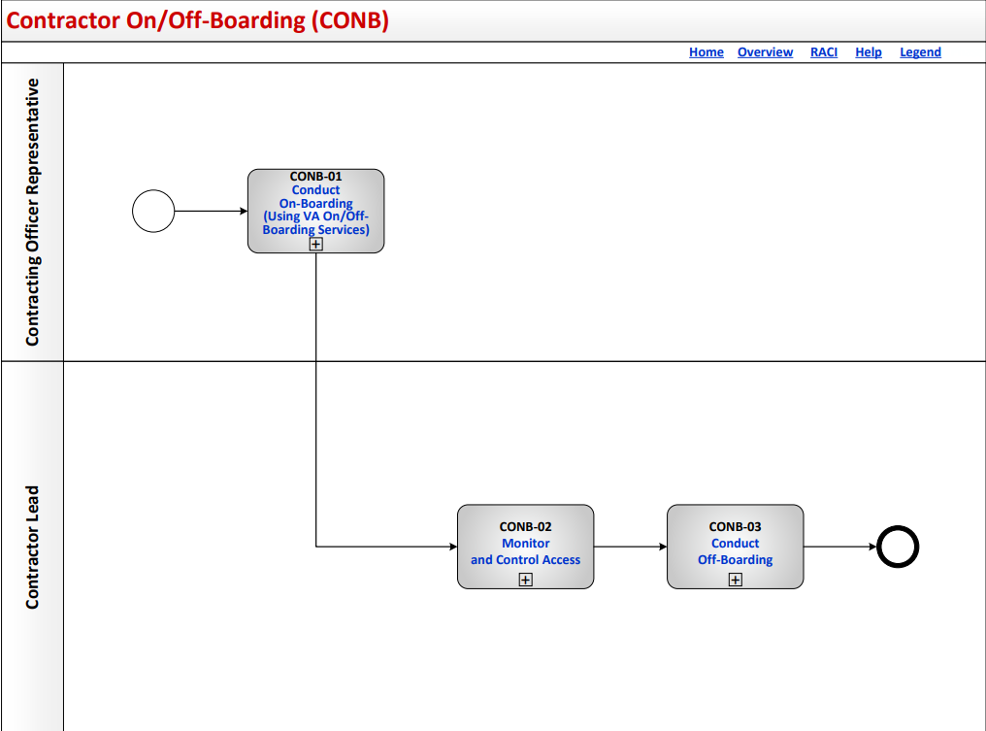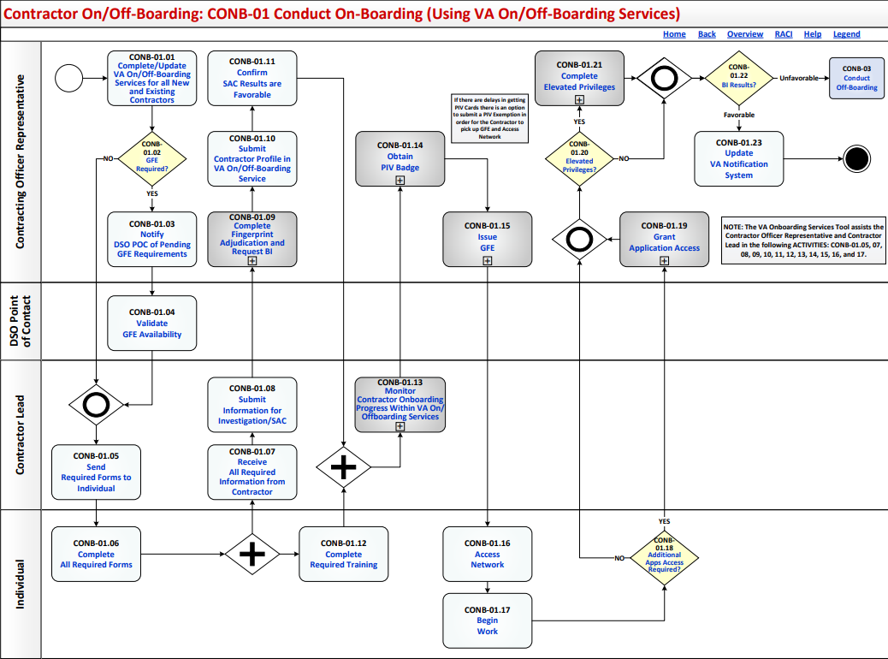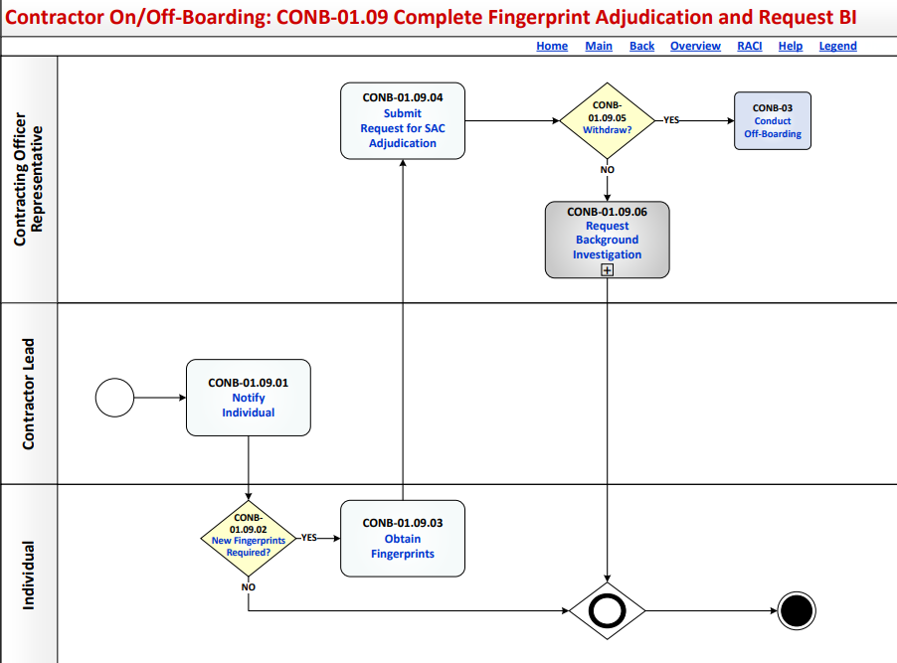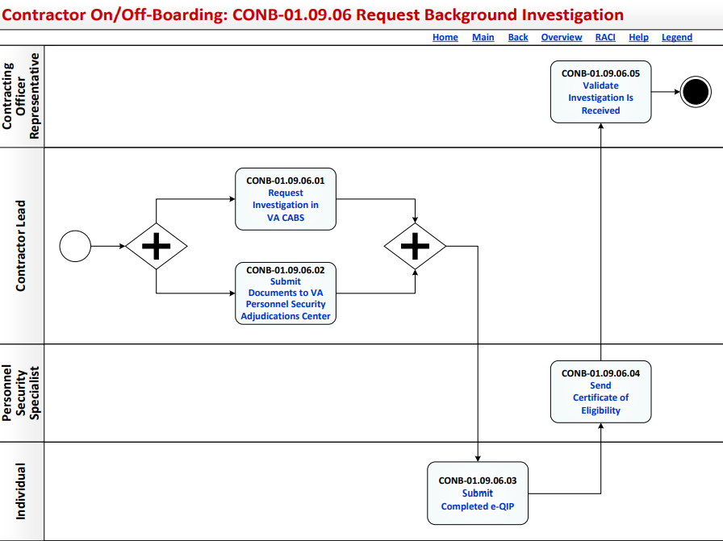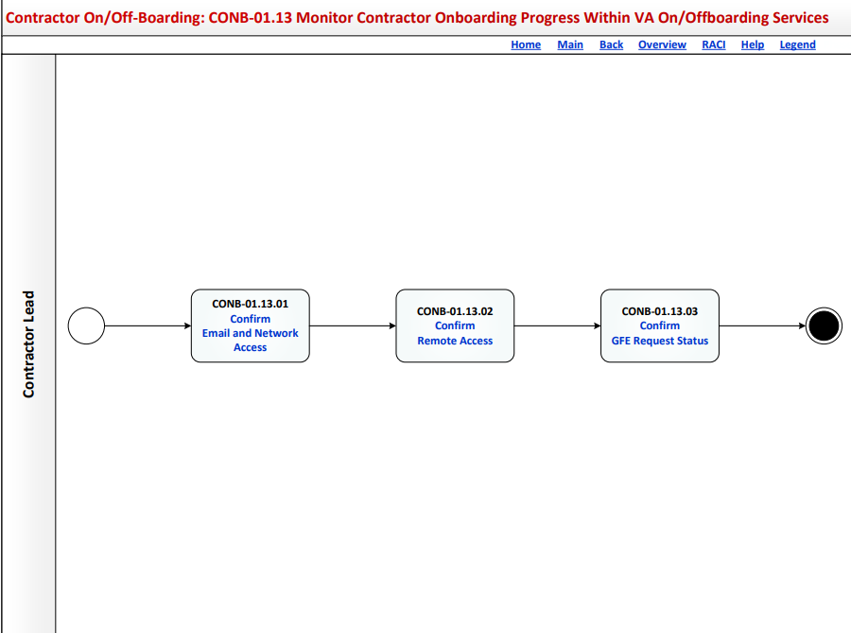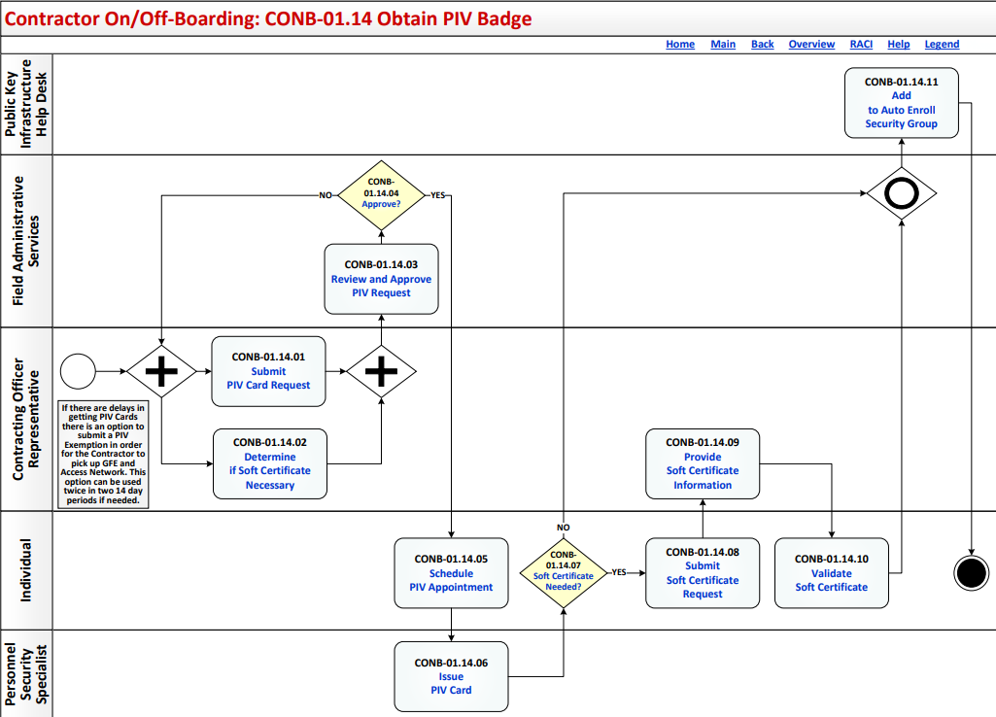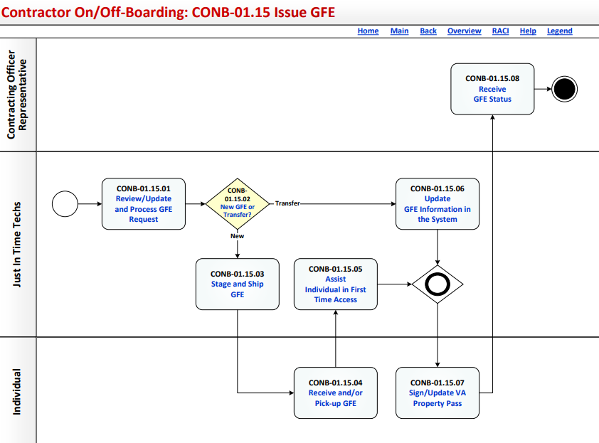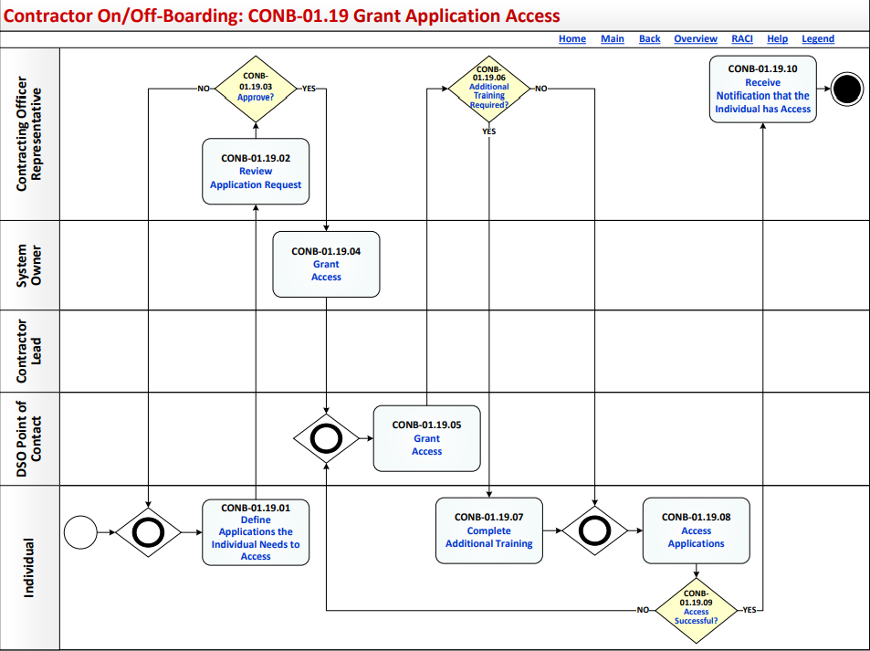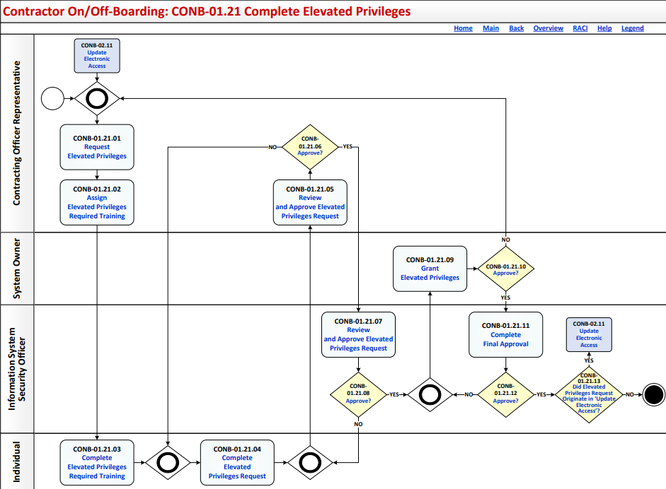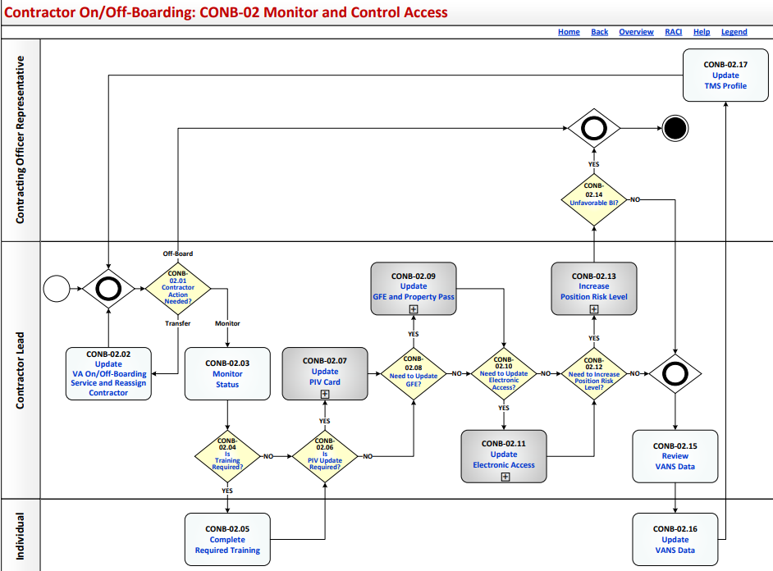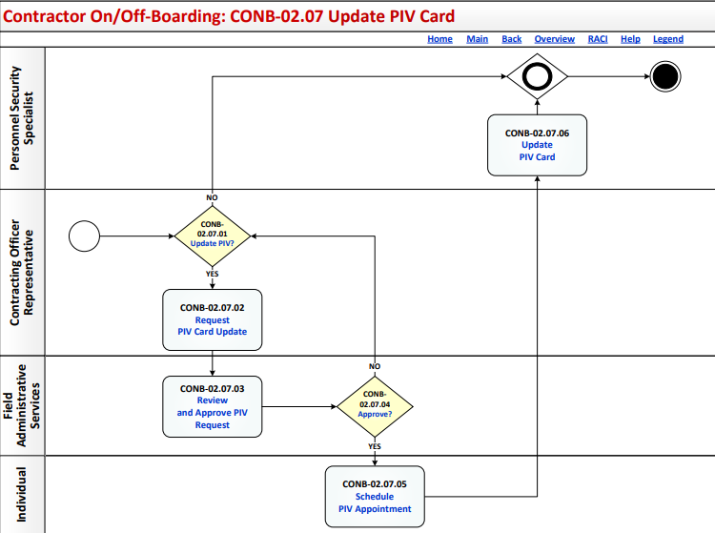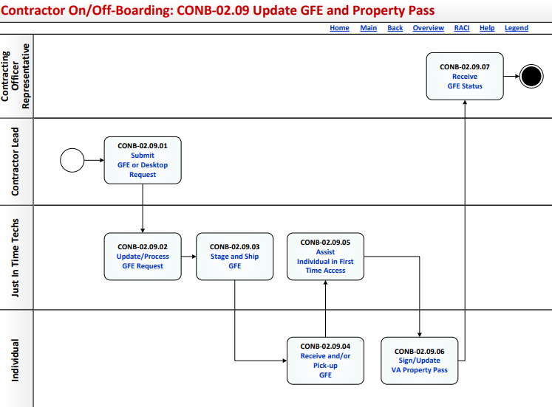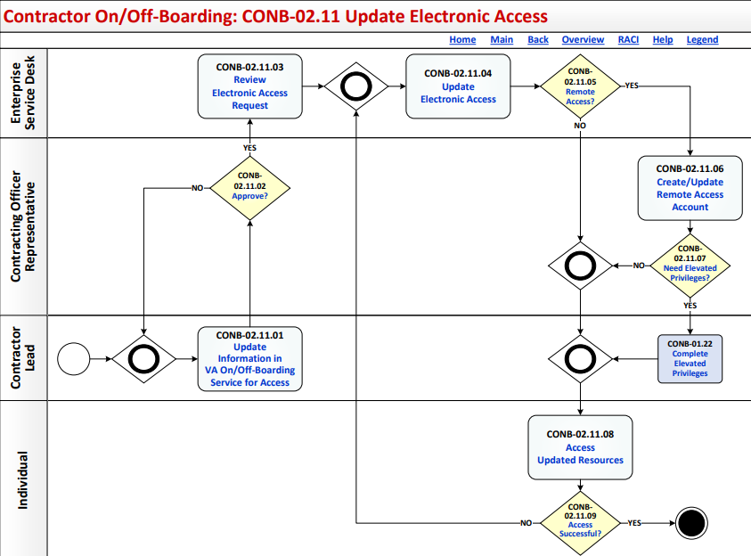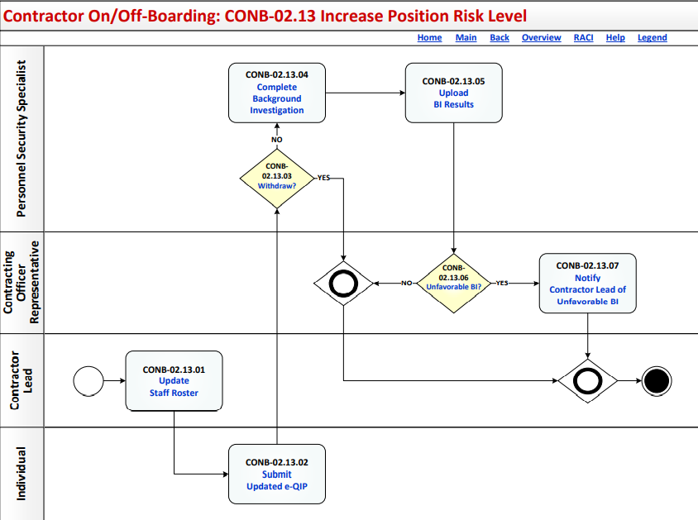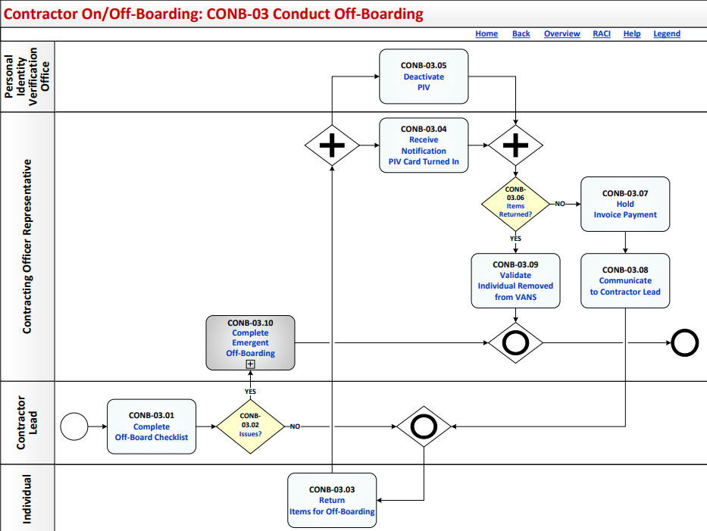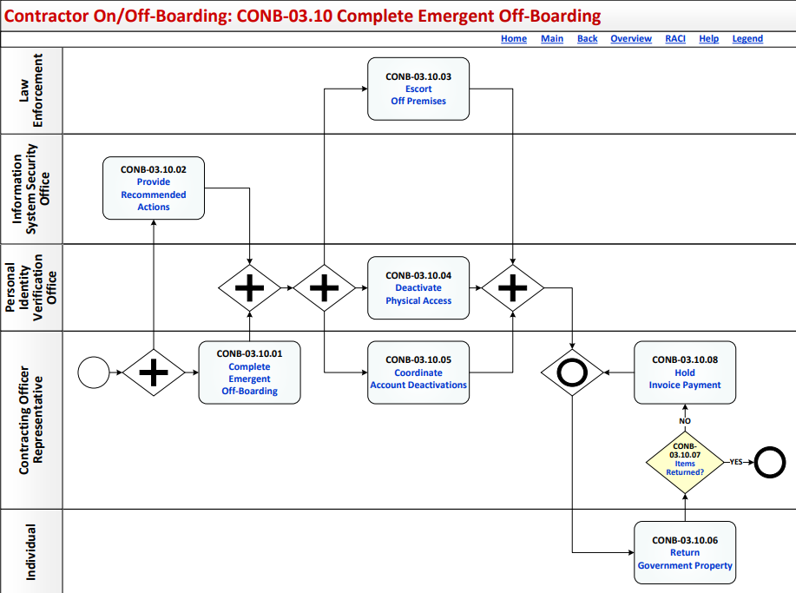

Process: Contractors On/Off-Boarding
Overview: The process map for Contractors On/Off-Boarding cycles through the following process and review activities:
CONB-01 Conduct On-Boarding (Using VA On/Off-Boarding Services)
CONB-01.01 Complete/Update VA On/Off-Boarding Services for all New and Existing Contractors
CONB-01.02 GFE Required?
CONB-01.03 Notify DSO POC of Pending GFE Requirements
CONB-01.04 Validate GFE Availability
CONB-01.05 Send Required Forms to Individual
CONB-01.06 Complete All Required Forms
CONB-01.07 Receive All Required Information from Contractor
CONB-01.08 Submit Information for Investigation/SAC
CONB-01.09 Complete Fingerprint Adjudication and Request BI
CONB-01.09.01 Notify Individual
CONB-01.09.02 New Fingerprints Required?
CONB-01.09.03 Obtain Fingerprints
CONB-01.09.04 Submit Request for SAC Adjudication
CONB-01.09.05 Withdraw?
CONB-01.09.06 Request Background Investigation
CONB-01.09.06.01 Request Investigation in VA CABS
CONB-01.09.06.02 Submit Documents to VA Personnel Security Adjudications Center
CONB-01.09.06.03 Submit Completed e-QIP
CONB-01.09.06.04 Send Certificate of Eligibility
CONB-01.09.06.05 Validate Investigation Is Received
CONB-01.10 Submit Contractor Profile in VA On/Off-Boarding Service
CONB-01.11 Confirm SAC Results Are Favorable
CONB-01.12 Complete Required Training
CONB-01.13 Monitor Contractor Onboarding Progress Within VA On/Offboarding Services
CONB-01.13.01 Confirm Email and Network Access
CONB-01.13.02 Confirm Remote Access
CONB-01.13.03 Confirm GFE Request Status
CONB-01.14 Obtain PIV Badge
CONB-01.14.01 Submit PIV Card Request
CONB-01.14.02 Determine if Soft Certificate Necessary
CONB-01.14.03 Review and Approve PIV Request
CONB-01.14.04 Approve?
CONB-01.14.05 Schedule PIV Appointment
CONB-01.14.06 Issue PIV Card
CONB-01.14.07 Soft Certificate Needed?
CONB-01.14.08 Submit Soft Certificate Request
CONB-01.14.09 Provide Soft Certificate Information
CONB-01.14.10 Validate Soft Certificate
CONB-01.14.11 Add to Auto Enroll Security Group
CONB-01.15 Issue GFE
CONB-01.15.01 Review/Update and Process GFE Request
CONB-01.15.02 New GFE or Transfer?
CONB-01.15.03 Stage and Ship GFE
CONB-01.15.04 Receive and/or Pick-up GFE
CONB-01.15.05 Assist Individual in First Time Access
CONB-01.15.06 Update GFE Information in the System
CONB-01.15.07 Sign/Update VA Property Pass
CONB-01.15.08 Receive GFE Status
CONB-01.16 Access Network
CONB-01.17 Begin Work
CONB-01.18 Additional Apps Access Required?
CONB-01.19 Grant Application Access
CONB-01.19.01 Define Applications the Individual Needs to Access
CONB-01.19.02 Review Application Request
CONB-01.19.03 Approve?
CONB-01.19.04 Grant Access
CONB-01.19.05 Grant Access
CONB-01.19.06 Additional Training Required?
CONB-01.19.07 Complete Additional Training
CONB-01.19.08 Access Applications
CONB-01.19.09 Access Successful?
CONB-01.19.10 Receive Notification that the Individual has Access
CONB-01.20 Elevated Privileges?
CONB-01.21 Complete Elevated Privileges
CONB-01.21.01 Request Elevated Privileges
CONB-01.21.02 Assign Elevated Privileges Required Training
CONB-01.21.03 Complete Elevated Privileges Required Training
CONB-01.21.04 Complete Elevated Privileges Request
CONB-01.21.05 Review and Approve Elevated Privileges Request
CONB-01.21.06 Approve?
CONB-01.21.07 Review and Approve Elevated Privileges Request
CONB-01.21.08 Approve?
CONB-01.21.09 Grant Elevated Privileges
CONB-01.21.10 Approve?
CONB-01.21.11 Complete Final Approval
CONB-01.21.12 Approve?
CONB-01.21.13 Did Elevated Privileges Request Originate in 'Update Electronic Access'?
CONB-01.22 BI Results?
CONB-01.23 Update VA Notification System
CONB-02 Monitor and Control Access
CONB-02.01 Contractor Action Needed?
CONB-02.02 Update VA On/Off-Boarding Service and Reassign Contractor
CONB-02.03 Monitor Status
CONB-02.04 Is Training Required?
CONB-02.05 Complete Required Training
CONB-02.06 Is PIV Update Required?
CONB-02.07 Update PIV Card
CONB-02.07.01 Update PIV?
CONB-02.07.02 Request PIV Card Update
CONB-02.07.03 Review and Approve PIV Request
CONB-02.07.04 Approve?
CONB-02.07.05 Schedule PIV Appointment
CONB-02.07.06 Update PIV Card
CONB-02.08 Need to Update GFE?
CONB-02.09 Update GFE and Property Pass
CONB-02.09.01 Submit GFE or Desktop Request
CONB-02.09.02 Update/Process GFE Request
CONB-02.09.03 Stage and Ship GFE
CONB-02.09.04 Receive and/or Pick-up GFE
CONB-02.09.05 Assist Individual in First Time Access
CONB-02.09.06 Sign/Update VA Property Pass
CONB-02.09.07 Receive GFE Status
CONB-02.10 Need to Update Electronic Access?
CONB-02.11 Update Electronic Access
CONB-02.11.01 Update Information in VA On/Off-Boarding Service for Access
CONB-02.11.02 Approve?
CONB-02.11.03 Review Electronic Access Request
CONB-02.11.04 Update Electronic Access
CONB-02.11.05 Remote Access?
CONB-02.11.06 Create/Update Remote Access Account
CONB-02.11.07 Need Elevated Privileges?
CONB-02.11.08 Access Updated Resources
CONB-02.11.09 Access Successful?
CONB-02.12 Need to Increase Position Risk Level?
CONB-02.13 Increase Position Risk Level
CONB-02.13.01 Update Staff Roster
CONB-02.13.02 Submit Updated e-QIP
CONB-02.13.03 Withdraw?
CONB-02.13.04 Complete Background Investigation
CONB-02.13.05 Upload BI Results
CONB-02.13.06 Unfavorable BI?
CONB-02.13.07 Notify Contractor Lead of Unfavorable BI
CONB-02.14 Unfavorable BI?
CONB-02.15 Review VANS Data
CONB-02.16 Update VANS Data
CONB-02.17 Update TMS Profile
CONB-03 Conduct Off-Boarding
CONB-03.01 Complete Off-Board Checklist
CONB-03.02 Issues?
CONB-03.03 Return Items for Off-Boarding
CONB-03.04 Receive Notification PIV Card Turned In
CONB-03.05 Deactivate PIV
CONB-03.06 Items Returned?
CONB-03.07 Hold Invoice Payment
CONB-03.08 Communicate to Contractor Lead
CONB-03.09 Validate Individual Removed from VANS
CONB-03.10 Complete Emergent Off-Boarding
CONB-03.10.01 Complete Emergent Off-Boarding
CONB-03.10.02 Provide Recommended Actions
CONB-03.10.03 Escort Off Premises
CONB-03.10.04 Deactivate Physical Access
CONB-03.10.05 Coordinate Account Deactivations
CONB-03.10.06 Return Government Property
CONB-03.10.07 Items Returned?
CONB-03.10.08 Hold Invoice Payment

Contractors On/Off-Boarding: Description and Goals

Description
The Contractors On/Off-Boarding (CONB) process describes the activities to obtain access to VA networks, facilities, and equipment by completing background investigations and required training, and obtaining Government Furnished Equipment with appropriate software. After initial on-boarding, the process also establishes the framework for consistently ensuring that all individual contractors have the proper access necessary to perform the role they are assigned and that they continue to meet those minimum requirements necessary to support granting the access. The CONB process complies with the Federal acquisition, security and privacy regulations.

Goals
The goal of the CONB process is to establish the set of activities required to provide, monitor, control, and remove an individual's access to VA systems, equipment, and facilities as appropriate to meet the needs of the VA.
Specific goals include:
- Completing required background investigation including the Special Agreement Check (SAC) for fingerprinting
- Reviewing and accepting VA Rules of Behavior
- Obtaining access to the Talent Management System
- Documenting the required information security and privacy training to access the VA network
- Receiving Government Furnished Equipment with needed software, if required
- Accessing the VA Network and establishing remote VA network access as required
- Obtaining VA identification and access to VA facilities
- Monitoring and verifying successful completion of annual security training requirements
- Monitoring and verifying successful adjudication of SAC, National Agency Check with Inquiries, Minimum Background Investigation, or Background Investigation as appropriate to the role
- Granting or withdrawing access based upon meeting or failing to meet requirements and initiating personnel actions as necessary
- Notifying appropriate management personnel of access changes required based upon clearance adjudications or failure to meet requirements
- Ensuring recovery of identity badges, Personal Identity Verification (PIV) cards, keys and other access granting items are recovered before the individual departs from the VA
- Ensuring access to Public Key Infrastructure (PKI), as applicable
- Ensuring all GFE (desktops, laptops, smart phone, printers, faxes, etc.) and other government property are properly recovered and transferred to the appropriate office in the VA within 24 hours if the individual departs from the VA
- Ensuring clearance through appropriate physical security personnel occurs
- Ensuring all system access privileges and network access are terminated
- Ensuring all appropriate personnel actions are initiated, documented and notifications are made

Contractors On/Off-Boarding: RACI Information
The following describes the RACI information for this process:
CONB-01.01 Complete/Update VA On/Off-Boarding Services for all New and Existing Contractors
Responsible Role: Contracting Officer Representative
Accountable Role: Contractor Lead
Informed Role: Individual
CONB-01.02 GFE Required?
Responsible Role: Contracting Officer Representative
Accountable Role: Contractor Lead
Consulted Role: Individual
CONB-01.03 Notify DSO POC of Pending GFE Requirements
Responsible Role: Contracting Officer Representative
Accountable Role: Contractor Lead
Informed Role: DSO Point of Contact
CONB-01.04 Validate GFE Availability
Responsible Role: DSO Point of Contact
Accountable Role: Principal Deputy Assistant Secretary for Information and Technology
CONB-01.05 Send Required Forms to Individual
Responsible Role: Contractor Lead
Accountable Role: Contracting Officer Representative
Informed Role: Individual
CONB-01.06 Complete All Required Forms
Responsible Role: Individual
Accountable Role: Contractor Lead
Informed Role: Contracting Officer Representative
CONB-01.07 Receive All Required Information from Contractor
Responsible Role: Contractor Lead
Accountable Role: Individual
CONB-01.08 Submit Information for Investigation/SAC
Responsible Role: Contractor Lead
Accountable Role: Contracting Officer Representative
Informed Role: Individual
CONB-01.09.01 Notify Individual
Responsible Role: Contractor Lead
Accountable Role: Contracting Officer Representative
Informed Role: Individual
CONB-01.09.02 New Fingerprints Required?
Responsible Role: Individual
Accountable Role: Contractor Lead
CONB-01.09.03 Obtain Fingerprints
Responsible Role: Individual
Accountable Role: Contracting Officer Representative
Informed Role: Contractor Lead
CONB-01.09.04 Submit Request for SAC Adjudication
Responsible Role: Contracting Officer Representative
Accountable Role: Contractor Lead
CONB-01.09.05 Withdraw?
Responsible Role: Contracting Officer Representative
Accountable Role: Contractor Lead
Informed Role: Individual
CONB-01.09.06.01 Request Investigation in VA CABS
Responsible Role: Contractor Lead
Accountable Role: Security and Investigations Center
CONB-01.09.06.02 Submit Documents to VA Personnel Security Adjudications Center
Responsible Role: Contractor Lead
Accountable Role: Contracting Officer Representative
Consulted Role: Security and Investigations Center
Informed Role: Individual
CONB-01.09.06.03 Submit Completed e-QIP
Responsible Role: Individual
Accountable Role: Contracting Officer Representative
Consulted Role: Personnel Security Specialist
CONB-01.09.06.04 Send Certificate of Eligibility
Responsible Role: Personnel Security Specialist
Accountable Role: Contracting Officer Representative
Consulted Role: VA Security Specialist
Informed Role: Individual
CONB-01.09.06.05 Validate Investigation Is Received
Responsible Role: Contracting Officer Representative Supervisor
Accountable Role: Personnel Security Specialist
Informed Role: Individual
CONB-01.10 Submit Contractor Profile in VA On/Off-Boarding Service
Responsible Role: Contracting Officer Representative
CONB-01.11 Confirm SAC Results Are Favorable
Responsible Role: Contracting Officer Representative
Accountable Role: Contractor Lead
Informed Role: Individual
CONB-01.12 Complete Required Training
Responsible Role: Individual
Accountable Role: Contractor Lead
CONB-01.13.01 Confirm Email and Network Access
Responsible Role: Contractor Lead
Accountable Role: Contracting Officer Representative
Informed Role: IT Specialist
CONB-01.13.02 Confirm Remote Access
Responsible Role: Contractor Lead
Accountable Role: Contracting Officer Representative
Informed Role: Individual; IT Specialist
CONB-01.13.03 Confirm GFE Request Status
Responsible Role: Contractor Lead
Accountable Role: Contracting Officer Representative
Informed Role: Individual; IT Specialist
CONB-01.14.01 Submit PIV Card Request
Responsible Role: Contracting Officer Representative
Accountable Role: Contractor Lead
Consulted Role: Field Administrative Services
Informed Role: Individual
CONB-01.14.02 Determine if Soft Certificate Necessary
Responsible Role: Contracting Officer Representative
Accountable Role: Contractor Lead
Informed Role: Individual
CONB-01.14.03 Review and Approve PIV Request
Responsible Role: Field Administrative Services
Accountable Role: Contracting Officer Representative
Informed Role: Contractor Lead
CONB-01.14.04 Approve?
Responsible Role: Field Administrative Services
Accountable Role: Contracting Officer Representative
CONB-01.14.05 Schedule PIV Appointment
Responsible Role: Individual
Accountable Role: Contracting Officer Representative
CONB-01.14.06 Issue PIV Card
Responsible Role: Personnel Security Specialist
Accountable Role: Individual
CONB-01.14.07 Soft Certificate Needed?
Responsible Role: Individual
Accountable Role: Contracting Officer Representative
CONB-01.14.08 Submit Soft Certificate Request
Responsible Role: Individual
Accountable Role: Contracting Officer Representative
CONB-01.14.09 Provide Soft Certificate Information
Responsible Role: Contracting Officer Representative
Accountable Role: Contractor Lead
Informed Role: Individual
CONB-01.14.10 Validate Soft Certificate
Responsible Role: Individual
Accountable Role: Contracting Officer Representative
CONB-01.14.11 Add to Auto Enroll Security Group
Responsible Role: Public Key Infrastructure (PKI) Help Desk
Accountable Role: Contracting Officer Representative
Informed Role: Individual
CONB-01.15.01 Review/Update and Process GFE Request
Responsible Role: Just in Time Techs
Accountable Role: Contracting Officer Representative
Informed Role: Individual; Contractor Lead
CONB-01.15.02 New GFE or Transfer?
Responsible Role: Just in Time Techs
Accountable Role: Contracting Officer Representative
CONB-01.15.03 Stage and Ship GFE
Responsible Role: Just in Time Techs
Accountable Role: Contracting Officer Representative
Informed Role: Contracting Officer Representative; Contractor Lead; Individual
CONB-01.15.04 Receive and/or Pick-up GFE
Responsible Role: Individual
Accountable Role: Just in Time Techs
Informed Role: Contracting Officer Representative
CONB-01.15.05 Assist Individual in First Time Access
Responsible Role: Just in Time Techs
Accountable Role: Individual
Informed Role: Contractor Lead
CONB-01.15.06 Update GFE Information in the System
Responsible Role: Just in Time Techs
Accountable Role: Contracting Officer Representative
Consulted Role: Individual
Informed Role: Individual
CONB-01.15.07 Sign/Update VA Property Pass
Responsible Role: Individual
Accountable Role: Contracting Officer Representative
CONB-01.15.08 Receive GFE Status
Responsible Role: Contracting Officer Representative
Accountable Role: Contractor Lead
Consulted Role: Individual
CONB-01.16 Access Network
Responsible Role: Individual
Accountable Role: Contractor Lead
Informed Role: Contracting Officer Representative
CONB-01.17 Begin Work
Responsible Role: Individual
Accountable Role: Contracting Officer Representative
Informed Role: Contractor Lead
CONB-01.18 Additional Apps Access Required?
Responsible Role: Individual
Accountable Role: Contracting Officer Representative
CONB-01.19.01 Define Applications the Individual Needs to Access
Responsible Role: Individual
Accountable Role: Contracting Officer Representative Supervisor
Consulted Role: Individual
CONB-01.19.02 Review Application Request
Responsible Role: Contracting Officer Representative
Accountable Role: Contractor Lead
CONB-01.19.03 Approve?
Responsible Role: Contracting Officer Representative
Accountable Role: Contractor Lead
CONB-01.19.04 Grant Access
Responsible Role: System Owner
Accountable Role: Contracting Officer Representative
CONB-01.19.05 Grant Access
Responsible Role: DSO Point of Contact
Accountable Role: System Owner
CONB-01.19.06 Additional Training Required?
Responsible Role: Contracting Officer Representative
Accountable Role: Talent Management System Administrator
CONB-01.19.07 Complete Additional Training
Responsible Role: Individual
Accountable Role: Contracting Officer Representative
CONB-01.19.08 Access Applications
Responsible Role: Individual
Accountable Role: Contracting Officer Representative
Informed Role: Contractor Lead
CONB-01.19.09 Access Successful?
Responsible Role: Individual
Accountable Role: Contracting Officer Representative
Informed Role: Contractor Lead; DSO Point of Contact
CONB-01.19.10 Receive Notification that the Individual has Access
Responsible Role: Contracting Officer Representative
Accountable Role: Individual
Informed Role: Contractor Lead
CONB-01.20 Elevated Privileges?
Responsible Role: Contracting Officer Representative
Accountable Role: Contractor Lead
CONB-01.21.01 Request Elevated Privileges
Responsible Role: Contracting Officer Representative
Accountable Role: Contractor Lead
Consulted Role: DSO Point of Contact; Individual
CONB-01.21.02 Assign Elevated Privileges Required Training
Responsible Role: Contracting Officer Representative
Accountable Role: Contractor Lead
CONB-01.21.03 Complete Elevated Privileges Required Training
Responsible Role: Individual
Accountable Role: Contractor Lead
CONB-01.21.04 Complete Elevated Privileges Request
Responsible Role: Individual
Accountable Role: Contractor Lead
CONB-01.21.05 Review and Approve Elevated Privileges Request
Responsible Role: Contracting Officer Representative
Accountable Role: Individual
CONB-01.21.06 Approve?
Responsible Role: Contracting Officer Representative
Accountable Role: Individual
Informed Role: Contractor Lead
CONB-01.21.07 Review and Approve Elevated Privileges Request
Responsible Role: Information System Security Officer
Accountable Role: Individual
CONB-01.21.08 Approve?
Responsible Role: Information System Security Officer
Accountable Role: Contracting Officer Representative
CONB-01.21.09 Grant Elevated Privileges
Responsible Role: System Owner
Accountable Role: Contracting Officer Representative
CONB-01.21.10 Approve?
Responsible Role: System Owner
Accountable Role: Information System Security Officer
CONB-01.21.11 Complete Final Approval
Responsible Role: Information System Security Officer
Accountable Role: Contracting Officer Representative
CONB-01.21.12 Approve?
Responsible Role: Information System Security Officer
Accountable Role: Contracting Officer Representative
CONB-01.21.13 Did Elevated Privileges Request Originate in 'Update Electronic Access'?
Responsible Role: Information System Security Officer
Accountable Role: Contracting Officer Representative
CONB-01.22 BI Results?
Responsible Role: Contracting Officer Representative
Accountable Role: Contractor Lead
Informed Role: Individual
CONB-01.23 Update VA Notification System
Responsible Role: Contracting Officer Representative
Accountable Role: Contractor Lead
Informed Role: Contracting Officer
CONB-02.01 Contractor Action Needed?
Responsible Role: Contractor Lead
Accountable Role: Contracting Officer Representative
CONB-02.02 Update VA On/Off-Boarding Service and Reassign Contractor
Responsible Role: Contractor Lead
Accountable Role: Contracting Officer Representative
Consulted Role: Individual
CONB-02.03 Monitor Status
Responsible Role: Contractor Lead
Accountable Role: Contracting Officer Representative
CONB-02.04 Is Training Required?
Responsible Role: Contractor Lead
Accountable Role: Contracting Officer Representative
CONB-02.05 Complete Required Training
Responsible Role: Individual
Accountable Role: Contractor Lead
Informed Role: Contracting Officer Representative
CONB-02.06 Is PIV Update Required?
Responsible Role: Contractor Lead
Accountable Role: Contracting Officer Representative
CONB-02.07.01 Update PIV?
Responsible Role: Contracting Officer Representative
Accountable Role: Contractor Lead
CONB-02.07.02 Request PIV Card Update
Responsible Role: Contracting Officer Representative
Accountable Role: Contractor Lead
Informed Role: Field Administrative Services
CONB-02.07.03 Review and Approve PIV Request
Responsible Role: Field Administrative Services
Accountable Role: Contracting Officer Representative
Consulted Role: Contractor Lead
Informed Role: Individual
CONB-02.07.04 Approve?
Responsible Role: Field Administrative Services
Accountable Role: Contracting Officer Representative
CONB-02.07.05 Schedule PIV Appointment
Responsible Role: Individual
Accountable Role: Contractor Lead
Informed Role: Contracting Officer Representative
CONB-02.07.06 Update PIV Card
Responsible Role: Personnel Security Specialist
Accountable Role: Contracting Officer Representative
Informed Role: Contractor Lead; Individual
CONB-02.08 Need to Update GFE?
Responsible Role: Contractor Lead
Accountable Role: Contracting Officer Representative
CONB-02.09.01 Submit GFE or Desktop Request
Responsible Role: Contractor Lead
Accountable Role: Contracting Officer Representative
CONB-02.09.02 Update/Process GFE Request
Responsible Role: Just in Time Techs
Accountable Role: Contractor Lead
Informed Role: Contracting Officer Representative
CONB-02.09.03 Stage and Ship GFE
Responsible Role: Just in Time Techs
Accountable Role: Contractor Lead
Informed Role: Contracting Officer Representative; Individual
CONB-02.09.04 Receive and/or Pick-up GFE
Responsible Role: Individual
Accountable Role: Just in Time Techs
Consulted Role: Contractor Lead; Contracting Officer Representative
CONB-02.09.05 Assist Individual in First Time Access
Responsible Role: Just in Time Techs
Accountable Role: Individual
CONB-02.09.06 Sign/Update VA Property Pass
Responsible Role: Individual
Accountable Role: Contractor Lead
Informed Role: Contracting Officer Representative
CONB-02.09.07 Receive GFE Status
Responsible Role: Contracting Officer Representative
Accountable Role: Contractor Lead
Consulted Role: Individual
CONB-02.10 Need to Update Electronic Access?
Responsible Role: Contractor Lead
Accountable Role: Contracting Officer Representative
CONB-02.11.01 Update Information in VA On/Off-Boarding Service for Access
Responsible Role: Contractor Lead
Accountable Role: Contracting Officer Representative
CONB-02.11.02 Approve?
Responsible Role: Contracting Officer Representative
Accountable Role: Contractor Lead
CONB-02.11.03 Review Electronic Access Request
Responsible Role: Enterprise Service Desk
Accountable Role: Contracting Officer Representative
Informed Role: Contractor Lead
CONB-02.11.04 Update Electronic Access
Responsible Role: Enterprise Service Desk
Accountable Role: Contracting Officer Representative
Informed Role: Contracting Officer Representative; Area Manager
CONB-02.11.05 Remote Access?
Responsible Role: Enterprise Service Desk
Accountable Role: Contractor Lead
CONB-02.11.06 Create/Update Remote Access Account
Responsible Role: Contracting Officer Representative
Accountable Role: Contractor Lead
Informed Role: Contractor Lead; Individual
CONB-02.11.07 Need Elevated Privileges?
Responsible Role: Contracting Officer Representative
Accountable Role: Contractor Lead
CONB-02.11.08 Access Updated Resources
Responsible Role: Individual
Accountable Role: Contractor Lead
CONB-02.11.09 Access Successful?
Responsible Role: Individual
Accountable Role: Contracting Officer Representative
CONB-02.12 Need to Increase Position Risk Level?
Responsible Role: Contractor Lead
Accountable Role: Contracting Officer Representative
CONB-02.13.01 Update Staff Roster
Responsible Role: Contractor Lead
Accountable Role: Contracting Officer Representative
CONB-02.13.02 Submit Updated e-QIP
Responsible Role: Individual
Accountable Role: Contractor Lead
CONB-02.13.03 Withdraw?
Responsible Role: Personnel Security Specialist
Accountable Role: Contracting Officer Representative
CONB-02.13.04 Complete Background Investigation
Responsible Role: Personnel Security Specialist
Accountable Role: Principal Deputy Assistant Secretary for Information and Technology
Consulted Role: VA Security Specialist
Informed Role: Contracting Officer Representative
CONB-02.13.05 Upload BI Results
Responsible Role: Personnel Security Specialist
Accountable Role: Principal Deputy Assistant Secretary for Information and Technology
CONB-02.13.06 Unfavorable BI?
Responsible Role: Contracting Officer Representative
Accountable Role: Contracting Officer Representative
CONB-02.13.07 Notify Contractor Lead of Unfavorable BI
Responsible Role: Contracting Officer Representative
Accountable Role: Principal Deputy Assistant Secretary for Information and Technology
CONB-02.14 Unfavorable BI?
Responsible Role: Contracting Officer Representative
Accountable Role: Contracting Officer Representative
CONB-02.15 Review VANS Data
Responsible Role: Contractor Lead
Accountable Role: Contracting Officer Representative
CONB-02.16 Update VANS Data
Responsible Role: Individual
Accountable Role: Contracting Officer Representative
CONB-02.17 Update TMS Profile
Responsible Role: Contracting Officer Representative
Accountable Role: Contractor Lead
Informed Role: Contracting Officer Representative
CONB-03.01 Complete Off-Board Checklist
Responsible Role: Contractor Lead
Accountable Role: Contracting Officer Representative
CONB-03.02 Issues?
Responsible Role: Contractor Lead
Accountable Role: Contracting Officer Representative
CONB-03.03 Return Items for Off-Boarding
Responsible Role: Individual
Accountable Role: Contractor Lead
CONB-03.04 Receive Notification PIV Card Turned In
Responsible Role: Contracting Officer Representative
Accountable Role: Local Administrative Support
Informed Role: Contractor Lead; Contracting Officer
CONB-03.05 Deactivate PIV
Responsible Role: PIV Office
Accountable Role: Contracting Officer Representative
CONB-03.06 Items Returned?
Responsible Role: Contracting Officer Representative
Accountable Role: Contractor Lead
CONB-03.07 Hold Invoice Payment
Responsible Role: Contracting Officer Representative
Accountable Role: Contractor Lead
Informed Role: Contracting Officer
CONB-03.08 Communicate to Contractor Lead
Responsible Role: Contracting Officer Representative
Accountable Role: Contractor Lead
CONB-03.09 Validate Individual Removed from VANS
Responsible Role: Contracting Officer Representative
Accountable Role: Contractor Lead
CONB-03.10.01 Complete Emergent Off-Boarding
Responsible Role: Contracting Officer Representative
Accountable Role: Principal Deputy Assistant Secretary for Information and Technology; Contractor Lead
CONB-03.10.02 Provide Recommended Actions
Responsible Role: Information System Security Officer
Accountable Role: Contracting Officer Representative
CONB-03.10.03 Escort Off Premises
Responsible Role: Law Enforcement
Accountable Role: Principal Deputy Assistant Secretary for Information and Technology
CONB-03.10.04 Deactivate Physical Access
Responsible Role: PIV Office
Accountable Role: Principal Deputy Assistant Secretary for Information and Technology
Informed Role: Contracting Officer Representative
CONB-03.10.05 Coordinate Account Deactivations
Responsible Role: Contracting Officer Representative
Accountable Role: Contractor Lead
Consulted Role: Just in Time Techs
CONB-03.10.06 Return Government Property
Responsible Role: Individual
Accountable Role: Contractor Lead
CONB-03.10.07 Items Returned?
Responsible Role: Contracting Officer Representative
Accountable Role: Principal Deputy Assistant Secretary for Information and Technology
CONB-03.10.08 Hold Invoice Payment
Responsible Role: Contracting Officer Representative
Accountable Role: Principal Deputy Assistant Secretary for Information and Technology

Contractors On/Off-Boarding: Associated Artifacts Information
Associated Artifacts information (including hyperlinks) for this process include:
Acquisition Requirements Package
Applicant Contractor On-boarding Checklist
Contract Employee: Background Investigation Request Worksheet Template
Contractor Staff Roster Template
GFE Space Form Template
OPM Form OF306-Declaration for Federal Employment Template
OPM INV-70B Request for PIPS-CVS User ID-Access Template
Performance Work Statement
PIV Applicant Information for Employees and Contractors
PIV Office Fingerprint Request Form
Self-Certification of Continuous Service Template
SF-85 Questionnaire for Non-Sensitive Position
Soft Certificate [Public Key Infrastructure (PKI)] Enrollment Form
Special Agreement Check Request Form
VA Form 0710- Authorization for a Release of Information Template
VA Form 0752-Confidentiality of Sensitive Information Non-Disclosure Agreement Template
VA Form 0887-VA Government Property Loan Form Template
VA Form 0923-Serious Incident Report Template
VA Form 3248-Employees Clearance from Indebtedness Template
VA Form 4236-Certificate of Eligibility Template
VA Handbook 6500.6 - Appendix A - Checklist for Information Security in the Initiation Phase of Acquisitions

Contractors On/Off-Boarding: Tools and Web Sites Information
The Tools and Web Sites associated with this process (including hyperlinks) include:
Access VA
Budget Tracking Tool (BTT)
Citrix Access Gateway
Electronic Questionnaires for Investigations Processing (e-QIP)
Form I-9, Employment Eligibility Verification
Invoice Payment Processing System
ISSO Locator List
ISSO Virtual Private Network Portal
IT Service Management
MyVA Elevated Privileges
OIT ITOPS SMP Facility and Travel Administration Home Page
Personal Identity Verification Database
Personnel Investigations Processing System (PIPS)
Physical Access Control System
PIV Appointment Scheduling Tool
PIV Badge Offices
PIV Credential Identity Verification Matrix
Position Designation Automated Tool (PDAT)
Remote Access Portal
Rescue AnyConnect Virtual Private Network
Service Desk Ticketing System
Talent Management System Self Enrollment Portal
The VA On/Offboarding Service Portal
VA Enterprise Architecture Repository
VA Enterprise PKI Information and Enrollment Portal
VA Forms Library
VA HSPD-12 Program, How to Get a VA ID Badge
VA Notification System
VA Office of Identity, Credential, and Access Management
VA On/Offboarding Service
VA PIV Enrollment Portal
VA Remote Access Information
VA Talent Management System (TMS)
VA-Personnel Security Adjudication Center Resource Site
yourIT Service Portal

Contractors On/Off-Boarding: Standards Information
Standards associated with this process (including hyperlinks) include:
Code of Federal Regulations, Part 731 - Suitability (Title 5, CFR 731)
eCOR File End User Guide
Executive Order 13467, Reforming Processes Related to Suitability for Government Employment, Fitness for Contractor Employees, and Eligibility for Access to Classified National Security Information
Executive Order 13488, Granting Reciprocity on Excepted Service and Federal Contractor Employee Fitness and Reinvestigating Individuals in Positions of Public Trust
Federal Information Processing Standards Publications (FIPS) 140-2, Security Requirements for Cryptographic Modules
Federal Information Processing Standards Publications (FIPS) 201-2, Personal Identity Verification (PIV) of Federal Employees and Contractors
Framework for Improving Critical Infrastructure Cybersecurity
How to Get a VA ID Card
HSPD-12 Communication - New Identity Source Document Guidelines
Information Access and Privacy Program
IT Operations and Services (ITOPS) Automated Service Catalog (SVC) User Guide Approver Edition
Job Aid: Assign Learning via Assignment Profiles
Mandatory Use of PIV Multifactor Authentication for Users with Elevated Privileges (VAIQ 7613597)
Mandatory Use of PIV Multifactor Authentication to VA Information System (VAIQ 7613595)
Office of Information and Technology Space Standards (VAIQ 7282835)
Personal Identity Verification (PIV) Logical Access Policy Clarification (VIEWS 00155984)
Personal Identity Verification (PIV) Responsibilities and Deadlines for OIT Offices (VAIQ 7103588)
PIV Credential Identity Verification Matrix
Resource Decision Matrix
Special Agreement Checks Requirements
Suitability Processing Handbook
VA Card Types and Requirements
VA Directive 0320, Comprehensive Emergency Management Homeland Security Program
VA Directive 0321, Serious Incident Reports
VA Directive 0710, Personnel Security and Suitability Program
VA Directive 0735, Homeland Security Presidential Directive 12 (HSPD-12) Program
VA Directive 6500, VA Cybersecurity Program
VA Handbook 0710, Personnel Security and Suitability Program
VA Handbook 0730/4, Security and Law Enforcement
VA Handbook 6500, Risk Management Framework for VA Information Systems: VA Information Security Program
VA Handbook 6500.6, Contract Security
VA Handbook 7002, Logistics Management Procedures
VA Public Key Infrastructure (PKI) Program Setting up E-mail Outlook 2003
VA Public Key Infrastructure (PKI) Program Setting up E-mail Outlook 2007
VA Public Key Infrastructure (PKI) Program Setting up E-mail Outlook 2010
VA Public Key Infrastructure (PKI) Program, Completing PKI Paperwork Instructional Document
VAPERSEC 17-02 Personal Identity Verification (PIV) Card Issuance
VAPERSEC 18-01 Special Agreement Checks Requirements

Contractors On/Off-Boarding: Acronyms
Acronyms associated with this process include:
ARP : Acquisition Requirements Package
BI : Background Investigation
COI : Certificate of Investigation
COR : Contracting Officer Representative
CRISP : Continuous Readiness in Information Security Program
EDR : Education Data Repository
EP : Elevated Privileges
e-QIP : Electronic Questionnaires for Investigations Processing
FAS : Field Administrative Services
FIPS : Federal Information Processing Standards
GAL : Global Address List
GFE : Government Furnished Equipment
HSPD : Homeland Security Presidential Directive
ITOPS : IT Operations and Services / IT Operations Platform
JIT : Just In Time
OF 306 : Optional Form (OF) 306, Declaration for Federal Employment
OPM : Office of Personnel Management
PDT; PDAT : Position Designation Automated Tool
PIPS/CVS : Personnel Investigations Processing System/Clearance Verification System
PIV : Personal Identity Verification
PKI : Public Key Infrastructure
RACI : Responsible Accountable Consulted Informed
SAC : Special Agreement Check
SIC : Security Investigation Center
SOP : Standard Operating Procedure
TMS : Talent Management System
USCIS : United States Citizenship and Immigration Services
VAIQ : Veterans Affairs Intranet Quorum
VASI : VA Systems Inventory

Contractors On/Off-Boarding Process

Activity Name: CONB-01 Conduct On-Boarding (Using VA On/Off-Boarding Services)
Previous Activities
Process Begins
Next Activities
CONB-01.01 Complete/Update VA On/Off-Boarding Services for all New and Existing Contractors
Description
The sub-process map for Conduct On-Boarding (Using VA On/Off-Boarding Services) cycles through the following dependent activities:
- Complete/Update VA On/Off-Boarding Services for all New and Existing Contractors
- GFE Required?
- Notify DSO POC of Pending GFE Requirements
- Validate GFE Availability
- Send Required Forms to Individual
- Complete All Required Forms
- Receive All Required Information from Contractor
- Submit Information for Investigation/SAC
- Compete Fingerprint Adjudication and Request BI
- Submit Contractor Profile in VA On/Off-Boarding Service
- Confirm SAC Results are Favorable
- Complete Required Training
- Monitor Contractor Onboarding Progress Within VA On/Off-Boarding Services
- Obtain PIV Badge
- Issue GFE
- Access Network
- Begin Work
- Additional Apps Access Required?
- Grant Application Access
- Elevated Privileges?
- Complete Elevated Privileges
- BI Results?
- Update VA Notification System
Responsible Role
Contracting Officer Representative
Accountable Role
Contracting Officer Representative

Activity Name: CONB-01.01 Complete/Update VA On/Off-Boarding Services for all New and Existing Contractors
Previous Activities
CONB-01 Conduct On-Boarding (Using VA On/Off-Boarding Services)
Next Activities
CONB-01.02 GFE Required?
Description
The Contracting Officer Representative (COR) updates information for the Contractor in the VA On/Offboarding Service tool. The VA On/Offboarding Service will provide information to the COR for the documentation needed from the Contractor. The COR assigns the Contractor Lead to work with the Contractor to complete all required information.
The Contracting Officer Representative (COR) updates the VA On/Offboarding Service Tool with key information about the Contractor. If this is a new Contractor, the COR will need to fill out all information about the Contractor require in the tool. If this is an existing Contractor the COR will update their information with the new contract.
The COR, using the VA On/Offboarding Service tool is able to identify key requirements for the Contractor to include GFE, Space, Access, and Security requirements.
The COR completes, signs and obtains required signatures for the Checklist for Information Security in the Initiation Phase of Acquisitions within Appendix A of VA Handbook 6500.6, Contract Security Tailoring and completing Appendix C of VA Handbook 6500.6, Contract Security.
Input
Acquisition Requirements Package
Performance Work Statement
VA Handbook 6500.6 - Appendix A - Checklist for Information Security in the Initiation Phase of Acquisitions
Output
Applicant Contractor On-boarding Checklist
VA On/Offboarding Service Updates
Associated Artifacts
Applicant Contractor On-boarding Checklist
Acquisition Requirements Package
Performance Work Statement
VA Handbook 6500.6 - Appendix A - Checklist for Information Security in the Initiation Phase of Acquisitions
Responsible Role
Contracting Officer Representative
Accountable Role
Contractor Lead
Informed Role
Individual
Tools and Websites
VA On/Offboarding Service
VA Office of Identity, Credential, and Access Management
The VA On/Offboarding Service Portal

Activity Name: CONB-01.02 GFE Required?
Previous Activities
CONB-01.01 Complete/Update VA On/Off-Boarding Services for all New and Existing Contractors
Next Activities
If 'YES':
CONB-01.03 Notify DSO POC of Pending GFE Requirements
Or
If 'NO':
CONB-01.05 Send Required Forms to Individual
Description
The Contracting Officer Representative reviews the information from the Statement of Work to see if Government Furnished Equipment (GFE) is required for the Contractor(s) (YES) or not (NO).
Responsible Role
Contracting Officer Representative
Accountable Role
Contractor Lead
Consulted Role
Individual

Activity Name: CONB-01.03 Notify DSO POC of Pending GFE Requirements
Previous Activities
CONB-01.02 GFE Required?
Next Activities
CONB-01.04 Validate GFE Availability
Description
The Contracting Officer Representative (COR) determines whether Government Furnished Equipment (GFE) is needed. Upon the COR determining GFE is needed, the COR notifies the Development, Security and Operations (DSO) Point of Contact at least 30 days prior to when the GFE is needed.
Input
Acquisition Requirements Package (Awarded Contract)
GFE /GFS Memo
Output
Updated GFE/GFS Memo
Notification to IT Operations and Services on Government Furnished Equipment
Associated Artifacts
GFE Space Form Template
Responsible Role
Contracting Officer Representative
Accountable Role
Contractor Lead
Informed Role
DSO Point of Contact
Tools and Websites
yourIT Service Portal
Budget Tracking Tool (BTT)
More Info
Requirements for GFE are ideally identified early in the acquisition life cycle and appropriate forms emailed to “VA IT FO GFE SUPPORT FOR IT FUNDED CONTRACTOR” GFE requirements must be identified in Performance Work Statements (PWS) and contract award documentation. The Budget Tracking Tool (BTT) Acquisition Review Module (ARM) streamlines the acquisition process by combining acquisition, budget, and the technical review process for all IT-related requirements.

Activity Name: CONB-01.04 Validate GFE Availability
Previous Activities
CONB-01.03 Notify DSO POC of Pending GFE Requirements
Next Activities
CONB-01.05 Send Required Forms to Individual
Description
The IT Operations and Services (ITOPS) Point of Contact receives the Government Furnished Equipment (GFE) notification from the Contracting Officer's Representative and validates Government Furnished Equipment (GFE) availability.
Input
Notification to IT Operations and Services on Government Furnished Equipment
Output
Updated Inventory
Responsible Role
DSO Point of Contact
Accountable Role
Principal Deputy Assistant Secretary for Information and Technology

Activity Name: CONB-01.05 Send Required Forms to Individual
Previous Activities
CONB-01.02 GFE Required?
Or
CONB-01.04 Validate GFE Availability
Next Activities
CONB-01.06 Complete All Required Forms
Description
The Contractor Lead sends information to the Contractor to complete for onboarding. The information required to start will be, Office of Personnel Management Form OF306, Declaration for Federal Employment, Self-Certification of Continuous Service (if applicable), SF-85 Questionnaire for Non-Sensitive Position (if applicable), Special Agreement Check Fingerprint Verification Worksheet Form, and other documents as required by the contract.
Input
Acquisition Requirements Package (Awarded Contract)
Announcement of Contract Award (E-mail)
Applicant Contractor On-boarding Checklist
Contracting Officer's Representative Designation Letter
Continuous Readiness in Information Security Program (CRISP) Screening Checklist
Output
Contract Employee: Background Investigation Request Worksheet
Contractor Staff Roster
Office of Personnel Management Form OF306, Declaration for Federal Employment
Self-Certification of Continuous Service (if applicable)
SF-85 Questionnaire for Non-Sensitive Position (if applicable)
Special Agreement Check Fingerprint Verification Worksheet Form
Updated Applicant Contractor On-boarding Checklist
Updated CRISP Screening Checklist
Associated Artifacts
Contract Employee: Background Investigation Request Worksheet Template
Contractor Staff Roster Template
OPM Form OF306-Declaration for Federal Employment Template
Self-Certification of Continuous Service Template
PIV Office Fingerprint Request Form
Applicant Contractor On-boarding Checklist
SF-85 Questionnaire for Non-Sensitive Position
Responsible Role
Contractor Lead
Accountable Role
Contracting Officer Representative
Informed Role
Individual
Tools and Websites
VA Talent Management System (TMS)
VA Forms Library
VA-Personnel Security Adjudication Center Resource Site

Activity Name: CONB-01.06 Complete All Required Forms
Previous Activities
CONB-01.05 Send Required Forms to Individual
Next Activities
CONB-01.07 Receive All Required Information from Contractor
And
CONB-01.12 Complete Required Training
Description
The Individual completes all information requested by the Contractor Lead and sends back all required information no later than day two of onboarding for submittal to the Contracting Officer Representative.
Input
Contract Employee: Background Investigation Request Worksheet
Contractor Staff Roster
Continuous Readiness in Information Security Program (CRISP) Screening Checklist
Office of Personnel Management (OPM) Form OF306, Declaration for Federal Employment
Security Information Center (SIC) Fingerprint Verification Worksheet Form
Self-Certification of Continuous Service (if applicable)
Output
Submitted Contract Employee: Background Investigation Request Worksheet
Submitted OPM Form OF306, Declaration for Federal Employment
Submitted SIC Fingerprint Verification Form
Submitted Self-Certification of Continuous Service (if applicable)
Worksheet Form
Updated Contractor Staff Roster
Updated CRISP Screening Checklist
Associated Artifacts
Contract Employee: Background Investigation Request Worksheet Template
Self-Certification of Continuous Service Template
PIV Office Fingerprint Request Form
Responsible Role
Individual
Accountable Role
Contractor Lead
Informed Role
Contracting Officer Representative
Tools and Websites
VA-Personnel Security Adjudication Center Resource Site
VA Talent Management System (TMS)
Talent Management System Self Enrollment Portal

Activity Name: CONB-01.07 Receive All Required Information from Contractor
Concurrent Activities
CONB-01.12 Complete Required Training
Previous Activities
CONB-01.06 Complete All Required Forms
Next Activities
CONB-01.08 Submit Information for Investigation/SAC
Description
The Contractor completes and submits all forms requested by the Contractor Lead within two days for submittal to the Contractor Lead and/or the Contracting Officer Representative.
Input
Contract Employee: Background Investigation Request Worksheet
Contractor Staff Roster
Continuous Readiness in Information Security Program (CRISP) Screening Checklist
Office of Personnel Management (OPM) Form OF306, Declaration for Federal Employment
Security Information Center (SIC) Fingerprint Verification Worksheet Form
Self-Certification of Continuous Service (if applicable)
Output
Submitted Contract Employee: Background Investigation Request Worksheet
Submitted OPM Form OF306, Declaration for Federal Employment
Submitted SIC Fingerprint Verification Form
Submitted Self-Certification of Continuous Service (if applicable)
Worksheet Form
Updated Contractor Staff Roster
Updated CRISP Screening Checklist
Responsible Role
Contractor Lead
Accountable Role
Individual
Tools and Websites
VA-Personnel Security Adjudication Center Resource Site

Activity Name: CONB-01.08 Submit Information for Investigation/SAC
Previous Activities
CONB-01.07 Receive All Required Information from Contractor
Next Activities
CONB-01.09 Complete Fingerprint Adjudication and Request BI
Description
The Contractor Lead submits all onboarding information to the Contracting Officer Representative for Investigation/Special Agreement Check (SAC) as required.
The Contractor may also need to submit fingerprints for the Special Agreement Check, PIV Badge and/or for the Background Investigation.
The Contractor, working with the Contract Lead, determines if new fingerprints are required, (YES) or not, (NO). If new fingerprints are required the Contractor Lead works with the Individual to make an appointment with a VA facility to have electronic fingerprints taken (if appointments are required). Otherwise, the individual requests information from the Contracting Officer Representative (COR) or their designee, to obtain fingerprints on a walk-in basis. Only electronic fingerprints are accepted by the VA, except for exceptional situations.
Input
Contract Employee: Background Investigation Request Worksheet
Contractor Staff Roster
Continuous Readiness in Information Security Program (CRISP) Screening Checklist
Office of Personnel Management (OPM) Form OF306, Declaration for Federal Employment
Security Information Center (SIC) Fingerprint Verification Worksheet Form
Self-Certification of Continuous Service (if applicable)
List of Locations to Obtain Cards (and Fingerprints)
Notification to Contract Lead Regarding Completion of Special Agreement Check (SAC) Fingerprint Verification Form
SAC Fingerprint Verification Form
Output
Submitted Contract Employee: Background Investigation Request Worksheet
Submitted OPM Form OF306, Declaration for Federal Employment
Submitted SIC Fingerprint Verification Form
Submitted Self-Certification of Continuous Service (if applicable)
Worksheet Form
Updated Contractor Staff Roster
Updated CRISP Screening Checklist
Notification to Complete Fingerprinting (E-Mail)
Associated Artifacts
Contract Employee: Background Investigation Request Worksheet Template
Contractor Staff Roster Template
Self-Certification of Continuous Service Template
PIV Office Fingerprint Request Form
OPM Form OF306-Declaration for Federal Employment Template
Responsible Role
Contractor Lead
Accountable Role
Contracting Officer Representative
Informed Role
Individual
Tools and Websites
VA-Personnel Security Adjudication Center Resource Site
VA Talent Management System (TMS)
Talent Management System Self Enrollment Portal
VA Forms Library
More Info
The list of locations to obtain cards and fingerprints is located on the VA HSPD-12 Program web site. Some VA facilities require authorization from the COR before a fingerprint appointment is granted. Fingerprints are sent electronically from VA to Office of Personnel Management (OPM) to the Federal Bureau of Investigation where the fingerprints are run against several databases. The results are then sent electronically back to VA and stored in folders according to the Security Office Identifier.

Activity Name: CONB-01.09 Complete Fingerprint Adjudication and Request BI
Previous Activities
CONB-01.08 Submit Information for Investigation/SAC
Next Activities
CONB-01.09.01 Notify Individual
Description
The sub-process for Complete Fingerprint Adjudication cycles through the following dependent activities and decisions:
- Notify Individual
- New Fingerprints Required?
- Obtain Fingerprints
- Submit Request for SAC Adjudication
- Withdraw?
- Request Background Investigation
Responsible Role
Contracting Officer Representative

Activity Name: CONB-01.09.01 Notify Individual
Previous Activities
CONB-01.09 Complete Fingerprint Adjudication and Request BI
Next Activities
CONB-01.09.02 New Fingerprints Required?
Description
The Contractor Lead notifies the Individual to move forward with fingerprinting if required. Existing contractors may not be required to obtain new fingerprints.
Input
Contractor Staff Roster
List of Locations to Obtain Cards (and Fingerprints)
Notification to Contract Lead Regarding Completion of Special Agreement Check (SAC) Fingerprint Verification Form
SAC Fingerprint Verification Form
Output
Forwarded CRISP Screening Checklist
Forwarded List of Locations to Obtain Cards (and Fingerprints)
Forwarded SAC Fingerprint Verification Form
Notification to Complete Fingerprinting (E-mail)
Associated Artifacts
PIV Office Fingerprint Request Form
Responsible Role
Contractor Lead
Accountable Role
Contracting Officer Representative
Informed Role
Individual
Tools and Websites
PIV Badge Offices
VA-Personnel Security Adjudication Center Resource Site
More Info
The list of locations to obtain cards and fingerprints is located on the VA HSPD-12 Program web site. Some VA facilities require authorization from the COR before a fingerprint appointment is granted. The preferred method to send the forwarded SAC Fingerprint Verification Form is by encrypted e-mail. If unable to send encrypted e-mail, reply with another method which complies with FIPS 140-2 compliant methods such as secure fax or using a traceable mail service.

Activity Name: CONB-01.09.02 New Fingerprints Required?
Previous Activities
CONB-01.09.01 Notify Individual
Next Activities
If 'YES':
CONB-01.09.03 Obtain Fingerprints
Or
If 'NO':
CONB-01.10 Submit Contractor Profile in VA On/Off-Boarding Service
Description
The Individual, working with the Contractor Lead, determines if new fingerprints are required, (YES) or not, (NO).
Responsible Role
Individual
Accountable Role
Contractor Lead

Activity Name: CONB-01.09.03 Obtain Fingerprints
Previous Activities
CONB-01.09.02 New Fingerprints Required?
Next Activities
CONB-01.09.04 Submit Request for SAC Adjudication
Description
Upon receipt of the Notification to Complete Fingerprinting (E-mail) the Individual makes an appointment with a VA facility to have electronic fingerprints taken (if appointments are required). Otherwise, the individual requests information from the Contracting Officer Representative (COR) or their designee, to obtain fingerprints on a walk-in basis. Only electronic fingerprints are accepted by the VA, except for exceptional situations.
Input
List of Locations to Obtain Cards (and Fingerprints)
Notification to Complete Fingerprinting (E-mail)
Output
Security and Investigations Center Contractor/Employee Fingerprinting Request Form
Associated Artifacts
OPM INV-70B Request for PIPS-CVS User ID-Access Template
PIV Office Fingerprint Request Form
Responsible Role
Individual
Accountable Role
Contracting Officer Representative
Informed Role
Contractor Lead
Tools and Websites
Personnel Investigations Processing System (PIPS)
PIV Badge Offices
More Info
The list of locations to obtain cards and fingerprints is located on the VA HSPD-12 Program web site. Some VA facilities require authorization from the COR before a fingerprint appointment is granted. Fingerprints are sent electronically from VA to Office of Personnel Management (OPM) to the Federal Bureau of Investigation where the fingerprints are run against several databases. The results are then sent electronically back to VA and stored in folders according to the Security Office Identifier. Personnel Investigation Processing System (PIPS) is a secured site. Access to the site will require the user to first obtain access to the OPM. Once access is granted to the OPM site, the user will then need to request access to PIPS using form INV-70B.

Activity Name: CONB-01.09.04 Submit Request for SAC Adjudication
Previous Activities
CONB-01.09.03 Obtain Fingerprints
Next Activities
CONB-01.09.05 Withdraw?
Description
The Contracting Officer Representative, or designee, submits the request for Special Agreement Check (SAC) Adjudication to the VA Security Specialist to receive notification once fingerprints are adjudicated.
Input
SAC Request Form
Output
Updated SAC Request Form
Associated Artifacts
Special Agreement Check Request Form
Responsible Role
Contracting Officer Representative
Accountable Role
Contractor Lead
Tools and Websites
VA-Personnel Security Adjudication Center Resource Site

Activity Name: CONB-01.09.05 Withdraw?
Previous Activities
CONB-01.09.04 Submit Request for SAC Adjudication
Next Activities
If 'YES':
CONB-03 Conduct Off-Boarding
Or
If 'NO':
CONB-01.09.06 Request Background Investigation
Description
The Contracting Officer Representative makes a determination if the issues identified in the SIC would require the individual to withdraw from the onboarding process (YES) or continue (NO).
Responsible Role
Contracting Officer Representative
Accountable Role
Contractor Lead
Informed Role
Individual

Activity Name: CONB-01.09.06 Request Background Investigation
Previous Activities
CONB-01.09.05 Withdraw?
Next Activities
CONB-01.09.06.01 Request Investigation in VA CABS
And
CONB-01.09.06.02 Submit Documents to VA Personnel Security Adjudications Center
Description
The sub-process Request Background Investigation cycles through the following dependent activities:
- Request Investigation in VA CABS
- Submit Documents to VA Personnel Security Adjudications Center
- Submit Completed e-QIP
- Send Certificate of Eligibility
- Validate Investigation Is Received
Responsible Role
Contractor Lead
Accountable Role
Contracting Officer Representative

Activity Name: CONB-01.09.06.01 Request Investigation in VA CABS
Concurrent Activities
CONB-01.09.06.02 Submit Documents to VA Personnel Security Adjudications Center
Previous Activities
CONB-01.09.06 Request Background Investigation
Next Activities
CONB-01.09.06.03 Submit Completed e-QIP
Description
The Contract Lead follows the guidance to submit a background investigation through VA CABS for the Individual.
Input
Contract Employee: Background Investigation Request Worksheet
Contractor Staff Roster
Office of Personnel Management (OPM) Form OF306, Declaration for Federal Employment
Special Agreement Check Fingerprint Verification Form
VA Form 0710, Authorization for a Release of Information (for moderate and high risk investigations only)
Output
Updated Contract Employee: Background Investigation Request Worksheet
Updated Contractor Staff Roster
Updated CRISP Screening Checklist
The Background Investigation scheduled date will be displayed in the VA On/Offboarding Service
Associated Artifacts
Contract Employee: Background Investigation Request Worksheet Template
Self-Certification of Continuous Service Template
VA Form 0710- Authorization for a Release of Information Template
OPM Form OF306-Declaration for Federal Employment Template
Contractor Staff Roster Template
Responsible Role
Contractor Lead
Accountable Role
Security and Investigations Center
Tools and Websites
VA-Personnel Security Adjudication Center Resource Site
VA On/Offboarding Service
More Info
See the Security and Investigations Center Resource Site page for Contract Officers and COR's for more guidance.

Activity Name: CONB-01.09.06.02 Submit Documents to VA Personnel Security Adjudications Center
Concurrent Activities
CONB-01.09.06.01 Request Investigation in VA CABS
Previous Activities
CONB-01.09.06 Request Background Investigation
Next Activities
CONB-01.09.06.03 Submit Completed e-QIP
Description
The Contractor Lead, or Contracting Officer Representative, submits the required documents by uploading the documents through the VA-Personnel Security Adjudication Center (PSAC) Resource Site. The Contractor Lead scans documents received from the Individual and renames them using PSAC Naming Convention Instructions. The naming system is used to save and upload documents. If the forms contain any mistakes or omissions, the Contractor Lead returns the forms to the Individual for corrections.
Input
Contract Employee: Background Investigation Request Worksheet
Contractor Staff Roster
OPM Form OF306, Declaration for Federal Employment
Self-Certification of Continuous Service (if applicable)
VA Form 0710, Authorization for a Release of Information (for moderate and high risk investigations only)
Output
Updated CRISP Screening Checklist
Uploaded Contract Employee: Background Investigation Request Worksheet
Uploaded OPM Form OF306, Declaration for Federal Employment
Uploaded Self-Certification of Continuous Service
Uploaded VA Form 0710, Authorization for a Release of Information (for moderate and high risk investigations only)
Associated Artifacts
OPM Form OF306-Declaration for Federal Employment Template
Self-Certification of Continuous Service Template
VA Form 0710- Authorization for a Release of Information Template
Contract Employee: Background Investigation Request Worksheet Template
Responsible Role
Contractor Lead
Accountable Role
Contracting Officer Representative
Consulted Role
Security and Investigations Center
Informed Role
Individual
Tools and Websites
VA-Personnel Security Adjudication Center Resource Site
Position Designation Automated Tool (PDAT)
More Info
The documents required for individual background investigations are located on the SIC Resource Site on a page for contractors in the web site. A secure scanner is used to process faxed documents which include Personally Identifiable Information.

Activity Name: CONB-01.09.06.03 Submit Completed e-QIP
Previous Activities
CONB-01.09.06.01 Request Investigation in VA CABS
And
CONB-01.09.06.02 Submit Documents to VA Personnel Security Adjudications Center
Next Activities
CONB-01.09.06.04 Send Certificate of Eligibility
Description
The Individual completes the Electronic Questionnaire for Investigations Processing (e-QIP) online form, certifies and prints the required e-QIP signature pages [Certification (CER), Release (REL), and Medical Release (MEL), as appropriate]. The Individual is instructed to complete e-QIP within five business days of receipt of the notice from the Personnel Security Specialist.
The Individual sends the e-QIP signature pages via e-mail, mail service, or fax to the Contracting Officer Representative to upload into the e-QIP system.
The e-QIP process will begin once the Personnel Security Specialist receives the following (which must be fully completed and accurate): a contractor background request form, all required supporting documents (as identified in the contractor required document chart), and verification of a current SAC
Input
E-mail Request to Complete e-QIP Forms
Output
Completed e-QIP Form
Signature Pages CER, REL and MEL, as appropriate
Responsible Role
Individual
Accountable Role
Contracting Officer Representative
Consulted Role
Personnel Security Specialist
Tools and Websites
Electronic Questionnaires for Investigations Processing (e-QIP)
More Info
Applicants will be notified that their e-QIP questionnaire has been initiated by the Security and Investigations Center (SIC) via email. In order to access e-QIP, the applicant will require a Registration Code. This Registration Code may be received through encrypted email if the individual has access to encrypted email. If not, the individual needs to contact the SIC Help Desk at (501) 257-4469/4490 or send an email to vhalitbackgroundinvestigations@va.gov. In all cases the applicant should not contact the SIC unless they have received notification to complete the e-QIP.

Activity Name: CONB-01.09.06.04 Send Certificate of Eligibility
Previous Activities
CONB-01.09.06.03 Submit Completed e-QIP
Next Activities
CONB-01.09.06.05 Validate Investigation Is Received
Description
The Personnel Security Specialist sends a Certificate of Eligibility to the Contracting Officer Representative.
Input
Signature Pages [Certification (CER), Release (REL) and Medical Release (MEL) (as appropriate)]
VA Form 4236, Certificate of Eligibility
Output
Submitted VA Form 4236, Certificate of Eligibility
Associated Artifacts
VA Form 4236-Certificate of Eligibility Template
Responsible Role
Personnel Security Specialist
Accountable Role
Contracting Officer Representative
Consulted Role
VA Security Specialist
Informed Role
Individual
Tools and Websites
Electronic Questionnaires for Investigations Processing (e-QIP)
More Info
A secure scanner is used to process faxed documents which include Personally Identifiable Information.

Activity Name: CONB-01.09.06.05 Validate Investigation Is Received
Previous Activities
CONB-01.09.06.04 Send Certificate of Eligibility
Next Activities
CONB-01.10 Submit Contractor Profile in VA On/Off-Boarding Service
Description
The Contracting Officer Representative validates the Background Investigation is received and the information is stored for the Contract Period of Performance.
Input
Contract Employee: Background Investigation Request Worksheet
OPM Form OF306, Declaration for Federal Employment
Self-Certification of Continuous Service
VA Form 0710, Authorization for a Release of Information (for moderate and high risk investigations only)
VA Form 0752, Confidentiality of Sensitive Information Non-Disclosure Agreement (if applicable)
VA Handbook 6500.6, Contract Security (Appendix D, Contractor Rules of Behavior)
Output
Background Investigation in Received Status
Responsible Role
Contracting Officer Representative Supervisor
Accountable Role
Personnel Security Specialist
Informed Role
Individual
Tools and Websites
VA-Personnel Security Adjudication Center Resource Site
Personnel Investigations Processing System (PIPS)

Activity Name: CONB-01.10 Submit Contractor Profile in VA On/Off-Boarding Service
Previous Activities
CONB-01.09.02 New Fingerprints Required?
Or
CONB-01.09.06.05 Validate Investigation Is Received
Next Activities
CONB-01.11 Confirm SAC Results Are Favorable
Description
The Contracting Officer Representative (COR) searches for the Contractor in the VA On/Offboarding Service that is integrated with the Master Person Index (MPI).
If the contractor is found, the VA On/Offboarding Service will display the current contractor information for review and allow the COR to make updates on the profile page. If the contractor is not found within the VA On/Offboarding Service, the COR will enter the required information on the contractor onboarding profile page.
Within the VA On/Offboarding Service, the COR will specify the date that the documents required for the Special Agreement Check (SAC) were uploaded to the VA-Personnel Security Adjudication Center.
Additionally, the COR will specify requirements for logical access, remote access (Citrix Access Gateway (CAG) / Virtual Private Network (VPN)), and government furnished equipment (GFE).
Based on the information provided, the VA On/Offboarding Service will:
• Create/Update TMS profile.
• Assign Privacy and Information Security Act (PISA) training and VHA Privacy and Health Insurance Portability and Accountability Act (HIPAA) training, if specified to the contractor.
• Send an email to the contractor’s non-VA email address with instructions to complete assigned training within the Talent Management System (TMS).
• Obtain SAC results from the VACABS system.
• Create the Active Directory account in a disabled state (new contractor) / Update the Active Directory account (existing contractor).
o Upon receipt of favorable SAC and completion of training, the VA OBS will automatically enable the Active Directory account.
• Create the Remote Access Portal account for CAG/VPN access.
• Submit a request to the Service Now system for requested GFE.
• Update Service Now GFE ticket status.
The COR completes, signs and obtains required signatures for the Checklist for Information Security in the Initiation Phase of Acquisitions within Appendix A of VA Handbook 6500.6, Contract Security Tailoring and completing Appendix C of VA Handbook 6500.6, Contract Security.
Input
Acquisition Requirements Package
Performance Work Statement
VA Handbook 6500.6 - Appendix A - Checklist for Information Security in the Initiation Phase of Acquisitions
Output
Submitted Profile
Associated Artifacts
Acquisition Requirements Package
Applicant Contractor On-boarding Checklist
Performance Work Statement
VA Handbook 6500.6 - Appendix A - Checklist for Information Security in the Initiation Phase of Acquisitions
Responsible Role
Contracting Officer Representative
Tools and Websites
VA On/Offboarding Service
VA Office of Identity, Credential, and Access Management

Activity Name: CONB-01.11 Confirm SAC Results Are Favorable
Previous Activities
CONB-01.10 Submit Contractor Profile in VA On/Off-Boarding Service
Next Activities
CONB-01.13 Monitor Contractor Onboarding Progress Within VA On/Offboarding Services
Description
The Contracting Officer Representative makes a determination if the issues identified in the Security and Investigation Center (SIC) would require the individual to withdraw from the onboarding process (YES) or continue (NO).
SAC adjudication results will be displayed in the VA On/Offboarding Service.
If the results are favorable, the onboarding process will proceed.
If the results are unfavorable, the onboarding process will stop and the contractor will be offboarded.
Input
Special Agreement Check Request Form
Output
Favorable Special Agreement Check Request Results
Associated Artifacts
Special Agreement Check Request Form
Responsible Role
Contracting Officer Representative
Accountable Role
Contractor Lead
Informed Role
Individual
Tools and Websites
VA On/Offboarding Service

Activity Name: CONB-01.12 Complete Required Training
Concurrent Activities
CONB-01.07 Receive All Required Information from Contractor
And
CONB-01.08 Submit Information for Investigation/SAC
And
CONB-01.09 Complete Fingerprint Adjudication and Request BI
And
CONB-01.10 Submit Contractor Profile in VA On/Off-Boarding Service
And
CONB-01.11 Confirm SAC Results Are Favorable
Previous Activities
CONB-01.06 Complete All Required Forms
Next Activities
CONB-01.13 Monitor Contractor Onboarding Progress Within VA On/Offboarding Services
Description
Upon receipt of favorable SAC adjudication, the VA On/Offboarding Service will email instructions to the Contractor’s non-VA email to inform them that mandatory training has been assigned. The Contractor will receive login instructions in a separate email. The training must be completed within five days of contract award:
- VA Privacy and Information Security Awareness and Rules of Behavior
- VHA Privacy and Health Insurance Portability and Accountability Act (HIPAA) Training (if anyone accesses Protected Health Information)
Role-based cyber security or privacy training may also be assigned, when applicable, by the Contracting Officer's Representatives for VA personnel with equivalent information system access.
Input
Notification to Individual of Required Actions and Timeframes
Output
TMS Record of Training Completion
Responsible Role
Individual
Accountable Role
Contractor Lead
Tools and Websites
VA Talent Management System (TMS)
Talent Management System Self Enrollment Portal

Activity Name: CONB-01.13 Monitor Contractor Onboarding Progress Within VA On/Offboarding Services
Previous Activities
CONB-01.12 Complete Required Training
And
CONB-01.11 Confirm SAC Results Are Favorable
Next Activities
CONB-01.13.01 Confirm Email and Network Access
Description
The sub-process Monitor Contractor Onboarding Progress within VA On/Offboarding Services cycles through the following dependent activities and decisions:
- Confirm Email and Network Access
- Confirm Remote Access
- Confirm GFE Request Status
Responsible Role
Contractor Lead
Accountable Role
Contracting Officer Representative

Activity Name: CONB-01.13.01 Confirm Email and Network Access
Previous Activities
CONB-01.13 Monitor Contractor Onboarding Progress Within VA On/Offboarding Services
Next Activities
CONB-01.13.02 Confirm Remote Access
Description
The Contractor Lead indicated when they submitted the Contractor Profile whether the Contractor needed logical access. During this process, the COR or Contract Lead identified the existing Active Directory email or indicated that a new email was needed. Upon receipt of favorable SAC and completion of mandatory training, the Active Directory account will be enabled based on the information provided on the Profile page.
Input
Information Provided on the VA OBS Contractor Profile
Personnel Investigations Processing System Results
Talent Management System (TMS) PISA Training Status
Output
Active Directory Email Account Status
Responsible Role
Contractor Lead
Accountable Role
Contracting Officer Representative
Informed Role
IT Specialist
Tools and Websites
VA On/Offboarding Service
More Info
The Personal Identify Verification Card Management and Personnel Investigations Processing Systems are restricted access systems only accessible by authorized personnel.

Activity Name: CONB-01.13.02 Confirm Remote Access
Previous Activities
CONB-01.13.01 Confirm Email and Network Access
Next Activities
CONB-01.13.03 Confirm GFE Request Status
Description
The Contractor Lead indicated when they submitted the Contractor Profile whether the Contractor needed remote access. If remote access was requested, the remote access request was automatically submitted.
The Contract Lead may confirm the status of the RAP account creation within the VA On/Offboarding Service.
Input
Information provided on the VA OBS Contractor Profile
Output
Remote Access Status
Responsible Role
Contractor Lead
Accountable Role
Contracting Officer Representative
Informed Role
Individual
IT Specialist
Tools and Websites
VA On/Offboarding Service
Remote Access Portal

Activity Name: CONB-01.13.03 Confirm GFE Request Status
Previous Activities
CONB-01.13.02 Confirm Remote Access
Next Activities
CONB-01.14 Obtain PIV Badge
Description
The Contractor Lead indicated during the submission of the Contractor Profile whether the Contractor needed Government Furnished Equipment (GFE), and if so, specified the type and other details. If GFE was requested, a Service Now (SNOW) request was automatically submitted.
The SNOW Request # is visible on the GFE tab of the Contractor Profile within the VA On/Offboarding Service. As status of the GFE request changes, the results are visible within VA OBS.
Input
Information provided on the VA OBS Contractor Profile
Output
GFE Request Status
Responsible Role
Contractor Lead
Accountable Role
Contracting Officer Representative
Informed Role
Individual
IT Specialist
Tools and Websites
yourIT Service Portal
VA On/Offboarding Service

Activity Name: CONB-01.14 Obtain PIV Badge
Previous Activities
CONB-01.13.03 Confirm GFE Request Status
Next Activities
CONB-01.14.01 Submit PIV Card Request
And
CONB-01.14.02 Determine if Soft Certificate Necessary
Description
The sub-process, Obtain PIV Badge, cycles through the following dependent activities:
- Submit PIV Card Request
- Determine if Soft Certificate Necessary
- Review and Approve PIV Request
- Approve?
- Schedule PIV Appointment
- Issue PIV Card
- Soft Certificate Needed?
- Submit Soft Certificate Request
- Provide Soft Certificate Information
- Validate Soft Certificate
- Add to Auto Enroll Security Group
Responsible Role
Contracting Officer Representative
Accountable Role
Contracting Officer Representative

Activity Name: CONB-01.14.01 Submit PIV Card Request
Concurrent Activities
CONB-01.14.02 Determine if Soft Certificate Necessary
Previous Activities
CONB-01.14 Obtain PIV Badge
Next Activities
CONB-01.14.03 Review and Approve PIV Request
Description
The Contracting Officer Representative (COR) gathers and inputs the Individual's data in the online application form within VA Personal Identity Verification (PIV) Enrollment Portal tool. The COR determines the appropriate type of card. Information on the card types is provided in the VA Card Types and Requirements document. The VA uses hard certificates for public key infrastructure as part of the PIV card. If the COR selects logical access for the individual, the PIV contains the hard certificate.
If the need for a new PIV Badge is due to a change in contracts a new Special Agreement Check is no longer required as this will be considered a replacement card per VAPERSEC18-01 guidance.
In the event there are delays due to backlogs in OPM updating the scheduled date of the Background Investigation in PIPS the COR can request a PIV exemption which will be good for 14 days. If needed a second extension can be requested, but only 2 are permitted per the PIV Office.
Input
PIV Sponsor Delegation of Authority Memorandum
Output
Determination if New PIV is Needed
PIV Applicant Information for Employees and Contractors
Associated Artifacts
PIV Applicant Information for Employees and Contractors
Responsible Role
Contracting Officer Representative
Accountable Role
Contractor Lead
Consulted Role
Field Administrative Services
Informed Role
Individual
Tools and Websites
OIT ITOPS SMP Facility and Travel Administration Home Page
VA PIV Enrollment Portal
Personal Identity Verification Database
PIV Appointment Scheduling Tool
PIV Badge Offices
VA On/Offboarding Service
More Info
The VA PIV Card Management System is a restricted access system only accessible by authorized personnel.

Activity Name: CONB-01.14.02 Determine if Soft Certificate Necessary
Concurrent Activities
CONB-01.14.01 Submit PIV Card Request
Previous Activities
CONB-01.14 Obtain PIV Badge
Next Activities
CONB-01.14.03 Review and Approve PIV Request
Description
The Contracting Officer Representative (COR), or designee, determines whether a soft certificate [Public Key Infrastructure (PKI)] is necessary in order to use encrypted e-mail on BlackBerry or for other special use. The COR notifies the Individual to initiate obtaining the Soft Certificate (PKI). The Citrix Access Gateway does not presently use certificates.
Input
Awarded Contract
Contractor Staff Roster
Output
Identity Proofing Form
Notice to Obtain Soft Certificate (PKI)
Responsible Role
Contracting Officer Representative
Accountable Role
Contractor Lead
Informed Role
Individual
Tools and Websites
VA Enterprise PKI Information and Enrollment Portal
More Info
All VA users on the VA Network use automatic enrollment; manual requests for PKI are no longer approved for VA contractors who qualify for automatic enrollment. For training on PKI go to VA Talent Management System and take the course entitled, "Getting Started With Public Key Infrastructure - PKI".

Activity Name: CONB-01.14.03 Review and Approve PIV Request
Previous Activities
CONB-01.14.01 Submit PIV Card Request
And
CONB-01.14.02 Determine if Soft Certificate Necessary
Next Activities
CONB-01.14.04 Approve?
Description
The OIT DevSecOps SMP Facility and Travel Administration reviews the Personal Identity Verification (PIV) Application Information for Employees and Contractors to ensure all information is complete and either approves or sends back to the Contracting Officer Representative to submit the required information.
If the need for a new PIV Badge is due to a change in contracts a new Special Agreement Check is no longer required as this will be considered a replacement card per VAPERSEC18-01 guidance.
Input
PIV Application Information for Employees and Contractors
Output
Approved PIV Application Information for Employees and Contractors
Associated Artifacts
PIV Applicant Information for Employees and Contractors
Responsible Role
Field Administrative Services
Accountable Role
Contracting Officer Representative
Informed Role
Contractor Lead
Tools and Websites
OIT ITOPS SMP Facility and Travel Administration Home Page
VA PIV Enrollment Portal
PIV Badge Offices
VA HSPD-12 Program, How to Get a VA ID Badge

Activity Name: CONB-01.14.04 Approve?
Previous Activities
CONB-01.14.03 Review and Approve PIV Request
Next Activities
If 'YES':
CONB-01.14.05 Schedule PIV Appointment
Or
If 'NO':
CONB-01.14.01 Submit PIV Card Request
And
CONB-01.14.02 Determine if Soft Certificate Necessary
Description
The OIT DevSecOps SMP Facility and Travel Administration reviews the Personal Identity Verification (PIV) Application Information of Employees and Contractors for approval and requests the individual to schedule a PIV appointment (YES) or sends the application back to the Contracting Officer Representative for more information (NO).
Responsible Role
Field Administrative Services
Accountable Role
Contracting Officer Representative

Activity Name: CONB-01.14.05 Schedule PIV Appointment
Previous Activities
CONB-01.14.04 Approve?
Next Activities
CONB-01.14.06 Issue PIV Card
Description
Upon notification by the OIT DevSecOps SMP Facility and Travel Administration representative with the Individual's adjudicated Special Agreement Check (SAC) date and received or Favorably Adjudicated Background Investigation (BI) date, the Individual makes an appointment with the Personal Identity Verification (PIV) Office. The Individual uses the automated scheduling tool in PIV System to schedule appointments unless the tool is down or the location does not have access to the automated scheduling tool.
NOTE: If the need for a new PIV Badge is due to a change in contracts a new Special Agreement Check is no longer required as this will be considered a replacement card per VAPERSEC18-01 guidance.
The Individual will notify both the Contracting Officer Representative and Contract Lead once they schedule to get their PIV Badge and also when they have their PIV Badge.
Note: Per the HSPD-12 Program Management Office Communication, the Lists of Acceptable Documents table on the I-9 form should no longer be used as a reference for acceptable forms of ID for the issuance of a PIV credential. The individual is to use the two Identity source documents from the matrix imbedded in the HSPD-12 PMO New Identity Source Document Guidelines Communication.
Input
Either SAC Adjudication Date with Investigation Received Date OR Favorably Adjudicated BI Completion Date
Identity Proofing Documents
PIV Application Information for Employees and Contractors
USCIS Form I-9 Employment Eligibility Verification
Output
Scheduled Appointment with PIV Office
Responsible Role
Individual
Accountable Role
Contracting Officer Representative
Tools and Websites
OIT ITOPS SMP Facility and Travel Administration Home Page
PIV Badge Offices
VA PIV Enrollment Portal
VA HSPD-12 Program, How to Get a VA ID Badge
PIV Credential Identity Verification Matrix
More Info
The Individual must provide two forms of acceptable personal identification at the PIV appointment. The HSPD-12 PMO Communication in Standards contains a matrix that is used as the list of acceptable documents for obtaining PIV. The individual is to pick up the PIV Badge prior to picking up Government Furnished Equipment to ensure that they use the PIV to log in for the first time to be in compliance VA policy.

Activity Name: CONB-01.14.06 Issue PIV Card
Previous Activities
CONB-01.14.05 Schedule PIV Appointment
Next Activities
CONB-01.14.07 Soft Certificate Needed?
Description
The Personnel Security Specialist issues the Personal Identification Verification (PIV) card to the Individual. If the need for a new PIV Badge is due to a change in contracts a new Special Agreement Check is no longer required as this will be considered a replacement card per VAPERSEC18-01 guidance.
Input
Identity Proofing Documents
PIV Applicant Information for Employees and Contractors
Output
Personal Identification Verification Card
Responsible Role
Personnel Security Specialist
Accountable Role
Individual
Tools and Websites
OIT ITOPS SMP Facility and Travel Administration Home Page
VA HSPD-12 Program, How to Get a VA ID Badge
PIV Badge Offices
More Info
The PIV Card Management System is a restricted access system only accessible by authorized personnel. The Individual must provide two forms of acceptable personal identification at the PIV appointment. The HSPD-12 PMO Communication in Standards contains a matrix that is used as the list of acceptable documents for obtaining PIV.

Activity Name: CONB-01.14.07 Soft Certificate Needed?
Previous Activities
CONB-01.14.06 Issue PIV Card
Next Activities
If 'YES':
CONB-01.14.08 Submit Soft Certificate Request
Or
If 'NO':
CONB-01.14.11 Add to Auto Enroll Security Group
Description
This activity determines if soft certificate is needed (YES) or not (NO).
Responsible Role
Individual
Accountable Role
Contracting Officer Representative

Activity Name: CONB-01.14.08 Submit Soft Certificate Request
Previous Activities
CONB-01.14.07 Soft Certificate Needed?
Next Activities
CONB-01.14.09 Provide Soft Certificate Information
Description
The Individual submits the request for Soft Certificate [Public Key Infrastructure (PKI)] after proving his or her identity by completing Section 3 of the Soft Certificate [Public Key Infrastructure (PKI)] Enrollment Form in the presence of the Registrar, Information System Security Officer, Trusted Agent or Notary Public and having the person proofing complete Sections 4 through 8 of the Soft Certificate [Public Key Infrastructure (PKI)] Enrollment Form. (Sections 4 & 5 are only applicable for Notary Public.) The Individual provides two forms of identification, one of which contains photo identification.
Input
Identity Proofing Form (including VA PKI Subscriber Agreement)
Personal Identification Documents
Soft Certificate [Public Key Infrastructure (PKI)] Enrollment Form
Output
Updated Soft Certificate [Public Key Infrastructure (PKI)] Enrollment Form
Associated Artifacts
Soft Certificate [Public Key Infrastructure (PKI)] Enrollment Form
Responsible Role
Individual
Accountable Role
Contracting Officer Representative
Tools and Websites
VA PIV Enrollment Portal
VA Enterprise PKI Information and Enrollment Portal

Activity Name: CONB-01.14.09 Provide Soft Certificate Information
Previous Activities
CONB-01.14.08 Submit Soft Certificate Request
Next Activities
CONB-01.14.10 Validate Soft Certificate
Description
The Contracting Officer Representative (COR), or designee, completes Section 2 of the Soft Certificate [Public Key Infrastructure (PKI)] Enrollment Form and submits to the Public Key Infrastructure Help Desk. The COR needs to be assigned to complete Section 2 of the soft Certificate.
Input
Soft Certificate [Public Key Infrastructure (PKI)] Enrollment Form
Output
Updated Soft Certificate [Public Key Infrastructure (PKI)] Enrollment Form
Associated Artifacts
Soft Certificate [Public Key Infrastructure (PKI)] Enrollment Form
Responsible Role
Contracting Officer Representative
Accountable Role
Contractor Lead
Informed Role
Individual
Tools and Websites
VA Enterprise PKI Information and Enrollment Portal
VA PIV Enrollment Portal
More Info
The Field Administration Services, or designee, accesses Section 2 of the Soft Certificate [Public Key Infrastructure (PKI)] Enrollment Form from the VA Public Key Infrastructure (PKI) Program, Completing PKI Paperwork Instructional Document.

Activity Name: CONB-01.14.10 Validate Soft Certificate
Previous Activities
CONB-01.14.09 Provide Soft Certificate Information
Next Activities
CONB-01.14.11 Add to Auto Enroll Security Group
Description
The Individual:
- Accesses VA Public Key Infrastructure (PKI) Information and Enrollment Portal
- Signs the VA PKI Subscriber Agreement portion of the Identity Proofing Form
- Fills out section one of the Soft Certificate [Public Key Infrastructure (PKI)] Enrollment Form (also part of the Identity Proofing Form)
- Submits to Information System Security Officer or Trusted Agent for Proofing. Two forms of identification must be provided.
The Individual submits the request for soft certificate [Public Key Infrastructure (PKI)] after proving his or her identity by completing Section 3 of the Soft Certificate [Public Key Infrastructure (PKI)] Enrollment Form in the presence of the Registrar, Information System Security Officer, Trusted Agent or Notary Public and having the person proofing complete Sections 4 through 8 of the Soft Certificate [Public Key Infrastructure (PKI)] Enrollment Form. (Sections 4 & 5 are only applicable for Notary Public).
Input
Identity Proofing Form
Output
Forwarded Identity Proofing Form
Soft Certificate [Public Key Infrastructure (PKI)] Enrollment Form
Responsible Role
Individual
Accountable Role
Contracting Officer Representative
Tools and Websites
VA Enterprise PKI Information and Enrollment Portal
More Info
All VA Users on the VA Network use automatic enrollment; manual requests for PKI are no longer approved for VA contractors who qualify for automatic enrollment.

Activity Name: CONB-01.14.11 Add to Auto Enroll Security Group
Previous Activities
CONB-01.14.07 Soft Certificate Needed?
Or
CONB-01.14.10 Validate Soft Certificate
Next Activities
CONB-01.15 Issue GFE
Description
The Public Key Infrastructure (PKI) Help Desk adds the Individual's VA network account to the Auto-Enroll Security Group. An e-mail is sent to the Individual to enroll for certificates via the PKI portal.
Input
Auto Enroll Security Group
Identity Proofing Form (including VA PKI Subscriber Agreement)
Notification from Contracting Officer's Representative
Soft Certificate [Public Key Infrastructure (PKI)] Enrollment Form
Output
E-mail sent to the Individual
Updated Auto Enroll Security Group
Updated Soft Certificate [Public Key Infrastructure (PKI)] Enrollment Form
Responsible Role
Public Key Infrastructure (PKI) Help Desk
Accountable Role
Contracting Officer Representative
Informed Role
Individual
Tools and Websites
VA Enterprise PKI Information and Enrollment Portal

Activity Name: CONB-01.15 Issue GFE
Previous Activities
CONB-01.14.11 Add to Auto Enroll Security Group
Next Activities
CONB-01.15.01 Review/Update and Process GFE Request
Description
The sub-process for Request/Issue Government Furnished Equipment (GFE) cycles through the following dependent activities and decisions
- Review/Update and Process GFE Request
- New GFE or Transfer?
- Stage and Ship GFE
- Receive and/or Pick-up GFE
- Assist Individual in First Time Access
- Update GFE Information in the System
- Sign/Update VA Property Pass
- Receive GFE Status
Responsible Role
Contracting Officer Representative
Accountable Role
Contracting Officer Representative

Activity Name: CONB-01.15.01 Review/Update and Process GFE Request
Previous Activities
CONB-01.15 Issue GFE
Next Activities
CONB-01.15.02 New GFE or Transfer?
Description
The Just In Time (JIT) Techs review/update and process the Government Furnished Equipment (GFE) request. The JIT Techs review the request to determine if the Contractor needs a laptop or desktop system and reviews provisioning information for set up and shipping requirements.
Input
JIT GFE Request Form
Notification to Individual to Obtain GFE (E-mail)
Output
Forwarded Notification to Individual to Obtain GFE (E-mail)
Reviewed JIT GFE Request Form
Responsible Role
Just in Time Techs
Accountable Role
Contracting Officer Representative
Informed Role
Individual
Contractor Lead
Tools and Websites
yourIT Service Portal
VA On/Offboarding Service
More Info
The Service Catalog GFE Request Form is located in the IT Operation Services Service Catalog.

Activity Name: CONB-01.15.02 New GFE or Transfer?
Previous Activities
CONB-01.15.01 Review/Update and Process GFE Request
Next Activities
If 'New':
CONB-01.15.03 Stage and Ship GFE
Or
If 'Transfer':
CONB-01.15.06 Update GFE Information in the System
Description
The Just in Time Tech reviews the Government Furnished Equipment (GFE) request to determine if a new GFE is being issued (New) or the GFE is being transferred (Transfer).
Responsible Role
Just in Time Techs
Accountable Role
Contracting Officer Representative

Activity Name: CONB-01.15.03 Stage and Ship GFE
Previous Activities
CONB-01.15.02 New GFE or Transfer?
Next Activities
CONB-01.15.04 Receive and/or Pick-up GFE
Description
The Just In Time (JIT) Techs stage and ship the Government Furnished Equipment (GFE) to the Individual per the Service Catalog GFE Request. The JIT Tech creates the VA Form 0887, VA Government Property Loan Form and submits for signatures by the Contracting Officer Representative (COR) and all required Individuals.
Input
Service Catalog GFE Request Form
Notification to Individual to Obtain GFE (E-mail)
Output
Record of Issuance of Government Furnished Equipment
VA Form 0887, VA Government Property Loan Form
Associated Artifacts
VA Form 0887-VA Government Property Loan Form Template
Responsible Role
Just in Time Techs
Accountable Role
Contracting Officer Representative
Informed Role
Contracting Officer Representative
Contractor Lead
Individual
Tools and Websites
yourIT Service Portal
More Info
All issuance of GFE is in accordance with protocols from the IT Asset Management Process. The COR assumes responsibility for the management and tracking of the GFE.

Activity Name: CONB-01.15.04 Receive and/or Pick-up GFE
Previous Activities
CONB-01.15.03 Stage and Ship GFE
Next Activities
CONB-01.15.05 Assist Individual in First Time Access
Description
The Individual works with the Contracting Officer Representative (COR) and the Just In Time Techs (JIT) to have the Government Furnished Equipment (GFE) shipped to the location for the individual.
Prior to picking up the GFE the individual must have already picked up their Personal Identity Verification (PIV) Badge to ensure first time access with the GFE uses the PIV Badge to be in compliance with VA Policy.
The JIT provide instructions for logging into the GFE for first time users. In the event the Individual requires assistance, the Individual can contact the Local Just In Time Techs or call the National Service Desk DEV/OPS at 855-673-4357 and chose Option 4.
Input
Service Catalog GFE Request Form
VA Form 0887, VA Government Property Loan Form
Output
Signed VA Form 0887, VA Government Property Loan Form
Associated Artifacts
VA Form 0887-VA Government Property Loan Form Template
Responsible Role
Individual
Accountable Role
Just in Time Techs
Informed Role
Contracting Officer Representative
Tools and Websites
yourIT Service Portal
More Info
The GFE Request information can be found in the Service Catalog tool.

Activity Name: CONB-01.15.05 Assist Individual in First Time Access
Previous Activities
CONB-01.15.04 Receive and/or Pick-up GFE
Next Activities
CONB-01.15.07 Sign/Update VA Property Pass
Description
The Just In Time Techs assist all Individuals in the first time access of the Government Furnished Equipment (GFE) to ensure the requirements for using Personal Identification Verification badges are followed.
Input
Service Catalog GFE Request Form
VA Form 0887-VA Government Property Loan Form Template
Output
Updated VA Form 0887-VA Government Property Loan Form Template
Associated Artifacts
VA Form 0887-VA Government Property Loan Form Template
Responsible Role
Just in Time Techs
Accountable Role
Individual
Informed Role
Contractor Lead
Tools and Websites
yourIT Service Portal

Activity Name: CONB-01.15.06 Update GFE Information in the System
Previous Activities
CONB-01.15.02 New GFE or Transfer?
Next Activities
CONB-01.15.07 Sign/Update VA Property Pass
Description
The Just in Time Tech updates the information from the Government Furnished Equipment (GFE) Request to transfer the GFE to the Individual's new contract.
Input
GFE Request
Output
Updated GFE Request
Responsible Role
Just in Time Techs
Accountable Role
Contracting Officer Representative
Consulted Role
Individual
Informed Role
Individual
Tools and Websites
IT Service Management

Activity Name: CONB-01.15.07 Sign/Update VA Property Pass
Previous Activities
CONB-01.15.05 Assist Individual in First Time Access
Or
CONB-01.15.06 Update GFE Information in the System
Next Activities
CONB-01.15.08 Receive GFE Status
Description
The Individual signs/updates the VA Form 0887 VA Government Property Loan Form electronically before taking the Government Furnished Equipment off-site. The Individual signs VA Form 0887, VA Government Property Loan Form when the unit is received and this is sent to the Contracting Officer Representative for signature.
Input
VA Form 0887 VA Government Property Loan Form
Output
Signed VA Form 0887 VA Government Property Loan Form
Associated Artifacts
VA Form 0887-VA Government Property Loan Form Template
Responsible Role
Individual
Accountable Role
Contracting Officer Representative
Tools and Websites
VA Forms Library

Activity Name: CONB-01.15.08 Receive GFE Status
Previous Activities
CONB-01.15.07 Sign/Update VA Property Pass
Next Activities
CONB-01.16 Access Network
Description
The Contracting Officer Representative (COR) receives information that the Government Furnished Equipment (GFE) was picked up by the Individual. The COR receives notification to sign the VA Form 0887, VA Government Property Loan Form for the equipment.
Input
Service Catalog GFE Request Form
VA Form 0887, VA Government Property Loan Form
Output
Notification of GFE was Picked Up Signed VA Form 0887 VA Government Property Loan Form
Responsible Role
Contracting Officer Representative
Accountable Role
Contractor Lead
Consulted Role
Individual
Tools and Websites
yourIT Service Portal

Activity Name: CONB-01.16 Access Network
Previous Activities
CONB-01.15.08 Receive GFE Status
Next Activities
CONB-01.17 Begin Work
Description
Within one business day of receipt of notification that the Individual has a Temporary Password in the system, the Individual logs into the system(s), using their Personal Identity Verification (PIV) Badge. If the Individual has any issues accessing the network using the PIV Badge, they contact their Contracting Officer Representative (COR) and designated Information Security Specialist to resolve the issue.
In addition the Individual updates the Talent Management System (TMS) profile to ensure the COR's name is in the supervisor field (supervisor field in TMS) and e-mail addresses are correct. The Individual also updates the information in the Global Address List (GAL) (address and telephone number) and requests necessary changes through the IT Operations and Services (ITOPS) Point of Contract.
Input
Instructions to Access the GAL
Service Desk Ticket
Temporary VA Network Password
Output
Access VA Network
GAL Data for the Individual
Strong VA Network Password
Updated Service Desk Ticket
Responsible Role
Individual
Accountable Role
Contractor Lead
Informed Role
Contracting Officer Representative
Tools and Websites
VA Talent Management System (TMS)
Personnel Investigations Processing System (PIPS)
Service Desk Ticketing System
More Info
The Personnel Investigations Processing System is a restricted access system only accessible by authorized personnel.

Activity Name: CONB-01.17 Begin Work
Previous Activities
CONB-01.16 Access Network
Next Activities
CONB-01.18 Additional Apps Access Required?
Description
The Individual, after receiving notification from the Contracting Officer Representative, starts work on the contract.
Input
Continuous Readiness in Information Security (CRISP) Screening Checklist
Personal Identification Verification (PIV) Card
Special Agreement Check Fingerprint Verification Report
Talent Management System Record of Training Completion
VA Form 0887, VA Government Property Loan Form
VA Form 0710, Authorization for a Release of Information (for moderate and high risk investigations only)
VA Form 0752, Confidentiality of Sensitive Information Non-Disclosure Agreement (if applicable)
VA Handbook 6500.6, Contract Security (Appendix D, Contractor Rules of Behavior)
VA Personnel Accountability System Profile
Output
Notification to Start Work
Updated CRISP Screening Checklist
Updated Signed VA Handbook 6500.6, Contract Security (Appendix D, Contractor Rules of Behavior)
Working PIV Card
Responsible Role
Individual
Accountable Role
Contracting Officer Representative
Informed Role
Contractor Lead

Activity Name: CONB-01.18 Additional Apps Access Required?
Previous Activities
CONB-01.17 Begin Work
Next Activities
If 'YES':
CONB-01.19 Grant Application Access
Or
If 'NO':
CONB-01.20 Elevated Privileges?
Description
The Individual, working with the Contracting Officer Representative, makes a determination if additional applications (Apps) access is required (YES) or not (NO).
Responsible Role
Individual
Accountable Role
Contracting Officer Representative

Activity Name: CONB-01.19 Grant Application Access
Previous Activities
CONB-01.18 Additional Apps Access Required?
Next Activities
CONB-01.19.01 Define Applications the Individual Needs to Access
Description
The sub-process map for Grant Application Access cycles through the following dependent activities:
- Define Applications the Individual Needs to Access
- Review Application Request
- Approve?
- Grant Access
- Grant Access
- Additional Training Required?
- Complete Additional Training
- Access Applications
- Access Successful?
- Receive Notification that the Individual has Access
Responsible Role
Contracting Officer Representative

Activity Name: CONB-01.19.01 Define Applications the Individual Needs to Access
Previous Activities
CONB-01.19 Grant Application Access
Or
CONB-01.19.03 Approve?
Next Activities
CONB-01.19.02 Review Application Request
Description
The Individual, working with the Contracting Officer Representative (COR), submits an email requesting the additional applications required for the Contractor. The Individual will work with other contractors working on the project to make a determination of all system access required, and if this is a new project the Individual works directly with the COR or their designee on the list.
Input
VA Systems Inventory List
Output
Email Request
Responsible Role
Individual
Accountable Role
Contracting Officer Representative Supervisor
Consulted Role
Individual
Tools and Websites
VA Enterprise Architecture Repository

Activity Name: CONB-01.19.02 Review Application Request
Previous Activities
CONB-01.19.01 Define Applications the Individual Needs to Access
Next Activities
CONB-01.19.03 Approve?
Description
The Contracting Officer Representative, or designee, reviews the list of systems the Contractor Lead submits and either approves or returns the submittal for additional information.
Input
Email Request
Output
Approved or Disapproved Email Request
Responsible Role
Contracting Officer Representative
Accountable Role
Contractor Lead
Tools and Websites
VA Enterprise Architecture Repository
Access VA

Activity Name: CONB-01.19.03 Approve?
Previous Activities
CONB-01.19.02 Review Application Request
Next Activities
If 'YES':
CONB-01.19.04 Grant Access
Or
If 'NO':
CONB-01.19.01 Define Applications the Individual Needs to Access
Description
The Contracting Officer Representative reviews and approves the email request for additional systems access submitted by the Contractor Lead for approval (YES) or not (NO).
Responsible Role
Contracting Officer Representative
Accountable Role
Contractor Lead

Activity Name: CONB-01.19.04 Grant Access
Previous Activities
CONB-01.19.03 Approve?
Next Activities
CONB-01.19.05 Grant Access
Description
The System Owner reviews the Email Request for systems the Contractor needs access to and grants approval by sending the request to the IT Operations and Services Point of Contact. If there are any issues or concerns, the System Owner resolves these by contacting the Contracting Office Representative by email and/or phone call to resolve.
Input
Email Request
Output
Approved Email Request
Responsible Role
System Owner
Accountable Role
Contracting Officer Representative
Tools and Websites
VA Enterprise Architecture Repository

Activity Name: CONB-01.19.05 Grant Access
Previous Activities
CONB-01.19.04 Grant Access
Or
CONB-01.19.09 Access Successful?
Next Activities
CONB-01.19.06 Additional Training Required?
Description
The DSO Point of Contact grants access to the systems submitted by the System Owner and Contracting Officer Representative.
Input
Email Request
Output
Granted System Access
Responsible Role
DSO Point of Contact
Accountable Role
System Owner
Tools and Websites
VA Enterprise Architecture Repository

Activity Name: CONB-01.19.06 Additional Training Required?
Previous Activities
CONB-01.19.05 Grant Access
Next Activities
If 'YES':
CONB-01.19.07 Complete Additional Training
Or
If 'NO':
CONB-01.19.08 Access Applications
Description
The Contracting Officer Representative, or designee, working in conjunction with the Talent Management System Administrator determines if any of the systems the contractor accesses will require additional training (Yes) or not (NO).
Responsible Role
Contracting Officer Representative
Accountable Role
Talent Management System Administrator

Activity Name: CONB-01.19.07 Complete Additional Training
Previous Activities
CONB-01.19.06 Additional Training Required?
Next Activities
CONB-01.19.08 Access Applications
Description
If required, the Individual completes the additional training recommended by the Contracting Officer Representative before accessing the systems.
Input
Notification to Individual of Required Actions and Timeframes
Output
Talent Management System Record of Training Completion
Responsible Role
Individual
Accountable Role
Contracting Officer Representative
Tools and Websites
VA Talent Management System (TMS)

Activity Name: CONB-01.19.08 Access Applications
Previous Activities
CONB-01.19.06 Additional Training Required?
Or
CONB-01.19.07 Complete Additional Training
Next Activities
CONB-01.19.09 Access Successful?
Description
The Individual alerts the Contracting Officer Representative and the Contractor Lead that they have been able to successfully access the systems.
Input
Email Request
Output
Acknowledgement Email
Responsible Role
Individual
Accountable Role
Contracting Officer Representative
Informed Role
Contractor Lead
Tools and Websites
VA Enterprise Architecture Repository

Activity Name: CONB-01.19.09 Access Successful?
Previous Activities
CONB-01.19.08 Access Applications
Next Activities
If 'YES':
CONB-01.19.10 Receive Notification that the Individual has Access
Or
If 'NO':
CONB-01.19.05 Grant Access
Description
The Individual acknowledges if they have been successful in accessing the applications/systems (YES) or not (NO). If yes, the acknowledgement goes to the Contracting Office Representative (COR) and Contractor Lead. If No the acknowledgment goes to the COR, Contractor Lead and IT Operations and Services Point of Contact.
Responsible Role
Individual
Accountable Role
Contracting Officer Representative
Informed Role
Contractor Lead
DSO Point of Contact

Activity Name: CONB-01.19.10 Receive Notification that the Individual has Access
Previous Activities
CONB-01.19.09 Access Successful?
Next Activities
CONB-01.20 Elevated Privileges?
Description
The Contracting Officer Representative, or designee, receives email acknowledgement that the individual has been successful in accessing the applications/systems assigned.
Input
Email Request
Output
Email Acknowledgement
Responsible Role
Contracting Officer Representative
Accountable Role
Individual
Informed Role
Contractor Lead

Activity Name: CONB-01.20 Elevated Privileges?
Previous Activities
CONB-01.18 Additional Apps Access Required?
Or
CONB-01.19.10 Receive Notification that the Individual has Access
Next Activities
If 'YES':
CONB-01.21 Complete Elevated Privileges
Or
If 'NO':
CONB-01.22 BI Results?
Description
The Contracting Officer Representative, or designee, makes a determination if Elevated Privileges are required (YES) or not (NO).
Responsible Role
Contracting Officer Representative
Accountable Role
Contractor Lead

Activity Name: CONB-01.21 Complete Elevated Privileges
Previous Activities
CONB-01.20 Elevated Privileges?
Next Activities
CONB-01.21.01 Request Elevated Privileges
Description
The sub-process, Complete Elevated Privileges, cycles through the following dependent activities and decisions:
- Request Elevated Privileges
- Assign Elevated Privileges Required Training
- Complete Elevated Privileges Required Training
- Complete Elevated Privileges Request
- Review and Approve Elevated Privileges Request
- Approve?
- Review and Approve Elevated Privileges Request
- Approve?
- Grant Elevated Privileges
- Approve?
- Complete Final Approval
- Approve?
- Did Elevated Privileges Request Originate in "Update Electronic Access"?
Responsible Role
Contracting Officer Representative
Accountable Role
Contracting Officer Representative

Activity Name: CONB-01.21.01 Request Elevated Privileges
Previous Activities
CONB-01.21 Complete Elevated Privileges
Or
CONB-01.21.10 Approve?
Or
CONB-02.11 Update Electronic Access
Next Activities
CONB-01.21.02 Assign Elevated Privileges Required Training
Description
The Contracting Officer Representative requests elevated privileges for the contractor if required in the performance of the contractor requirements.
Input
Performance Work Statement
Output
Elevated Privileges Request
Responsible Role
Contracting Officer Representative
Accountable Role
Contractor Lead
Consulted Role
DSO Point of Contact
Individual
Tools and Websites
MyVA Elevated Privileges

Activity Name: CONB-01.21.02 Assign Elevated Privileges Required Training
Previous Activities
CONB-01.21.01 Request Elevated Privileges
Next Activities
CONB-01.21.03 Complete Elevated Privileges Required Training
Description
The Contracting Officer Representative assigns the required training from the Talent Management System (TMS) to the Individual for obtaining elevated privileges.
Input
Elevated Privileges Request
Output
TMS Record of Training Completion
Responsible Role
Contracting Officer Representative
Accountable Role
Contractor Lead
Tools and Websites
MyVA Elevated Privileges

Activity Name: CONB-01.21.03 Complete Elevated Privileges Required Training
Previous Activities
CONB-01.21.02 Assign Elevated Privileges Required Training
Next Activities
CONB-01.21.04 Complete Elevated Privileges Request
Description
The Individual completes the training assigned by the Contracting Officer Representative in order to obtain elevated privileges.
Input
Talent Management System (TMS) Record of Training Completion
Output
Completed TMS Record of Training
Responsible Role
Individual
Accountable Role
Contractor Lead
Tools and Websites
MyVA Elevated Privileges
VA Talent Management System (TMS)

Activity Name: CONB-01.21.04 Complete Elevated Privileges Request
Previous Activities
CONB-01.21.03 Complete Elevated Privileges Required Training
Or
CONB-01.21.06 Approve?
Next Activities
CONB-01.21.05 Review and Approve Elevated Privileges Request
Description
The Individual completes the Elevated Privileges request online once all training is complete and submits the associated Training Certificates.
Input
Elevated Privileges Request
Output
Updated Elevated Privilege Request
Responsible Role
Individual
Accountable Role
Contractor Lead
Tools and Websites
MyVA Elevated Privileges
VA Talent Management System (TMS)

Activity Name: CONB-01.21.05 Review and Approve Elevated Privileges Request
Previous Activities
CONB-01.21.04 Complete Elevated Privileges Request
Or
CONB-01.21.08 Approve?
Next Activities
CONB-01.21.06 Approve?
Description
The Contracting Officer Representative reviews and electronically signs the Elevated Privileges request completed by the Individual.
Input
Elevated Privileges Request
Output
Approved Elevated Privileges Request
Responsible Role
Contracting Officer Representative
Accountable Role
Individual
Tools and Websites
MyVA Elevated Privileges
VA Talent Management System (TMS)

Activity Name: CONB-01.21.06 Approve?
Previous Activities
CONB-01.21.05 Review and Approve Elevated Privileges Request
Next Activities
If 'YES':
CONB-01.21.07 Review and Approve Elevated Privileges Request
Or
If 'NO':
CONB-01.21.04 Complete Elevated Privileges Request
Description
The Contracting Officer Representative reviews the Elevated Privilege request and approves (YES) or not (NO).
Responsible Role
Contracting Officer Representative
Accountable Role
Individual
Informed Role
Contractor Lead

Activity Name: CONB-01.21.07 Review and Approve Elevated Privileges Request
Previous Activities
CONB-01.21.06 Approve?
Next Activities
CONB-01.21.08 Approve?
Description
The Information System Security Officer (ISSO) from MyVA Elevated Privileges reviews the Elevated Privileges (EP) request for approval. If approved the ISSO sends the EP to the System Owner for approval.
Input
Elevated Privileges Request
Output
Approved Elevated Privileges Request
Responsible Role
Information System Security Officer
Accountable Role
Individual
Tools and Websites
MyVA Elevated Privileges
VA Talent Management System (TMS)

Activity Name: CONB-01.21.08 Approve?
Previous Activities
CONB-01.21.07 Review and Approve Elevated Privileges Request
Next Activities
If 'YES':
CONB-01.21.09 Grant Elevated Privileges
Or
If 'NO':
CONB-01.21.05 Review and Approve Elevated Privileges Request
Description
The Information System Security Officer reviews the Elevated Privilege Request and approves (YES) or not (NO).
Responsible Role
Information System Security Officer
Accountable Role
Contracting Officer Representative

Activity Name: CONB-01.21.09 Grant Elevated Privileges
Previous Activities
CONB-01.21.08 Approve?
Or
CONB-01.21.12 Approve?
Next Activities
CONB-01.21.10 Approve?
Description
The System Owner, or designee, reviews the request for Elevated Privileges (EP) and grants the request. If additional information is required, the System Owner returns the Elevated Privilege Request to the Individual for updates. If granted the System Owner updates the Service Desk Ticket that the EP is granted.
Input
EP Request
Output
Granted EP Request
Responsible Role
System Owner
Accountable Role
Contracting Officer Representative
Tools and Websites
MyVA Elevated Privileges
Service Desk Ticketing System

Activity Name: CONB-01.21.10 Approve?
Previous Activities
CONB-01.21.09 Grant Elevated Privileges
Next Activities
If 'YES':
CONB-01.21.11 Complete Final Approval
Or
If 'NO':
CONB-01.21.01 Request Elevated Privileges
Description
The System Owner reviews and either approves Elevated Privileges request (YES) or sends the request back to the Contracting Officer Representative for more information (NO).
Responsible Role
System Owner
Accountable Role
Information System Security Officer

Activity Name: CONB-01.21.11 Complete Final Approval
Previous Activities
CONB-01.21.10 Approve?
Next Activities
CONB-01.21.12 Approve?
Description
The Information System Security Officer from MyVA Elevated Privileges completes a final review of the Elevated Privileges request to ensure all actions are complete.
Input
Elevated Privilege Request
Output
Approved Elevated Privilege Request
Responsible Role
Information System Security Officer
Accountable Role
Contracting Officer Representative
Tools and Websites
MyVA Elevated Privileges
Service Desk Ticketing System

Activity Name: CONB-01.21.12 Approve?
Previous Activities
CONB-01.21.11 Complete Final Approval
Next Activities
If 'YES':
CONB-01.21.13 Did Elevated Privileges Request Originate in 'Update Electronic Access'?
Or
If 'NO':
CONB-01.21.09 Grant Elevated Privileges
Description
The Information System Security Officer makes a final determination to approve the Elevated Privileges Request (YES) or not (NO).
Responsible Role
Information System Security Officer
Accountable Role
Contracting Officer Representative

Activity Name: CONB-01.21.13 Did Elevated Privileges Request Originate in 'Update Electronic Access'?
Previous Activities
CONB-01.21.12 Approve?
Next Activities
If 'YES':
CONB-02.11 Update Electronic Access
Or
If 'NO':
CONB-01.22 BI Results?
Description
The Information System Security Officers makes a determination if the Elevated Privileges Request originated in the Update Electronic Access, Yes, or not, No.
Responsible Role
Information System Security Officer
Accountable Role
Contracting Officer Representative

Activity Name: CONB-01.22 BI Results?
Previous Activities
CONB-01.20 Elevated Privileges?
Or
CONB-01.21.13 Did Elevated Privileges Request Originate in 'Update Electronic Access'?
Next Activities
If 'Favorable':
CONB-01.23 Update VA Notification System
Or
If 'Unfavorable':
CONB-03 Conduct Off-Boarding
Description
The Contracting Officer Representative (COR) determines if the Background Investigation (BI) result is favorable (Favorable) or not (Unfavorable). The COR takes appropriate action for either outcome.
Responsible Role
Contracting Officer Representative
Accountable Role
Contractor Lead
Informed Role
Individual

Activity Name: CONB-01.23 Update VA Notification System
Previous Activities
CONB-01.22 BI Results?
Next Activities
CONB-02 Monitor and Control Access
Description
The Contracting Officer Representative updates the VA Notification System (VANS) when the Individual has a VA email address. VANS contains employee and contractor contact information for the sole purpose of alerting and collecting personnel accountability safety status during an emergency. VANS uses multiple means, e.g., phone, email, and text messaging, to alert employees in an emergency.
Input
Contractor Staff Roster
Favorable Background Investigation Results
Completed Training
Output
Password and Log-in Instructions for VA Notification System
VA Notification System Profile
Responsible Role
Contracting Officer Representative
Accountable Role
Contractor Lead
Informed Role
Contracting Officer
Tools and Websites
VA Notification System
More Info
VANS will verify that your VANS username and your computer login username matches before logging you in. If you receive an error message stating that you do not have an account or your account is disabled, contact the help desk at 1-855-673-4357.

Activity Name: CONB-02 Monitor and Control Access
Previous Activities
CONB-01.23 Update VA Notification System
Next Activities
CONB-02.01 Contractor Action Needed?
Description
The sub-process for Monitor and Control Access cycles through the following dependent activities:
- Contractor Action Needed?
- Update VA On/Off-Boarding Service and Reassign Contractor
- Monitor Status
- Is Training Required?
- Complete Required Training
- Is PIV Update Required?
- Update PIV Card
- Need to Update GFE?
- Update GFE and Property Pass
- Need to Update Electronic Access?
- Update Electronic Access
- Need to Increase Position Risk Level?
- Increase Position Risk Level
- Unfavorable BI?
- Review VANS Data
- Update VANS Data
- Update TMS Profile
Responsible Role
Contracting Officer Representative
Accountable Role
Contracting Officer Representative

Activity Name: CONB-02.01 Contractor Action Needed?
Previous Activities
CONB-02 Monitor and Control Access
Or
CONB-02.02 Update VA On/Off-Boarding Service and Reassign Contractor
Or
CONB-02.17 Update TMS Profile
Next Activities
If 'Off-Board':
CONB-03 Conduct Off-Boarding
Or
If 'Transfer':
CONB-02.02 Update VA On/Off-Boarding Service and Reassign Contractor
Or
If 'Monitor':
CONB-02.03 Monitor Status
Description
The Contractor Lead makes a determination of the next steps for the Contractor. This can be to Off-Board is the Contractor is leaving, Transfer if the Contractor is moving to a new Project or Monitor if the Contractor is staying on the existing contract.
Responsible Role
Contractor Lead
Accountable Role
Contracting Officer Representative

Activity Name: CONB-02.02 Update VA On/Off-Boarding Service and Reassign Contractor
Previous Activities
CONB-02.01 Contractor Action Needed?
Next Activities
CONB-02.01 Contractor Action Needed?
Description
The Contractor Lead updates the VA On/Offboarding Service to reflect the change in status that the Contractor is transferring to a new contract.
Input
Performance Work Statement
Output
Updated VA On/Offboarding Service
Responsible Role
Contractor Lead
Accountable Role
Contracting Officer Representative
Consulted Role
Individual
Tools and Websites
VA On/Offboarding Service
The VA On/Offboarding Service Portal

Activity Name: CONB-02.03 Monitor Status
Previous Activities
CONB-02.01 Contractor Action Needed?
Next Activities
CONB-02.04 Is Training Required?
Description
The Contractor Lead monitors status of the individual via the Identity, Credentialing, and Access Management Tool for Training requirements, and other requirements to include access, badging, GFE and any requirements needed to perform the contract.
If there is a change in status, the Contractor Lead determines if the change in status is due to pending separation. If the change in status is due to separation, Off-Boarding procedures are followed. If the change in status is not due to separation, the Contracting Officer Representative determines the type of change in status.
If there is no change in status, the Contractor Lead continues to monitor the Individual and ensures the annual security training requirements are met.
Input
Contract
Talent Management System (TMS) Profile
Output
Individual File (COR keeps one file - COR Contract File)
Notification to the Individual to Update TMS Profile (if applicable)
Responsible Role
Contractor Lead
Accountable Role
Contracting Officer Representative
Tools and Websites
VA Talent Management System (TMS)
VA On/Offboarding Service
VA Office of Identity, Credential, and Access Management
More Info
The Individual File is maintained, electronically preferably.

Activity Name: CONB-02.04 Is Training Required?
Previous Activities
CONB-02.03 Monitor Status
Next Activities
If 'YES':
CONB-02.05 Complete Required Training
Or
If 'NO':
CONB-02.06 Is PIV Update Required?
Description
The Contractor Lead determines if training needs to be completed, Yes, or not, No. This is a notification of the ICAM Tool as well as from TMS.
Responsible Role
Contractor Lead
Accountable Role
Contracting Officer Representative

Activity Name: CONB-02.05 Complete Required Training
Previous Activities
CONB-02.04 Is Training Required?
Next Activities
CONB-02.06 Is PIV Update Required?
Description
The Individual completes the mandatory training upon notification by the Contractor Lead:
- VA Privacy and Information Security Awareness and Rules of Behavior
- VHA Privacy and Health Insurance Portability and Accountability Act (HIPAA) Training (if anyone accesses Protected Health Information)
- Role based cyber security or privacy training when applicable and identified by the Contracting Officer's Representatives for VA personnel with equivalent information system access.
Input
Notification to Individual of Required Actions and Timeframes
TMS Self-Enrollment Profile
Output
TMS Record of Training Completion
Updated TMS Self-Enrollment Profile
Responsible Role
Individual
Accountable Role
Contractor Lead
Informed Role
Contracting Officer Representative
Tools and Websites
Talent Management System Self Enrollment Portal
VA Talent Management System (TMS)

Activity Name: CONB-02.06 Is PIV Update Required?
Previous Activities
CONB-02.04 Is Training Required?
Or
CONB-02.05 Complete Required Training
Next Activities
If 'YES':
CONB-02.07 Update PIV Card
Or
If 'NO':
CONB-02.08 Need to Update GFE?
Description
The Contractor Lead determines if a new PIV card is needed (Yes) or not (No).
Responsible Role
Contractor Lead
Accountable Role
Contracting Officer Representative

Activity Name: CONB-02.07 Update PIV Card
Previous Activities
CONB-02.06 Is PIV Update Required?
Next Activities
CONB-02.07.01 Update PIV?
Description
The sub-process for Update PIV Card cycles through the following dependent activities:
- Update PIV?
- Request PIV Card Update
- Review and Approve PIV Request
- Approve?
- Schedule PIV Appointment
- Update PIV Card
Responsible Role
Contractor Lead
Accountable Role
Contractor Lead

Activity Name: CONB-02.07.01 Update PIV?
Previous Activities
CONB-02.07 Update PIV Card
Or
CONB-02.07.04 Approve?
Next Activities
If 'YES':
CONB-02.07.02 Request PIV Card Update
Or
If 'NO':
CONB-02.08 Need to Update GFE?
Description
The Contracting Officer Representative (COR), working with the Contractor Lead, makes a determination if a new PIV Badge is needed, Yes, or not, No.
Responsible Role
Contracting Officer Representative
Accountable Role
Contractor Lead

Activity Name: CONB-02.07.02 Request PIV Card Update
Previous Activities
CONB-02.07.01 Update PIV?
Next Activities
CONB-02.07.03 Review and Approve PIV Request
Description
The Contracting Officer Representative (COR) gathers and inputs the Individual's data in the online application form within VA PIV Enrollment Portal tool. There are five card types of PIV. The COR determines the appropriate type of card. Information on the card types is provided in the VA Card Types and Requirements document. The VA uses hard certificates for public key infrastructure as part of the PIV card. If the COR selects logical access for the individual, the PIV contains the hard certificate.
Since October 17, 2011, upon PIV card issuance, reissuance and renewal, VA-wide policy required a new Special Agreement Check (SAC) fingerprints. On October 5, 2017, the Assistant Secretary for Operations, Security, and Preparedness approved changing this and removing the requirement for a SAC upon PIV card replacement/reissuance and renewal.
Input
PIV Applicant Information for Employees and Contractors
PIV Sponsor Delegation of Authority Memorandum
Output
Completed PIV Applicant Information for Employees and Contractors
Associated Artifacts
PIV Applicant Information for Employees and Contractors
Responsible Role
Contracting Officer Representative
Accountable Role
Contractor Lead
Informed Role
Field Administrative Services
Tools and Websites
VA PIV Enrollment Portal
PIV Appointment Scheduling Tool
PIV Badge Offices
VA HSPD-12 Program, How to Get a VA ID Badge
More Info
The VA PIV Card Management System is a restricted access system only accessible by authorized personnel.

Activity Name: CONB-02.07.03 Review and Approve PIV Request
Previous Activities
CONB-02.07.02 Request PIV Card Update
Next Activities
CONB-02.07.04 Approve?
Description
The Field Administrative Services reviews the PIV Application Information for Employees and Contractors to ensure all information is complete and determines whether or not to approve the PIV Request.
Input
PIV Applicant Information for Employees and Contractors
Output
Reviewed PIV Applicant Information for Employees and Contractors
Associated Artifacts
PIV Applicant Information for Employees and Contractors
Responsible Role
Field Administrative Services
Accountable Role
Contracting Officer Representative
Consulted Role
Contractor Lead
Informed Role
Individual
Tools and Websites
OIT ITOPS SMP Facility and Travel Administration Home Page
VA HSPD-12 Program, How to Get a VA ID Badge
VA PIV Enrollment Portal
More Info
Since October 17, 2011, upon PIV card issuance, reissuance and renewal, VA-wide policy required a new Special Agreement Check (SAC) fingerprints. On October 5, 2017, the Assistant Secretary for Operations, Security, and Preparedness approved changing this and removing the requirement for a SAC upon PIV card replacement/reissuance and renewal.

Activity Name: CONB-02.07.04 Approve?
Previous Activities
CONB-02.07.03 Review and Approve PIV Request
Next Activities
If 'YES':
CONB-02.07.05 Schedule PIV Appointment
Or
If 'NO':
CONB-02.07.01 Update PIV?
Description
If the Field Administrative Services determines the PIV Application Information for Employees and Contractors is approved (YES), it is sent to the individual to schedule a PIV appointment. If the Field Administrative Services determines the PIV Application Information for Employees and Contractors is incomplete and is not approved (NO), it is sent back to the COR for more information.
Responsible Role
Field Administrative Services
Accountable Role
Contracting Officer Representative

Activity Name: CONB-02.07.05 Schedule PIV Appointment
Previous Activities
CONB-02.07.04 Approve?
Next Activities
CONB-02.07.06 Update PIV Card
Description
Upon notification by the Field Administrative Services representative the Individual makes an appointment with the Personal Identity Verification (PIV) Office.
Input
Approved PIV Applicant Information for Employees and Contractors
Output
Scheduled Appointment with PIV Office
Responsible Role
Individual
Accountable Role
Contractor Lead
Informed Role
Contracting Officer Representative
Tools and Websites
Form I-9, Employment Eligibility Verification
PIV Badge Offices
VA HSPD-12 Program, How to Get a VA ID Badge
OIT ITOPS SMP Facility and Travel Administration Home Page
More Info
The Individual must provide two forms of acceptable personal identification at the PIV appointment. The USCIS Form I-9 is used as the list of acceptable documents for obtaining PIV. Since October 17, 2011, upon PIV card issuance, reissuance and renewal, VA-wide policy required a new Special Agreement Check (SAC) fingerprints. On October 5, 2017, the Assistant Secretary for Operations, Security, and Preparedness approved changing this and removing the requirement for a SAC upon PIV card replacement/reissuance and renewal.

Activity Name: CONB-02.07.06 Update PIV Card
Previous Activities
CONB-02.07.05 Schedule PIV Appointment
Next Activities
CONB-02.08 Need to Update GFE?
Description
The Personnel Security Specialist issues the Personal Identification Verification (PIV) card to the Individual.
Input
Identity Proofing Documents
PIV Applicant Information for Employees and Contractors
Output
Personal Identification Verification Card
Responsible Role
Personnel Security Specialist
Accountable Role
Contracting Officer Representative
Informed Role
Contractor Lead
Individual
Tools and Websites
VA HSPD-12 Program, How to Get a VA ID Badge
OIT ITOPS SMP Facility and Travel Administration Home Page
PIV Badge Offices
More Info
The PIV Card Management System is a restricted access system only accessible by authorized personnel. Since October 17, 2011, upon PIV card issuance, reissuance and renewal, VA-wide policy required a new Special Agreement Check (SAC) fingerprints. On October 5, 2017, the Assistant Secretary for Operations, Security, and Preparedness approved changing this and removing the requirement for a SAC upon PIV card replacement/reissuance and renewal.

Activity Name: CONB-02.08 Need to Update GFE?
Previous Activities
CONB-02.06 Is PIV Update Required?
Or
CONB-02.07.01 Update PIV?
Or
CONB-02.07.06 Update PIV Card
Next Activities
If 'YES':
CONB-02.09 Update GFE and Property Pass
Or
If 'NO':
CONB-02.10 Need to Update Electronic Access?
Description
The Contractor Lead makes a determination if the Government Furnished Equipment (GFE) needs updated or if new GFE may be needed, Yes, or not, No.
Responsible Role
Contractor Lead
Accountable Role
Contracting Officer Representative

Activity Name: CONB-02.09 Update GFE and Property Pass
Previous Activities
CONB-02.08 Need to Update GFE?
Next Activities
CONB-02.09.01 Submit GFE or Desktop Request
Description
The sub-process, Update GFE and Property Pass, cycles through the following dependent activities:
- Submit GFE or Desktop Request
- Update/Process GFE Request
- Stage and Ship GFE
- Receive and/or Pick-up GFE
- Assist Individual in First Time Access
- Sign/Update VA Property Pass
- Receive GFE Status
Responsible Role
Contractor Lead
Accountable Role
Contracting Officer Representative

Activity Name: CONB-02.09.01 Submit GFE or Desktop Request
Previous Activities
CONB-02.09 Update GFE and Property Pass
Next Activities
CONB-02.09.02 Update/Process GFE Request
Description
The Contractor Lead submits the Government Furnished Equipment (GFE) or Desktop Request form in the Service Catalog User Provisioning and GFE Request System.
Input
Service Catalog GFE Request
Output
Updated Service Catalog GFE Request
Responsible Role
Contractor Lead
Accountable Role
Contracting Officer Representative
Tools and Websites
yourIT Service Portal

Activity Name: CONB-02.09.02 Update/Process GFE Request
Previous Activities
CONB-02.09.01 Submit GFE or Desktop Request
Next Activities
CONB-02.09.03 Stage and Ship GFE
Description
The Just In Time (JIT) Techs reviews and updates and processes the Government Furnished Equipment (GFE) request. The JIT Techs review the request to determine if the Contractor needs a laptop or desktop system and reviews provisioning information for set up and shipping requirements.
Input
Service Catalog GFE Request Form
Output
Processed Service Catalog GFE Request Form
Responsible Role
Just in Time Techs
Accountable Role
Contractor Lead
Informed Role
Contracting Officer Representative
Tools and Websites
yourIT Service Portal

Activity Name: CONB-02.09.03 Stage and Ship GFE
Previous Activities
CONB-02.09.02 Update/Process GFE Request
Next Activities
CONB-02.09.04 Receive and/or Pick-up GFE
Description
The Just In Time (JIT) Techs stages and ships the Government Furnished Equipment (GFE) to the individual per the Service Catalog GFE Request. The JIT Tech creates the VA Form 0887, VA Government Property Loan Form and submits for signatures by the Contracting Officer Representative (COR) and all required individuals.
Input
•Notification to Individual to Obtain GFE (E-mail)
•Service Catalog GFE Request
Output
Update Service Catalog GFE Request
VA Form 0887, VA Government Property Loan Form
Associated Artifacts
VA Form 0887-VA Government Property Loan Form Template
Responsible Role
Just in Time Techs
Accountable Role
Contractor Lead
Informed Role
Contracting Officer Representative
Individual
Tools and Websites
VA Forms Library
yourIT Service Portal

Activity Name: CONB-02.09.04 Receive and/or Pick-up GFE
Previous Activities
CONB-02.09.03 Stage and Ship GFE
Next Activities
CONB-02.09.05 Assist Individual in First Time Access
Description
The Individual works with the Contractor Lead, Contracting Officer Representative (COR) and the Just In Time Techs (JIT) to have the Government Furnished Equipment (GFE) shipped to the location for the individual.
Prior to picking up the GFE the individual must have already picked up their Personal Identity Verification (PIV) Badge to ensure first time access with the GFE uses the PIV Badge to be in compliance with VA Policy.
The JIT provide instructions for logging into the GFE for first time users. In the event the Individual requires assistance, the Individual can contact the Local Just In Time Techs or call the National Service Desk DEV/OPS at 855-673-4357 and chose Option 4.
Input
Service Catalog GFE Request Form
VA Form 0887, VA Government Property Loan Form
Output
Updated Service Catalog GFE Request Form
Signed VA Form 0887, VA Government Property Loan Form
Associated Artifacts
VA Form 0887-VA Government Property Loan Form Template
Responsible Role
Individual
Accountable Role
Just in Time Techs
Consulted Role
Contractor Lead
Contracting Officer Representative
Tools and Websites
yourIT Service Portal

Activity Name: CONB-02.09.05 Assist Individual in First Time Access
Previous Activities
CONB-02.09.04 Receive and/or Pick-up GFE
Next Activities
CONB-02.09.06 Sign/Update VA Property Pass
Description
The Just In Time Techs assist all individuals in the first time access of the Government Furnished Equipment (GFE) to ensure the requirements for using Personal Identification Verification badges are followed.
Input
Service Catalog GFE Request Form
VA Form 0887-VA Government Property Loan Form Template
Output
Updated VA Form 0887-VA Government Property Loan Form Template
Associated Artifacts
VA Form 0887-VA Government Property Loan Form Template
Responsible Role
Just in Time Techs
Accountable Role
Individual
Tools and Websites
VA Forms Library
yourIT Service Portal

Activity Name: CONB-02.09.06 Sign/Update VA Property Pass
Previous Activities
CONB-02.09.05 Assist Individual in First Time Access
Next Activities
CONB-02.09.07 Receive GFE Status
Description
The Individual signs/updates the VA Form 0887 VA Government Property Loan Form electronically before taking the Government Furnished Equipment off-site. The VA Form 0887, VA Government Property Loan Form is sent to the Contracting Officer Representative for signature as well.
Input
VA Form 0887-VA Government Property Loan Form
Output
Signed VA Form 0887-VA Government Property Loan Form
Responsible Role
Individual
Accountable Role
Contractor Lead
Informed Role
Contracting Officer Representative
Tools and Websites
VA Forms Library

Activity Name: CONB-02.09.07 Receive GFE Status
Previous Activities
CONB-02.09.06 Sign/Update VA Property Pass
Next Activities
CONB-02.10 Need to Update Electronic Access?
Description
The Contracting Officer Representative (COR) receives information that the Government Furnished Equipment (GFE) was picked up by the individual. The COR receives notification to sign the VA Form 0887, VA Government Property Loan Form for the equipment.
Input
VA Form 0887, VA Government Property Loan Form
Output
Notification of GFE was Picked Up
Signed VA Form 0887 VA Government Property Loan Form
Associated Artifacts
VA Form 0887-VA Government Property Loan Form Template
Responsible Role
Contracting Officer Representative
Accountable Role
Contractor Lead
Consulted Role
Individual
Tools and Websites
VA Forms Library
yourIT Service Portal

Activity Name: CONB-02.10 Need to Update Electronic Access?
Previous Activities
CONB-02.08 Need to Update GFE?
Or
CONB-02.09.07 Receive GFE Status
Next Activities
If 'YES':
CONB-02.11 Update Electronic Access
Or
If 'NO':
CONB-02.12 Need to Increase Position Risk Level?
Description
The Contractor Lead works with the Contracting Officer Representative to determine if electronic access needs updated, Yes, or not, No.
NOTE: This includes Remote Access as well as Elevated Privileges.
Responsible Role
Contractor Lead
Accountable Role
Contracting Officer Representative

Activity Name: CONB-02.11 Update Electronic Access
Previous Activities
CONB-02.10 Need to Update Electronic Access?
Or
CONB-02.11.02 Approve?
Next Activities
CONB-02.11.01 Update Information in VA On/Off-Boarding Service for Access
Description
The sub-process for Update Electronic Access cycles through the following dependent activities:
- Update Information in VA On/Off-Boarding Service for Access
- Approve?
- Review Electronic Access Request
- Update Electronic Access
- Remote Access?
- Create /Update Remote Access Account
- Need Elevated Privileges?
- Access Updated Resources
- Access Successful?
Responsible Role
Contractor Lead
Accountable Role
Contractor Lead

Activity Name: CONB-02.11.01 Update Information in VA On/Off-Boarding Service for Access
Previous Activities
CONB-02.11 Update Electronic Access
Or
CONB-02.11.02 Approve?
Next Activities
CONB-02.11.02 Approve?
Description
The Contractor Lead, or the designee, updates/modifies Master Person Index in the Identity, Credentialing, and Access Management tool for updating or modifying system access.
Input
Contractor Rules of Behavior
Information System Security Officer Notification
Information System Security Officer Locator
Personnel Investigations Processing System entry results
Talent Management System (TMS) Training Certificates
VA Form 0752, Confidentiality of Sensitive Information Non-Disclosure Agreement (if applicable)
VA Rules of Behavior
Output
Elevated Privilege Request Memorandum
Service Desk Ticket
Your IT Service Catalog User Provisioning Request Form
Associated Artifacts
VA Form 0752-Confidentiality of Sensitive Information Non-Disclosure Agreement Template
Responsible Role
Contractor Lead
Accountable Role
Contracting Officer Representative
Tools and Websites
yourIT Service Portal
ISSO Locator List
ISSO Virtual Private Network Portal
Service Desk Ticketing System
VA Talent Management System (TMS)
More Info
ISSOs may verify/audit COR files to ensure documentation of completion. Information in COR files include completed Contractor Rules of Behavior, Electronic Contractor Onboarding Access Request, Non-Disclosure Statement Form (if applicable), TMS training certificates, and the favorable Special Agreement Check adjudication decision. Use ISSO Locator List or contact VA FSS ISO REQUESTS to identify ISSO. Encrypted e-mail to ISSO includes Name, Responsible Project Manager or COR, and Global Address List properties. The COR provides a COR Appointment Letter to the ISSO upon request. Contractor Rules of Behavior may be found in VA Handbook 6500.6, Contract Security (Appendix D, Contractor Rules of Behavior). The PIV Card Management and PIPS Systems are restricted access systems only accessible by authorized personnel.

Activity Name: CONB-02.11.02 Approve?
Previous Activities
CONB-02.11.01 Update Information in VA On/Off-Boarding Service for Access
Next Activities
If 'YES':
CONB-02.11.03 Review Electronic Access Request
Or
If 'NO':
CONB-02.11.01 Update Information in VA On/Off-Boarding Service for Access
Description
The Contracting Officer Representative reviews the electronic Contractor Onboarding Access Request Form for approval.
Responsible Role
Contracting Officer Representative
Accountable Role
Contractor Lead

Activity Name: CONB-02.11.03 Review Electronic Access Request
Previous Activities
CONB-02.11.02 Approve?
Next Activities
CONB-02.11.04 Update Electronic Access
Description
The Enterprise Service Desk (ESD) reviews the request to determine if any separation of duty issues exists.
If the review reveals no known separation of duty issues, the ESD confirms with the Contracting Officer Representative (COR) that the network access will be completed.
For Individuals who access multiple sites, assurance to VA Directive 6500 compliance can be provided by the Information System Security Officer (ISSO) of record for the contract. If elevated privileges are requested by the COR, then additional role based training and elevated rules of behavior needs to be completed. The ISSO makes a risk based decision for Individuals requiring elevated access on what level of initial access oversight is granted.
Input
JIT GFE Request Form
Service Desk Ticket
Output
Forwarded JIT GFE Request Form
Updated Service Desk Ticket
Responsible Role
Enterprise Service Desk
Accountable Role
Contracting Officer Representative
Informed Role
Contractor Lead
Tools and Websites
yourIT Service Portal
Service Desk Ticketing System

Activity Name: CONB-02.11.04 Update Electronic Access
Previous Activities
CONB-02.11.03 Review Electronic Access Request
Or
CONB-02.11.09 Access Successful?
Next Activities
CONB-02.11.05 Remote Access?
Description
The Enterprise Service Desk (ESD) updates network, application systems and/or remote access by reviewing request form and adding the user and requested options into the appropriate system(s). The ESD generally uses the service desk ticketing system. The ESD notifies the Contracting Officer Representative (COR) and copies the Facility Chief Information Officer (FCIO), or designee, and Information System Security Officer that the account has been established and password is available.
The task is closed and the EDS staff resolve/close the service desk ticket. The COR is notified that the request has been completed. ESD provides the Individual with instructions to access the Global Address List.
If elevated privileges are requested, an additional active directory account is needed and the individual is directed to the MyElevated Privileges Portal to complete the request.
Input
Your IT Service Catalog User Provisioning Request Form
Service Desk Ticket
Output
Active Directory Account
Instructions to Access the Global Address List (GAL)
Notice of Password (one time)
Notice to Contracting Officer's Representative
Updated/Resolved/Closed Service Desk Ticket
Updated Your IT Service Catalog User Provisioning Request Form
Responsible Role
Enterprise Service Desk
Accountable Role
Contracting Officer Representative
Informed Role
Contracting Officer Representative
Area Manager
Tools and Websites
yourIT Service Portal
Service Desk Ticketing System
More Info
Integrated Campus Support (ICS) performs this function in some instances.

Activity Name: CONB-02.11.05 Remote Access?
Previous Activities
CONB-02.11.04 Update Electronic Access
Next Activities
If 'YES':
CONB-02.11.06 Create/Update Remote Access Account
Or
If 'NO':
CONB-02.11.08 Access Updated Resources
Description
The Enterprise Service Desk (ESD) reviews the request to verify if Remote Access is needed. This is a Yes, it is needed, or no, it is not needed per the request.
Responsible Role
Enterprise Service Desk
Accountable Role
Contractor Lead

Activity Name: CONB-02.11.06 Create/Update Remote Access Account
Previous Activities
CONB-02.11.05 Remote Access?
Next Activities
CONB-02.11.07 Need Elevated Privileges?
Description
The Contracting Officer Representative (COR) creates/updates the remote access account, The COR would only need to create the Remote Access Account if the initial request did not include this function. Updates are generally to the expiration date of the contractor for the period of performance of the contract, but can cover other changes such as name, address, phone contacts or other pertinent information on the request.
Input
Service Desk Ticket
Your IT Service Catalog User Provisioning Request Form
Output
Remote Access
Resolved/Closed Service Desk Ticket
Updated Your IT Service Catalog User Provisioning Request Form
Responsible Role
Contracting Officer Representative
Accountable Role
Contractor Lead
Informed Role
Contractor Lead
Individual
Tools and Websites
Citrix Access Gateway
yourIT Service Portal
Rescue AnyConnect Virtual Private Network
Service Desk Ticketing System
Remote Access Portal
VA Remote Access Information

Activity Name: CONB-02.11.07 Need Elevated Privileges?
Previous Activities
CONB-02.11.06 Create/Update Remote Access Account
Next Activities
If 'YES':
CONB-01.22 BI Results?
Or
If 'NO':
CONB-02.11.08 Access Updated Resources
Description
The Contracting Officer Representative, working with the Contractor Lead, determines if Elevated privileges is needed, Yes, or not, No.
Responsible Role
Contracting Officer Representative
Accountable Role
Contractor Lead

Activity Name: CONB-02.11.08 Access Updated Resources
Previous Activities
CONB-02.11.05 Remote Access?
Or
CONB-02.11.07 Need Elevated Privileges?
Or
CONB-01.22 BI Results?
Next Activities
CONB-02.11.09 Access Successful?
Description
Within one business day the Individual accesses the sites to ensure they are able to access them without issues.
Input
Instructions to Access Global Address List (GAL)
Service Desk Ticket
Temporary VA Network Password
Output
Access VA Network
Global Address List Data for the Individual
Strong VA Network Password
Updated Service Desk Ticket
Responsible Role
Individual
Accountable Role
Contractor Lead
Tools and Websites
Personnel Investigations Processing System (PIPS)
Service Desk Ticketing System
VA Talent Management System (TMS)
yourIT Service Portal

Activity Name: CONB-02.11.09 Access Successful?
Previous Activities
CONB-02.11.08 Access Updated Resources
Next Activities
If 'YES':
CONB-02.12 Need to Increase Position Risk Level?
Or
If 'NO':
CONB-02.11.04 Update Electronic Access
Description
The Individual tests their access to see if successful (Yes) or not (No).
Responsible Role
Individual
Accountable Role
Contracting Officer Representative

Activity Name: CONB-02.12 Need to Increase Position Risk Level?
Previous Activities
CONB-02.10 Need to Update Electronic Access?
Or
CONB-02.11.09 Access Successful?
Next Activities
If 'YES':
CONB-02.13 Increase Position Risk Level
Or
If 'NO':
CONB-02.15 Review VANS Data
Description
The Contractor Lead works with the Contracting Officer Representative to determine if the Security Risk Level of the Contractor will increase in the contract updates, Yes, or not, No.
Responsible Role
Contractor Lead
Accountable Role
Contracting Officer Representative

Activity Name: CONB-02.13 Increase Position Risk Level
Previous Activities
CONB-02.12 Need to Increase Position Risk Level?
Next Activities
CONB-02.13.01 Update Staff Roster
Description
The process map for Increase Position Risk Level cycles through the following dependent activities:
- Update Staff Roster
- Submit Update e-QIP
- Withdraw?
- Complete Background Investigation
- Upload BI Results
- Unfavorable BI?
- Notify Contractor Lead of Unfavorable BI
Responsible Role
Contractor Lead
Accountable Role
Contractor Lead

Activity Name: CONB-02.13.01 Update Staff Roster
Previous Activities
CONB-02.13 Increase Position Risk Level
Next Activities
CONB-02.13.02 Submit Updated e-QIP
Description
The Contractor Lead receives notice from the Individual of completion of mandatory training in the Talent Management System (TMS) and updates the Contractor Staff Roster.
Input
Contractor Staff Roster
Notification to Individual of Required Actions and Timeframe's
Notification to Contractor Lead of Completion of Training
Output
Updated and Forwarded Contractor Staff Roster
Associated Artifacts
Contractor Staff Roster Template
Responsible Role
Contractor Lead
Accountable Role
Contracting Officer Representative

Activity Name: CONB-02.13.02 Submit Updated e-QIP
Previous Activities
CONB-02.13.01 Update Staff Roster
Next Activities
CONB-02.13.03 Withdraw?
Description
The Individual updates the Electronic Questionnaire for Investigations Processing (e-QIP) online form, certifies and prints the required e-QIP signature pages [Certification (CER), Release (REL), and Medical Release (MEL), as appropriate]. The Individual is instructed to complete e-QIP within five business days of receipt of the notice from the Personnel Security Specialist.
The Individual then sends via e-mail, mail service, or faxes the e-QIP signature pages to the Contracting Officer Representative to upload into the e-QIP system.
Input
E-mail Request to Complete e-QIP Forms
Output
Electronic Questionnaire for Investigations Processing (e-QIP) Form
Signature Pages [Certification (CER), Release (REL) and Medical Release (MEL), as appropriate]
Responsible Role
Individual
Accountable Role
Contractor Lead
Tools and Websites
Electronic Questionnaires for Investigations Processing (e-QIP)

Activity Name: CONB-02.13.03 Withdraw?
Previous Activities
CONB-02.13.02 Submit Updated e-QIP
Next Activities
If 'YES':
CONB-02.14 Unfavorable BI?
Or
If 'NO':
CONB-02.13.04 Complete Background Investigation
Description
The Personnel Security Specialist determines whether to withdraw the candidate's application (Yes) or continue with the BI (No).
Responsible Role
Personnel Security Specialist
Accountable Role
Contracting Officer Representative

Activity Name: CONB-02.13.04 Complete Background Investigation
Previous Activities
CONB-02.13.03 Withdraw?
Next Activities
CONB-02.13.05 Upload BI Results
Description
The Personnel Security Specialist adjudicates the Background Investigation, signs off on the Certificate of Investigation (COI), and notifies the Contracting Officer's Representative (COR) of final adjudication and provides a copy of the Certificate of Investigation to the COR.
Input
Certificate of Investigation
Output
Recorded Adjudication in Personnel Investigation Processing System (PIPS)
Signed Certificate of Investigation
Responsible Role
Personnel Security Specialist
Accountable Role
Principal Deputy Assistant Secretary for Information and Technology
Consulted Role
VA Security Specialist
Informed Role
Contracting Officer Representative
Tools and Websites
Personnel Investigations Processing System (PIPS)
VA-Personnel Security Adjudication Center Resource Site
More Info
The PIPS System is a restricted access system only accessible by authorized personnel. No link is provided to the Suitability Processing Handbook because it is a controlled item.

Activity Name: CONB-02.13.05 Upload BI Results
Previous Activities
CONB-02.13.04 Complete Background Investigation
Next Activities
CONB-02.13.06 Unfavorable BI?
Description
The Personnel Security Specialist uploads results of the Background Investigation into the Personnel Investigations Processing System (PIPS).
Input
Certificate of Investigation
Output
Recorded Adjudication in Personnel Investigation Processing System (PIPS)
Signed Certificate of Investigation
Responsible Role
Personnel Security Specialist
Accountable Role
Principal Deputy Assistant Secretary for Information and Technology
Tools and Websites
Personnel Investigations Processing System (PIPS)
VA-Personnel Security Adjudication Center Resource Site
More Info
The PIPS System is a restricted access system only accessible by authorized personnel. No link is provided to the Suitability Processing Handbook because it is a controlled item.

Activity Name: CONB-02.13.06 Unfavorable BI?
Previous Activities
CONB-02.13.05 Upload BI Results
Next Activities
If 'YES':
CONB-02.13.07 Notify Contractor Lead of Unfavorable BI
Or
If 'NO':
CONB-02.14 Unfavorable BI?
Description
The Contracting Officer Representative evaluates the BI to determine if Unfavorable (Yes) or Favorable (No).
Responsible Role
Contracting Officer Representative
Accountable Role
Contracting Officer Representative

Activity Name: CONB-02.13.07 Notify Contractor Lead of Unfavorable BI
Previous Activities
CONB-02.13.06 Unfavorable BI?
Next Activities
CONB-02.14 Unfavorable BI?
Description
The Contracting Officer Representative notifies the Contractor Lead of the background investigation (BI) determination received from the Personnel Security Specialist.
If the initial BI is unfavorable, the Contractor Lead initiates the off-boarding procedures.
If the initial BI is favorable, the routine monitoring and controlling of the Individual is begun.
Input
Recorded Adjudication in Personnel Investigation Processing System (PIPS)
Output
Unfavorable BI Notification
Responsible Role
Contracting Officer Representative
Accountable Role
Principal Deputy Assistant Secretary for Information and Technology
More Info
No link is provided to the Suitability Processing Handbook because it is a controlled item.

Activity Name: CONB-02.14 Unfavorable BI?
Previous Activities
CONB-02.13.03 Withdraw?
Or
CONB-02.13.06 Unfavorable BI?
Or
CONB-02.13.07 Notify Contractor Lead of Unfavorable BI
Next Activities
If 'YES':
CONB-03 Conduct Off-Boarding
Or
If 'NO':
CONB-02.15 Review VANS Data
Description
The Contracting Officer Representative reviews the BI to determine if the BI is unfavorable and additional action must be taken (Yes) or if the BI is acceptable and access level can be increased (No).
Responsible Role
Contracting Officer Representative
Accountable Role
Contracting Officer Representative

Activity Name: CONB-02.15 Review VANS Data
Previous Activities
CONB-02.12 Need to Increase Position Risk Level?
Or
CONB-02.14 Unfavorable BI?
Next Activities
CONB-02.16 Update VANS Data
Description
The Contractor Lead reviews the VA Notification System (VANS) data, as required, to ensure contact information, duty location, and cost accounting information is accurately maintained in VANS.
Input
VA Notification System Data
Output
Updated VA Notification System Data
Responsible Role
Contractor Lead
Accountable Role
Contracting Officer Representative
Tools and Websites
VA Notification System

Activity Name: CONB-02.16 Update VANS Data
Previous Activities
CONB-02.15 Review VANS Data
Next Activities
CONB-02.17 Update TMS Profile
Description
The Individual reviews and/or updates the VA Notification System (VANS) data for changes in contact information, duty station or contract.
Input
VANS Data
Output
Updated VANS Data
Responsible Role
Individual
Accountable Role
Contracting Officer Representative
Tools and Websites
VA Notification System
More Info
VANS will verify that your VANS username and your computer login username matches before logging you in. If you receive an error message stating that you do not have an account or your account is disabled, contact the help desk at 1-855-673-4357.

Activity Name: CONB-02.17 Update TMS Profile
Previous Activities
CONB-02.16 Update VANS Data
Next Activities
CONB-02.01 Contractor Action Needed?
Description
The Contracting Officer Representative, working with the Contractor Lead, updates the Talent Management System (TMS) profile with new status, contact information, supervisor (Contracting Officer's Representative) contact information, etc. when changes occur.
Input
Notification to Individual to Update Talent Management System Profile
Talent Management System Profile
Output
Updated Talent Management System Profile
Responsible Role
Contracting Officer Representative
Accountable Role
Contractor Lead
Informed Role
Contracting Officer Representative
Tools and Websites
VA Talent Management System (TMS)
VA On/Offboarding Service

Activity Name: CONB-03 Conduct Off-Boarding
Previous Activities
CONB-01.09.05 Withdraw?
Or
CONB-01.23 Update VA Notification System
Or
CONB-02.01 Contractor Action Needed?
Or
CONB-02.14 Unfavorable BI?
Next Activities
CONB-03.01 Complete Off-Board Checklist
Description
The sub-process map for Conduct Off-Boarding cycles through the following dependent activities:
- Complete Off-Board Checklist
- Issues?
- Return Items for Off-Boarding
- Receive Notification PIV Card Turned In
- Deactivate PIV
- Items Returned?
- Hold Invoice Payment
- Communicate to Contractor Lead
- Validate Individual Removed from VANS
- Complete Emergent Off-Boarding
Responsible Role
Contractor Lead
Accountable Role
Contracting Officer Representative

Activity Name: CONB-03.01 Complete Off-Board Checklist
Previous Activities
CONB-03 Conduct Off-Boarding
Next Activities
CONB-03.02 Issues?
Description
From the VA On/Offboarding Service Enterprise Offboarding Dashboard, the Contracting Officer Representative (COR) or Contractor Lead identifies the Contractor to be offboarded.
User information is displayed to allow the COR/CL to confirm the correct user has been selected.
Upon confirmation, the COR/CL will proceed with the offboard by clicking on the “Start Full Offboard” button.
The COR/CL will complete the offboard checklist, following the on-line instructions and entering required information regarding return and receipt of the contractor’s PIV badge, government-furnished equipment, disablement of user accounts, and other pertinent information.
Input
E-mail from Individual Requesting/Informing of Status Change (if applicable)
Notification of Deactivation (if applicable)
Notification of Non-Compliance for Annual Information Security Training Requirements (if applicable)
Output
Notification to the Contracting Officer's Representative of Change in Status
Responsible Role
Contractor Lead
Accountable Role
Contracting Officer Representative
Tools and Websites
VA On/Offboarding Service
VA Office of Identity, Credential, and Access Management
The VA On/Offboarding Service Portal

Activity Name: CONB-03.02 Issues?
Previous Activities
CONB-03.01 Complete Off-Board Checklist
Next Activities
If 'YES':
CONB-03.10 Complete Emergent Off-Boarding
Or
If 'NO':
CONB-03.03 Return Items for Off-Boarding
Description
The Contractor Lead determines if there are issues that would require emergent off-boarding (Yes) or not (No).
Responsible Role
Contractor Lead
Accountable Role
Contracting Officer Representative

Activity Name: CONB-03.03 Return Items for Off-Boarding
Previous Activities
CONB-03.02 Issues?
Or
CONB-03.08 Communicate to Contractor Lead
Next Activities
CONB-03.04 Receive Notification PIV Card Turned In
And
CONB-03.05 Deactivate PIV
Description
The Individual returns, or, as appropriate, turns in for destruction items in the manner directed by the Contractor Lead (i.e., turn in directly to the VA or turn in to the Contractor Lead to pass to the VA) within 24 hours of departing. If directed to return to the VA return to either the Contracting Officer Representative or Administrative Support Staff. Items include:
- Keys
- Equipment (laptops, hard drives, notebooks, tablets, thumb drives, government credit cards, smartphones, mobile devices, etc.)
- Parking Passes
- Personal Identity Verification (PIV) Card/ Local Identifications
- Sanitize non-Government Furnished Equipment (GFE) equipment
- Fitness Room equipment
- Sensitive data (paper or electronic) turn-in
- Library books
- etc.
Input
VA Form 0887, VA Government Property Loan Form
VA Form 3248, Employees Clearance from Indebtedness (if applicable)
Output
Updated VA Form 0887, VA Government Property Loan Form
Updated VA Form 3248, Employees Clearance from Indebtedness (if applicable)
Associated Artifacts
VA Form 0887-VA Government Property Loan Form Template
VA Form 3248-Employees Clearance from Indebtedness Template
Responsible Role
Individual
Accountable Role
Contractor Lead
More Info
VA Form 0887, VA Government Property Loan Form is updated in Part II - VA Property Return Receipt. Also, VA Form 3248 has multiple versions for the different locations and each location should select the one assigned by the Contracting Officer's Representative.

Activity Name: CONB-03.04 Receive Notification PIV Card Turned In
Concurrent Activities
CONB-03.05 Deactivate PIV
Previous Activities
CONB-03.03 Return Items for Off-Boarding
Next Activities
CONB-03.06 Items Returned?
Description
The Contracting Officer Representative (COR) receives notification from the Local Administrative Support when the Personal Identity Verification (PIV) Card is returned. The COR maintains the notification in the record for the Individual being off-boarded. The COR verifies the Individual has successfully completed off-boarding and returned all government property to include the PIV Card. If the Individual has not successfully completed Off-Boarding, the COR coordinates with the Contracting Officer to withhold the next invoice payment for the Contract until all government property is recovered.
Input
Forwarded VA Form 0887, VA Government Property Loan Form
Notification to Contracting Officer's Representative
Personal Identity Verification Database Card Record
Output
Contracting Officer's Representative Record (if applicable)
Notification to Release Payment
Associated Artifacts
VA Form 0887-VA Government Property Loan Form Template
Responsible Role
Contracting Officer Representative
Accountable Role
Local Administrative Support
Informed Role
Contractor Lead
Contracting Officer
Tools and Websites
Personal Identity Verification Database

Activity Name: CONB-03.05 Deactivate PIV
Concurrent Activities
CONB-03.04 Receive Notification PIV Card Turned In
Previous Activities
CONB-03.03 Return Items for Off-Boarding
Next Activities
CONB-03.06 Items Returned?
Description
The Personal Identity Verification (PIV) Office staff deactivates the PIV and Non-PIV card according to VA Handbook 6500, Risk Management Framework for VA Information Systems - Tier 3: VA Information Security Program guidance. The PIV staff verifies the Individual's PIV deactivation information is properly entered into the PIV Database.
Input
Personal Identity Verification Card
Personal Identity Verification Database Card Record
VA Form 3248, Employees Clearance from Indebtedness
Output
Deactivated Personal Identity Verification Card Record
Associated Artifacts
VA Form 3248-Employees Clearance from Indebtedness Template
Responsible Role
PIV Office
Accountable Role
Contracting Officer Representative
Tools and Websites
Personal Identity Verification Database

Activity Name: CONB-03.06 Items Returned?
Previous Activities
CONB-03.04 Receive Notification PIV Card Turned In
And
CONB-03.05 Deactivate PIV
Next Activities
If 'YES':
CONB-03.09 Validate Individual Removed from VANS
Or
If 'NO':
CONB-03.07 Hold Invoice Payment
Description
The Contracting Officer Representative determines if all items are returned (Yes) or not (No).
Responsible Role
Contracting Officer Representative
Accountable Role
Contractor Lead

Activity Name: CONB-03.07 Hold Invoice Payment
Previous Activities
CONB-03.06 Items Returned?
Next Activities
CONB-03.08 Communicate to Contractor Lead
Description
The Contracting Officer Representative (COR) receives the VA Form 3248, Employees Clearance from Indebtedness, if applicable, electronically and reviews and completes for final off-boarding. If there are still items to be returned by the Contractor the COR is authorized to withhold payment until the items are returned. The COR will update the Invoice Payment Processing System (IPPS) to reflect the payment is being withheld. The COR needs to coordinate with the Contractor Lead to ensure the items in question are returned and informs them that payment is being withheld until all items are returned.
Input
Individual's Files (if applicable)
Invoice Payment Processing System Invoice
VA Form 3248, Employees Clearance from Indebtedness
Output
Updated Individual's Files (if applicable)
Updated Invoice Payment Processing System Invoice
Updated VA Form 3248, Employees Clearance from Indebtedness
Associated Artifacts
VA Form 3248-Employees Clearance from Indebtedness Template
Responsible Role
Contracting Officer Representative
Accountable Role
Contractor Lead
Informed Role
Contracting Officer
Tools and Websites
Invoice Payment Processing System

Activity Name: CONB-03.08 Communicate to Contractor Lead
Previous Activities
CONB-03.07 Hold Invoice Payment
Next Activities
CONB-03.03 Return Items for Off-Boarding
Description
The Contracting Officer Representative (COR) informs the contractor lead once items are returned that payment is being held until all items are returned. In addition to the VA Form 3248 the COR uses the Invoice Payment Processing System (IPPS) to authorize payment of the final invoice.
Input
Individual's Files (if applicable)
VA Form 3248, Employees Clearance from Indebtedness
Output
Updated Individual's Files (if applicable)
Updated VA Form 3248, Employees Clearance from Indebtedness
Associated Artifacts
VA Form 3248-Employees Clearance from Indebtedness Template
Responsible Role
Contracting Officer Representative
Accountable Role
Contractor Lead
Tools and Websites
Invoice Payment Processing System

Activity Name: CONB-03.09 Validate Individual Removed from VANS
Previous Activities
CONB-03.06 Items Returned?
Next Activities
Process Ends
Description
The Contracting Officer Representative (COR) validates that the VA Notification System (VANS) information for the individual has been removed after the individual has been removed from the Talent Management System. If the information has not been removed, the COR contacts the Human Resource Representative to manually deactivate the profile data.
Input
Individual File
VA Form 3248, Employees Clearance from Indebtedness
Output
Archived Individual File (if applicable)
Associated Artifacts
VA Form 3248-Employees Clearance from Indebtedness Template
Responsible Role
Contracting Officer Representative
Accountable Role
Contractor Lead
Tools and Websites
VA Notification System
More Info
If you experience any problems disabling the account, contact the help desk at 1-855-673-4357.

Activity Name: CONB-03.10 Complete Emergent Off-Boarding
Previous Activities
CONB-03.02 Issues?
Next Activities
CONB-03.10.01 Complete Emergent Off-Boarding
And
CONB-03.10.02 Provide Recommended Actions
Description
The sub-process for Complete Emergent Off-Boarding cycles through the following dependent activities:
- Complete Emergent Off-Boarding
- Provide Recommended Actions
- Escort Off Premises
- Deactivate Physical Access
- Coordinate Account Deactivations
- Return Government Property
- Items Returned?
- Hold Invoice Payment
Responsible Role
Contracting Officer Representative
Accountable Role
Contractor Lead

Activity Name: CONB-03.10.01 Complete Emergent Off-Boarding
Concurrent Activities
CONB-03.10.02 Provide Recommended Actions
Previous Activities
CONB-03.10 Complete Emergent Off-Boarding
Next Activities
CONB-03.10.03 Escort Off Premises
And
CONB-03.10.04 Deactivate Physical Access
And
CONB-03.10.05 Coordinate Account Deactivations
Description
When the Contracting Officer Representative (COR) receives notice of a situation with an Individual from the appropriate (depending on the situation) VA personnel, the COR determines the need for and initiates emergent offboarding.
From the VA On/Offboarding Service Enterprise Offboarding Dashboard, the Contracting Officer Representative (COR) or Contractor Lead identifies the Contractor to be offboarded.
User information is displayed to allow the COR/CL to confirm the correct user has been selected.
Upon confirmation, the COR/CL will proceed with the offboard by clicking on the “Start Full Offboard” button.
The COR/CL will indicate “Emergent Offboard” to immediately revoke the online access of the user selected.
The COR/CL will complete the required information for the offboard checklist, following the on-line instructions regarding return and receipt of the contractor’s PIV badge, government-furnished equipment, disablement of user accounts, and other pertinent information.
Input
Incident Report
Contracting Officer's Representative Statement
VA Form 0887, VA Government Property Loan Form
Output
VA Form 0923, Serious Incident Report (if applicable)
Notifications to Information System Security Officer, IT Operations and Services (ITOPS) Point of Contact, and Law Enforcement
Associated Artifacts
VA Form 0887-VA Government Property Loan Form Template
VA Form 0923-Serious Incident Report Template
Responsible Role
Contracting Officer Representative
Accountable Role
Principal Deputy Assistant Secretary for Information and Technology
Contractor Lead
Tools and Websites
VA Talent Management System (TMS)
VA On/Offboarding Service
More Info
VA Handbook 6500, Risk Management Framework for VA Information Systems - Tier 3: VA Information Security Program includes Individual requirements which if not fulfilled, might initiate emergent off-boarding of an Individual, for instance: - Failure to immediately report a security incident - Theft or break-in or other criminal activity If applicable to the Program, the following steps must be followed as well: 1. The Individual’s Contracting Officer Representative/Supervisor notifies the Product Line (PL) Onboarding Analyst via email of the personnel change(s) (e.g., terminating, relocating out of PL). The PL Onboarding Analyst performs the following actions: - Removes the Individual from the Product Line distribution group(s). - Requests the PMO Support Program Manager remove the Individual’s access from the PL Internal Communications SharePoint site(s). - Requests the Jira Administrator remove the Individual’s access from PL Max.gov space/projects. 2. The Individual’s Contracting Officer Representative/Supervisor notifies the PL PMO Support Program Manager via email of the personnel change (e.g., terminating, relocating out of PL). The PMO Support Program Manager removes the Individual from the Product Line distribution groups. 3. The Individual’s Contracting Officer Representative/Supervisor emails the meeting organizers of known PL recurring meetings from which the Individual should be removed.

Activity Name: CONB-03.10.02 Provide Recommended Actions
Concurrent Activities
CONB-03.10.01 Complete Emergent Off-Boarding
Previous Activities
CONB-03.10 Complete Emergent Off-Boarding
Next Activities
CONB-03.10.03 Escort Off Premises
And
CONB-03.10.04 Deactivate Physical Access
And
CONB-03.10.05 Coordinate Account Deactivations
Description
The Information System Security Officer provides recommended actions to the Contracting Officer's Representative and Security and Investigations Center and sends the Notification to the IT Operations and Services (ITOPS) Point of Contact to Deactivate Network Access if appropriate.
Input
Notifications to Information System Security Officer, IT Operations and Services (ITOPS) Point of Contact, and Law Enforcement
VA Form 0887, VA Government Property Loan Form
Output
Notification to IT Operations and Services (ITOPS) Point of Contact to Deactivate Network Access
Recommendations to Contracting Officer's Representative and Security and Investigations Center
Associated Artifacts
VA Form 0887-VA Government Property Loan Form Template
Responsible Role
Information System Security Officer
Accountable Role
Contracting Officer Representative

Activity Name: CONB-03.10.03 Escort Off Premises
Concurrent Activities
CONB-03.10.04 Deactivate Physical Access
And
CONB-03.10.05 Coordinate Account Deactivations
Previous Activities
CONB-03.10.01 Complete Emergent Off-Boarding
Or
CONB-03.10.02 Provide Recommended Actions
Next Activities
CONB-03.10.06 Return Government Property
Description
If necessary, Law Enforcement is contacted to escort Individual off the premises. Otherwise, the Contracting Officer Representative coordinates having the Individual escorted off the premises.
Law Enforcement or a designated official seizes and/or secures the Government Furnished Equipment.
Input
Notifications to Information System Security Officer, IT Operations and Services (ITOPS) Point of Contact, and Law Enforcement
Notification to Contracting Officer's Representative from IT Operations and Services (ITOPS) Point of Contact
Recommendations to Sponsor and Security and Investigations Center
Output
Notification to Contracting Officer's Representative from Law Enforcement
Responsible Role
Law Enforcement
Accountable Role
Principal Deputy Assistant Secretary for Information and Technology

Activity Name: CONB-03.10.04 Deactivate Physical Access
Concurrent Activities
CONB-03.10.03 Escort Off Premises
And
CONB-03.10.05 Coordinate Account Deactivations
Previous Activities
CONB-03.10.01 Complete Emergent Off-Boarding
Or
CONB-03.10.02 Provide Recommended Actions
Next Activities
CONB-03.10.06 Return Government Property
Description
The Personal Identity Verification (PIV) Office deactivates physical access by disabling the PIV and Non-PIV card according to VA Handbook 6500, Risk Management Framework for VA Information Systems - Tier 3: VA Information Security Program guidance. The PIV Office notifies Contracting Officer's Representative that the action is complete.
Input
Notifications to Information System Security Officer, IT Operations and Services (ITOPS) Point of Contact, and Law Enforcement
Output
Notification that Personal Identity Verification has been Disabled
Responsible Role
PIV Office
Accountable Role
Principal Deputy Assistant Secretary for Information and Technology
Informed Role
Contracting Officer Representative
Tools and Websites
Personal Identity Verification Database
Physical Access Control System

Activity Name: CONB-03.10.05 Coordinate Account Deactivations
Concurrent Activities
CONB-03.10.03 Escort Off Premises
And
CONB-03.10.04 Deactivate Physical Access
Previous Activities
CONB-03.10.01 Complete Emergent Off-Boarding
Or
CONB-03.10.02 Provide Recommended Actions
Next Activities
CONB-03.10.06 Return Government Property
Description
The Contracting Officer Representative, coordinates account deactivations (i.e., IT systems, special system access, government credit cards, Talent Management System Profile, VA Personnel Accountability System (VA-PAS), etc.) through appropriate organizations such as the National Help Desk.
Input
VA Form 3248, Employees Clearance from Indebtedness (if appropriate)
Your IT Service Catalog Request Form
Output
Request to Deactivate Special System Access
Updated VA Form 3248, Employees Clearance from Indebtedness
Updated Your IT Service Catalog Request Form
Associated Artifacts
VA Form 3248-Employees Clearance from Indebtedness Template
Responsible Role
Contracting Officer Representative
Accountable Role
Contractor Lead
Consulted Role
Just in Time Techs
Tools and Websites
Service Desk Ticketing System
VA Notification System
yourIT Service Portal
More Info
The User Provisioning and GFE Request Form is located in the Your IT Service Catalog. VA Form 3248 has multiple versions for the different locations and each location should select the appropriate location. When the individual's Talent Management Account is deactivated, the VA Personnel Accountability System is deactivated during the EDR data push every two weeks.

Activity Name: CONB-03.10.06 Return Government Property
Previous Activities
CONB-03.10.03 Escort Off Premises
Or
CONB-03.10.04 Deactivate Physical Access
Or
CONB-03.10.05 Coordinate Account Deactivations
Or
CONB-03.10.08 Hold Invoice Payment
Next Activities
CONB-03.10.07 Items Returned?
Description
The Individual returns any Government Property not already collected via the procedure outlined by the Contracting Officer's Representative (COR) within 24 hours.
The Contractor Lead is responsible for ensuring that all government property is collected from the Individual, all government property is returned to the appropriate VA personnel, and copies of receipts for turn-in of Government Furnished Equipment are provided to the COR.
Input
VA Form 0887, VA Government Property Loan Form
VA Form 3248, Employees Clearance from Indebtedness
Output
Returned Government Property
Updated VA Form 0887, VA Government Property Loan Form
Associated Artifacts
VA Form 0887-VA Government Property Loan Form Template
VA Form 3248-Employees Clearance from Indebtedness Template
Responsible Role
Individual
Accountable Role
Contractor Lead
More Info
VA Form 0887, VA Government Property Loan Form is updated in Part II-VA Property Return Receipt. Reference VA Form 3248, Employees Clearance from Indebtedness for a list of items that are to be returned. VA Form 3248 has multiple versions for the different locations and each location should select the version assigned for the appropriate location.

Activity Name: CONB-03.10.07 Items Returned?
Previous Activities
CONB-03.10.06 Return Government Property
Next Activities
If 'YES':
Process Ends
Or
If 'NO':
CONB-03.10.08 Hold Invoice Payment
Description
The Contracting Officer Representative determines if all items are returned (Yes) or not (No).
Input
VA Form 0887, VA Government Property Loan Form
Output
Notification to Appropriate Office
Updated VA Form 0887, VA Government Property Loan Form
Associated Artifacts
VA Form 0887-VA Government Property Loan Form Template
Responsible Role
Contracting Officer Representative
Accountable Role
Principal Deputy Assistant Secretary for Information and Technology

Activity Name: CONB-03.10.08 Hold Invoice Payment
Previous Activities
CONB-03.10.07 Items Returned?
Next Activities
CONB-03.10.06 Return Government Property
Description
The Contracting Officer Representative (COR) receives the VA Form 3248, Employees Clearance from Indebtedness, if applicable, electronically and reviews and completes for final off-boarding. If there are still items to be returned by the Contractor the COR is authorized to withhold payment until the items are returned. The COR will update the Invoice Payment Processing System (IPPS) to reflect the payment is being withheld. The COR needs to coordinate with the Contractor Lead to ensure the items in question are returned and informs them that payment is being withheld until all items are returned.
Input
Individual's Files (if applicable)
VA Form 3248, Employees Clearance from Indebtedness
Output
Archived Individual Files (if applicable)
Associated Artifacts
VA Form 3248-Employees Clearance from Indebtedness Template
Responsible Role
Contracting Officer Representative
Accountable Role
Principal Deputy Assistant Secretary for Information and Technology
END OF PROCESS

